[ARTEM DUDKO] - [HW #5] - [2/24/2020]
[PROBLEM #8] 1
[PROBLEM #14] 1

[PROBLEM #8]
format compact, clear, clc, close all
theta = [0:0.01:360];
r = (3.44.*10^7)./(1-0.206.*cos(theta));
plot(theta,r);
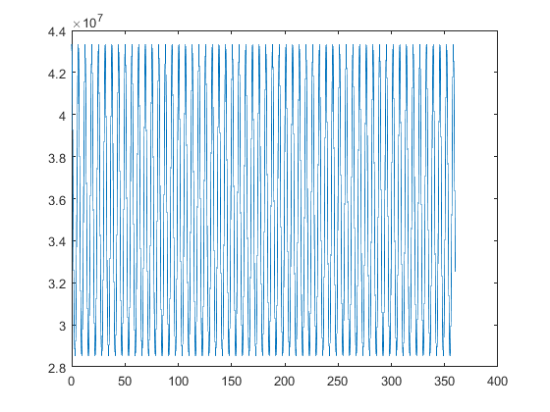

[PROBLEM #14]
format compact, clear, clc, close all
xleft = [-4:0.01:-1];
xmiddle = [-1:0.01:1];
xright = [1:0.01:4];
fxnleft = xleft + 1 ./ (xleft.^2 - 1);
fxnmiddle = xmiddle + 1 ./ (xmiddle.^2 - 1);
fxnright = xright + 1 ./ (xright.^2 - 1);
plot(xleft,fxnleft,'--',xmiddle,fxnmiddle,xright,fxnright,'-.')
axis([-4 4 -15 15]);
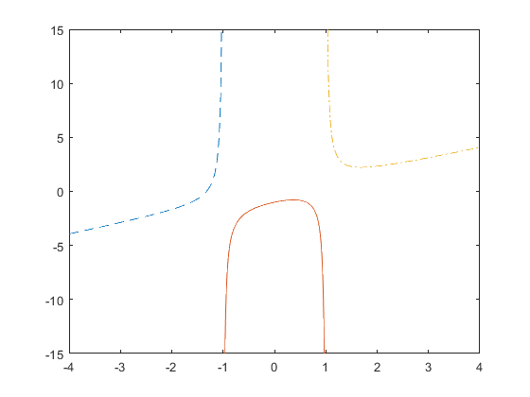
Published with MATLAB® R2019b

