Software Requirements Specification
For
TicketFlow
Version 1.0
Prepared by: Kuchma Artem
12.12.2020
Table of Contents
Table of Contents ii
Revision History ii
1. Introduction 1
1.1 Purpose 1
1.2 Document Conventions 1
1.3 Intended Audience and Reading Suggestions 1
1.4 Product Scope 1
1.5 References 2
2. Overall Description 2
2.1 Product Perspective 2
2.2 Product Functions 2
2.3 User Classes and Characteristics 3
2.4 Operating Environment 3
2.5 Design and Implementation Constraints 3
2.6 User Documentation 4
2.7 Assumptions and Dependencies 4
3. External Interface Requirements 4
3.1 User Interfaces 4
3.2 Hardware Interfaces 6
3.3 Software Interfaces 6
3.4 Communications Interfaces 6
4. System Features 7
4.1 Personal account 7
4.2 Home page 7
4.3 Data seeding 8
4.4 Movie page 9
4.5 Order page 9
5. Other Nonfunctional Requirements 10
5.1 Performance Requirements 10
5.2 Safety Requirements 10
5.3 Security Requirements 10
5.4 Software Quality Attributes 10
5.5 Business Rules 11
6. Other Requirements 11
Appendix A: Glossary 11
Appendix B: Analysis Models 11

Revision History
Name | Date | Reason For Changes | Version
Kuchma A. | 12.12.20 | Initial version | 1.0.0

Introduction

Purpose
The main purpose of the TicketFlow project is to give users the ability to buy tickets for movies in cinema halls. All purchases are expected to be done online via the TicketFlow web application.

This document fully covers all functional and non-functional requirements of the TicketFlow application.

Document Conventions
In this document, the “film” is an item of cinematography, which is directed and cut by somebody. The “movie” is an event in a cinema hall when a particular film is shown at a particular time. All tickets could be sold for a particular movie.

Intended Audience and Reading Suggestions
This document is intended for everyone who is somehow interested in the project.

For users, the most useful part will be 4. System Features, which describes the functionality of the project

For developers, all parts of the document are much or less useful

For operational team members, the Operating Environment part is the essential cause there they can find requirements for operating environments.

For business people the most useful parts may be Business Rules and
System Features

For quality assurance engineers, the most useful parts are System Features and Other Nonfunctional Requirements

Product Scope
The main purpose of that project is to practice software engineering and web application creation skills. Because of it, some aspects of the project may be more creator-friendly than user-friendly.

The whole development of the project is expected to be open-source. So, each developer who is interested in the project, may somehow interact with the project and participate in it.

The project is designed to be an easy-to-use solution for buying movie tickets. The customer will be able to see upcoming movies and details about each movie. Users can also see information about available tickets and buy some of them if needed. Moreover, the user will be able to create a personal account, where personal details and bought tickets will be listed.

The solution will contain frontend and backend parts. The backend part is expected to have microservice architecture.

References
- Project repository: https://github.com/ArtemK123/Ticket_Flow
- PostgreSQL website:: https://www.postgresql.org/
- Consul website: https://www.consul.io/
- NodeJS website: https://nodejs.org/en/
- .Net core references: https://dotnet.microsoft.com/download
- Azure website: https://azure.microsoft.com/en-us/
- Docker website: https://www.docker.com/

Overall Description

Product Perspective
This project should be a stand-alone application, which contains two parts: front-end and back-end applications. Back-end applications will be designed in a microservice-oriented way, so it will be split into multiple separated applications.

Product Functions
The main functions of the project:
- Show upcoming movies
- Show film details for each movie
- Show tickets for the movie (available and sold)
- Give an ability for a user to buy tickets
- Give an ability for a user to register and create a personal account
- Give an ability for a user to log into his account
- In personal account – show personal information about a user
- In personal account – show all tickets which were bought by the user

User Classes and Characteristics
- Anonymous user – Can log in or create a new account. Can view movies, film details, and available tickets
- Logged-in user – Can log out. Can go to a personal account. Can buy tickets, which are available at the moment
- Admin – Can add, update, or delete movies and tickets. Can view a profile of each user.

Operating Environment
The TicketFlow project will require the following dependencies:

- PostgreSQL as a database. Can be deployed with other components or used as a software-as-a-service and taken from third-party providers
- Consul as service discovery. Can be deployed with other components or used as a software-as-a-service and taken from third-party providers
- For frontend application – NodeJS v.12+.
- For backend application - .Net Core v3.1. Each backend service should be deployed independently

Each component of the project should be ready to be hosted in both Unix-like and Windows operating systems.

Each component of the project should be installed in the docker-image, which will be used as a deployment unit.

The whole project is expected to be hosted in the Azure cloud services in a container-oriented environment.

Design and Implementation Constraints
- Frontend application should be created using the React.JS framework
- Backend application should follow the microservice-oriented architecture and should be split to separate services where possible
- Each backend component should be created as an Asp.Net Core WebApi application
- The whole backend should have a single point of entrance, which should be implemented as publicity accessible WebApi
- All components of the system should communicate via HTTP requests
- All components should fetch addresses of other services from service discovery
- Each component with database access should have a separate database
- Public WebApi should be secured from unauthorized access, internal communication between services shouldn`t be secured.

User Documentation
The repository should contain the following documentation:
- Short description of the project with dependencies, how-to-run guide, and general information. Can be done as a README.MD file in the repository
- High-level architecture diagram
- Database schema
- Description of the public web API with information about all possible requests and responses(with examples)

Assumptions and Dependencies
- All required dependencies work as it was described in their documentation
- The project doesn`t have any deadlines and time frames in which it should be finished.
- It is not expected to have any financial profit from this project.

External Interface Requirements

User Interfaces
The application should have a graphical user interface.

The GUI should have a gray-white main graphic theme with color highlights where necessary.

The following fonts are allowed: "Roboto", "Helvetica", "Arial", “sans-seri”.

The final GUI should be similar to the following mockups:
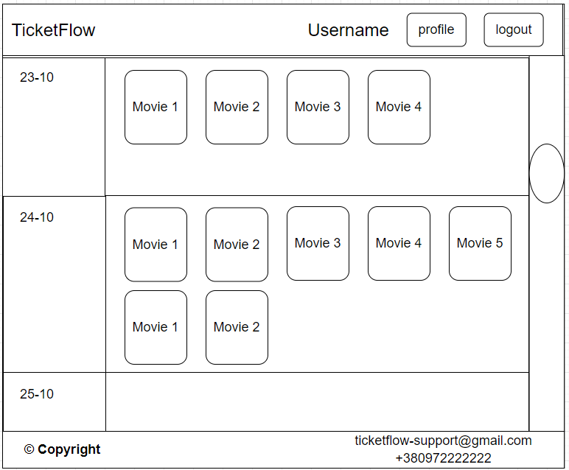
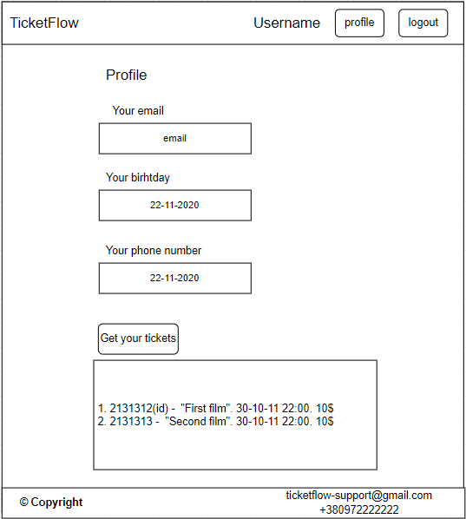
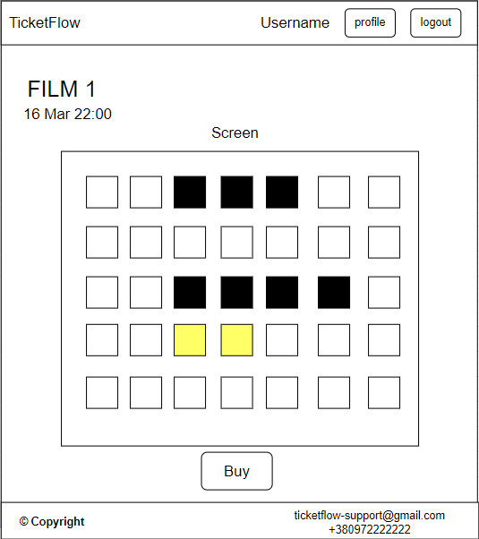

Hardware Interfaces
The project should not have any specific hardware interface. It should communicate with hardware via operating system interfaces both in case of server hosting and in case of working on the client-side.

Software Interfaces
The project should have a publicly accessible web API interface. All clients should communicate with this API using HTTP calls. The frontend application communicates with this API in the same way as other clients could. The API endpoints should be documented.

Communications Interfaces
- For frontend app and GUI – web browser
- For public web API – any HTTP client, including web browsers

System Features

Personal account

Description and Priority
This feature is essential for ordering tickets because only authenticated users will be able to buy tickets. Priority is 8.

Stimulus/Response Sequences
The user should have the ability to create a personal account and then log into it. If it is necessary, a user should be able to log out.

Functional requirements
- As an unauthorized user, I want to register and create a personal account, so that I will be able to log in later.
- As an unauthorized user, I want to log into my account, so that I will become an authorized user and will have access to ordering tickets.
- As an authorized user, I want to open my account, so that I will see my personal information.
- As an authorized user, I want to log out from my account, so that I log in later or log into another account.
- As an unauthorized user, during the account creation, I want to know that the email which I want to use is already taken so that I will provide another email to make it unique
- As an unauthorized user, during the login, I want to have messages when an account with the provided email doesn`t exist or a password is invalid so that it will inform me about the login process and help me to log in faster
- As an unauthorized user, I want to see buttons “Login” and “Register” in the header, so that I will be able to create an account or log in to an existing one from every page around the GUI.
- As an authorized user, I want to see my account name (email address usually) and buttons “Profile” and “Log out” in the header, so that I will be able to go to my profile or log out from it from every page around the GUI

Home page

Description and Priority
The home page will contain all the upcoming movies. It will be the front page, the first page that the user will see. The priority of creating an empty home page – 10, the priority of filling it with data about movies – 6.

Stimulus/Response Sequences
This page should show information about upcoming movies and give the user the ability to choose the movie.

Functional requirements
- As a user, I want to see information about upcoming movies, which includes the film name, cinema hall, and time of the event, so that I can choose a suitable movie.
- As a user, I want to see the page with movies as the first page of the TicketFlow project.
- As a user, I want to click on the movie, so that I will be redirected to the movie page with all details about the movie.
- As a user, I want to have a button in the header, so that it will redirect me to the home page.
- As a user, I want to see movies ordered and grouped by event date, so that I will faster choose the desired movie.

Data seeding

Description and Priority
Administrators should have the ability to seed data about films, cinema halls, movies, and tickets. The priority is 8

Stimulus/Response Sequences
User will not be able to orders tickets if any of those isn`t shown. So, administrators should have the ability to add necessary data about cinema halls, films, and tickets via web API.

Functional requirements
- As an administrator, I want to add the cinema hall to the database via web API, so that I can add movies in that cinema hall later
- As an administrator, I want to add films to the database via web API, so that I can add movies for this film later
- As an administrator, I want to add movies to the database via web API, so that users can buy tickets for this movie
- As an administrator, I want to have tickets for the movie added with the movie, so that all cinema hall seats should have a corresponding ticket

Movie page

Description and Priority
Users should be able to see detailed information about the chosen movie. The priority is 6

Stimulus/Response Sequences
This page should give the user information about a chosen movie

Functional requirements
- As a user, I want to see information about when and where the movie will be shown so that I can plan the visit to the cinema
- As a user, I want to see information about the shown film, so that I can learn a little about the shown film before ordering the tickets
- As an authorized user, I want to go to the ordering page for the chosen movie.

Order page

Description and Priority
A page where the user can order tickets for the chosen movie. The priority is 5.

Stimulus/Response Sequences
Users should be able to choose and order tickets for the desired movie.

Functional requirements
- As an administrator, I want to block the order page for unauthorized users, so that only authorized users will be able to order tickets.
- As an unauthorized user, I want to see information about why the page is blocked so that I can log into my account and go to that page again.
- As an authorized user, I want to see information about the chosen movie(name, location, time), so that I can check the information
- As an authorized user, I want to see all tickets, which are taken or available, so that I can choose which tickets I want to buy.
- As an authorized user, I want to differ available and taking tickets, so that I will choose only available.
- As an authorized user, I want to select and order multiples tickets in one transaction
- As an authorized user, I want to see information about all bought tickets in my account

Other Nonfunctional Requirements

Performance Requirements
For GUI (with network profile: download 10Mb/s, upload 10Mb/s, latency 150ms):

- The home page should be loaded within 3 seconds.
- FCP for the home page should be done in 1 second.
- The total size of downloaded resources (encoded) should not exceed 50 MB.

For web API (with network profile: download 10Mb/s, upload 10Mb/s, latency 150ms):
- Expected maximum number of requests at the same time - 10
- Expected maximum of requests per minute - 100

Safety Requirements
Not applied

Security Requirements
- All users could be authenticated via email/password pair or a session token.
- User should be authenticated before using actions, which is available only for the following roles: authenticated user, admin
- Web API calls should be secured, communication inside backend components is not required to be secured

Software Quality Attributes
- All backend components should be covered by unit or integration tests. The total coverage should more than 50% lines
- Public web API should be covered by web API tests, which checks that all contracts and responses are correct
- GUI should be covered by manual test cases
- All components (GUI and backend) should follow the predefined style guides and should not have any compile-time warnings

Business Rules
- The project should be developed with open source code.
- There should be no limitations regarding users of the project.
- It should be possible to add third-party developers to the project developments as volunteers.

Other Requirements
- TicketFlow should be an open-source project
- The project should have an MIT license, which means that any person can use or modify the project`s source code.
Appendix A: Glossary
- Cinema hall – a place when films are shown
- Film – an item of cinematography art, which was directed and cut by somebody
- Movie – and event, when a particular film is shown at a particular time in a particular cinema hall
- User – the client of the project. Can use project via GUI or web API
- Authorized user – the user which was authorized using email/password pair or session token
- Unauthorized user – the user which haven`t authorized yet
- Ticket – ticket for the movie, which is related to the particular seat and has the price. Can be ordered by the user
- Home page – the first page which is shown for a user
- Redirect – action when a user is driven to another page
- Front-end application – part of the project, which is responsible for GUI
- Back-end application – part of the project, which is responsible for web API
- GUI (graphic user interface) – web interface, which is usually used by a user via a browser
- Web API (application programming interface) – web interface, which is usually used by user by HTTP clients. This interface is usually used by software, not by a user directly.
Appendix B: Analysis Models
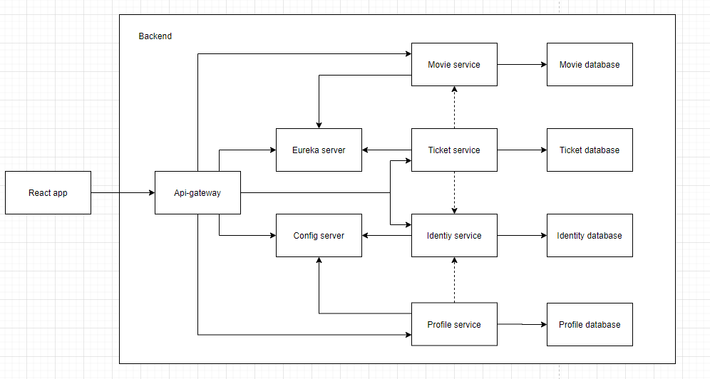
Proposed architecture diagram (for Java stack):

Proposed database scheme:
