****High-Impact Content  
-

Differentiated Services

## Executive summary

In short, this document describes our approach for a ***pilot*** to allow for faster editorial & production time for content with high potential for citation, and by:

* Proposing a dedicated workflow for HIC that will allow for 50% faster time from submission to publication;
* Making HIC more visible on SD;
* Proposing manual procedures for initial implementation of this workflow;
* Establishing the ground for automated identification via the development of EDGE and filtering / tagging of HIC on SD.

This project is part of a suite of initiatives supporting the strategy aiming to reach 30% of the highly-cited article share, publishing more than 24k articles in the top 5% cited papers by 2017

## Fast-tracking HIC

### Differentiated services for HIC

#### Workflow

The plan is that:

1. The JM or editorial assistant checks the list of authors against a database of HI authors and institutions;
2. He/She activates a flag to draw the attention of the editor(s) that the submission is linked to a HIA/HII
3. The editor can activate a second flag that will trigger the article to follow a HIC workflow based on his/her opinion of the article

#### Fast-tracking editorial and production processes

In the HI workflow, we want to cut the editorial and production time by 50% to allow for fast-tracking of HIC. The plan is to:

1. Use a different set of template letters for inviting reviewer emphasising that this submission has high-potential and that we trust this reviewer with our highest-quality material;
2. Allow for 50% lower time for review with regular reminders (weekly);
3. Send the article for copy-editing/type-setting at *acceptance* that has proven to speed up the production process and enable accessibility of the article in its final form earlier.

### ***Implementation for a pilot***

#### Enabling flags in the editorial system

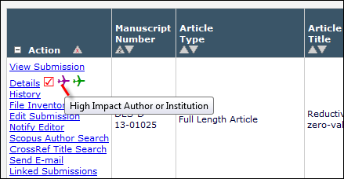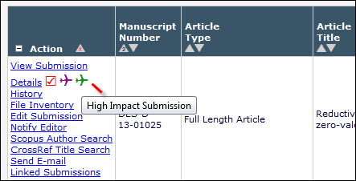

A set of two flags have beenimplemented on an EES test site to prove feasibility.

#### HIA/HII Identification

* A list of HIAs and HII will be pulled out of MAS-SCOPUS for the categories relevant to the journals in the pilot.
* A queryable database will be created on nonsolus
* If the name of the author/institution appear on the list, then the JM/Editorial Assistant activates the first flag

#### Editors’ choice

* Editors will be instructed to pay specific attention to articles with the first flag activated;
* They will also be invited to activate the second flag for content they think has the highest potential (top 5%);
* The Journal Manager will monitor monthly the number of articles that have been sent for fast-tracking;
* The articles that have been flagged by the editor will follow the HIC workflow.

#### Production

The fast-tracking of the production can be performed manually by the JM, who sends the submission to the supplier, until a more automated workflow can be integrated.

#### At the journal and article level

We propose that for the journals in the pilot, a section labelled “Editor’s choice” is created on Sciencedirect and that HIC articles are clearly labelled “Editor’s choice”.

The journal seclected for the pilot will have to be ABP to ensure the fastest possible turn around.

Examples of journals where this exists already, on SD:

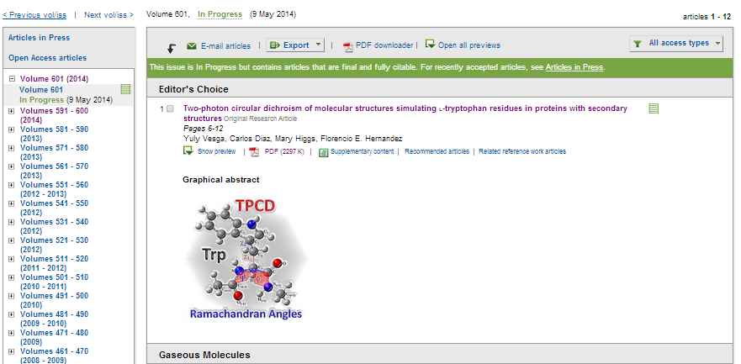

And on the article:

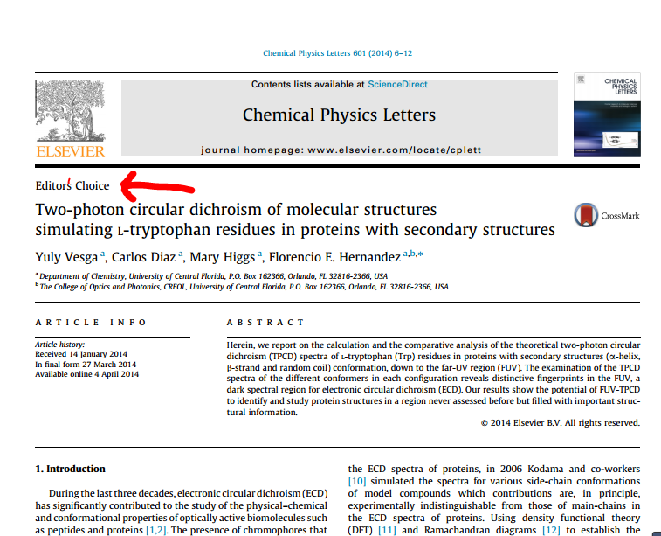

#### Pilot

We devised that DIAB is a prime candidate for this:

* the Publisher, Andrew Miller, was involved in the project and fully aware of what it entails
* DIAB publishes articles is in an area of direct relevance to societal problems (potential for altmetrics) and where our capture of HIC is not very high (see Article & Citation Share analysis from R & AR)
* it has content from HIAs
* the supplier for the typesetting (Thomson) has worked on the 24h publishing project and
* it has an internal editorial assistant based in Oxford (Jo Frankland’s team), which will help to establish an efficient feedback loop with the EES development team

We propose that this journal embarks on this program by 1st July 2014 for a 3 month pilot, where we will monitor the uptake from the editors, the improvement in processing time etc.