CURRICULUM VITAE

MAHMOUD ABU-KHARMA

Phone: (0962-6) 40-23070  Cell phone: 0777767669  mkharma@fet.edu.jo  mkharma@bau.edu.jo  mah_kharma@hotmail.com | Work: Department of Applied Sciences,  Faculty of Applied Engineering  Al-Balqa Applied University,  P.O. Box 15008, Amman11134, Jordan  Home: Sahab-Amman-Jordan
Personal Information:  Name: Mahmoud Hasan Joma’h Abu-Kharma  Date and Place of Birth: 15 Aug. 1955, Zarqa /Jordan  Nationality: Jordanian  Marital Status: Married |  | 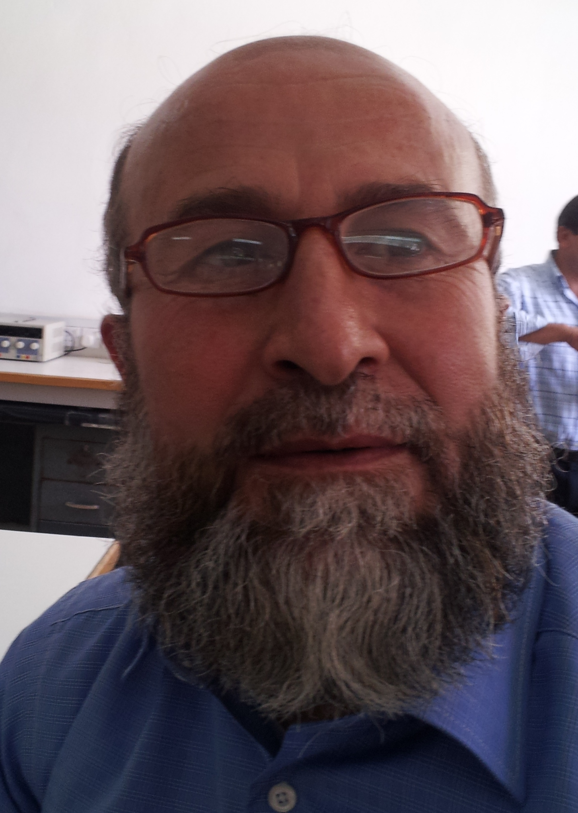

Education

PhD Memorial University of Newfoundland , Physics Department 2005
Dissertation: “Collision-induced absorption of the first overtone bands of H₂ and
D₂” Advisor: Professor S. Paddi Reddy

MS Memorial University of Newfoundland, Physics Department 2002
Thesis: “Investigation of The Elastic Properties of LiKSO4 Single Crystals as a Function of Temperature and Pressure”
Advisor: Professor Guy Quirion

MS Jordan University, Physics Department 1982
Thesis: “the lifetime of the first excited singlet state of anthracene crystal as a
function of temperature, frequency, pressure, and thickness of the
crystal.”
Advisor: Professor Riyad Ahmad Bitar & Basim Nabih Bulos
BS Jordan University, Physics Department 1978
Bachelor of Science, Physics

Honors and Awards
Title of Award
- Royal Scholarship for the First Student in the High School to Study B.Sc. Ministry of Education / Jordan.1974.
- M.Sc. Scholarship Memorial University of Newfoundland.2000.
- Ph. D. Scholarship Memorial University of Newfoundland. 2002.
Title of Fellowship
- Fellow of the school of graduate studies, Memorial University of Newfoundland, 2005.
Title of Award
- Certificate of appreciation from the physics and physical oceanography department (Marking guidelines for second-year physics laboratory reports). 14 Nov. 2003.
- Nomination for the Award for Excellence in Community Service 30 March 2005. Memorial University

Training:
- The Ministry of Energy and Mineral Resources/Jordan/Amman, Radiation Protection First Level, 3-7/Sep./1994
- Memorial University of Newfoundland/ Canada, Workplace Hazardous Materials Information System (WHMIS) Lab Safety, 31 May 2000.
- Many work shops to improve the graduate students at the physics department (Physics Department & Instructional Development Office).

Publications

* Books

  - Lagrangian and Hamiltonian Mechanics, Mutah University, 1995
  - Experimental Physics (1) Mechanics 5th edition 2006
  - Experimental Physics (2) Electricity and Magnetism 5th edition 2006
  - Experimental Physics in Arabic 5th edition 2006
  - General Physics in Arabic 1st edition 2012

* Journal Publications
- Investigation of the Elastic Properties of LiKSO₄ Single Crystals as a Function of Temperature and Pressure, Journal of Physics: Condensed Matter 15 pp 4979-4993(2003). doi:10.1088/0953-8984/15/29/309

- Analysis of the CIA spectra of the first overtone band of D₂ in D₂-N_{2,} Journal of Molecular Spectroscopy, 232(2), 369-374,( 2005).
http://dx.doi.org/10.1016/j.jms.2005.04.019

3. Collision-induced first overtone band of D₂ in binary mixtures D₂-X where X is Ar, Kr
and Xe., Journal of Molecular Spectroscopy, 233, 133-137(2005)
http://dx.doi.org/10.1016/j.jms.2005.06.010

4. Collision-induced absorption by D₂ pairs in the first overtone band at 77 K, 201 K and
298 K, The European Physical Journal D , vol. 37, nº1, pp. 59-66, (2005)
http://dx.doi.org/10.1140/epjd/e2005-00259-5

5. Collision-Induced First Overtone Band of H₂ in Binary Mixtures H₂-N₂ and H₂-
CO, Journal of Quantitative Spectroscopy and Radiative Transfer, vol. 97, nº3, pp. 332-343.( 2006 )
http://dx.doi.org/10.1016/j.jqsrt.2005.04.012

6. Analysis of the collision-induced absorption spectra of H₂ in H₂–N₂ in the range 5600–
9500 cm⁻¹, J. Phys. B: At. Mol. Opt. Phys. 40 2345-2350.(2007)
http://dx.doi.org/10.1088/0953-4075/40/12/010

7. Magnitudes of Bremsstrahlung and Cyclotron Cooling From on-Axis Accretion Shocks
onto AM-Her Systems, Jordan Journal of Physics,V1,N2 ,pp79-87 (2008)
http://journals.yu.edu.jo/jjp/Vol1No2Contents2008.html

8. Collision induced absorption spectra of the fundamental band of D₂ in binary mixtures
D₂–Kr at 298 K , Journal of Molecular Spectroscopy 259(2), 111-115 (2010)
http://dx.doi.org/10.1016.j.jms.2009.11.009

9. Collision-induced absorption spectra of the fundamental band of D₂ in D₂–rare
gas binary mixtures at room temperature: further analysis of the fundamental band, Journal of Physics. B: Atomic, Molecular and Optical Physics. 43 135104 (7pp) (2010) 135104
doi:10.1088/0953-4075/43/13/135104

10. الإعجاز الفيزيائي في آيات مدّ الأرض, مجلة جامعة الملك فيصل

Journal Papers Accepted
Collision-Induced Absorption In The Second Overtone Band Of H₂, Canadian Journal of Physics, 2012

Conference Papers

- Poster (Investigation of the Temperature and Pressure Phase Diagram of LiKSO₄), International Conference on Application of Photonic Technology-/ Quebec City ,Canada, -June 2 to 6 / 2002
- Paper (The Collision Induced Absorption of the First Overtone Band of H₂ in H₂-N₂ and H₂-CO Binary Mixtures at Room Temperatures), 22-26 March 2004 APS, Montreal/ Canada
3. Analysis of the CIA spectra of the first overtone band of D₂ in D₂-N₂, 22-23
Feb. 2005 Memorial University of Newfoundland, GSU (Aldrich)
4. Analysis of the CIA Spectra of the Second Overtone Band of D₂ at 77K, the 20Th
International Conference on Spectral Line Shapes at Memorial University. St.
John’s, Canada, June 6-11(2010).
http://dx.doi.org/10.1063/1.3517563

Conference Papers “accepted”

1. Analysis of the CIA Spectra of the Second Overtone Band of H₂ at 77K, the 21st
International Conference on Spectral Line Shapes. Saint Petersburg, Russia, June 3-9
(2012).

Practical Experience:
Saudi Arabia / Jordan 1977-1990 | Ministry of Education
Karak, Mu’tah /Jordan 1990-2000 | Mu’tah University
St. John’s/Canada 2000-2006 | Memorial University
Jordan- Jarash 2006 | Jarash University
Jordan-Amman 2006-Now | Al-Balqa Applied University

Courses
- General physics 101 and 102, Classical mechanics Electricity and Magnetism
- Astronomy,
- Modern Physics,
- Physics labs
- Molecular spectroscopy.

Professional Affiliations

- Mutah University , 1990-2000 Teaching
- Memorial University of Newfoundland, 2000-2006
Teaching, Researcher, Graduate Student (M. Sc, Ph. D)
- Al-Balqa Applied University 2006-present Teaching and Researcher

Languages
English: Advanced Reading and Writing
Arabic: Native Language

Computer Skills
Excellent skills in computer programming and software, Windows, Linux.

References
Dr. Husain Y. R. Al-Omari, [Professor]
أ. د. حسين يوسف راشد عمري
[Department of Physics]
[Mutah University]
[Mutah, Mutah University, Department of Physics]
Phone: [0795507497]
Email: rashed@mutah.edu.jo

Dr. Naseem T. Shawagfeh, [Assistant Professor]
د. نسيم طالب أحمد شواقفة
[Department of Applied Sciences]
[Al-Balqa Applied University]
Phone: [0777425595]
Email: nassha63@yahoo.com

