single and married teachers and experiencing different amount of stress.

Sig. | Correlation coefficient(r) | Variables
0.23 | 0.12 | Level of teaching and stress
The relationship between level of teaching and stress

.

The relationship between teachers’ stress and burnout

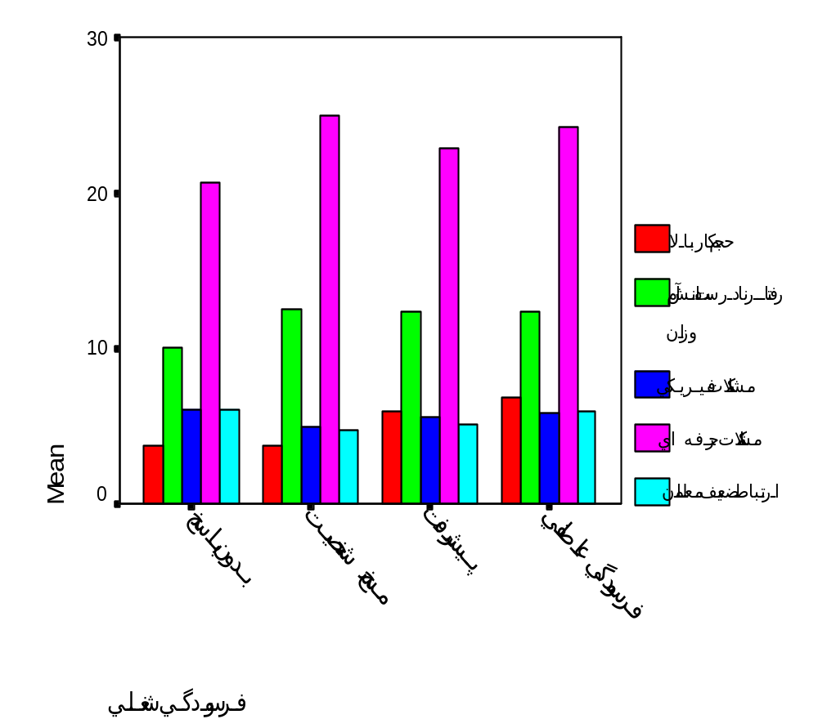

Mean
Heavy workload

Students misbehaviour

Classroom resources

Professional recognitions

Poor relationships with colleagues

Missing Depersonalization Personal Emotional
exhaustion accomplishment

Figure 1.The relationship between teachers’ stress and burnout

