Asdfajlfdl;soiwedlskalfweoiklsdkfafaskljjkBusiness case:
~1p so everyone has context for what the application should do. Focus on customer perspective.

Overview: The Case Management Dashboard will be used by compliance executives and line managers to get a single view of the alert response process, including alert data captured in Searchspace, case data captured in DH Case Management, process auditing data captured in DH Case Management, and account data from external sources. The case management dashboard will make the information contained in these source systems more valuable by correlating it, providing comparisons to benchmarks, and highlighting exception conditions.

Background: The Alert Response (Case Management) Process
NOTE: This section is background reading to describe the underlying case management application which will be monitored by the dashboard. Details about the dashboard follow.

A compliance analyst responding to a money laundering alert needs to understand all of the information about the customer, products, accounts, employees. To do this, the analyst follows a process: investigate alerts, create cases, drill down for details, and decide what action to take.

- Assign: Assign analysts from a pool based on rules (e.g. region, type of alert, workload)

- Review: Filter alerts to sift out obvious false positives. Drill across systems to investigate structured or unstructured information not in the alert database itself.

- Build Digital Case File: When an analyst finds interesting information, save findings into a digital case file. Not all information will be saved—only relevant information.

- Investigation (Single User Workflow): Follow a single-user workflow to get details. Process tracks what a user does.

- Escalation or Kickback (Multi-User Workflow): Allow escalation of a case (multi-user workflow) both manually and automatically (on rules like age of alert >20 days).

- Resolution: Allow actions including flag for follow up (like outlook), initiate process, send email alert, update external DB, file SAR (Suspicious Activity Report), or others.

- Regulatory Reporting: SAR filing must be done electronically by inputting required data into a form and generating the required output format.

- Auditing: Track what was done, when, by whom for later review and auditing. Tracking should be via a separate console (Admin /Manager Console).

- Monitoring Dashboard (focus of this document): Help managers understand how the business is operating. E.g. show aggregate and detail metrics as outlined in this document.

Manager Usage: Rob Edwards is Compliance Manager. He uses the AML Dashboard to get a “complete picture” of the compliance situation. He needs to see summary metrics on the process as well as details for any exceptions. He wants to evaluate risks at different stages in the cycle of a case, measure actual results against expected thresholds, and understand what is happening by looking at details for bottlenecks, overloaded analysts, cases that were kicked back or escalated, and cases that are closed. He wants a clear, one page summary view with exceptions highlighted, plus the ability to drill into relevant details as necessary. He must be able to print a readable version to take to meetings. Rob opens the dashboard several times every day to view status and understand the situation by sorting and filtering on different dimensions, such as analyst, stage, or alert type. Noting the last modified timestamp that is included with each opportunity, Rob can quickly get a sense of the compliance situation

The following diagram illustrates the process flow that must be followed at AmSouth:

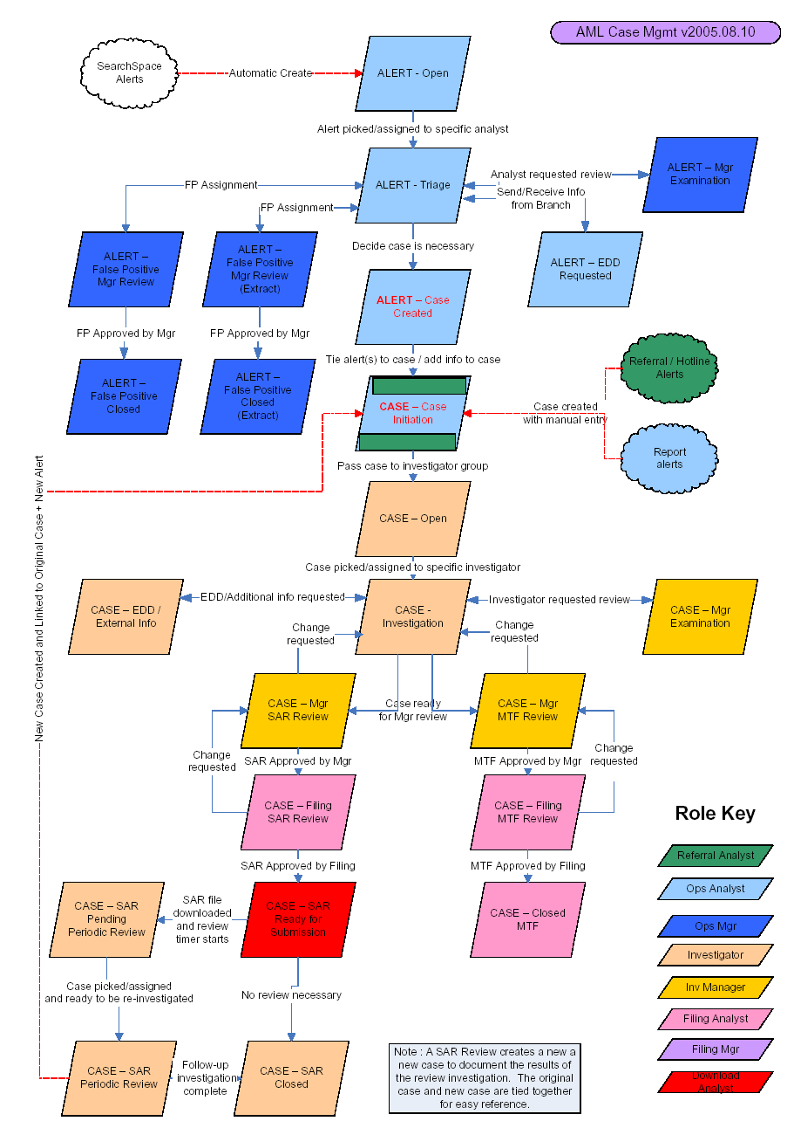

Application requirements:
5-8pp covering environment, datasources, UI (including correlations, asks, etc). This should call out explicit requirements with a header so it is clear what we require them to test and what is supplementary / explanatory detail. You can determine whether it is necessary for you to provide screen shots and data models in order for QA to understand the use case. Otherwise, they will create detailed specs from your req’ts.

Application Definition

Supporting PiiE Capabilities
- Live data
- Data aggregation queries. User customized queries via Input Values dialog
- Exception management (threshold, images in table)
- Correlation and Popups
- Highlighting and multi-select
- ASK
- Transferability (printing, emails, screen shots)
- Rule-driven interface changes
- Security
- Rolling 6 month and quarterly forecast chart based grouping of raw dates in DB
- Multi-chart: Forecast vs. Actual from two tables in 2 DBs in same table
- Matrix view with Sum of Weighted Avg revenue forecast by salesperson by stage with totals
- Highlighting based on a threshold that uses a dynamic variable
- Export to excel (Export table, export chart as data table, export formats)
- Parameterization of queries

Data Sources
The Searchspace DB contains alert data
The AML DB contains case data
Fusion server contains process metadata
The SAR DB (part of the AML Model) contains SAR-specific fields

The Fusion model is below.

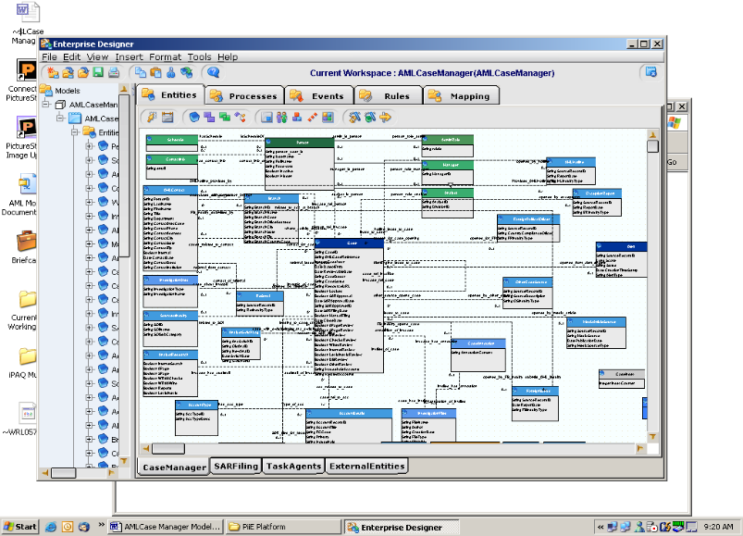
The data fields required for filing a SAR will be captured as part of the model. Several SAR entities are based on defined pick lists as described in SARS specification document.
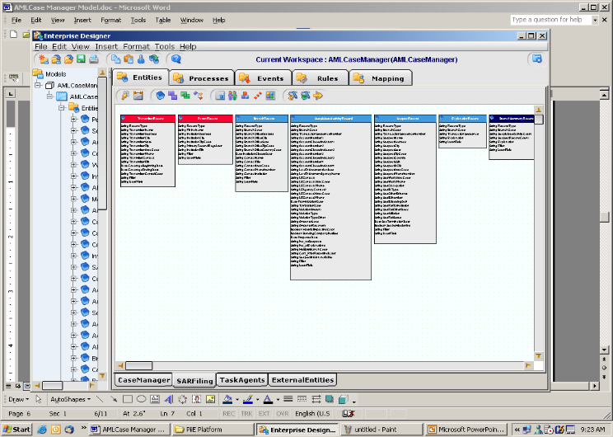

Application Interface
The user will be greeted by the following primary view. Details concerning the queries and functionality of each of the individual component groups are described in the next section of this document.
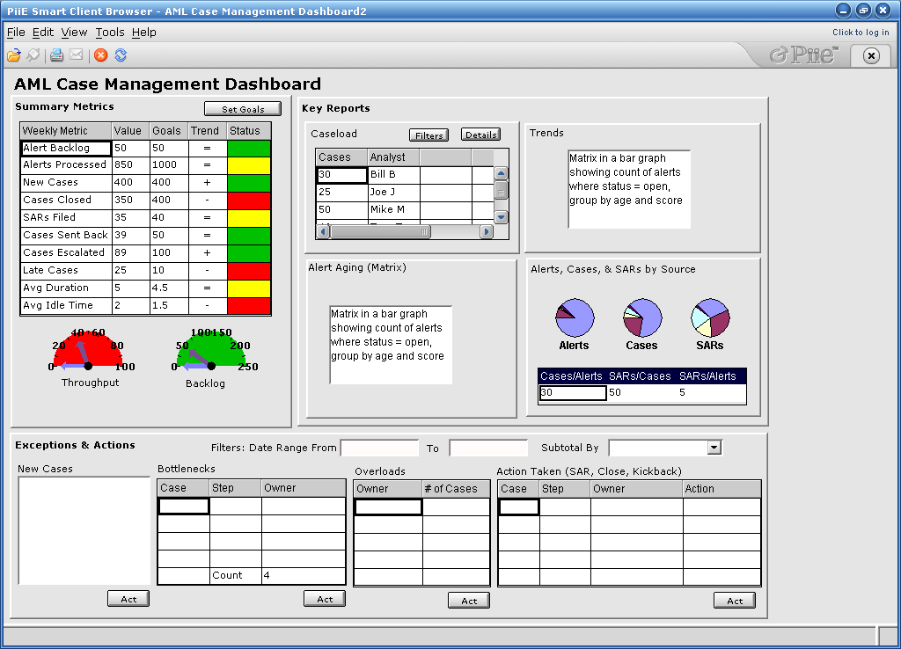
A
B
C
D
E
F
G
H
I
J
K
L
M
N
O
P
Q
R

Cross-Reference of System Test Components with Requirements Tested
Index | Name | Component Description | Requirements Met | PRD Source
A | Summary Metrics | This smartlet will show calculated metrics that are based on underlying data or processes and have a rule that compares them to user-defined goals +/- a user-defined variance to determine status. Some metrics will be based on raw data, some based on transformed attributes in fusion server, some based on aggregates of process attributes (e.g. avg duration). It may not make sense to put these all in a single table. It may make more sense to have separate components with separate queries for each metric. If this is the case, we could trim down the number of metrics to avoid a lot of duplication of tests. | Calculations in a table (Calculations should be done 3 ways: ED transformations, in new table, using staged data) | Dashboard UI
B | Set Goals |  |  | na
C | Key Reports |  |  | na
D | Caseload | Caseload (count of cases) by different filters including specific actors (e.g. Joe Analyst), types of actors (e.g. Manager), type of alert (e.g. Breakpoint), score (e.g. 80-100), region (e.g. Caribbean), status (e.g. Open), source of inquiry (e.g. Searchspace, 314b inquiry, branch notification). | Display all processes assigned to a particular actor (same as caseload) | PFS Workflow
E | Caseload Filters | Parameters for caseload query | Parameterized query | Dashboard UI
F | Caseload Details | Show specific cases (instances) by analyst with subtotal count of cases plus total count of cases) | -Table totals & subtotals  -Export ASK results to excel (Export table, export chart as data table, export formats) | Dashboard UI
G | Trends | Compare 4 period rolling trend of number of open cases, closed cases, and alerts by week, month, or quarter (optional: could filter the list by different constraints such as status – closed, open, SAR request, by analyst, by source of inquiry, open for more than a particular period) | -Relative (rolling) dates,  -date groupings,  -parameterized query,  -multi-chart with 3 lines (ideally from 2 different DBs with different scales) | Dashboard UI
H | Alert Aging | Aging: Show all alerts open for >20 days with score >80 by analyst or by source. | -Matrix view  -Display all processes in state Open, assigned to a particular actor, where the process is started within a range of dates. | PFS Workflow
I | Ratios |  |  | PFS Workflow
J | Exceptions |  |  | PFS Workflow
K | Filters |  |  | PFS Workflow
L | New Cases |  |  | PFS Workflow
M | Bottlenecks |  |  | PFS Workflow
N | Overloads |  |  | PFS Workflow
O | Action Taken | Manager reviewing a list of open cases should be able to set a new actor on a process in three ways (reassign back to analyst, escalate to special investigator, or assign automatic step of generating a SAR) |  | PFS Workflow
P | Act |  |  | PFS Workflow

Unassigned Requirements / Validate Coverage
 |  |  | Group By is applied to the attributes, inputs, outputs, actors, and resources of Processes in conjunction with aggregates. | PFS Workflow
 |  |  | PFS should support Group By queries where the Group By is applied to the attributes, inputs, outputs, actors, and resources of Processes in conjunction with aggregates. | PFS Workflow
 |  |  | PFS should support Group By queries where the Group By is applied to the attributes, inputs, outputs, actors, and resources of Processes in conjunction with aggregates. | PFS Workflow
 |  |  | PFS should support queries against Entities where the filters are based on their association with one or more Processes as an actor, input, output and resources. | PFS Workflow
 |  |  | PFS should support aggregates for queries against Entities, where the filters are based on their association with one or more Processes as an actor, input, output and resources. | PFS Workflow
 |  |  | A console developer should be able to define a Fusion Query on Processes in “FusionQueryGroup” in order to represent Business Process data in an hierarchical format in a Table, Tree or Document component. | PFS Workflow
 |  |  | A console developer should be able to bind to attributes of non-primitive types which are attributes of Processes in the capacity of inputs, outputs, actors and resources. | Dashboard UI
 |  |  | Correlation should be supported across components which are bound to process data as a result of Business Process queries.
 |  |  | Selecting an attribute of one of the Business Process should select the actor for that Business Process instance in another component.
 |  |  | Selecting an actor in a Business Process should select the resource for that Business Process instance in another component.
 |  |  | Highlighting based on a threshold that uses a dynamic variable
 |  |  | Display the count of Cases which are currently inputs to CaseAnalysis and CaseReview process and where the CaseAnalysis and CaseReview process are still running.
 |  |  | Display the count of all processes which have been completed by each actor this month.
 |  |  | Display the average duration of processes by priority.
 |  |  | Display the count of all processes by process state.
 |  |  | A console developer should be able to define a Fusion Query on Processes in “FusionQueryGroup” in order to represent Business Process data in an hierarchical format in a Table, Tree or Document component.
 |  |  | A console developer should be able to bind to attributes of non-primitive types which are attributes of Processes in the capacity of inputs, outputs, actors and resources.
 |  |  | Correlation should be supported across components which are bound to process data as a result of Business Process queries.

Detailed Smartlet Descriptions
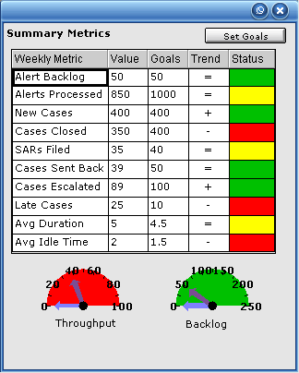
This smartlet may be better implemented as multiple components, since each metric may involve a different query.
It would be nice to use a gauge component and to use the new banding capability, but the specific measurement shown here may not be the best one.

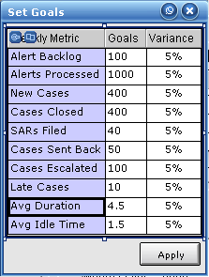

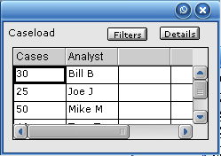

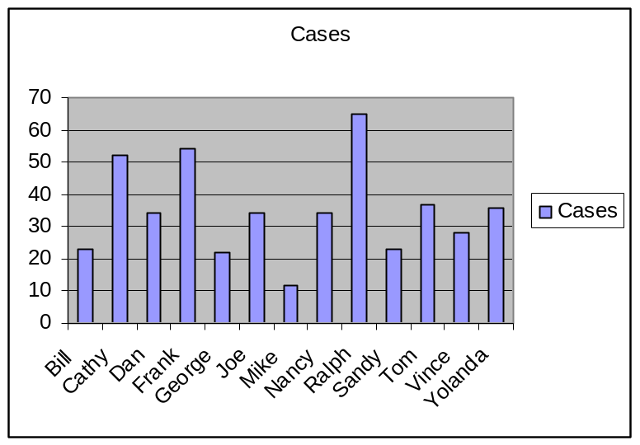
NOTE: We could not previously support graphs that can automatically adjust the number of rows (x axis) based on user selected filter (i.e date range). This should be validated.

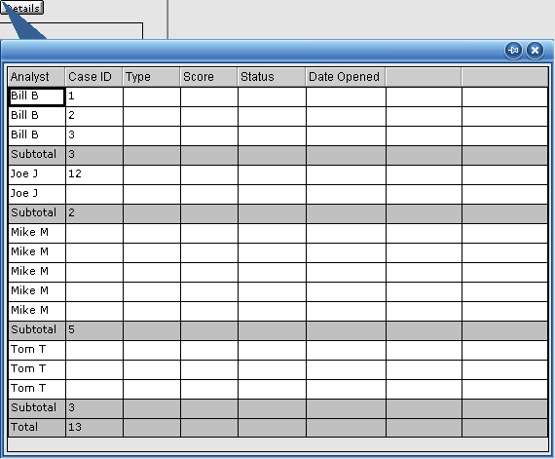

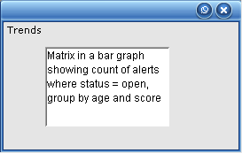

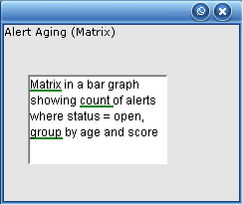

NOTE: The following is an example of an Aging Trend Report that Citigroup wanted but we could not deliver in Concorde. It shows a trending report of open alerts (with score >80) that are open for > 20 days.
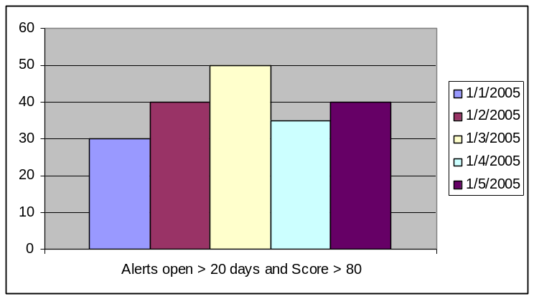

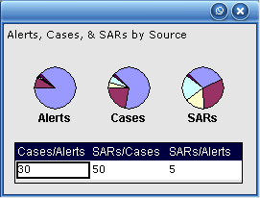

NOTE: The following is an example of chart we could not support in concorde but should be able to support in discovery: a trend of aggregates.

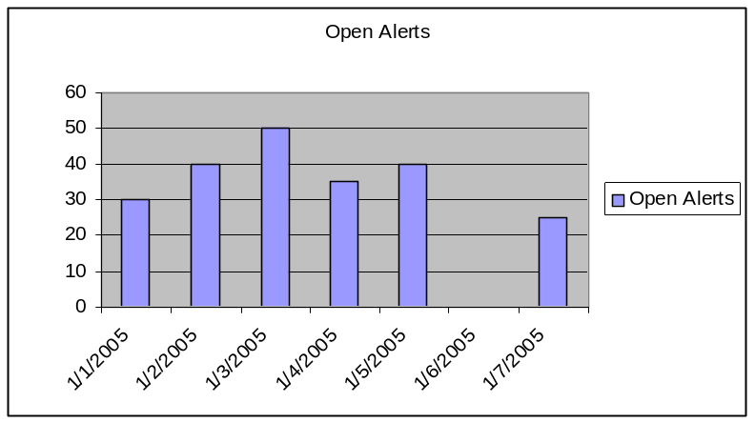

NOTE: The following is an example of chart we could not support in concorde but should be able to support in discovery: multiple aggregates on the same graph.

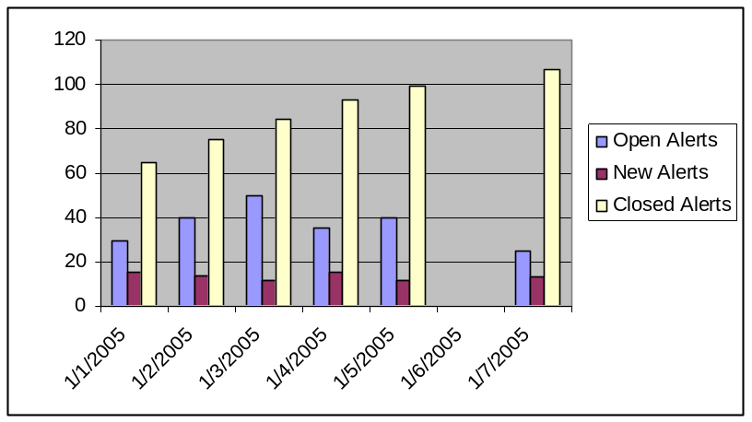

NOTE: The following is an example of chart we could not support in concorde but should be able to support in discovery: aggregates from different entities on the same graph
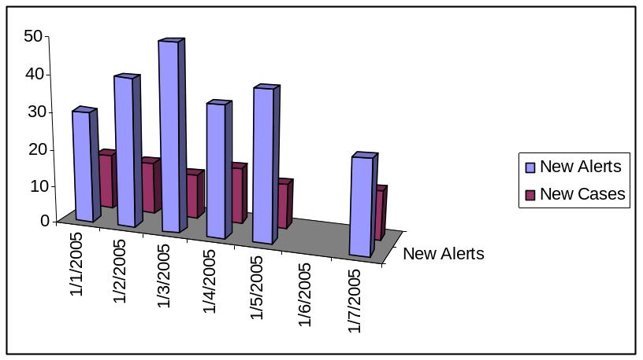

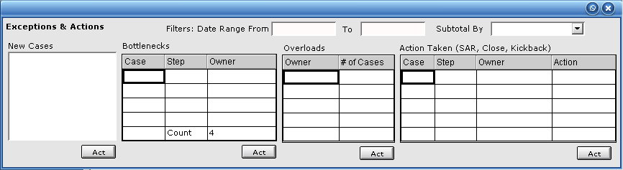

Performance and Reliability
<1p if relevant, list any explicit requirements you expect as part of the system test execution.

- MTBF – Broker/Browser Runtime Test under many-user load should run for 100 hours
- Typical Query– Composite Application consoles requiring multiple queries involving multiple tables to support PiiE correlation should complete in <5 seconds.
- Open published application—Time it takes to open a published application the first and second time should occur in <15 seconds
- It is recommended that a maintenance log be kept of each time that the Broker or Fusion Server requires a restart in order to begin the process of gathering platform uptime statistics.

Appendix:
Any existing material we have in the form of screen shots, models, data if appropriate (if we have it, include it…if we don’t, you can provide an example but let QA fill in the details).

Previous Attempts at AML Dashboards
Below is the AML dashboard that was built for the Smith Barney POC in Blackbird. This dashboard did not allow many of the functions required.
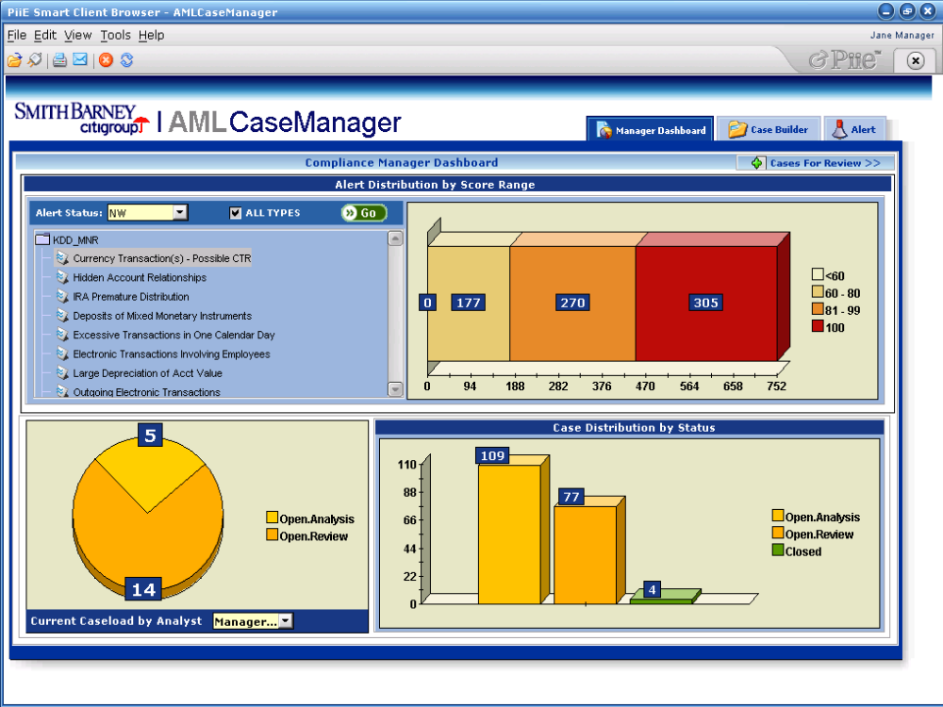

Open Issues
 | Question / Business Need | Implementation | Priority

Out of Scope
- Offline - Since dashboard users put a premium on the accuracy of data, constant network connectivity can be assumed.
- Web Services – Web Services are not likely to be included in a dashboard unless used for simple “nice to have” features such as company stock price or current weather conditions.
This Smartlet displays the potential revenue for opportunities in stages 6-9 as grouped by close date.

