
Spellcheck And Thesaurus
Table of Contents
Spellcheck 1
Two Ways To Activate AutoSpellcheck. 1
1 - Activate AutoSpellcheck from The "Standard Toolbar" 1
2 - Activate AutoSpellcheck in the Spellcheck Window 1
Using Spellcheck On The Document Or A Text Selection 2
Correct Misspelled Words As You Enter Text 3
Add A Word 4
Delete A Word 4
Add A Dictionary 5
Delete A Dictionary 6
Thesaurus (Synonyms) 7

Spellcheck
When AutoSpellcheck is on, it automatically checks spelling as you type and underlines errors with a wavy red line. When the word is corrected, the red wavy line disappears.

Two Ways To Activate AutoSpellcheck.

1 - Activate AutoSpellcheck from The "Standard Toolbar"
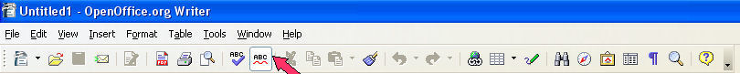
- Notice how the AutoSpellcheck 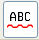 icon looks on your Standard Toolbar. Click the AutoSpellcheck icon. The 'AutoSpellcheck" is on. (The icon now has a brighter background)
- Click it again to turn it off. (The brighter background is now gone)

2 - Activate AutoSpellcheck in the Spellcheck Window
- Type derections. (notice that the word is spelled incorrectly) Press the space bar. A red wavy line does not appear under “derections”.
- Click Tools > Spellcheck. The "Spellcheck "window appears.
- Click Options. (The "Writing aids" window appears.) In the menu box under Options, click Check spelling as you type to put a check mark by it. Click OK.
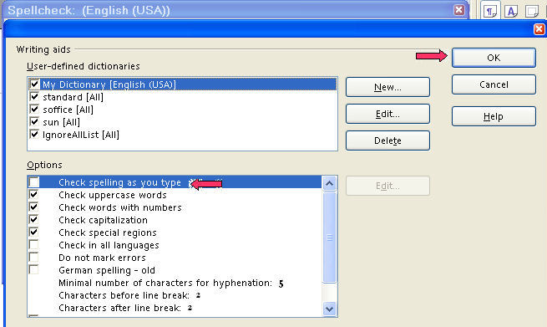
- Type behaveour. Press the space bar. You will see:

Using Spellcheck On The Document Or A Text Selection
- Type the words, Agoodspeller is a persen who. Press the space bar. You will see . (Typing errors and misspelled words are highlighted in the document with a red, wavy, underline.)
- Click the Spellcheck, , icon. The "Spellcheck" window appears. Under Not in dictionary, the word(s), “agoodspeller” will be in red. Place your cursor between the words, a good speller, in agoodspeller, and press the Space bar to add spaces, “agoodspeller” becomes “a good speller”. Click Change. Persen will be the next word in red. Under Suggestions, persen will have two suggestions, person and per sen, select person. Click Change. “persen” becomes person. Other choices are Ignore Once, Ignore All, Add, Change, Change All, and AutoCorrect.
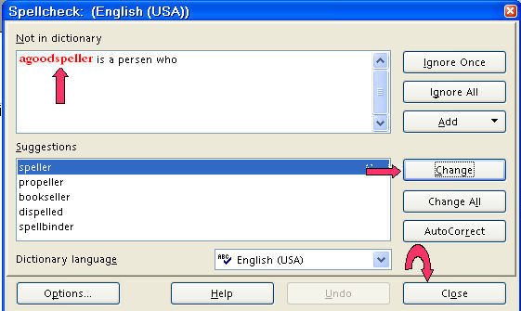
- Click Close.

Correct Misspelled Words As You Enter Text
- Type the word, thae. Press the space bar. A red wavy line appears under the misspelled word, thae.
- Right-click on the misspelled word, thae. A menu appears.
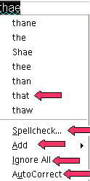
- The menu will have a list of suggested corrections and a line to separate the suggested words from the your choice of the selections. Under the line are the selections:
“Spellcheck” opens the Spellcheck dialog.
“Add” gives you a choice of dictionaries to add the word.
“Ignore All” gives you the choice to ignore that word in the document
“AutoCorrect” gives you a list of suggested corrections.
- Select the suggested correction, that.
- The menu closes and the spelling of the word has been corrected .
- If you make the same mistake again while typing the document, it will be corrected automatically. (These automatic replacements are only made during the current OpenOffice.org session).

Add A Word
- Type the word, Spellcheck. (A red, wavy line appears under the word.) This word is spelled correctly and we want to add this word to the dictionary.
- Right-click on the word, Spellcheck.
- Click Add . (A list of dictionaries appear.) Click standard.dic. (Soffice.dic and sun.dic are two other choices.)
- " Spellcheck " will not have a red, wavy line under it the next time you type it. The word has been added to the standard.dic.

Delete A Word
- Click Tools > Options > Language Settings > Writing Aids. (The “Options – Language Settings – Writing Aids” window appears.)
- Under User-defined dictionaries, click standard [All].
- Click Edit. (“Edit” is located on the right side of the “Options-Language Settings-Writing Aids” window. The “Edit Custom Dictionary” window appears.)
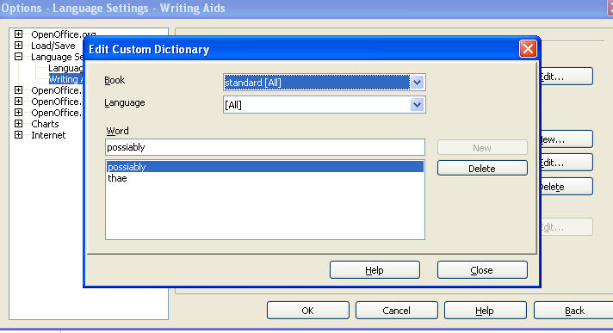
- If the word, possiably, is not in the dialog box below Word, type possiably.
- Click Delete > Close. (The “Edit Custom Dictionary” window closes.)
- Click OK. (The “Options > Language Settings > Writing Aids” window closes.
- If you happen to type the word, possiably, in your document, there will be a red wavy line under the word.

Add A Dictionary
- Click Tools > Options > Language Settings > Writing Aids. (The “Options – Language Settings – Writing Aids” window appears.)
- Click New. (“New” is located on the right side of the “Options-Language Settings-Writing Aids” window.)
- Type OpenOffice as the name of the new dictionary. (OpenOffice [All] appears in the list of dictionaries under User-defined dictionaries.)
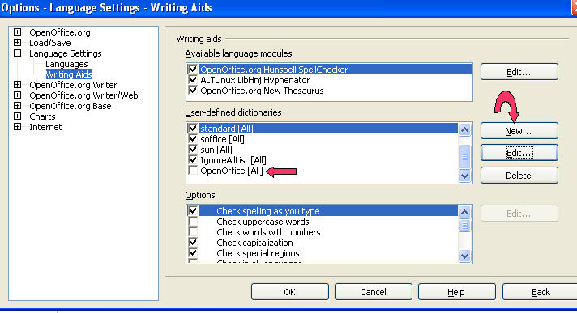
- Click on OpenOffice [All] to put a check mark. Now when you add a word, OpenOffice will appear in the list of dictionaries.
- Click OK. (The “Options – Language Settings – Writing Aids” window closes.)

Delete A Dictionary
- Click Tools > Options > Language Settings > Writing Aids. (The “Options – Language Settings – Writing Aids” window appears.)
- Under the User-defined dictionaries, click/select OpenOffice [All].
- Click Delete. (“Delete” is located on the right side of the “Options-Language Settings-Writing Aids” window.) You will see the message below.
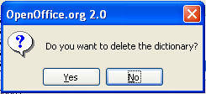
- Click Yes. (The “OpenOffice” dictionary will no longer appear in the list of dictionaries.)
- Click OK. (The “Options – Language Settings – Writing Aids” window closes.)

Thesaurus (Synonyms)
- Type the word, bargain. Click on the word, bargain.
- Click Tools > Language > Thesaurus. (The “Thesaurus” window appears.)
- In the Meaning” pull-down menu, select the meaning, (noun) deal.
- In the Synonym box, select the word, agreement (generic term).
- Click the OK button. “Bargain” is replaced by the word, “agreement”.

Notes

Tutorials are improved by input from users. We welcome your constructive criticism.
E-mail suggestions and comments to: contact@tutorialsforopenoffice.org
For other free tutorials go to: http://www.tutorialsforopenoffice.org

This work is licensed under a Creative Commons Attribution 3.0 License

