Getting Started with
Apache OpenOffice
Version 3.4
Chapter 11
Setting Up and Customizing Apache OpenOffice
Choosing Options to Suit the Way You Work

Copyright
This document is Copyright © 2013 by its contributors as listed below. You may distribute it and/or modify it under the terms of either the GNU General Public License (http://www.gnu.org/licenses/gpl.html), version 3 or later, or the Creative Commons Attribution License (http://creativecommons.org/licenses/by/3.0/), version 3.0 or later.
Apache, Apache OpenOffice, and OpenOffice.org are trademarks of the Apache Software Foundation. Used with permission. No endorsement by The Apache Software Foundation is implied by the use of these marks. All other trademarks mentioned in this guide belong to their respective owners.
Contributors
Jean Hollis Weber
Acknowledgements
This chapter is adapted from Chapters 2 and 14 of Getting Started with OpenOffice.org 3.3, with additional material adapted from Getting Started with LibreOffice 3.4. The contributors to those books are:
OpenOffice.org
Agnes Belzunce Daniel Carrera Peter Hillier-Brook
Stefan A. Keel Jean Hollis Weber Michele Zarri
LibreOffice
Ron Faile Jr. Hazel Russman Jean Hollis Weber
Feedback
Please direct any comments or suggestions about this document to:
odfauthors-discuss@lists.odfauthors.org
Publication date and software version
Published 30 April 2013. Based on Apache OpenOffice 3.4.1.
Contents
Copyright 2
Note for Mac users 4
Choosing options for all of Apache OpenOffice 5
User Data options 5
General options 6
Memory options 8
View options 8
Print options 11
Path options 11
Color options 12
Font options 14
Security options 14
Security options and warnings 15
Appearance options 16
Accessibility options 16
Java options 17
Online Update options 18
Choosing options for loading and saving documents 18
General Load/Save options 18
VBA Properties Load/Save options 20
Microsoft Office Load/Save options 21
HTML compatibility Load/Save options 21
Choosing language settings 23
Install the required dictionaries 23
Change locale and language settings 23
Choose spelling options 24
Choosing Internet options 25
Controlling AOO’s AutoCorrect functions 25
Customizing Apache OpenOffice 26
Customizing menus 26
Creating a new menu 27
Modifying existing menus 28
Adding a command to a menu 29
Modifying menu entries 29
Customizing toolbars 29
Creating a new toolbar 30
Adding a command to a toolbar 31
Choosing icons for toolbar commands 31
Example: Adding a Fax icon to a toolbar 32
Assigning shortcut keys 33
Example: Assigning styles to shortcut keys 34
Saving changes to a file 35
Loading a saved keyboard configuration 35
Resetting the shortcut keys 35
Adding functionality with extensions 35
Installing extensions 35
Some popular extensions 36

Note for Mac users
Some keystrokes and menu items are different on a Mac from those used in Windows and Linux. The table below gives some common substitutions for the instructions in this chapter. For a more detailed list, see the application Help.
Windows or Linux | Mac equivalent | Effect
Tools > Options menu selection | Apache OpenOffice > Preferences | Access setup options
Right-click | Control+click | Opens a context menu
Ctrl (Control) | z (Command) | Used with other keys
F5 | Shift+z+F5 | Opens the Navigator
F11 | z+T | Opens the Styles and Formatting window

Choosing options for all of Apache OpenOffice
This section covers some of the settings that apply to all the components of Apache OpenOffice. For information on settings not discussed here, see the online help.
Click Tools > Options. The list in the left-hand box of the Options – OpenOffice.org dialog varies depending on which component is open. The illustrations in this chapter show the list as it appears when a Writer document is open.
Click the marker (+ or triangle) by OpenOffice.org on the left-hand side. A list of pages drops down. Selecting an item in the list causes the right-hand side of the dialog to display the relevant page.
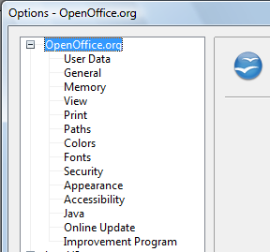
Figure 1: OpenOffice.org options
Note | The Back button has the same effect on all pages of the Options dialog. It resets the options to the values that were in place when you opened OpenOffice.org.

User Data options
Because the name or initials stored in the OpenOffice.org – User Data page are used for several things, including document properties (created by and last edited by information) and the name of the author of notes and changes, you should ensure that the correct information appears here. Fill in the form (shown in Figure 2), or amend or delete any existing incorrect information.
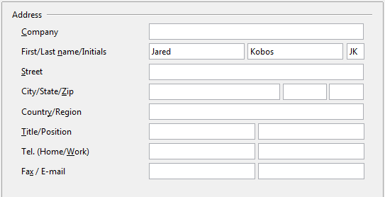
Figure 2: Filling in user data

General options
The options on the OpenOffice.org – General page are described below.
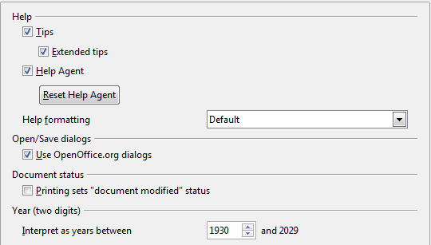
Figure 3: Setting general options for OpenOffice.org
Help - Tips
When Tips is active, one or two words will appear when you hold the mouse pointer over an icon or field, without clicking.
Help - Extended tips
When Extended tips is active, a brief description of the function of a particular icon or menu command or a field on a dialog appears when you hold the mouse pointer over that item.
Help Agent
To turn off the Help Agent (similar to Microsoft’s Office Assistant), deselect this option. To restore the default behavior, click Reset Help Agent.
Help formatting
High contrast is an operating system setting that changes the system color scheme to improve readability. To display Help in high contrast (if your computer’s operating system supports this), choose one of the high-contrast style sheets from the pull-down list.
High-contrast style | Visual effect
Default | Black text on white background
High Contrast #1 | Yellow text on black background
High Contrast #2 | Green text on black background
High Contrast Black | White text on black background
High Contrast White | Black text on white background
Open/Save dialogs
To use the standard Open and Save dialogs for your operating system, deselect the Use OpenOffice.org dialogs option. When this option is selected, the Open and Save dialogs supplied with OpenOffice.org will be used. See Chapter 1 (Introducing Apache OpenOffice) for more about the AOO Open and Save dialogs. This book uses the AOO Open and Save dialogs in illustrations.
Print dialogs – Use OpenOffice.org dialogs
(Mac OS X only) To use the standard Print dialogs for your operating system, deselect the Use OpenOffice.org dialogs option. When this option is selected, the Print dialogs supplied with OpenOffice.org will be used. This book uses the AOO Print dialogs in illustrations.
Document status
If this option is selected, then the next time you close the document after printing, the print date is recorded in the document properties as a change and you will be prompted to save the document again, even if you did not make any other changes.
Year (two digits)
Specifies how two-digit years are interpreted. For example, if the two-digit year is set to 1930, and you enter a date of 1/1/30 or later into your document, the date is interpreted as 1/1/1930 or later. An “earlier” date is interpreted as being in the following century; that is, 1/1/20 is interpreted as 1/1/2020.

Memory options
In the Options dialog, click OpenOffice.org > Memory.
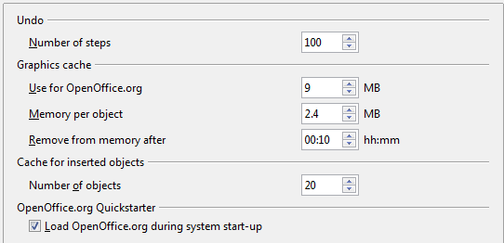
Figure 4: Choosing Memory options for the OpenOffice.org applications
These options control how the program uses your computer’s memory and how much memory it requires. Before changing them, you may wish to consider the following points:
- More memory can make AOO faster and more convenient (for example, more undo steps require more memory); but the trade-off is less memory available for other applications and you could run out of memory altogether.
- If your documents contain a lot of objects such as images, or the objects are large, AOO’s performance may improve if you increase the memory for AOO or the memory per object. If you find that objects seem to disappear from a document that contains a lot of them, increase the number of objects in the cache. (The objects are still in the file even if you cannot see them on screen.)
- To load the Quickstarter (an icon on the desktop or in the system tray) when you start your computer, select the option near the bottom of the dialog. This makes AOO start faster; the trade-off is AOO uses some memory even when not being used. This option (sometimes called Enable systray quickstarter) is not available on all operating systems.

View options
The options on the OpenOffice.org – View page affect the way the document window looks and behaves. Some of these options are described below. Set them to suit your personal preferences.
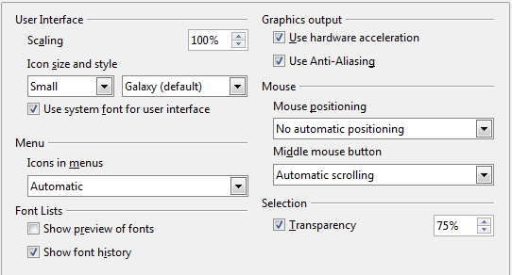
Figure 5: Choosing View options for AOO applications
User Interface – Scaling
If the text in the help files or on the menus of the AOO user interface is too small or too large, you can change it by specifying a scaling factor. Sometimes a change here can have unexpected results, depending on the screen fonts available on your system. However, it does not affect the actual font size of the text in your documents.
User Interface – Icon size and style
The first box specifies the display size of toolbar icons (Automatic, Small, or Large). The Automatic icon size option uses the setting for your operating system. The second box specifies the icon style (theme); here the Automatic option uses an icon set compatible with your operating system and choice of desktop: for example, KDE or Gnome on Linux.
User Interface – Use system font for user interface
If you prefer to use the system font (the default font for your computer and operating system) instead of the font provided by AOO for the user interface, select this option.
User interface – Screen font anti-aliasing
(Not available in Windows; not shown in Figure 5.) Select this option to smooth the screen appearance of text. Enter the smallest font size to apply anti-aliasing.
Menu – icons in menus
Causes icons as well as words to be visible in menus.
Font Lists - Show preview of fonts
Causes the font list to look like Figure 6, Left, with the font names shown as an example of the font; with the option deselected, the font list shows only the font names, not their formatting (Figure 6, Right). The fonts you will see listed are those that are installed on your system.
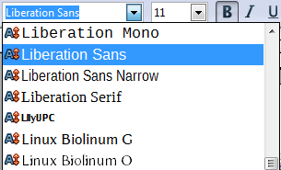 | 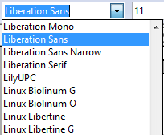
Figure 6. Font list (Left) With preview; (Right) Without preview
Font Lists - Show font history
Causes the last five fonts you have assigned to the current document are displayed at the top of the font list. Otherwise fonts are shown in alphabetical order.
Graphics output – Use hardware acceleration
Directly accesses hardware features of the graphical display adapter to improve the screen display. Not supported on all operating systems and AOO distributions.
Graphics output – Use anti-aliasing
Enables and disables anti-aliasing, which makes the display of most graphical objects look smoother and with fewer artifacts. Not supported on all operating systems and AOO distributions.
Tip | Press Shift+Control+R to restore or refresh the view of the current document.
Mouse positioning
Specifies if and how the mouse pointer will be positioned in newly opened dialogs.
Middle mouse button
Defines the function of the middle mouse button.
- Automatic scrolling – dragging while pressing the middle mouse button shifts the view.
- Paste clipboard – pressing the middle mouse button inserts the contents of the “Selection clipboard” at the cursor position.
The “Selection clipboard” is independent of the normal clipboard that you use by Edit > Copy/Cut/Paste or their respective keyboard shortcuts. Clipboard and “Selection clipboard” can contain different contents at the same time.
Function | Clipboard | Selection clipboard
Copy content | Edit > Copy Control+C | Select text, table, or object.
Paste content | Edit > Paste Control+V pastes at the cursor position. | Clicking the middle mouse button pastes at the mouse pointer position.
Pasting into another document | No effect on the clipboard contents. | The last marked selection is the content of the selection clipboard.
Selection – Transparency
Determines the appearance of selected text or graphics, which appear on a shaded background. To make the shaded background more or less dark, increase or decrease the Transparency setting.
If you prefer selected material to appear in reversed color (typically white text on a black background), deselect this option.

Print options
On the OpenOffice.org – Print page, set the print options to suit your default printer and your most common printing method.
In the Printer warnings section near the bottom of the page, you can choose whether to be warned if the paper size or orientation specified in your document does not match the paper size or orientation available for your printer. Having these warnings turned on can be quite helpful, particularly if you work with documents produced by people in other countries where the standard paper size is different from yours.
Tip | If your printouts are incorrectly placed on the page or chopped off at the top, bottom, or sides, or the printer is refusing to print, the most likely cause is page size incompatibility.
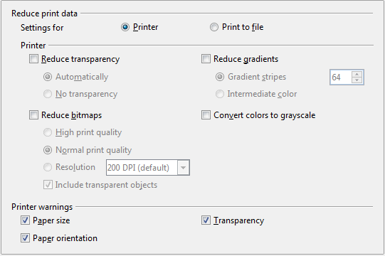Figure 7: Choosing general printing options to apply to all AOO components

Path options
On the OpenOffice.org – Paths page, you can change the location of files associated with, or used by, OpenOffice.org to suit your working situation. In a Windows system, for example, you might want to store documents by default somewhere other than My Documents.
To make changes, select an item in the list shown in Figure 8 and click Edit. On the Select Path dialog (not shown; may also be titled Edit Paths), add or delete folders as required, and then click OK to return to the Options dialog. Note that some items can have at least two paths listed: one to a shared folder (which might be on a network) and one to a user-specific folder (normally on the user’s personal computer).
Tip | You can use the entries in the OpenOffice.org – Paths dialog to compile a list of files, such as those containing AutoText, that you need to back up or copy to another computer.
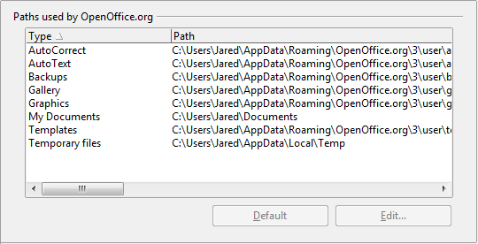
Figure 8: Viewing the paths of files used by OpenOffice.org

Color options
On the OpenOffice.org – Colors page, you can specify colors to use in AOO documents. You can select a color from a color table, edit an existing color, and define new colors. These colors are stored in your color palette and are then available in all components of AOO.
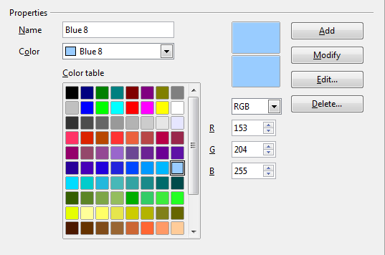
Figure 9: Defining colors to use in color palettes in AOO
To modify a color:
- Select the color to modify from the list or the color table.
- Enter the new values that define the color. If necessary, change the settings from RGB (Red, Green, Blue) to CMYK (Cyan, Magenta, Yellow, Black) or vice versa. The changed color appears in the lower of the two color preview boxes at the top.
- Modify the Name as required.
- Click the Modify button. The newly defined color is now listed in the Color table.
Alternatively, click the Edit button to open the Color Picker dialog, shown in Figure 10. Here you can select a color from the color window on the left; or you can enter values in the boxes on the right, using your choice of RGB, CMYK, or HSB (Hue, Saturation and Brightness) values.
The color window is linked directly with the color input fields on the right; as you choose a color in the window, the numbers change accordingly. The lower color field on the left shows the value of the selected color on the left and the currently set value from the color value fields on the right.
Modify the color components as required and click OK to exit the dialog. The newly defined color now appears in the lower of the color preview boxes shown in Figure 9. Type a name for this color in the Name box, then click the Add button. A small box showing the new color is added to the Color table.
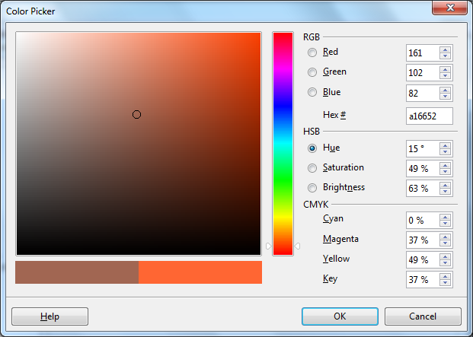
Figure 10: Choosing colors
Another way to define or alter colors is through the Colors page of the Area dialog, where you can also save and load palettes, a feature that is not possible here. In Calc, draw a temporary draw object and use the context menu of this object to open the Area dialog. If you load a palette in one component of AOO, it is only active in that component; the other components keep their own palettes.

Font options
You can define replacements for any fonts that might appear in your documents. If you receive from someone else a document containing fonts that you do not have on your system, OpenOffice.org will substitute fonts for those it does not find. You might prefer to specify a different font from the one the program chooses.
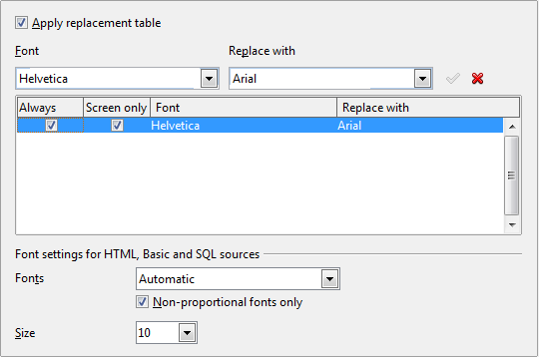
Figure 11: Defining a font to be substituted for another font
On the OpenOffice.org – Fonts page:
- Select the Apply Replacement Table option.
- Select or type the name of the font to be replaced in the Font box. (If you do not have this font on your system, it will not appear in the drop-down list in this box, so you need to type it in.)
- In the Replace with box, select a suitable font from the drop-down list of fonts installed on your computer.
- The checkmark to the right of the Replace with box turns green. Click on this checkmark. A row of information now appears in the larger box below the input boxes. Select the options under Always and Screen.
- In the bottom section of the page, you can change the typeface and size of the font used to display source code such as HTML and Basic (in macros).

Security options
Use the OpenOffice.org – Security page (Figure 12) to choose security options for saving documents and for opening documents that contain macros.
Security options and warnings
If you record changes, save multiple versions, or include hidden information or notes in your documents, and you do not want some of the recipients to see that information, you can set warnings to remind you to remove it, or you can have AOO remove some of it automatically. Note that (unless removed) much of this information is retained in a file whether the file is in AOO’s default OpenDocument format, or has been saved to other formats, including PDF.
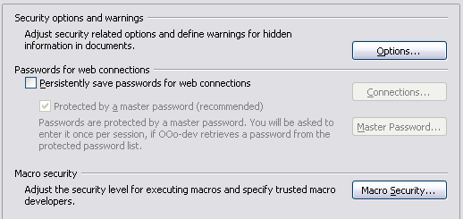
Figure 12: Choosing security options for opening and saving documents
Click the Options button to open a separate dialog with specific choices (Figure 13).
Macro security
Click the Macro Security button to open the Macro Security dialog (not shown here), where you can adjust the security level for executing macros and specify trusted sources.

Security options and warnings
The following options are on the Security options and warnings dialog (Figure 13).

Figure 13: Security options and warnings dialog
Remove personal information on saving
Select this option to always remove user data from the file properties when saving the file. To manually remove personal information from specific documents, deselect this option and then use the Delete button under File > Properties > General.
Ctrl-click required to follow hyperlinks
In older versions of AOO, clicking on a hyperlink in a document opened the linked document. Now you can choose whether to keep this behavior (by unchecking this box). Many people find creation and editing of documents easier when accidental clicks on links do not activate the links.
The other options on this dialog should be self-explanatory.

Appearance options
Writing, editing, and (especially) page layout are often easier when you can see the page margins (text boundaries), the boundaries of tables and sections (in Writer documents), page breaks in Calc, grid lines in Draw or Writer, and other features. In addition, you might prefer to use colors that are different from AOO’s defaults for such items as note indicators or field shadings.
On the OpenOffice.org – Appearance page, you can specify which items are visible and the colors used to display various items.
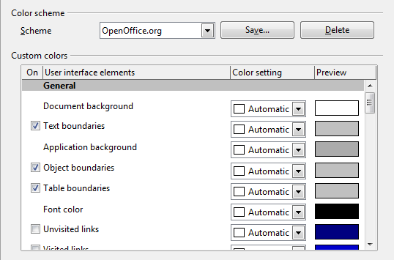
Figure 14: Showing or hiding text, object, and table boundaries
- To show or hide items such as text boundaries, select or deselect the options next to the names of the items.
- To change the default colors for items, click the down-arrow in the Color Setting column by the name of the item and select a color from the pop-up box.
- To save your color changes as a color scheme, click Save, type a name in the Scheme box; then click OK.

Accessibility options
Accessibility options include whether to allow animated graphics or text, how long help tips remain showing, some options for high contrast display, and a way to change the font for the user interface of the OpenOffice.org program.
Accessibility support relies on Sun Microsystems Java technology for communications with assistive technology tools. See “Java options“ below. The Support assistive technology tools option is not shown on all AOO installations. See Assistive Tools in OpenOffice.org in the Help for other requirements and information.
Select or deselect the options as required.
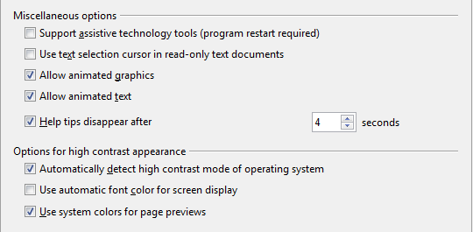
Figure 15: Choosing accessibility options

Java options
If you install or update a Java Runtime Environment (JRE) after you install OpenOffice.org, or if you have more than one JRE installed on your computer, you can use the OpenOffice.org – Java options page to choose the JRE for AOO to use.
If you are a system administrator, programmer, or other person who customizes JRE installations, you can use the Parameters and Class Path pages (reached from the Java page) to specify this information.
If you do not see anything listed in the middle of the page, wait a few minutes while AOO searches for JREs on the hard disk.
If AOO finds one or more JREs, it will display them there. You can then select the Use a Java runtime environment option and (if necessary) choose one of the JREs listed.
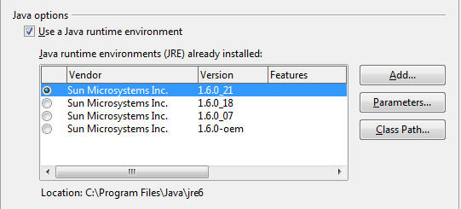
Figure 16: Choosing a Java runtime environment

Online Update options
On the OpenOffice.org – Online Update page, you can choose whether and how often to have AOO check the AOO website for program updates. If the Check for updates automatically option is selected, an icon appears at the right-hand end of the menu bar when an update is available. Click this icon to open a dialog where you can choose to download the update.
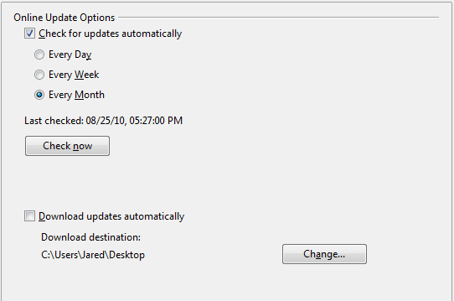
Figure 17: Configuring Online Update
If the Download updates automatically option is selected, the download starts when you click the icon. To change the download destination, click the Change button and select the required folder in the file browser window.

Choosing options for loading and saving documents
You can set the Load/Save options to suit the way you work.
If the Options dialog is not already open, click Tools > Options. Click the expansion symbol (+ or triangle) to the left of Load/Save.
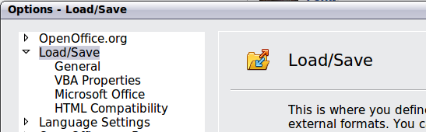
Figure 18: Load/Save options

General Load/Save options
Most of the choices on the Load/Save – General page are familiar to users of other office suites. Some items of interest are described below.
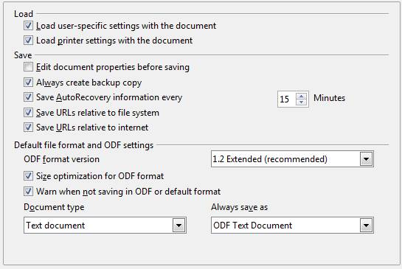
Figure 19: Choosing Load and Save options
Load user-specific settings with the document
When you save a document, certain settings are saved with it. Some settings (printer name, data source linked to the document) are always loaded with a document, whether or not this option is selected. If you select this option, these document settings are overruled by the user-specific settings of the person who opens it. If you deselect this option, the user’s personal settings do not overrule the settings in the document. For example, your choice (in the options for AOO Writer) of how to update links is affected by the Load user-specific settings option.
Load printer settings with the document
If this option is not selected, the printer settings that are stored with the document are ignored when you print it using the Print File Directly icon. The default printer in your system will be used instead.
Edit document properties before saving
If you select this option, the Document Properties dialog pops up to prompt you to enter relevant information the first time you save a new document (or whenever you use Save As).
Save AutoRecovery information every
Choose whether to enable AutoRecovery and how often to save the information used by the AutoRecovery process.
AutoRecovery in AOO overwrites the original file. If you also choose Always create backup copy, the original file then overwrites the backup copy. If you have this set, recovering your document after a system crash will be easier; but recovering an earlier version of the document may be harder.
Save URLs relative to file system / internet
Relative addressing to a file system is only possible if the source document and the referenced document are both on the same drive. A relative address always starts from the directory in which the current document is located. It is recommended to save relatively if you want to create a directory structure on an Internet server.
Default file format and ODF settings
ODF format version. AOO by default saves documents in OpenDocument Format (ODF) version 1.2 Extended. While this allows for improved functionality, there may be backwards compatibility issues. When a file saved in ODF 1.2 Extended is opened in an earlier version of OpenOffice.org (using ODF 1.0/1.1), some of the advanced features may be lost. Two notable examples are cross-references to headings and the formatting of numbered lists. If you plan to share documents with people who are still using older versions of OpenOffice.org, save the document using ODF version 1.0/1.1.
Size optimization for ODF format. OpenOffice.org documents are XML files. When you select this option, AOO writes the XML data without indents and line breaks. If you want to be able to read the XML files in a text editor in a structured form, deselect this option.
Document type. If you routinely share documents with users of Microsoft Office, you might want to change the Always save as attribute for documents to one of the Microsoft Office formats.
Note | Although AOO can open files in the .docx, .xlsx, and .pptx formats produced by Microsoft Office 2007, it cannot save in those formats. This capability is planned for a future release.

VBA Properties Load/Save options
On the Load/Save – VBA Properties page, you can choose whether to keep any macros in Microsoft Office documents that are opened in OpenOffice.org.
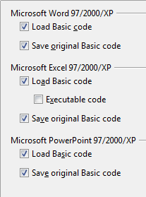
Figure 20: Choosing Load/Save VBA Properties
- If you choose Save original Basic code, the macros will not work in AOO but are retained if you save the file into Microsoft Office format.
- If you choose Load Basic code to edit, the changed code is saved in an AOO document but is not retained if you save into a Microsoft Office format.
- If you are importing a Microsoft Excel file containing VBA code, you can select the option Executable code. Whereas normally the code is preserved but rendered inactive (if you inspect it with the StarBasic IDE you will notice that it is all commented), with this option the code is ready to be executed.

Microsoft Office Load/Save options
On the Load/Save – Microsoft Office page, you can choose what to do when importing and exporting Microsoft Office OLE objects (linked or embedded objects or documents such as spreadsheets or equations).
Select the [L] options to convert Microsoft OLE objects into the corresponding OpenOffice.org OLE objects when a Microsoft document is loaded into AOO (mnemonic: “L” for “load”).
Select the [S] options to convert OpenOffice.org OLE objects into the corresponding Microsoft OLE objects when a document is saved in a Microsoft format (mnemonic: “S” for “save”).
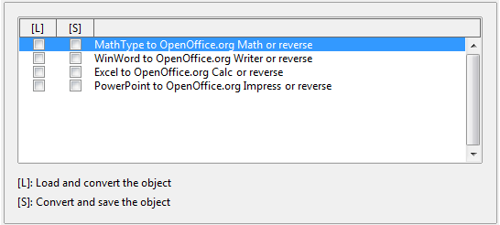
Figure 21: Choosing Load/Save Microsoft Office options

HTML compatibility Load/Save options
Choices made on the Load/Save – HTML Compatibility page affect HTML pages imported into OpenOffice.org and those exported from AOO. See HTML documents; importing/exporting in the Help for more information.
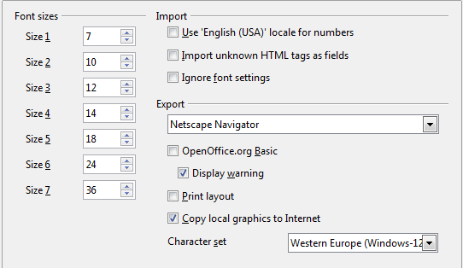
Figure 22. Choosing HTML compatibility options
Font sizes
Use these fields to define the respective font sizes for the HTML <font size=1> to <font size=7> tags, if they are used in the HTML pages. (Many pages no longer use these tags.)
Import – Use 'English (USA)' locale for numbers
When importing numbers from an HTML page, the decimal and thousands separator characters differ according to the locale of the HTML page. The clipboard, however, contains no information about the locale. If this option is not selected, numbers will be interpreted according to the Language - Locale setting in Tools > Options > Language Settings > Languages (see page 23). If this option is selected, numbers will be interpreted as for the English (USA) locale.
Import – Import unknown HTML tags as fields
Select this option if you want tags that are not recognized by AOO to be imported as fields. For an opening tag, an HTML_ON field will be created with the value of the tag name. For a closing tag, an HTML_OFF will be created. These fields will be converted to tags in the HTML export.
Import – Ignore font settings
Select this option to have AOO ignore all font settings when importing. The fonts that were defined in the HTML Page Style will be used.
Export
To optimize the HTML export, select a browser or HTML standard from the Export box. If OpenOffice.org Writer is selected, specific OpenOffice.org Writer instructions are exported.
Export – OpenOffice.org Basic
Select this option to include AOO Basic macros (scripts) when exporting to HTML format. You must activate this option before you create the OpenOffice.org Basic macro; otherwise the script will not be inserted. OpenOffice.org Basic macros must be located in the header of the HTML document. Once you have created the macro in the OpenOffice.org Basic IDE, it appears in the source text of the HTML document in the header.
If you want the macro to run automatically when the HTML document is opened, choose Tools > Customize > Events. See Chapter 13 (Getting Started with Macros) for more information.
Export – Display warning
When the OpenOffice.org Basic option (see above) is not selected, the Display warning option becomes available. If the Display warning option is selected, then when exporting to HTML a warning is shown that OpenOffice.org Basic macros will be lost.
Export – Print layout
Select this option to export the print layout of the current document as well. The HTML filter supports CSS2 (Cascading Style Sheets Level 2) for printing documents. These capabilities are only effective if print layout export is activated.
Export – Copy local graphics to Internet
Select this option to automatically upload the embedded pictures to the Internet server when uploading using FTP.
Export – Character set
Select the appropriate character set for the export.

Choosing language settings
You may need to do several things to set the language settings to what you want:
- Install the required dictionaries
- Change some locale and language settings
- Choose spelling options

Install the required dictionaries
AOO automatically installs several dictionaries with the program. To add other dictionaries, be sure you are connected to the Internet, and then use Tools > Language > More Dictionaries Online. AOO will open your default web browser to a page containing links to additional dictionaries that you can install. Follow the prompts to select and install the ones you want.

Change locale and language settings
You can change some details of the locale and language settings that AOO uses for all documents, or for specific documents.
In the Options dialog, click Language Settings > Languages.
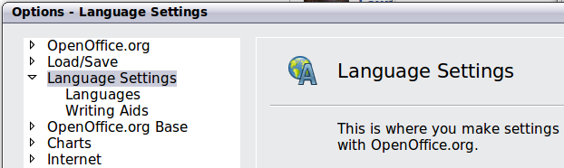
Figure 23: Language Setting Options
On the right-hand side of the Language Settings – Languages page (Figure 25), change the User interface, Locale setting, Default currency, and Default languages for documents as required. In the example, English (UK) has been chosen for all the appropriate settings.
If you want the language (dictionary) setting to apply to the current document only, instead of being the default for all new documents, select the option labelled For the current document only.
If necessary, select the options to enable support for Asian languages (Chinese, Japanese, Korean) and support for CTL (complex text layout) languages such as Urdu, Thai, Hebrew, and Arabic. If you choose either of these options, the next time you open this dialog, you will see some extra choices under Language Settings, as shown in Figure 24. These choices (Searching in Japanese, Asian Layout, and Complex Text Layout) are not discussed here.
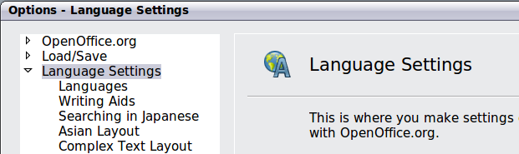
Figure 24: Extra pages available when enhanced language support options are selected
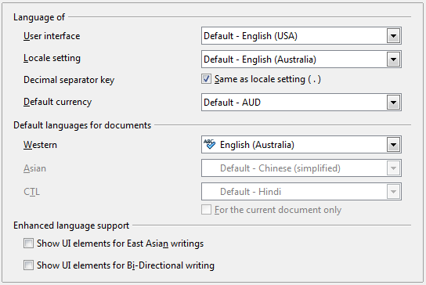
Figure 25: Choosing language options

Choose spelling options
To choose the options for checking spelling, click Language Settings > Writing Aids. In the Options section of the page (Figure 26), choose the settings that are useful for you.
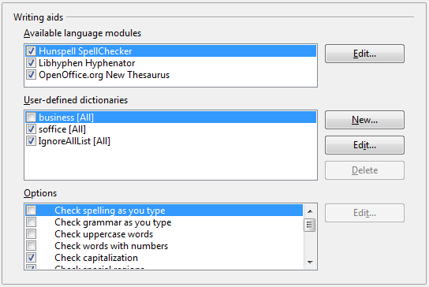
Figure 26: Choosing languages, dictionaries, and options for checking spelling
Some considerations:
- If you do not want spelling checked while you type, deselect Check spelling as you type and select Do not mark errors. (To find the second item, scroll down in the Options list.)
- If you use a custom dictionary that includes words in all upper case and words with numbers (for example, AS/400), select Check uppercase words and Check words with numbers.
- Check special regions includes headers, footers, frames, and tables when checking spelling.
Here you can also check which user-defined (custom) dictionaries are active by default, and add or remove dictionaries, by clicking the New or Delete buttons.
Note | OpenOffice.org does not have a grammar checker, but you can install a grammar checker extension such as Language Tool and access that tool from Tools > Spelling and Grammar. See “Adding functionality with extensions” on page 35 for more information.

Choosing Internet options
Use the Internet Options pages to define search engines and save proxy settings for use with OpenOffice.org.
If you are using a Netscape or Mozilla browser (such as Firefox), you can enable the Browser Plug-in so you can open AOO files in your browser, print them, save them, and work with them in other ways.
If you are using a Unix- or Linux-based operating system (including Mac OS X), an additional page of E-mail options is available, where you can specify the e-mail program to use when you send the current document as e-mail. Under Windows the operating system’s default e-mail program is always used.
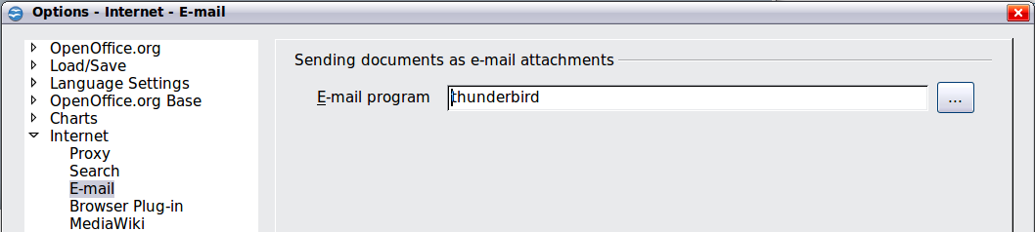
Figure 27: Internet options, showing E-mail page available to Linux and Mac OS X users.

Controlling AOO’s AutoCorrect functions
Some people find some or all of the items in AOO’s AutoCorrect function annoying because they change what you type when you do not want it changed. Many people find some of the AutoCorrect functions quite helpful; if you do, then select the relevant options. But if you find unexplained changes appearing in your document, this is a good place to look to find the cause.
To open the AutoCorrect dialog, click Tools > AutoCorrect Options. (You need to have a document open for this menu item to appear.)
In Writer, this dialog has five tabs, as shown in Figure 28. In other components of AOO, the dialog has only four tabs.
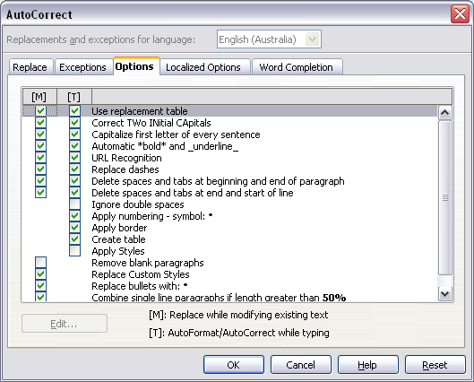
Figure 28: The AutoCorrect dialog in Writer, showing the five tabs and some of the choices

Customizing Apache OpenOffice
You can customize menus, toolbars, and keyboard shortcuts in OpenOffice.org, add new menus and toolbars, and assign macros to events. However, you cannot customize context (right-click) menus.
Other customizations are made easy by extensions that you can install from the OpenOffice.org website or from other providers.
Note | Customizations to menus and toolbars can be saved in a template. To do so, first save them in a document and then save the document as a template as described in Chapter 2 (Styles and Templates).

Customizing menus
You can add and rearrange items on the menu bar, add items to menus, and make other changes.
To customize menus:
- Choose Tools > Customize.
- On the Customize dialog, go to the Menus page.
- In the Save In drop-down list, choose whether to save this changed menu for the application (for example, OpenOffice.org Writer) or for a selected document (for example, MyDoc.odt).
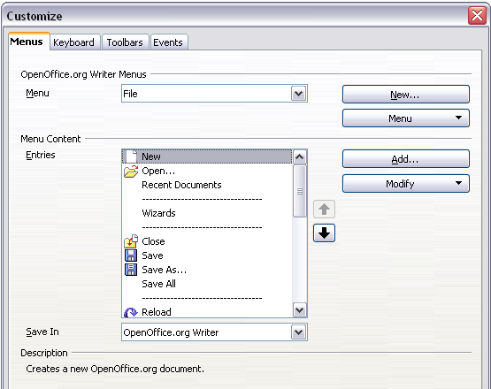
Figure 29. The Menus page of the Customize dialog
- In the section OpenOffice.org [name of the program (example: Writer)] Menus, select from the Menu drop-down list the menu that you want to customize. The list includes all the main menus as well as submenus (menus that are contained under another menu). For example, in addition to File, Edit, View, and so on, there is File | Send and File |Templates. The commands available for the selected menu are shown in the central part of the dialog.
- To customize the selected menu, click on the Menu or Modify buttons. You can also add commands to a menu by clicking on the Add button. These actions are described in the following sections. Use the up and down arrows next to the Entries list to move the selected menu item to a different position.
- When you have finished making all your changes, click OK (not shown in illustration) to save them.

Creating a new menu
In the Customize dialog, click New to display the dialog shown in Figure 29.
- Type a name for your new menu in the Menu name box.
- Use the up and down arrow buttons to move the new menu into the required position on the menu bar.
- Click OK to save.
The new menu now appears on the list of menus in the Customize dialog. (It will appear on the menu bar itself after you save your customizations.)
After creating a new menu, you need to add some commands to it, as described in “Adding a command to a menu” on page 29.
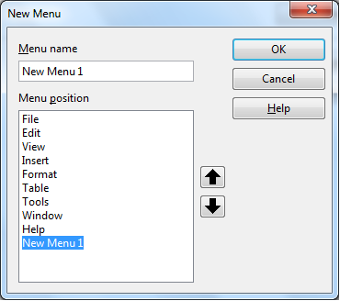
Figure 30: Adding a new menu

Modifying existing menus
To modify an existing menu, select it in the Menu list and click the Menu button to drop down a list of modifications: Move, Rename, Delete. Not all of these modifications can be applied to all the entries in the Menu list. For example, Rename and Delete are not available for the menus supplied by AOO.
To move a menu (such as File), choose Menu > Move. A dialog similar to the one shown in Figure 29 (but without the Menu name box) opens. Use the up and down arrow buttons to move the menu into the required position.
To move submenus (such as File | Send), select the main menu (File) in the Menu list and then, in the Menu Content section of the dialog, select the submenu (Send) in the Entries list and use the arrow keys to move it up or down in the sequence.
In addition to renaming, you can specify a keyboard shortcut that allows you to select a menu command when you press Alt+ an underlined letter in a menu command.
- Select a menu entry.
- Click the Modify button and select Rename.
- Add a tilde (~) in front of the letter that you want to use as an accelerator. For example, to select the Save All command by pressing Alt+V (after opening the File menu using Alt+F), enter Sa~ve All.
Caution   | Be careful when using these shortcuts. In the example above, if the File menu is not already open, then pressing Alt+V opens the View menu; if some other menu is open, Alt+V might activate some other command.

Adding a command to a menu
You can add commands to the supplied menus and to menus you have created. On the Customize dialog, select the menu in the Menu list and click the Add button in the Menu Content section of the dialog.
On the Add Commands dialog (Figure 31), select a category and then the command, and click Add. The dialog remains open, so you can select several commands. When you have finished adding commands, click Close. Back on the Customize dialog, you can use the up and down arrow buttons to arrange the commands in your preferred sequence.
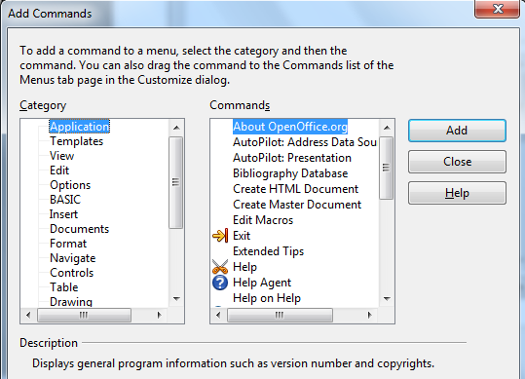
Figure 31: Adding a command to a menu

Modifying menu entries
In addition to changing the sequence of entries on a menu or submenu, you can add submenus, rename or delete the entries, and add group separators.
To begin, select the menu or submenu in the Menu list near the top of the Customize page, then select the entry in the Entries list under Menu Content. Click the Modify button and choose the required action from the drop-down list of actions.
Most of the actions should be self-explanatory. Begin a group adds a separator line after the highlighted entry.

Customizing toolbars
You can customize toolbars in several ways, including choosing which icons are visible and locking the position of a docked toolbar, as described in Chapter 1 (Introducing OpenOffice.org). This section describes how to create new toolbars and add other icons (commands) to the list of those available on a toolbar.
To get to the toolbar customization dialog, do any of the following:
- On the toolbar, click the arrow at the end of the toolbar and choose Customize Toolbar.
- Choose View > Toolbars > Customize from the menu bar.
- Choose Tools > Customize from the menu bar and pick the Toolbars page (Figure 32).
To customize toolbars:
- In the Save In drop-down list, choose whether to save this changed toolbar for the application (for example, Writer) or for a selected document.
- In the section OpenOffice.org <name of the program (example: Writer)> Toolbars, select from the Toolbar drop-down list the toolbar that you want to customize.
- You can create a new toolbar by clicking on the New button, or customize existing toolbars by clicking on the Toolbar or Modify buttons, and add commands to a toolbar by clicking on the Add button. These actions are described below.
- When you have finished making all your changes, click OK to save them.
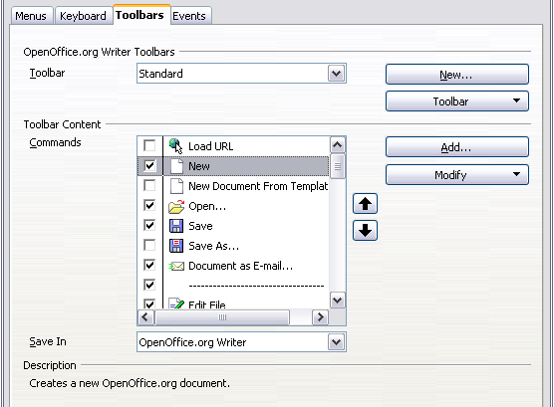
Figure 32. The Toolbars page of the Customize dialog

Creating a new toolbar
To create a new toolbar:
- Choose Tools > Customize > Toolbars from the menu bar.
- Click New. On the Name dialog, type the new toolbar's name and choose from the Save In drop-down list where to save this changed menu: for the application (for example, Writer) or for a selected document.
The new toolbar now appears on the list of toolbars in the Customize dialog. After creating a new toolbar, you need to add some commands to it, as described below.
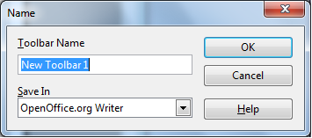

Adding a command to a toolbar
If the list of available buttons for a toolbar does not include all the commands you want on that toolbar, you can add commands. When you create a new toolbar, you need to add commands to it.
- On the Toolbars page of the Customize dialog, select the toolbar in the Toolbar list and click the Add button in the Toolbar Content section of the dialog.
- The Add Commands dialog is the same as for adding commands to menus (Figure 31). Select a category and then the command, and click Add. The dialog remains open, so you can select several commands. When you have finished adding commands, click Close. If you insert an item which does not have an associated icon, the toolbar will display the full name of the item: the next section describes how to choose an icon for a toolbar command.
- Back on the Customize dialog, you can use the up and down arrow buttons to arrange the commands in your preferred sequence.
- When you are done making changes, click OK to save.

Choosing icons for toolbar commands
Toolbar buttons usually have icons, not words, on them, but not all of the commands have associated icons.
To choose an icon for a command, select the command and click Modify > Change icon. On the Change Icon dialog, you can scroll through the available icons, select one, and click OK to assign it to the command.
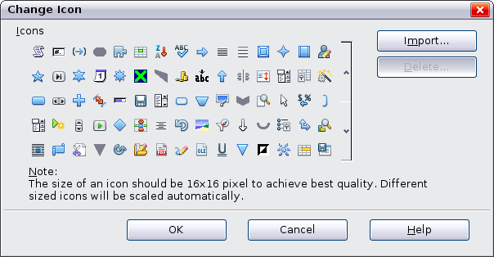
Figure 33: Change Icon dialog
To use a custom icon, create it in a graphics program and import it into AOO by clicking the Import button on the Change Icon dialog. Custom icons must be 16 x 16 or 26 x 26 pixels in size and cannot contain more than 256 colors.

Example: Adding a Fax icon to a toolbar
You can customize OpenOffice.org so that a single click on an icon automatically sends the current document as a fax.
- Be sure the fax driver is installed. Consult the documentation for your fax modem for more information.
- Choose Tools > Options > OpenOffice.org Writer > Print. The dialog shown in Figure 34 opens.
- Select the fax driver from the Fax list and click OK.
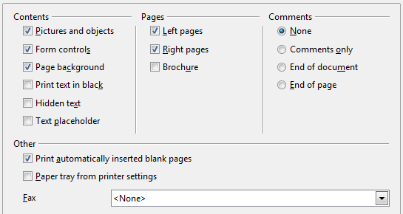
Figure 34: Setting up AOO for sending faxes
- Click the arrow icon at the end of the Standard toolbar. In the drop-down menu, choose Customize Toolbar. The Toolbars page of the Customize dialog appears (Figure 32). Click Add.
- On the Add Commands dialog (Figure 35), select Documents in the Category list, then select Send Default Fax in the Commands list. Click Add. Now you can see the new icon in the Commands list.
- In the Commands list, click the up or down arrow button to position the new icon where you want it. Click OK and then click Close.
Your toolbar now has a new icon to send the current document as a fax.
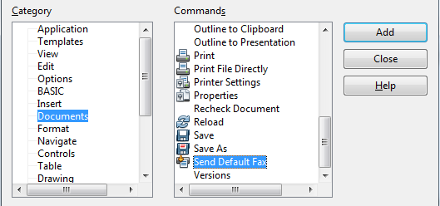
Figure 35: Adding a Send Fax command to a toolbar

Assigning shortcut keys
In addition to using the built-in keyboard shortcuts (listed in the included Help), you can define your own. You can assign shortcuts to standard AOO functions or your own macros and save them for use with the entire OpenOffice.org suite.
Caution | Be careful when reassigning your operating system’s or AOO’s predefined shortcut keys. Many key assignments are universally understood shortcuts, such as F1 for Help, and are always expected to provide certain results. Although you can easily reset the shortcut key assignments to the AOO defaults, changing some common shortcut keys can cause confusion, frustration and possible data loss or corruption, especially if other users share your computer.
To adapt shortcut keys to your needs, use the Customize dialog, as described below.
- Select Tools > Customize > Keyboard. The Customize dialog opens.
- To have the shortcut key assignment available in all components of OpenOffice.org select the OpenOffice.org button.
- Next select the required function from the Category and Function lists.
- Now select the desired shortcut keys in the Shortcut keys list and click the Modify button at the upper right.
- Click OK to accept the change. Now the chosen shortcut keys will execute the function chosen in step 3 above whenever they are pressed.
Note | All existing shortcut keys for the currently selected Function are listed in the Keys selection box. If the Keys list is empty, it indicates that the chosen key combination is free for use. If it were not, and you wanted to reassign a shortcut key combination that is already in use, you must first delete the existing key.  Shortcut keys that are greyed-out in the listing on the Customize dialog, such as F1 and F10, are not available for reassignment.

Example: Assigning styles to shortcut keys
You can configure shortcut keys to quickly assign styles in your document. Some shortcuts are predefined, such as Ctrl+0 for the Text body paragraph style, Ctrl+1 for the Heading 1 style, and Ctrl+2 for Heading 2. You can modify these shortcuts and create your own.
- Click Tools > Customize > Keyboard. The Keyboard page of the Customize dialog (Figure 33) opens.
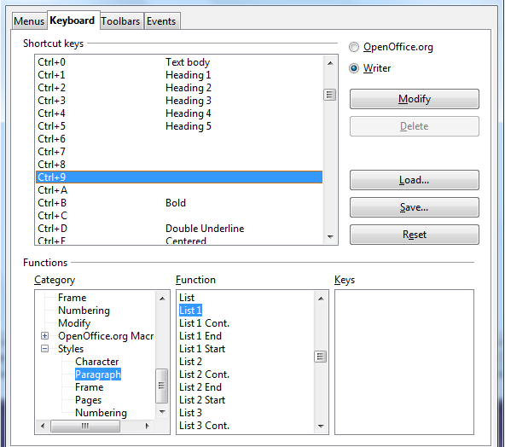
Figure 36. Defining keyboard shortcuts for applying styles
- To have the shortcut key assignment available only with one component (for example, Writer), select that component’s name in the upper right corner of the page; otherwise select OpenOffice.org button to make it available to every component.
- Choose the shortcut keys you want to assign a style to. In this example, we have chosen Ctrl+9.
- In the Functions section at the bottom of the dialog, scroll down in the Category list to Styles. Click the expansion symbol (usually a + sign or triangle) to expand the list of styles.
- Choose the category of style. (This example uses a paragraph style, but you can also choose character styles and others.) The Function list will display the names of the available styles for the selected category. The example shows some of AOO’s predefined styles.
- To assign Ctrl+9 to be the shortcut key combination for the List 1 style, select List 1 in the Function list, and then click Modify. Ctrl+9 now appears in the Keys list on the right, and List 1 appears next to Ctrl+9 in the Shortcut keys box at the top.
- Make any other required changes, and then click OK to save these settings and close the dialog.

Saving changes to a file
Changes to the shortcut key assignments can be saved in a keyboard configuration file for use at a later time, thus permitting you to create and apply different configurations as the need arises. To save keyboard shortcuts to a file:
- After making your keyboard shortcut assignments, click the Save button at the right of the Customize dialog (Figure 33).
- In the Save Keyboard Configuration dialog, select All files from the Save as Type list.
- Next enter a name for the keyboard configuration file in the File name box, or select an existing file from the list. If you need to, browse to find a file from another location.
- Click Save. A confirmation dialog appears if you are about to overwrite an existing file, otherwise the file will be saved immediately.

Loading a saved keyboard configuration
To load a saved keyboard configuration file and replace your existing configuration, click the Load button at the right of the Customize dialog, and then select the configuration file from the Load Keyboard Configuration dialog.

Resetting the shortcut keys
To reset all of the keyboard shortcuts to their default values, click the Reset button near the bottom right of the Customize dialog. Use this feature with care as no confirmation dialog will be displayed; the defaults will be set without any further notice or user input.

Adding functionality with extensions
An extension is a package that can be installed into OpenOffice.org to add new functionality.
Although individual extensions can be found in different places, the official extension repository is at http://extensions.services.openoffice.org/. Some extensions are free of charge; others are available for a fee. Check the descriptions to see what licenses and fees apply to the ones that interest you.

Installing extensions
To install an extension, follow these steps:
- Download an extension and save it anywhere on your computer.
- In AOO, select Tools > Extension Manager from the menu bar. In the Extension Manager dialog (Figure 30), click Add.
- A file browser window opens. Find and select the extension you want to install and click Open. The extension begins installing. You may be asked to accept a license agreement.
- When the installation is complete, the extension is listed in the Extension Manager dialog.
Tip | To get extensions that are listed in the repository, you can open the Extension Manager and click the Get more extensions here link.
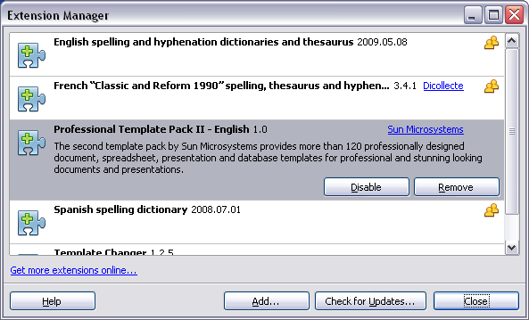
Figure 37: Using the Extension Manager
Note | To install a shared extension, you need write access to the Apache OpenOffice installation directory.

Some popular extensions
This section describes a few of the more important and popular extensions to Apache OpenOffice. In each case, you need to first install the extension as described in the previous section. All tools listed here are open source and free of charge.
PDF Import
Enables you to make minor modifications to the text of existing PDF files when the original source files do not exist or you are unable to open the source files. (Whenever possible, modify the source and regenerate the PDF to obtain the best results.)
When the extension is installed, PDF is listed as a choice in the File Type drop-down list in the File > Open dialog.
Best results can be achieved with the PDF/ODF hybrid file format, which this extension also enables. A hybrid PDF/ODF file is a PDF file that contains an embedded ODF source file. Hybrid PDF/ODF files will be opened in OpenOffice.org as an ODF file without any layout changes.
Non-hybrid PDF documents open in Draw. Depending on the complexity of the layout, changes may be easy or difficult to make, and the saved result may or may not preserve the original layout. Font substitution may occur.
Documents with more sophisticated layouts, such as those created with professional desktop publishing applications that use special fonts and complex vector graphics, are not suitable for the PDF Import Extension. Similarly, longer documents (> 20 pages) may cause some performance and stability problems.
Professional Template Pack II
Provides more than 120 templates for Writer, Calc, and Impress. Available in several languages. After you have installed this extension, you will find the templates under File > New > Templates and Documents.
Template Changer (for Writer)
Adds two new items to the File > Templates menu in Writer that allow you to assign a new template to the current document or to a folder of documents. All styles and formatting will be loaded from that template and the document will behave as it was created using that template.
DataPilot Tools for Calc
Adds some utility functions that make using the Calc DataPilot easier:
- Display the current source range for a DataPilot
- Change the source range for a DataPilot
- Refresh all DataPilots on the current sheet

