
Publishing Extensions for LibreOffice

Copyright
This document is Copyright © 2011 by its contributors as listed below. You may distribute it and/or modify it under the terms of either the GNU General Public License (http://www.gnu.org/licenses/gpl.html), version 3 or later, or the Creative Commons Attribution License (http://creativecommons.org/licenses/by/3.0/), version 3.0 or later.
All trademarks within this guide belong to their legitimate owners.
Contributors
Andreas Mantke
David Nelson
Gustavo Buzzatti Pacheco
Hazel Russman
Laurent Balland-Poirier
Kálmán Szalai
Tom Davies
Feedback
Please direct any comments or suggestions about this document to: documentation@global.libreoffice.org
Publication date and software version
Published 26 September 2011. Based on LibreOffice 3.4.

Note for Mac users
Some keystrokes and menu items are different on a Mac from those used in Windows and Linux. The table below gives some common substitutions for the instructions in this chapter. For a more detailed list, see the application Help.
Windows/Linux | Mac equivalent | Effect
Tools → Options menu selection | LibreOffice → Preferences | Access setup options
Right-click | Control+click | Opens a context menu
Ctrl (Control) | z (Command) | Used with other keys
F5 | Shift+z+F5 | Opens the Navigator
F11 | z+T | Opens the Styles & Formatting window

Contents
Copyright 2
Note for Mac users 2
Introduction 4
Create a Software Project 5
Adding a Release section 10
Adding files 13
Adding a downloadable file 13
Adding a link for an externally hosted file 15
Publishing a release 16

Introduction
You can enhance the functionality of LibreOffice with extensions.
Just install these small programs into LibreOffice and, after restarting the office suit, you can enjoy the new facilities.
If you are an extension developer, you can use several languages to develop LibreOffice extensions. Supported programming languages are Basic, Python, JavaScript and Java. For a higher level of integrity and functionality you can use the C++, Python and Java languages to develop UNO complement-based extensions.
As UNO components, you can provide new implementations of existing functionality or specialized components like Calc Add-Ins, Add-Ons, DataPilots, Chart Add-Ins, or linguistic components: Spellchecker, Hyphenator or Thesaurus.
Also you can create extensions to provide additional Templates, Gallery images and Autotexts.
LibreOffice remains committed to providing users with quality software authored under free software licenses, and, as such, our catalog of extensions and templates is published under free software licenses. These extensions are free of charge.
This manual describes the basic steps for publishing an extension in the LibreOffice official extension repository, located at http://extensions.libreoffice.org/.
We recommend reading this document before you start to publish your extension, especially to gather the basic information you will need to fill the mandatory fields.

Create a Software Project
First of all, you need to register yourself at the Extensions website. Open the Extensions web site in your browser and click on the Register button, in the right upper corner. Fill the Registration form and click Register.
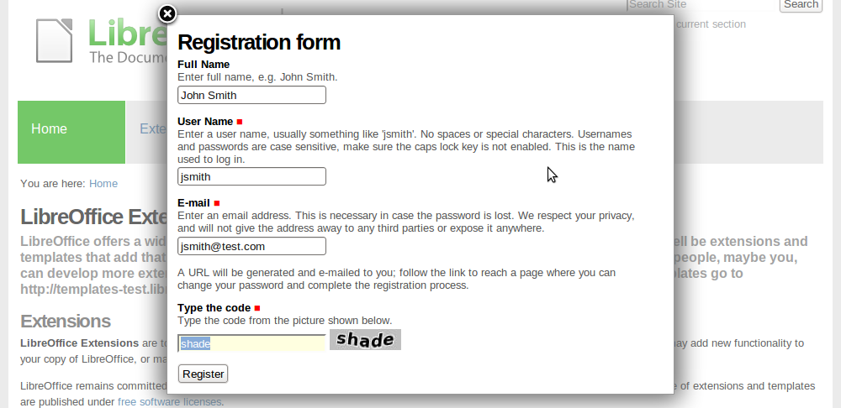
You should receive an e-mail containing a link to set your password and complete your registration process. You may set the password before the deadline date indicated in the e-mail. After this date, you may use the “Forgot your password” link to get a new password.
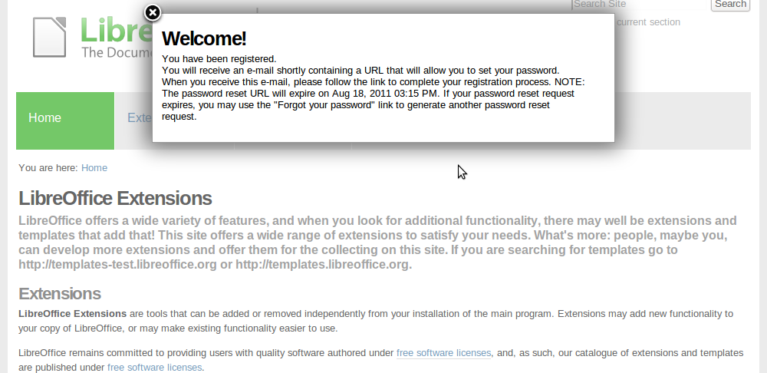
After your registration process is complete, you will be able to log in and create a new extension project.

In the right upper corner, click on Log in to start.
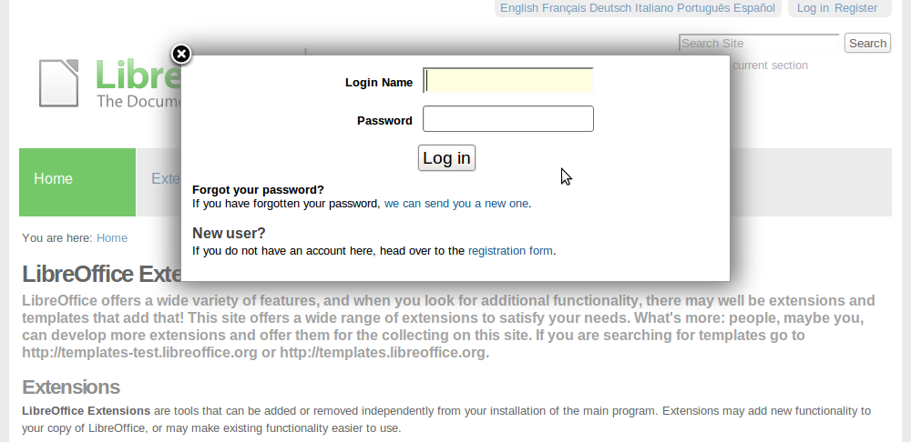
Next, click on Extension Center and, after that, on Submit your Extension, on the green block to the right.
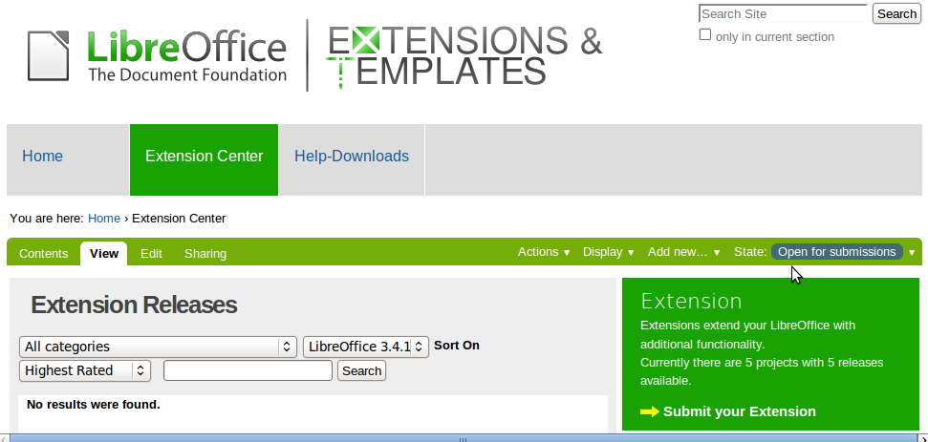
The Add Software Project form will appear.
In this form, you have some mandatory fields in the Default tab: Title, Categories, Project Summary, Full Project Description and Contact address. Each one has a short description below the field name.
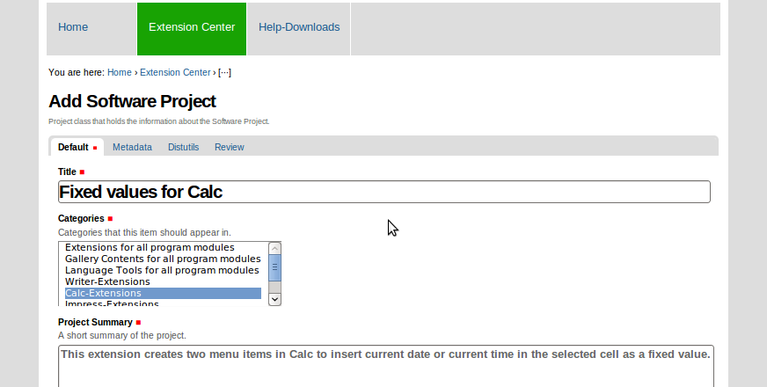
Caution   | It is not recommended to use special characters like ">>", "<<", "&", "ç", "é" or anything similar in the Title field. Please use only plain English text.
In Categories, you can select more than one option by pressing Ctrl.
You can see a list of categories and their explanation in the table below.
Categories | Description | Example
All modules | Extensions for all program modules | Extensions that could be used with any program module.
Gallery Contents | Extensions for all program modules | Pictures, Backgrounds, ...
Language Tools | Extensions for all program modules | Dictionaries and similar
Writer | Extensions for Writer | Extensions that could be used to extend the word processor module.
Calc | Extensions for Calc | Extensions that could be used to extend the spreadsheet module.
Impress | Extensions for Impress | Extensions that could be used to extend the presentation module.
Draw | Extensions for Draw | Extensions that could be used to extend the drawing module.
Base | Extensions for Base | Extensions that could be used to extend the database module.
Math | Extensions for Math | Extensions that could be used to extend the module for formula.

In Contact address, Use mailto: prefix for e-mail contact or http:// prefix for a external web site.
In the next table, the Add Software Project form fields are listed.
Field | Description
Title | Title of the software project.
Categories | Categories that this item should appear in.
Project Summary | A short summary of the project.
Full Project Description | The complete project description.
Contact address | Contact address for the project. Use mailto: or http:// prefix depending on what contact method you prefer.
Home page | If the project has an external home page, enter its URL.
URL of documentation repository | If the project has externally hosted documentation, enter its URL.
URL of version control repository | If the project has a code repository, enter its URL.
Issue tracker URL | If the project has an external issue tracker, enter its URL.
Support mailing list or forum URL | URL of mailing list information page/archives or support forum, if the project has one.
Logo | Add a logo for the project (or organization/company) by clicking the 'Browse' button. Max 150x75 pixels (will be resized if bigger).
Logo link | The URL the logo should link to, if applicable.
Screenshot | Add a screenshot by clicking the 'Browse' button. Max 800x600 (will be resized if bigger).

After filling in the form, click Save.
Caution | Please make sure that the Language field on the Metadata page of your project is Language neutral! Otherwise the project will not be visible to users with another language setting in their browser.

Your Extension project will be created. However, at this time, you can not add releases, documentation or feature proposals. To achieve that, you need to submit your project for approval.
To do this, click on State: Submit for approval link, in the right side of the green bar.
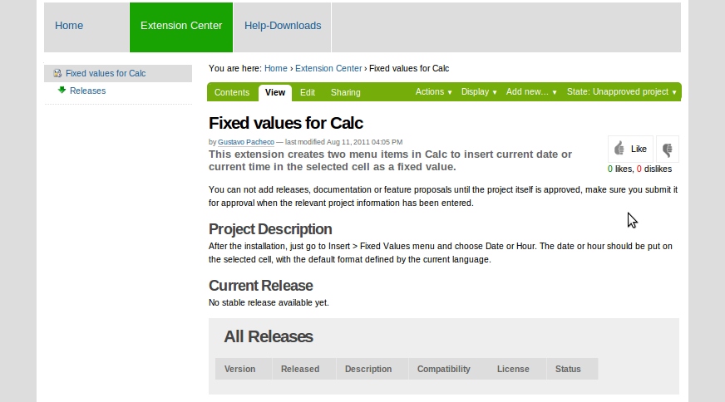
The status of your project will be changed to State: Pending approval, until it is approved by a reviewer. It is possible that the approval will take a few days.
After approval, the status will be changed to State: Public and you can add releases, documentation and feature proposals.
Note | You will not be notified about the project approval. You should verify the project status at the website.

Adding a Release section
After approval, go to Add new > Release section to create a new workspace for your releases information and files.
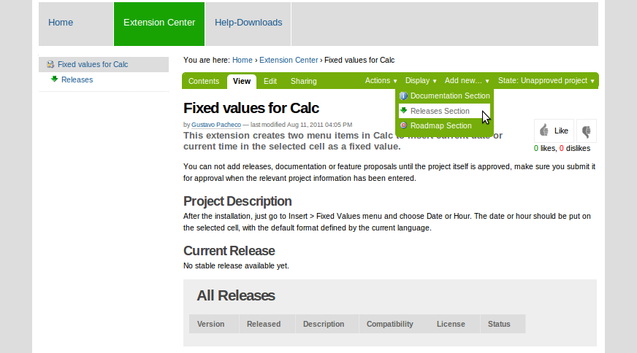
At the Add Releases Section form, on the Metadata tab, you need to set the language to Language neutral, to have this section visible for all users. Then just click on the Save button.
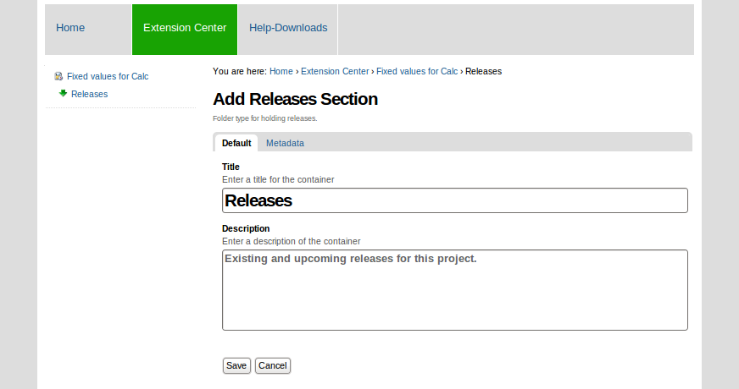
Caution | It is not recommended to use special characters like ">>", "<<", "&", "ç", "é" or anything similar in the Title field. Please use only plain English text.
The Releases folder will be created and you can add a new release clicking on Add new > Software Release.
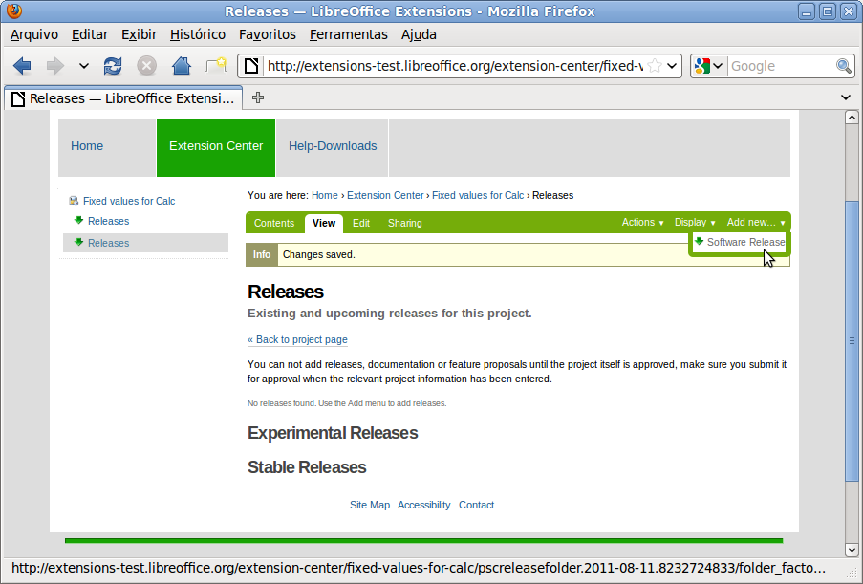
Now you need to fill in the Add Software Release form.
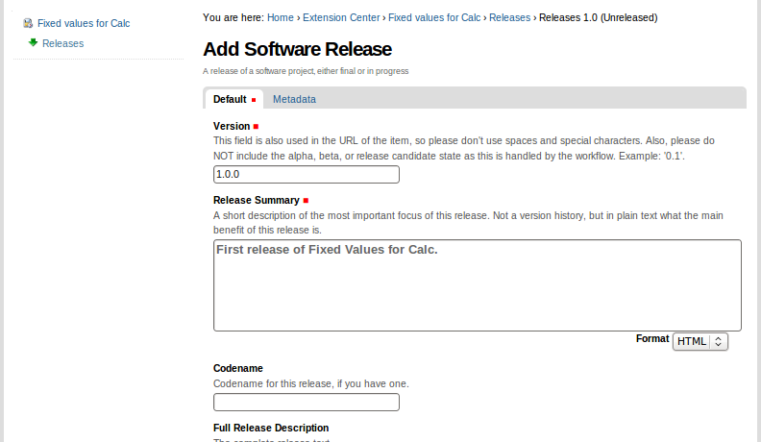
Some fields on the Default tab are mandatory: Version, Release Summary, License and Compatibility.

All fields of the Add Software Release form are described on the list below:

Field | Description
Version | This field is also used in the URL of the item, so please don't use spaces and special characters. Also, please do NOT include the alpha, beta, or release candidate state as this is handled by the work flow. Example: '0.1'.
Release Summary | A short description of the most important focus of this release. Not a version history, but in plain text what the main benefit of this release is.
Codename | Codename for this release, if you have one.
Full Release Description | The complete release text.
Changelog | A detailed log of what has changed since the previous release.
Release Manager | Release manager for this release.
Release Manager Contact E-mail | Contact e-mail for Release Manager.
Proposals freeze date | Date after which no more Improvement Proposals will be associated with the release
Feature freeze date | Date after which no new features will added to the release
(Expected) Release Date | Date on which a final release is expected to be made or was made
License | Release License: Please examine carefully which license you choose for your contribution. You can't change it after the release. The options are:  GPL - GNU General Public License  LGPL - GNU Lesser General Public License  MPL – Mozilla Public License  BSD License (revised)  Public Domain  Other OSI Approved  You need to select at least one licence, but you can choose up to three.
Compatibility | Tested and working with the selected versions
Associated feature proposals | Related improvement proposals for features going into this release.
Repository branch | URL of version control repository branch for this release.

After filling in the Add Software Release form, click Save.
Caution | Please make sure that the Language field on the Metadata page of your release is Language neutral! Otherwise the release will not be visible to users with another language setting in their browser.

Adding files
Now, after creating the Release folder, you have two options for the files of the release: add a downloadable file or add a link for an externally hosted file. These options are detailed in the next two sections.

Adding a downloadable file
For the first option, click Add new > Downloadable File on the green bar.
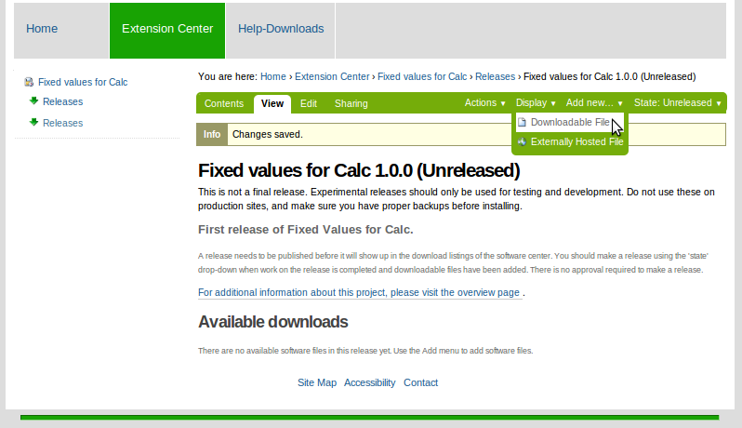

In the Add Downloadable File form shown below, you have just chosen your extension file in the File field and need to define the operating system in Platform field.
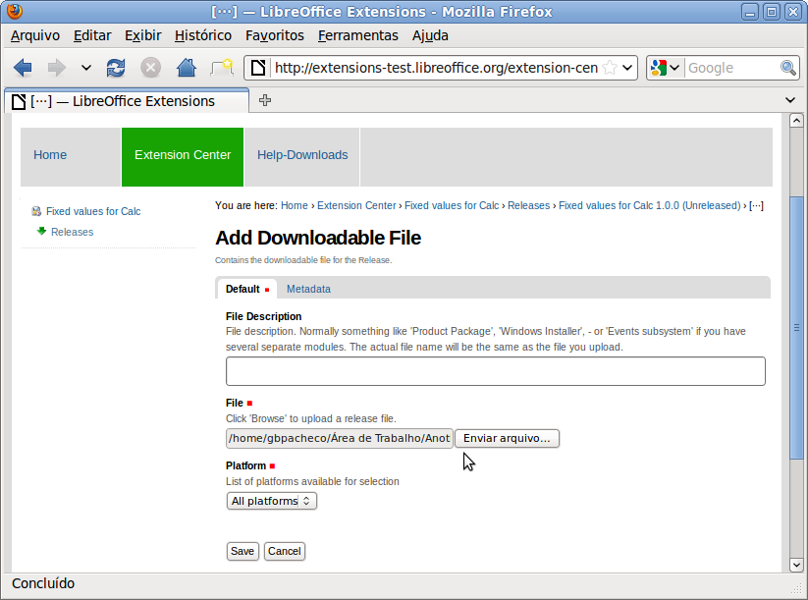
At the end of the form, click Save.

Caution | Please make sure that the Language field on the Metadata page of your downloadable file is Language neutral! Otherwise the project will not be visible to users with another language setting in their browser.
Caution | Leave the File Description field empty. Otherwise the file will have this field for its name. You may set the file description afterwards on the Contents tab of the release, with the Rename button: New Short Name stands for the name of the file whereas New Title stands for the description of the file.

Adding a link for an externally hosted file
To add an externally hosted file, just click Add new > Externally Hosted File on the green bar and fill the Add Externally Hosted File form. For externally hosted files, only the Platform and URL fields are mandatory.
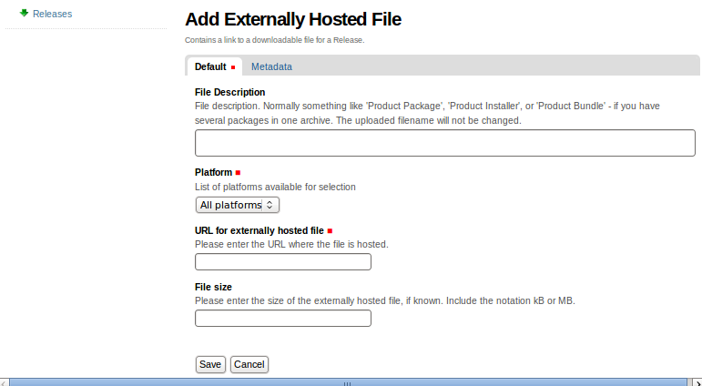
Click Save to finish.

Caution | Please make sure that the Language field on the Metadata page of your externally-hosted file is Language neutral! Otherwise the project will not be visible to users with another language setting in their browser.

Publishing a release
After adding a downloadable file or a link for an externally hosted file for the release, you will see the Extension release and the file(s).
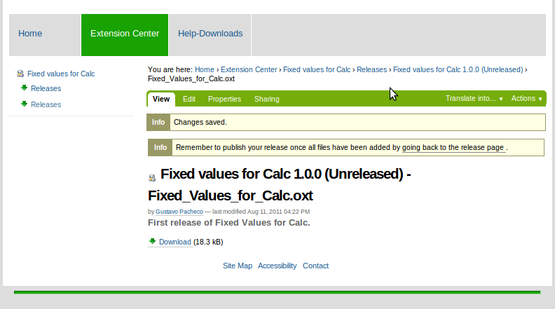
Click on going back to the release page link to change the release status. To publish the release, go to State: Unreleased menu and define the new state, for example, Release final release.
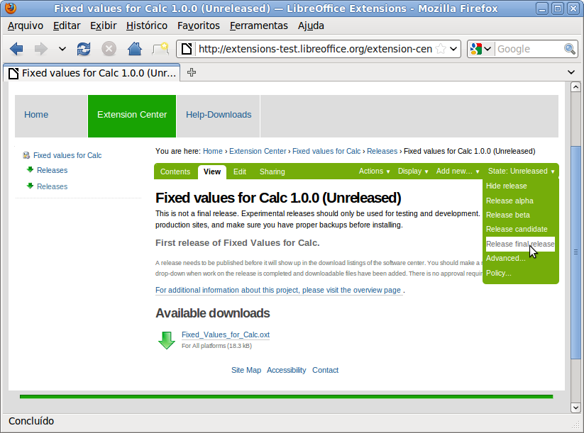
Finally, log out and go to the new extension page to see your extension published!

