INSERT YOUR TITLE HERE. Check spelling carefully. USE DOUBLE-SPACING IF YOUR TITLE MORE THAN ONE LINE

By

Insert your name here

A Thesis/Project Presented to
The Faculty of Humboldt State University
In Partial Fulfillment of the Requirements for the Degree
Master of Science/Arts in Program: Option if applicable

Committee Membership
Dr. Insert Faculty Name, Committee Chair
Dr. Insert Faculty Name, Committee Member
Dr. Insert Faculty Name, Graduate Coordinator

Month Year

Abstract
INSERT YOUR TITLE, SINGLE SPACE IF MORE THAN ONE LINE

Insert your name

Begin your abstract here.

Acknowledgements
Begin your text here. Acknowledgements are optional, unless your study was funded. If you are not including acknowledgements delete this page.

TABLE OF CONTENTS

Abstract ii
Acknowledgements iii
List of Tables v
List of Figures vi
Introduction 7
Heading Two 7
Method 8
Results 10
Discussion 11
References 12
Appendix 13

List of Tables
Table 1: Example of Table Format 3

List of Figures
Figure 1: Alt Text dialog box 3

Introduction
Insert your introduction (or first section) here. This template makes use of a feature in Word called Styles. Using styles has several benefits including, creating an automatic Table of Contents, consistently formatted headings, and conversion to a tagged accessible PDF.

Heading Two
The built-in heading styles need to be applied to each heading added to your document. Select the entry to which you want to apply a heading style. On the Home tab, in the Styles group, click the style that you want. For example, if you selected text that you want to style as a secondary heading, click the style called Heading 2 in the Quick Style gallery. Please refer to “Using the templates” on the Thesis/Project Help webpage for instructions for adding headings and updating the Table of Contents.

Method
Begin your methods or third section here. If your document includes tables and/or figures you must add captions. You may add caption manually or by using the Word feature called Insert Caption. Using Insert Caption has the benefit of automated generation of a list of figures/tables. Additionally, you need to add alternative text to the figures in your document. Alternative text is a description of an image that conveys the same essential information as the image. Alternative text allows people with screen readers to understand the content of your pictures, charts and graphs. Instructions for inserting captions and creating alternative text are available on the thesis/project help webpage at https://humboldt.edu/gradprograms/node/17
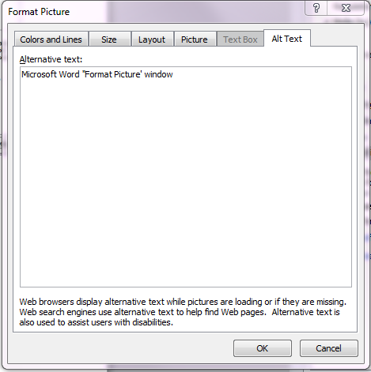
Figure 1: Alt Text dialog box

Results
Begin your results or fourth section here. If you will present information in table form, use the Insert Table tool to create accessible tables in your document. Tables should have clear column headings to provide context and assist in navigation of the table’s contents (Table 1). Identify the top row of the table as a header row in Table Properties. If the table spans more than one page, check “Repeat as header row at the top of each page” in Table Properties.
Do not use tabs or spaces to create tables. It may look like a table; however, it will not be accessible or readable by assistive technologies. Avoid merging or splitting cells, using the Draw Table tool in Word to create tables, and copying and inserting tables as pictures or figures.

Table 1: Example of Table Format
Measure | Column Head | Column Head | Column Head | Column Head
Row 1
Row 2
Row 3

Discussion
Begin your discussion or fifth section here.

References

Insert references here. References are listed in alphabetical order. Please check with your committee and style manual for specific requirements.
This example is the basic outline for most references cited. The order of author(s), title, publication, volume, and page numbers is discipline specific.

Appendix
Appendices are used to include material too detailed or lengthy for inclusion in the body of the study (e.g., raw data, questionnaires, letters of permission). Label each appendix alphabetically in the order they appear in the text (Example: APPENDIX A, APPENDIX B, etc.). Do not include a alphabetic label if there is only one appendix.

