DYNAMIC ASSET ALLOCATION
A Comparison of Markowitz Optimization,
Michaud Resampling, and Hierarchical Risk Parity
Variant B — Dynamic Asset Allocation
Course: Financial Markets Analytics
Academic Year: 2025/2026
Professor: Prof. G. Forte
University: University of Milano-Bicocca
Author: Artem Khomytskyi
Date: 13 July 2026

Abstract
This report evaluates dynamic multi-asset allocation strategies in an out-of-sample setting. The empirical problem is whether optimization-based portfolio construction improves realized performance relative to transparent naive benchmarks once estimation error, transaction costs, turnover, and timing discipline are taken seriously. The project uses adjusted Yahoo Finance ETF prices for a diversified 27-ETF universe covering equities, government bonds, credit, commodities, real estate, and cash. The main optimized comparison uses a 23-ETF core universe from January 2008 through May 2026 and evaluates all strategies on the common realized period from March 2013 through May 2026 after a 60-month rolling estimation window. The strategies include Equal Weight, 60/40, classical Markowitz minimum-variance, maximum-Sharpe and target-volatility portfolios, Michaud resampling with 100, 250, and 500 resamples, and a Hierarchical Risk Parity extension. The strongest realized Sharpe ratio is obtained by the Maximum Sharpe Ledoit-Wolf strategy, while Target Volatility Ledoit-Wolf produces the highest terminal wealth. Michaud 500 does not dominate on Sharpe, but it improves turnover and effective diversification relative to Maximum Sharpe Ledoit-Wolf with only a modest risk-adjusted performance sacrifice. HRP becomes overwhelmingly concentrated in the cash-like BIL ETF, producing extremely low drawdown and turnover but the worst Sharpe ratio. The contribution of the project is a reproducible, bias-controlled comparison of classical optimization, resampling, shrinkage, benchmarks, and a modern robust extension in a realistic ETF universe. The evidence supports careful robust estimation, but it does not prove universal superiority of any single allocation rule.

Table of Contents

1. Introduction | 7
2. Literature Review | 9
2.1 Markowitz mean-variance optimization | 9
2.2 The Markowitz optimization enigma | 9
2.3 Covariance shrinkage | 9
2.4 Naive diversification | 9
2.5 Hierarchical Risk Parity | 10
3. Data and Investment Universe | 11
3.1 Data source | 11
3.2 ETF universe | 11
3.3 Sample policy | 11
3.4 Data inspection and cleaning | 12
4. Methodology | 14
4.1 Monthly returns | 14
4.2 Expected-return estimation | 14
4.3 Covariance estimation | 14
4.4 Portfolio constraints | 14
4.5 Benchmark portfolios | 15
4.6 Minimum-variance portfolio | 15
4.7 Maximum-Sharpe portfolio | 15
4.8 Target-volatility portfolio | 16
4.9 Michaud resampling | 16
4.10 Hierarchical Risk Parity | 16
4.11 Backtesting framework | 17
4.12 Transaction costs and turnover | 17

Table of Contents (continued)
4.13 Performance measures | 17
5. Empirical Results | 19
5.1 Descriptive asset-level evidence | 19
5.2 Benchmark results | 19
5.3 Classical Markowitz results | 20
5.4 Effect of covariance shrinkage | 20
5.5 Michaud resampling | 21
5.6 HRP extension | 21
5.7 Final strategy comparison | 22
5.8 Equity curves and drawdowns | 24
5.9 Risk-return and implementation trade-offs | 24
6. Discussion | 27
6.1 Did optimization add value? | 27
6.2 Did shrinkage help? | 27
6.3 Did Michaud solve the estimation problem? | 27
6.4 What did HRP reveal? | 27
6.5 Economic versus statistical significance | 27
7. Limitations | 28
8. Conclusion | 28
9. References | 29
Appendix A - Complete ETF Universe | 30
Appendix B - Data Availability and Sample Policy | 31
Appendix C - Optimization Parameters and Reproducibility | 32
Appendix D - Additional Diagnostics | 33

List of Figures

Figure 1. First available daily price by ETF | 12
Figure 2. Core-universe monthly return correlations | 13
Figure 3. Annualized return by ETF | 19
Figure 4. Rolling maximum-Sharpe Markowitz weights | 20
Figure 5. Michaud versus maximum-Sharpe equity curve | 21
Figure 6. Final strategy equity curves | 23
Figure 7. Final strategy drawdowns | 24
Figure 8. Risk-return scatter | 25
Figure 9. Turnover versus Sharpe | 26
Figure 10. Diversification versus Sharpe | 26
Figure 11. HRP weight heatmap | 22
Figure 12. Missing values by year | 31
Figure 13. Effective number of assets over time | 33
Figure 14. Michaud turnover comparison | 33

List of Tables

Table 1. Assignment-compliance summary | 8
Table 2. Universe by asset class | 11
Table 3. Sample-policy summary | 11
Table 4. Main backtest and optimization parameters | 15
Table 5. Benchmark performance, common final period | 19
Table 6. Classical Markowitz performance, common final period | 20
Table 7. Markowitz versus Michaud | 21
Table 8. Final risk and performance comparison | 22
Table 9. Turnover and diversification comparison | 23
Table 10. Key findings summary | 27
Table 11. Complete ETF metadata | 30
Table 12. Late-inception ETFs | 31
Table 13. Reproducibility configuration | 32
Table 14. Software environment | 32
Table 15. Top annualized ETF returns | 34
Table 16. Highest-volatility ETFs | 34

1. Introduction
Asset allocation is the central portfolio decision for investors who must distribute capital across economically different sources of risk and return. This report is the Final Project - Variant B: Dynamic Asset Allocation for Financial Markets Analytics. Variant B was selected because the research question concerns the allocation of capital across asset classes through time, rather than security selection within a single equity market. In a multi-asset setting, the relevant problem is not only which securities appear attractive individually, but also how their joint behavior affects portfolio risk, drawdown, turnover, and implementation cost. Classical mean-variance optimization remains influential because it gives a disciplined framework for combining expected returns, variances, and covariances into portfolio weights. However, its practical weakness is equally well known: expected returns and covariances are estimated with error, and small input changes can produce large allocation changes. For this reason, an allocation that appears optimal in sample may be fragile out of sample.
Out-of-sample testing is therefore essential. A dynamic allocation rule must be evaluated as it would have operated in real time, with each rebalance using only information available before the allocation decision. This project implements that discipline through a 60-month rolling estimation window, monthly rebalancing, a one-month implementation lag, and transaction-cost-adjusted realized returns. The use of ETFs is appropriate for a university asset-allocation study because ETFs provide diversified, transparent, liquid exposures to broad asset classes without turning the project into a stock-selection exercise.
The supplied S&P 500 and STOXX 600 stock datasets would have been suitable for an equity-selection project, but they do not provide the cross-asset covariance structure required for flexible allocation. Broad ETFs were therefore chosen to represent investable equity, government-bond, credit, commodity, real-estate, and cash exposures. This choice aligns the data with the assignment variant and reduces firm-specific noise.
Black-Litterman was considered an optional extension. It was not implemented because the model requires explicit investor views and confidence levels; no defensible subjective view set was available for this academic study (Idzorek, 2005). HRP was instead added as an optional original extension and is not presented as an assignment requirement.
The principal research question is: how do classical Markowitz optimization, covariance shrinkage, Michaud resampling, and hierarchical risk parity compare out of sample against simple benchmark portfolios in a diversified ETF universe? Four subordinate questions organize the analysis. First, does Ledoit-Wolf shrinkage improve classical Markowitz allocations relative to sample covariance? Second, does Michaud resampling improve diversification and turnover without materially sacrificing Sharpe? Third, does HRP produce a robust alternative in a universe containing a cash proxy? Fourth, do optimized strategies add value relative to 1/N and 60/40 benchmarks?
The empirical contribution is methodological as much as numerical. The project does not merely compute an efficient frontier and present in-sample weights. It builds a complete walk-forward pipeline in which data availability is audited before sample selection, prices are converted into clean monthly panels, estimates are formed only from lagged information, portfolio weights are saved, and realized returns are computed with transaction costs and drift-aware turnover. This design matters because many apparent optimization gains disappear once portfolio timing, data availability, trading costs, and benchmark comparability are enforced. The report therefore places equal emphasis on implementation discipline and on performance ranking. A strategy that produces high terminal wealth but requires frequent trading or concentrated exposures is not equivalent to a simple benchmark with lower operational burden.
Table 1 summarizes how the implementation satisfies the assignment requirements. The report proceeds as follows. Section 2 reviews the relevant portfolio literature. Section 3 describes the data, universe, and sample policy. Section 4 documents the methodology and timing convention. Section 5 presents the empirical results. Section 6 discusses the economic meaning of the findings, Section 7 states limitations, and Section 8 concludes.
Table 1. Assignment-compliance summary
Variant B requirement | Assessment | Evidence
Out-of-sample dynamic allocation | Satisfied | 60-month rolling window; monthly decisions; one-month implementation lag
Classical Markowitz | Satisfied | Minimum variance, maximum Sharpe, and target volatility
Michaud resampling | Satisfied | 100, 250, and 500 resample implementations
Multi-asset ETF universe | Satisfied | 27 configured ETFs; common 23-ETF optimized universe
Minimum 15-year history | Satisfied | Core prices span 2008-01 through 2026-05
Periodic rebalancing | Satisfied | Monthly walk-forward rebalancing
Benchmark comparison | Satisfied | Equal Weight and 60/40 on common dates and costs
Graphs and tables | Satisfied | Performance, drawdown, turnover, concentration, and allocation diagnostics
Volatility, drawdown, Sharpe | Satisfied | Reported for every final strategy
Original robust extension | Satisfied | HRP is an optional original extension
Black-Litterman | Optional / not implemented | No defensible subjective views were available

2. Literature Review

2.1 Markowitz mean-variance optimization
Markowitz (1952) introduced the mean-variance framework, in which portfolio choice is represented by a trade-off between expected return and variance. For a vector of expected returns and a covariance matrix, the efficient frontier contains portfolios that minimize risk for a given return or maximize return for a given level of risk. The framework remains foundational because it formalizes diversification: the risk of a portfolio depends not only on asset volatilities but also on correlations among assets. The same structure creates a practical weakness. Expected returns and covariances are unknown and must be estimated, so the optimized portfolio may reflect estimation noise rather than genuine investment opportunity.

2.2 The Markowitz optimization enigma
Michaud (1989) described the optimization enigma: the very process designed to find the best portfolio can amplify errors in estimated inputs. Mean-variance optimizers tend to favor assets with high estimated returns, low estimated risk, or favorable estimated correlations. When these estimates are noisy, the optimizer may produce concentrated and unstable weights. Michaud and Michaud (2008) propose resampling as a practical way to average across plausible capital-market assumptions. The intuition is not that uncertainty disappears, but that averaging optimized portfolios across simulated inputs can reduce dependence on a single noisy efficient frontier.
This critique is particularly relevant for maximum-Sharpe and target-return problems. The optimizer is not neutral with respect to estimation error; it actively searches for the most favorable combination of estimated return and estimated risk. Assets whose expected returns are overestimated or whose covariances are underestimated can receive disproportionate weights. As a result, the optimized portfolio may be more a reflection of sampling error than of persistent economic compensation. Resampling addresses this problem by treating the estimated inputs as uncertain and averaging the portfolios obtained from many plausible input sets. The resulting allocation is not guaranteed to be optimal in any single simulated world, but it can be more stable and easier to implement.

2.3 Covariance shrinkage
Sample covariance matrices can be unstable when the number of assets is large relative to the estimation window or when correlations shift over time. Ledoit and Wolf (2004) propose shrinkage estimators that pull the noisy sample covariance matrix toward a structured target. Shrinkage is expected to improve matrix conditioning and reduce extreme allocation responses, especially in optimization problems that depend heavily on covariance estimates. In this project, Ledoit-Wolf covariance estimation is compared with the sample covariance for each classical Markowitz strategy.
The expected benefit of shrinkage is practical rather than cosmetic. A covariance matrix used in optimization must be numerically well behaved, because small eigenvalues or unstable correlation estimates can materially alter the optimizer's risk assessment. In rolling backtests, the covariance matrix is re-estimated repeatedly, so instability can create unnecessary turnover even when the economic opportunity set has not changed dramatically. Shrinkage can reduce this problem by sacrificing some sample specificity in exchange for a more stable estimator. The empirical question is whether that trade-off improves the realized portfolio, not whether shrinkage is theoretically preferable in every setting.

2.4 Naive diversification
Naive diversification remains an important benchmark because complex optimization must justify its implementation burden. The 1/N portfolio requires no expected-return or covariance estimates, while a 60/40 equity-government bond portfolio reflects a conventional balanced allocation rule. DeMiguel, Garlappi, and Uppal (2009) show that optimized strategies can struggle to outperform naive diversification once estimation error is considered. This literature motivates the inclusion of both Equal Weight and 60/40 in the final comparison.

2.5 Hierarchical Risk Parity
Hierarchical Risk Parity, associated with López de Prado (2016), uses correlation-based clustering and recursive allocation to avoid direct inversion of the covariance matrix. The approach can be attractive when covariance inversion is unstable. However, HRP is not immune to the consequences of universe design. If the universe includes a near-zero-volatility cash proxy, an unconstrained hierarchical allocation can become dominated by that defensive asset. The HRP extension in this project is therefore interpreted as an empirical stress test of method-universe interaction rather than as a universal verdict on HRP.
This caveat is important because HRP is often described as a robust alternative to classical mean-variance optimization. Robustness, however, is not the same as immunity to design choices. The distance matrix, clustering method, asset universe, and presence of defensive assets all influence the final allocation. A cash-like ETF can appear attractive to a risk-allocation algorithm because it contributes little variance, even if its expected excess return is low. Consequently, HRP should be evaluated with the same out-of-sample discipline and economic interpretation applied to Markowitz and Michaud portfolios.

3. Data and Investment Universe

3.1 Data source
The project uses adjusted ETF price data obtained from Yahoo Finance through yfinance. Adjusted prices are appropriate because they incorporate distributions and corporate actions into the price series used to compute returns. Yahoo Finance is publicly accessible and reproducible for academic analysis through the yfinance interface. With auto-adjustment enabled, the downloaded series reflects price history adjusted for splits and distributions, so percentage changes approximate total returns before investor-specific taxes and trading frictions. Yahoo Finance is not equivalent to Bloomberg, FactSet, or an institutional total-return database. A fresh live download may differ slightly if adjusted histories are revised by the provider. The submitted results rely on the included raw and processed artifacts.

3.2 ETF universe
The initial universe contains 27 ETFs across six broad asset classes. Twenty-seven funds were selected to provide several instruments within most sleeves, regional breadth, multiple duration exposures, and enough cross-sectional choice for constrained optimization while keeping the universe interpretable and computationally manageable. Table 2 summarizes the asset-class composition. Equities provide exposure to global growth across US, developed international, European, Japanese, Asia-Pacific, and emerging markets. Government bonds provide defensive duration exposure, including short-, intermediate-, long-term, inflation-linked, and international bonds. Credit ETFs add investment-grade, high-yield, emerging-market, and bank-loan exposures. Commodities and gold introduce real-asset sensitivity, real estate adds listed property exposure, and cash is represented by short Treasury bills. The full metadata table is included in Appendix A.
Table 2. Universe by asset class
Asset class | ETFs | Tickers
Cash | 1 | BIL
Commodities | 3 | GLD, DBC, GSG
Credit | 4 | LQD, HYG, EMB, BKLN
Equity | 9 | SPY, QQQ, IWM, MDY, EFA, EEM, VGK, EWJ, VPL
Government Bonds | 7 | SHY, VGSH, IEF, TLT, TIP, BWX, IGOV
Real Estate | 3 | VNQ, RWX, VNQI

3.3 Sample policy
The raw universe contains four late-inception ETFs: IGOV, VGSH, VNQI, and BKLN. Table 3 reports the resulting sample policy. The main analysis uses a core universe of 23 ETFs from 2008-01-31 to 2026-05-31. Excluding the four late-inception ETFs preserves the Global Financial Crisis while maintaining a complete fixed cross-section. The extended 27-ETF panel begins in 2011-03 and is used as a descriptive data-policy robustness analysis, not as a full optimized-strategy robustness backtest. The final strategy comparison begins in 2013-03 because the rolling optimizer requires 60 prior monthly returns before the first realized out-of-sample portfolio return.
Table 3. Sample-policy summary
Universe | ETFs | Start | End | Months | Excluded | Reason
core_23 | 23 | 2008-01-31 | 2026-05-31 | 221 | IGOV;VGSH;VNQI;BKLN | Retains the 2008 crisis period while excluding ETFs without January 2008 history.
extended_27 | 27 | 2011-03-31 | 2026-05-31 | 183 | None | Includes all configured ETFs from the first complete common month.

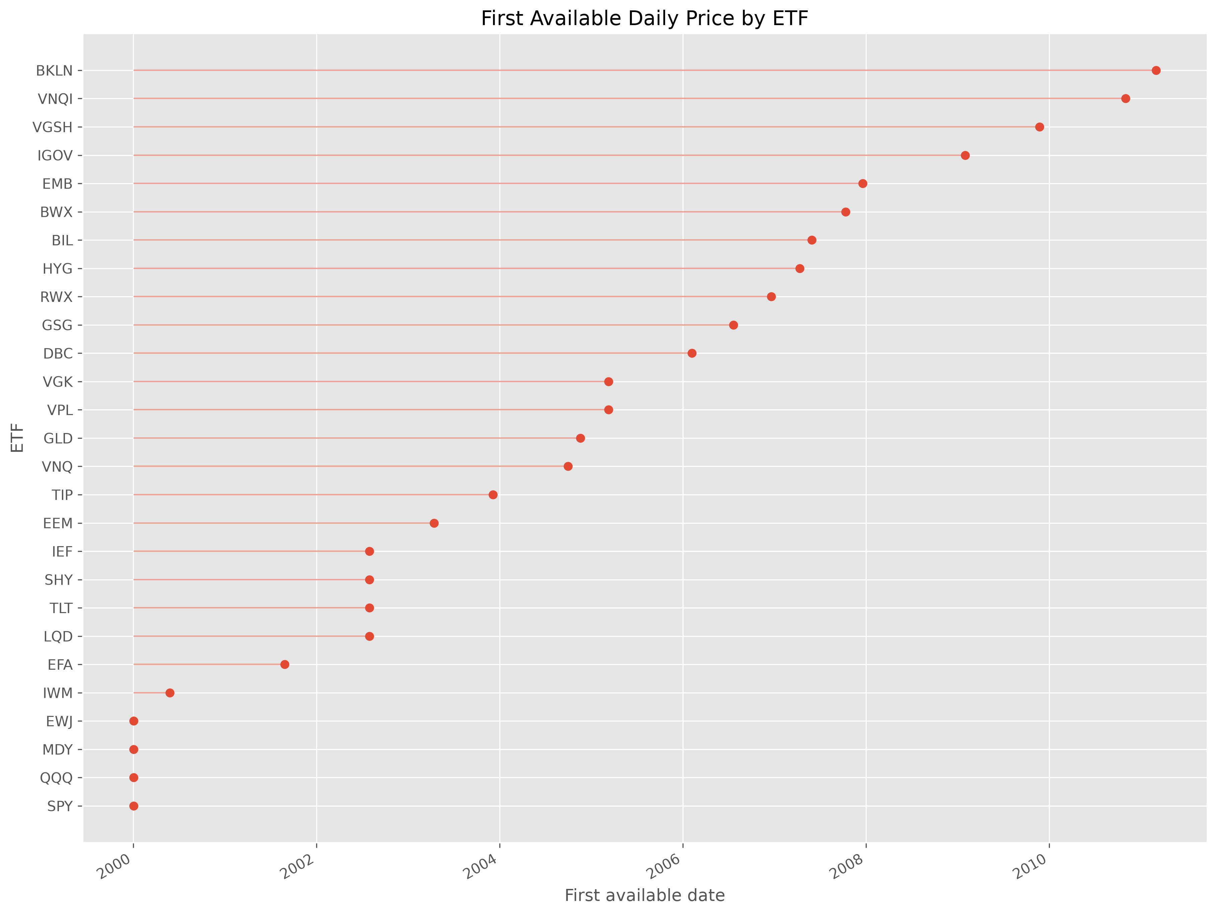
Figure 1. First available daily price by ETF. ETF launch dates motivate the explicit core and extended sample policy.

3.4 Data inspection and cleaning
Data-quality diagnostics show that missing observations are structural pre-inception gaps rather than within-lifetime gaps. Figure 1 displays first available dates by ETF, and Appendix B reports additional missingness diagnostics. No ETF prices are interpolated, synthetically created, or backfilled. The incomplete June 2026 observation is excluded from clean panels, leaving a sample end of 2026-05-31. Figure 2 shows the core-universe correlation matrix. The average pairwise correlation in the core sample is 0.417, with observed off-diagonal correlations ranging from -0.367 to 0.987. This confirms both the presence of strong equity clustering and the diversification contribution of bonds, commodities, and cash.
The choice to retain the 2008 crisis period is economically meaningful. A sample beginning after the crisis would include more ETFs but omit one of the most severe stress periods in modern market history. The core 23-ETF design accepts a narrower universe in exchange for a longer and more demanding test. The extended 27-ETF panel documents what is gained in breadth and lost in history, but it is not used to claim full optimized robustness. This distinction prevents the report from comparing strategies across unequal opportunity sets or unequal market histories.
The sample policy also separates an availability decision from a performance decision. The late-inception ETFs are excluded from the core analysis because they do not exist at the beginning of the desired sample, not because their later returns are unattractive or inconvenient. This distinction is important for reproducibility. A researcher who silently drops assets after seeing portfolio results could bias the study, whereas this project records the availability constraint before optimization and applies the resulting core universe consistently to all final strategies. The extended panel remains useful because it shows how the broader 27-ETF universe can be represented once all assets have common history, but the final comparison avoids mixing that descriptive evidence with the optimized core backtest.
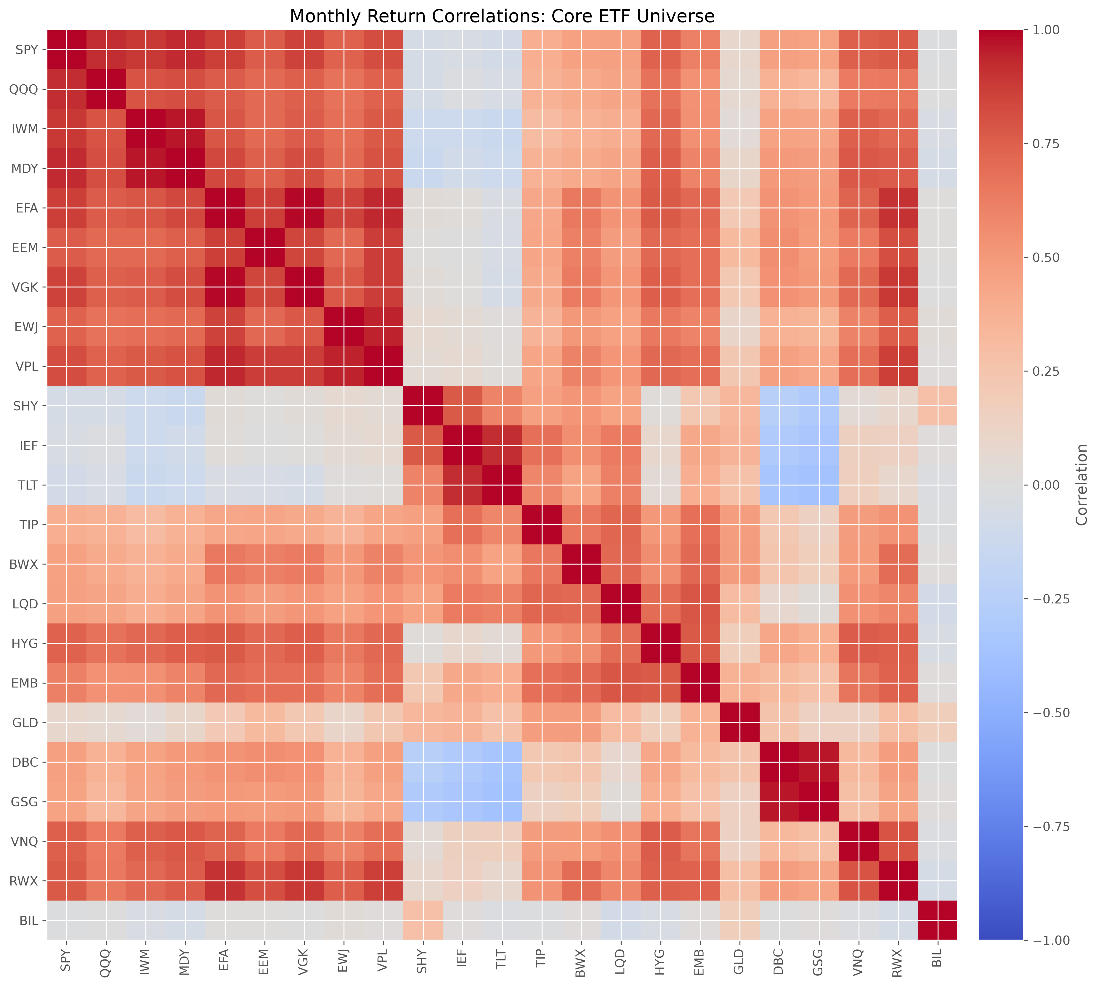
Figure 2. Core-universe monthly return correlations. The matrix shows equity clustering and the lower correlations supplied by bonds, commodities, and cash.

4. Methodology

4.1 Monthly returns
The project computes simple monthly returns from month-end adjusted prices. For ETF i in month t, the simple return is
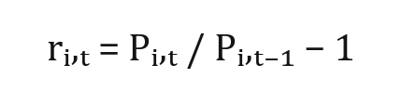
Equation 1. Simple monthly return.
Simple returns are used for portfolio aggregation and realized wealth because portfolio returns are weighted sums of constituent simple returns. Log returns are also computed as diagnostics, but they are not used for realized portfolio wealth in the final strategy comparison.

4.2 Expected-return estimation
Expected returns are estimated as arithmetic monthly means over the trailing 60-month window and annualized by multiplying by 12. This choice balances estimation stability against responsiveness and leaves 60 observations to estimate a 23-asset covariance matrix. It is project-specific rather than uniquely optimal; 36-month support exists in the code and tests, but the saved final weights use 60 months. A shorter window would react faster but be noisier, while a longer window would be more stable but potentially less responsive to regime changes. The report interprets expected-return-driven strategies cautiously because estimated means are noisy even with a five-year window.

4.3 Covariance estimation
The project compares sample covariance and Ledoit-Wolf covariance shrinkage. Monthly covariance estimates are annualized by multiplying by 12. Positive-semidefinite and stable covariance matrices matter because portfolio variance and Sharpe objectives are functions of the covariance matrix. Ledoit-Wolf shrinkage is expected to reduce estimation error and improve numerical stability, but the empirical results are interpreted as sample-specific rather than universal.

4.4 Portfolio constraints
Table 4 lists the main backtest parameters. Classical Markowitz and Michaud portfolios are fully invested, long only, unleveraged, and constrained to weights between 0% and 25% per ETF. Long-only constraints reflect the assignment's investable policy-portfolio setting and avoid short-sale financing assumptions. Leverage is prohibited so performance cannot be increased by scaling risk mechanically. The 25% cap prevents single-asset corner solutions and preserves interpretability while still allowing meaningful active allocation; it is a project-specific concentration control rather than a universal optimum. All constrained weights sum to one. HRP is implemented using PyPortfolioOpt HRPOpt and is not subject to the same 25% cap in the saved allocation, which is important for interpreting its cash concentration.
Table 4. Main backtest and optimization parameters
Parameter | Implemented value
Evaluation period | 2013-03-31 to 2026-05-31 (159 months)
Estimation window | 60 monthly returns
Rebalancing | Monthly, month-end
Information timing | Weight date t uses observations through t-1; applied to t+1
Risk-free rate | 2% per year
Target volatility | 10% per year
Transaction cost | 5 bps one-way
Turnover | Drift-aware; initial establishment excluded from averages
Constraints | Long only, fully invested, no leverage
Markowitz/Michaud cap | 25% per ETF
Covariance estimators | Sample and Ledoit-Wolf
Michaud resamples | 100, 250, 500
Random seed | 42
Solver fallback | OSQP, SCS, then ECOS when installed
HRP | PyPortfolioOpt HRPOpt; no 25% cap

4.5 Benchmark portfolios
Equal Weight assigns 1/N to every eligible ETF. The 60/40 benchmark allocates 60% equally across equity ETFs and 40% equally across government-bond ETFs; credit, commodities, real estate, and cash receive zero benchmark weight. The final benchmark metrics are recomputed on the common core period using the same 5 bps drift-aware transaction-cost convention as the optimized strategies.

4.6 Minimum-variance portfolio
The minimum-variance strategy solves
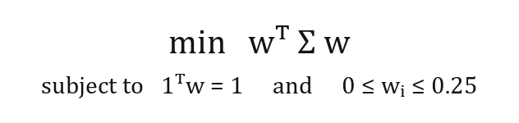
Equation 2. Minimum variance.
Because the objective ignores expected returns, the strategy is expected to allocate toward low-volatility and low-correlation assets. In a universe with short bonds and cash-like exposure, this can produce low realized risk but also limited return.

4.7 Maximum-Sharpe portfolio
The maximum-Sharpe strategy maximizes expected excess return per unit of volatility using a constant 2% annual risk-free rate. The fixed rate is a project-specific comparability convention, not a claim that cash yields were constant across 2013-2026. Conceptually, it solves
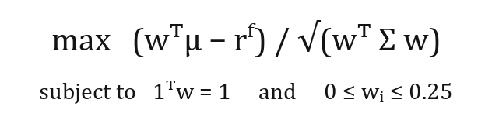
Equation 3. Maximum Sharpe.
subject to the same investment and weight constraints. The implementation uses a convex tangency transformation: scaled weights are constrained to deliver one unit of expected excess return, portfolio variance is minimized, and the solution is normalized back to fully invested weights. CVXPY attempts OSQP, then SCS, then ECOS when installed. The strategy depends directly on estimated expected returns, so it is more exposed to mean-estimation error, concentration, and turnover than the minimum-variance portfolio.

4.8 Target-volatility portfolio
The target-volatility strategy maximizes expected return subject to the 10% annual volatility ceiling and the same long-only 25% cap.
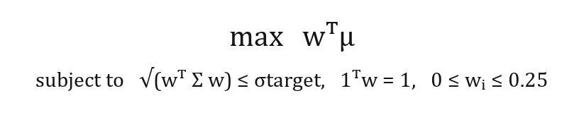
Equation 4. Target volatility.

4.9 Michaud resampling
At each rebalance date, the Michaud procedure estimates mean returns and a Ledoit-Wolf covariance matrix from the previous 60 monthly observations. It then simulates alternative capital-market assumptions, solves the same constrained maximum-Sharpe optimization for each simulated scenario, averages the resulting optimal weights, and applies the averaged portfolio to the next realized month. For each resample, the mean vector is drawn from its estimated sampling distribution and a covariance realization is generated from the estimated covariance structure and sample size. The same constrained maximum-Sharpe problem is solved repeatedly, after which component weights are averaged.
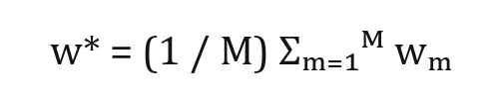
Equation 5. Michaud averaged weights.
The project evaluates 100, 250, and 500 resamples using deterministic seed 42. The three counts assess Monte Carlo convergence: 100 is economical, 250 is intermediate, and 500 is the configured primary result. The simulation is based on multivariate-normal capital-market-assumption draws rather than a simple historical bootstrap. The expected practical benefit is not higher Sharpe in every sample, but reduced concentration and turnover through averaging across plausible estimates.

4.10 Hierarchical Risk Parity
HRP converts correlations into distances, performs hierarchical clustering, orders assets through the resulting tree, and allocates recursively across clusters. Its attraction is that it avoids direct covariance-matrix inversion. The project implements HRP using PyPortfolioOpt HRPOpt with the 60-month rolling window and the same out-of-sample timing discipline. Because the saved HRP allocation is not constrained by the 25% single-ETF cap, its empirical outcome must be interpreted separately from the capped Markowitz and Michaud portfolios.

4.11 Backtesting framework
The timing convention is deliberately conservative. At weight date t, the estimator uses only data strictly before t; the new weights are applied to the realized return in t+1. This one-month implementation lag prevents contemporaneous information leakage and represents the delay between observing a month-end dataset, forming estimates, and holding the portfolio during the next month. Monthly rebalancing matches the monthly return frequency and permits adaptation without the trading intensity of daily or weekly re-estimation. Quarterly rebalancing could lower turnover but would answer a different design question and is reserved for sensitivity analysis. All final strategies use the same core universe, the same realized months, and the same final period from 2013-03-31 to 2026-05-31.

4.12 Transaction costs and turnover
Turnover is one-way and drift-aware. After returns are realized, weights drift mechanically; the next rebalance trades from drifted weights to target weights. Transaction cost equals one-way turnover multiplied by 5 basis points. Five basis points is a transparent project-specific approximation for liquid ETFs; it is held constant so trading intensity is penalized consistently rather than claimed as an exact historical execution cost. Initial portfolio establishment is excluded from average turnover, so reported turnover measures ongoing rebalancing intensity rather than an unavoidable initial investment. Drift-aware turnover first updates prior weights by asset returns, normalizes the post-return portfolio, and then measures the one-way trade required to reach the next target.

4.13 Performance measures
The report uses annualized geometric return, annualized volatility, Sharpe ratio, Sortino ratio, maximum drawdown, Calmar ratio, final wealth, annualized turnover, effective number of assets, and the Herfindahl-Hirschman Index. The annualized return column reports the geometric mean. Sharpe and Sortino ratios use the annualized arithmetic mean of monthly excess returns. Therefore, the reported Sharpe ratio cannot be reconstructed directly from the geometric-return column. The effective number of assets is the inverse of the Herfindahl index and summarizes concentration in portfolio weights rather than economic risk contribution.
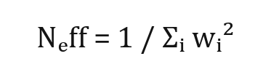
Equation 6. Effective number of assets.
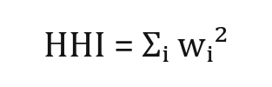
Equation 7. Herfindahl index.
The use of several metrics is necessary because no single statistic captures the investment problem. Geometric return and final wealth describe compounding. Volatility and Sharpe describe average variation and excess return per unit of variation. Maximum drawdown and Calmar summarize path dependence and downside experience. Turnover connects the backtest to implementability, while effective assets and HHI describe concentration. A strategy can rank highly on one metric and poorly on another; the empirical interpretation therefore emphasizes trade-offs rather than a single leaderboard.
The 60-month estimation window is a deliberately moderate choice. It provides five years of monthly data, enough to estimate a 23-asset covariance matrix with more stability than a very short window, but not so much history that the model is dominated by distant regimes. The window is still short relative to the difficulty of estimating expected returns, which explains why the report treats expected-return-driven strategies with caution. The same window is used across Markowitz, Michaud, and HRP so that differences in outcomes reflect allocation rules and estimators rather than unequal information sets.

5. Empirical Results

5.1 Descriptive asset-level evidence
Figure 3 reports annualized core-universe ETF returns. The strongest annualized return in the core sample is QQQ at 17.43%, followed by SPY and MDY. The highest-volatility ETFs are led by GSG at 23.40%, VNQ, and EEM. Equity and real-asset exposures therefore supply much of the return opportunity but also much of the volatility. Figure 2 shows strong positive correlations within equities and between some regional equity ETFs, while long-duration bonds and commodities display several low or negative relationships. These relationships support the use of a multi-asset universe, while also warning that diversification is regime-dependent.
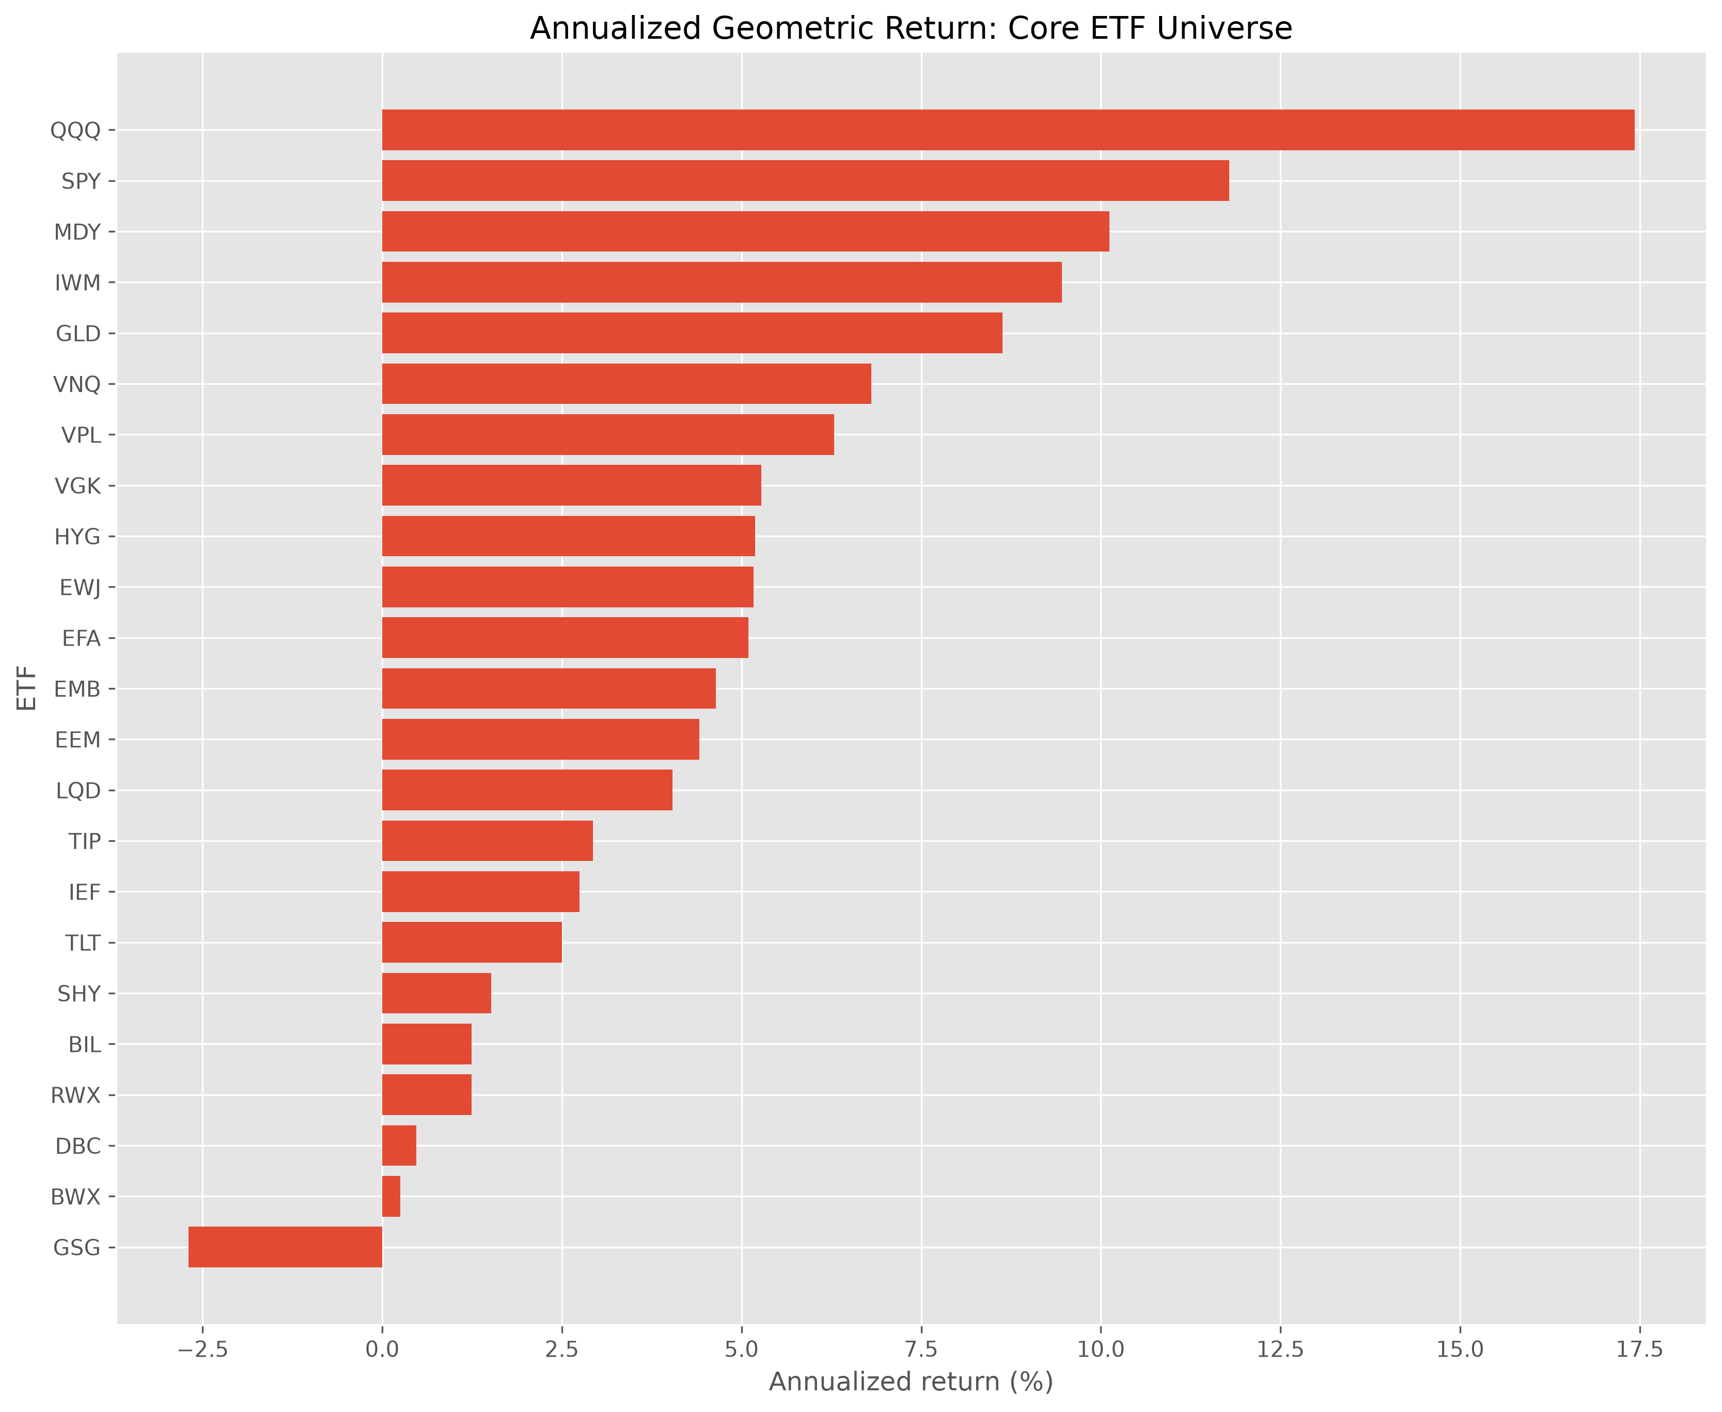
Figure 3. Annualized return by ETF. Return dispersion creates allocation opportunity but also exposes expected-return estimates to sampling error.

5.2 Benchmark results
Table 5 compares the two naive benchmarks on the final common period. Equal Weight earns an annualized geometric return of 6.09%, volatility of 9.11%, and Sharpe of 0.476. The 60/40 benchmark earns 7.01%, volatility of 9.76%, and Sharpe of 0.540. The 60/40 portfolio has higher return and Sharpe but also a larger maximum drawdown than Equal Weight. Both benchmarks remain valuable reference points because they are transparent, low-turnover, and do not depend on estimated expected returns or covariances.
Table 5. Benchmark performance, common final period
Strategy | Ann. geometric return | Ann. volatility | Sharpe | Max drawdown | Ann. turnover | Final wealth
Equal Weight | 6.09% | 9.11% | 0.476 | -19.07% | 13.23% | 2.19
60/40 | 7.01% | 9.76% | 0.540 | -23.32% | 12.45% | 2.45

5.3 Classical Markowitz results
Table 6 reports classical Markowitz performance. Minimum-variance portfolios have very low realized volatility but also low returns, causing weak Sharpe ratios relative to the 2% risk-free reference. This behavior is consistent with allocation toward low-volatility assets. Maximum-Sharpe portfolios deliver the strongest risk-adjusted Markowitz results, with the Ledoit-Wolf version reaching the highest Sharpe in the full comparison. Figure 4 illustrates why implementation risk remains important: maximum-Sharpe weights can be concentrated and change meaningfully over time. Target Volatility Ledoit-Wolf produces the highest terminal wealth, 4.17, and the highest annualized geometric return, 11.38%. It also has the strongest Calmar ratio among meaningful risk-bearing strategies, although HRP has a numerically higher Calmar for a mechanical reason discussed below.
Table 6. Classical Markowitz performance, common final period
Strategy | Ann. geometric return | Ann. volatility | Sharpe | Max drawdown | Ann. turnover | Final wealth
Min Variance Sample | 2.25% | 2.77% | 0.096 | -8.03% | 26.06% | 1.34
Min Variance Ledoit-Wolf | 2.31% | 2.88% | 0.114 | -9.11% | 23.46% | 1.35
Max Sharpe Sample | 9.23% | 7.89% | 0.909 | -20.66% | 99.14% | 3.22
Max Sharpe Ledoit-Wolf | 9.86% | 8.45% | 0.922 | -22.02% | 88.06% | 3.48
Target Volatility Sample | 11.30% | 11.45% | 0.822 | -22.62% | 103.94% | 4.13
Target Volatility Ledoit-Wolf | 11.38% | 11.63% | 0.818 | -22.27% | 98.66% | 4.17

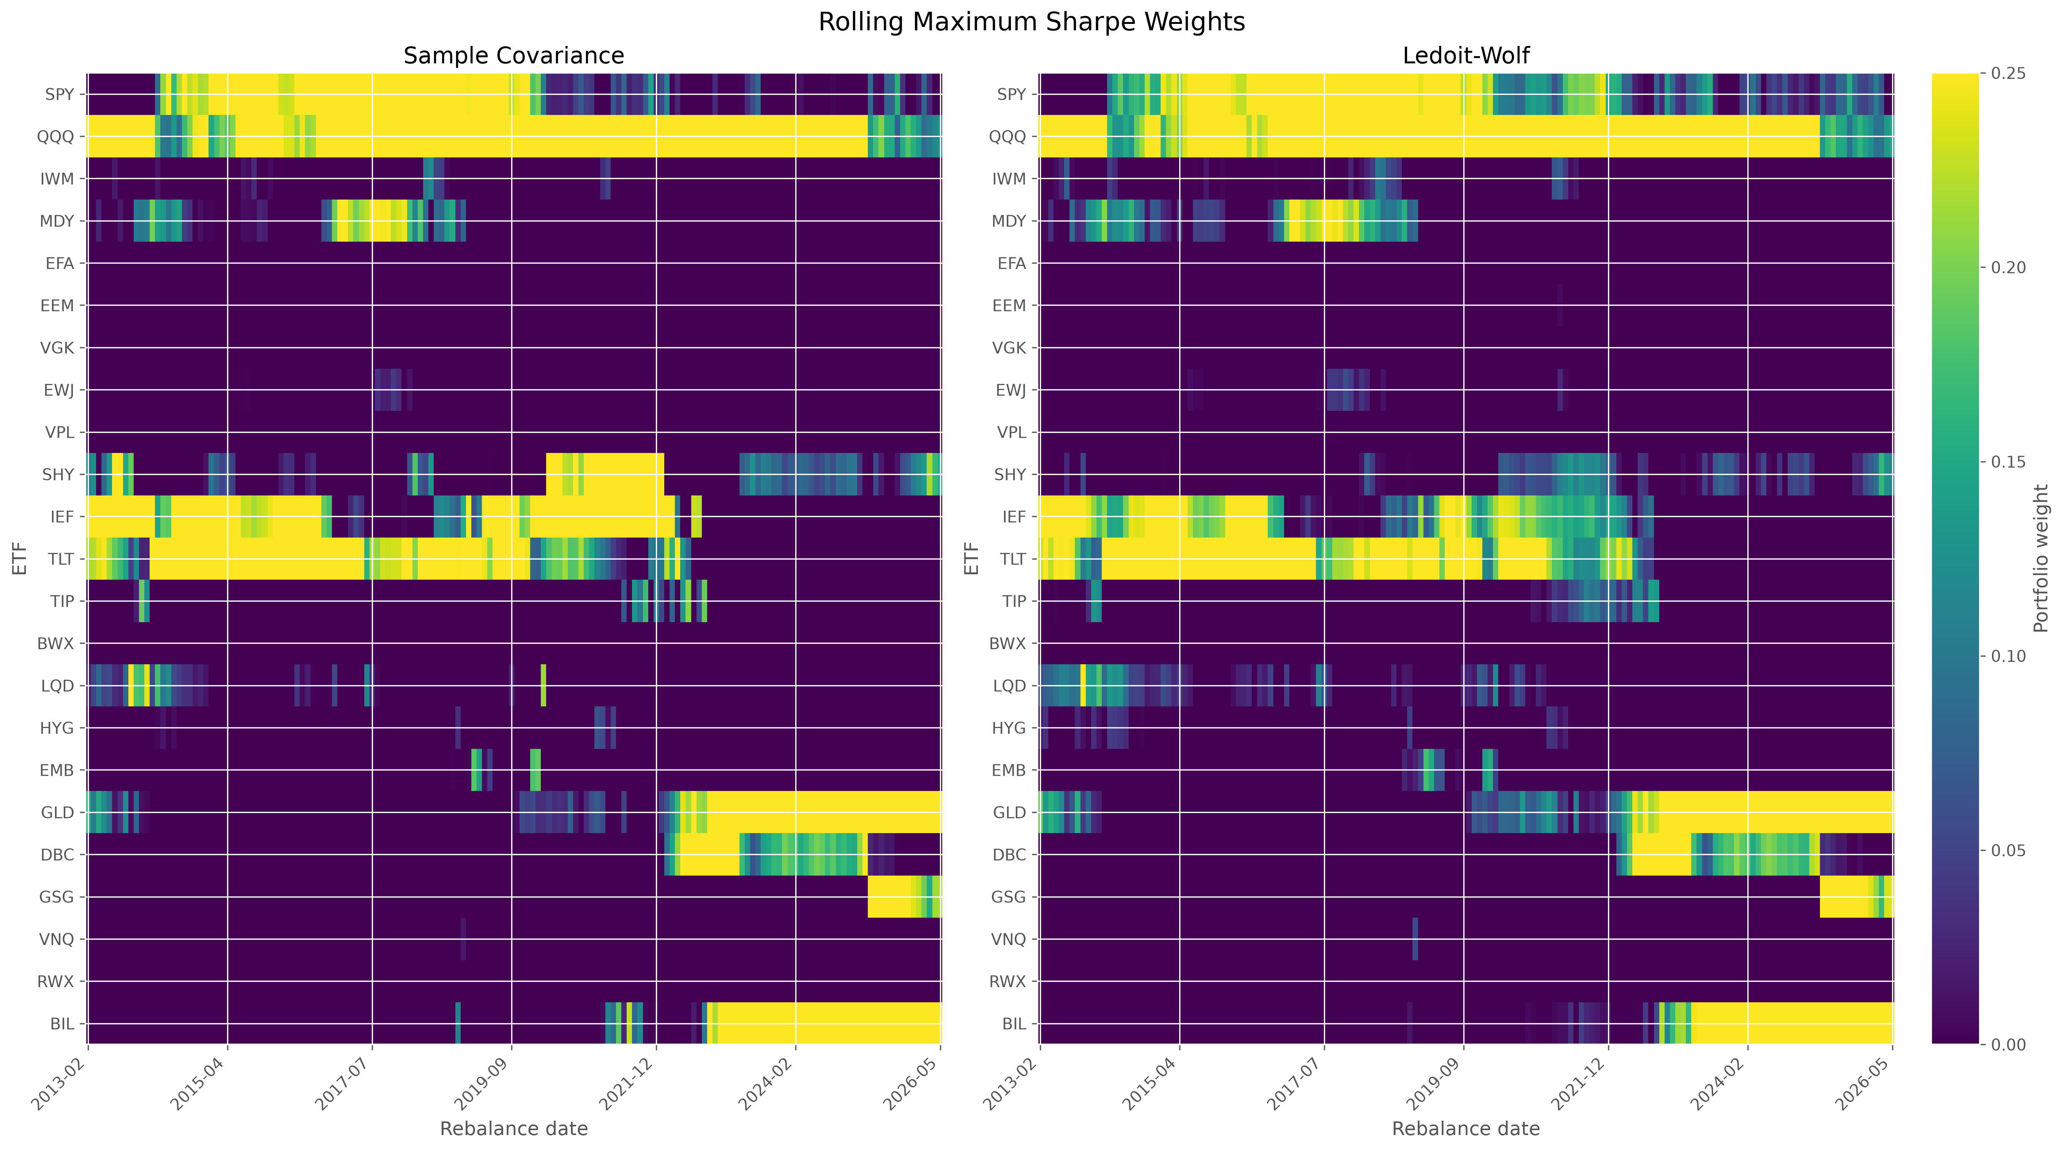
Figure 4. Rolling maximum-Sharpe Markowitz weights. Rolling weights illustrate the concentration and instability of expected-return-sensitive optimization.

5.4 Effect of covariance shrinkage
Ledoit-Wolf shrinkage improves some but not all empirical outcomes. For minimum variance, the Ledoit-Wolf version has a slightly higher Sharpe and lower turnover than the sample-covariance version, while also increasing average effective assets. For maximum Sharpe, Ledoit-Wolf raises Sharpe from 0.909 to 0.922, reduces annualized turnover from 99.14% to 88.06%, and increases effective assets from 4.50 to 4.77. For target volatility, Ledoit-Wolf slightly increases terminal wealth and reduces turnover, but the Sharpe difference is small. The evidence therefore supports shrinkage as useful in this sample, especially for maximum Sharpe, without establishing universal superiority.

5.5 Michaud resampling
Table 7 compares Maximum Sharpe Ledoit-Wolf with the three Michaud variants. Maximum Sharpe Ledoit-Wolf earns an annualized geometric return of 9.86%, volatility of 8.45%, Sharpe of 0.922, turnover of 88.06%, and average effective assets of 4.77. Michaud 500 earns 9.23%, volatility of 7.98%, Sharpe of 0.900, turnover of 78.00%, and average effective assets of 6.25. Figure 5 shows that the wealth paths remain close, while the diversification and turnover metrics favor the resampled allocation. The 100, 250, and 500 resample results are stable, and changes diminish at higher resample counts. Michaud resampling therefore improves implementation characteristics, but it does not deliver the highest Sharpe.
Table 7. Markowitz versus Michaud
Strategy | Resamples | Ann. geometric return | Ann. volatility | Sharpe | Max drawdown | Ann. turnover | Avg. effective assets | Avg. HHI
Max Sharpe Ledoit-Wolf |  | 9.86% | 8.45% | 0.922 | -22.02% | 88.06% | 4.77 | 21.26%
Michaud 100 | 100.0 | 9.23% | 7.95% | 0.903 | -20.48% | 91.53% | 6.23 | 16.35%
Michaud 250 | 250.0 | 9.22% | 7.97% | 0.899 | -20.53% | 81.45% | 6.23 | 16.33%
Michaud 500 | 500.0 | 9.23% | 7.98% | 0.900 | -20.51% | 78.00% | 6.24 | 16.31%

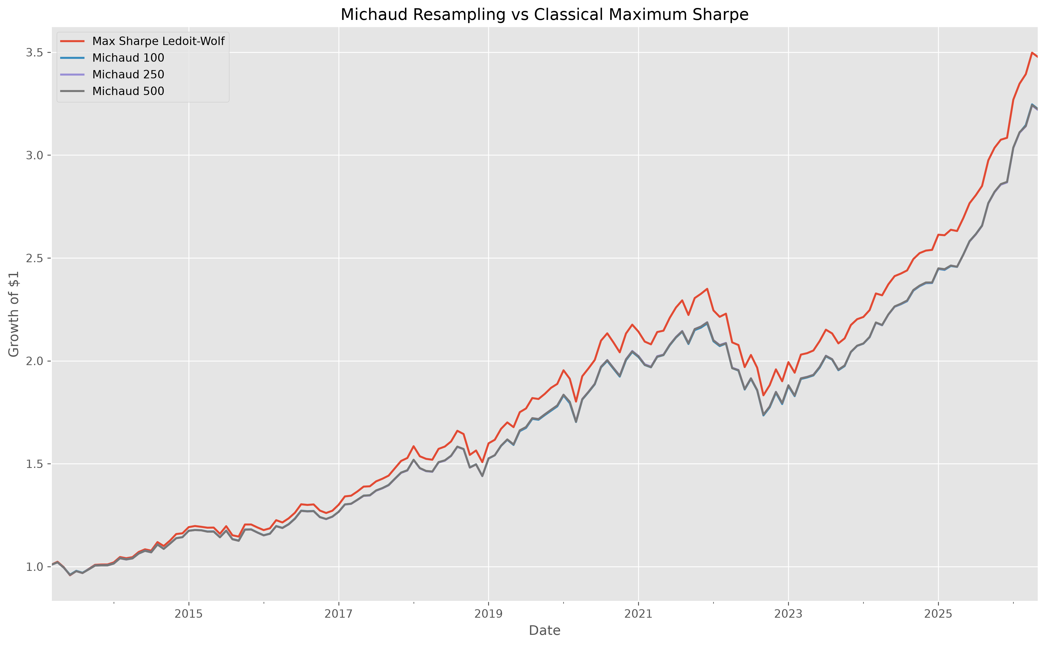
Figure 5. Michaud versus maximum-Sharpe equity curve. Resampling stays close to the classical wealth path while improving allocation breadth and turnover.

5.6 HRP extension
HRP is the clearest example of method-universe interaction. It earns an annualized geometric return of 1.62%, volatility of 0.58%, Sharpe of -0.670, maximum drawdown of -0.35%, turnover of 7.49%, and average effective assets of 1.09. The mean BIL allocation in the saved HRP weights is 95.60%. Figure 11 makes the concentration visible. The result is an empirical consequence of applying unconstrained hierarchical allocation to a universe containing a near-zero-volatility cash proxy. It is not evidence that HRP is universally ineffective. In this implementation, HRP minimizes portfolio variation by overwhelmingly favoring BIL. Its numerically high Calmar ratio is mechanically driven by an extremely small drawdown denominator, and its Sharpe is negative because the realized return is below the constant 2% risk-free reference.
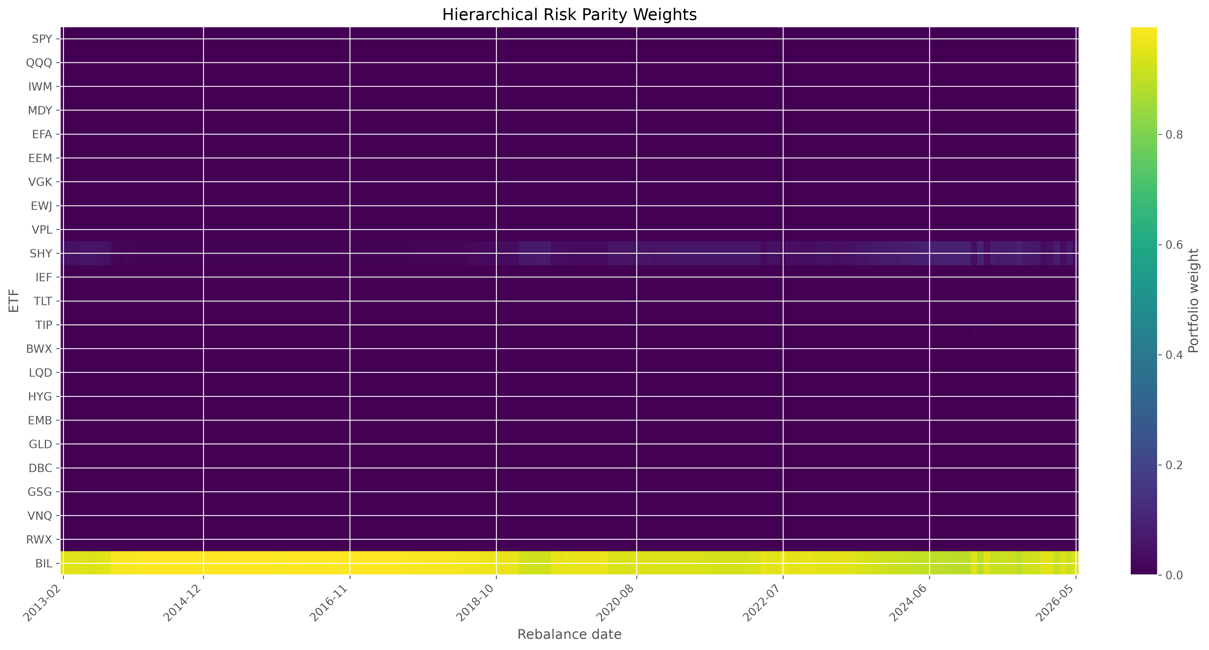
Figure 11. HRP weight heatmap. The saved unconstrained HRP allocation is overwhelmingly concentrated in BIL.

5.7 Final strategy comparison
Table 8 and Table 9 split the final comparison into performance and implementation dimensions. Figure 6 shows that Target Volatility Ledoit-Wolf finishes with the highest terminal wealth, while Maximum Sharpe Ledoit-Wolf and the Michaud portfolios remain close in realized wealth. Figure 7 shows that HRP has the smallest drawdown, but this is achieved by near-cash concentration rather than broad risk allocation. Table 10 summarizes the headline findings: best Sharpe belongs to Maximum Sharpe Ledoit-Wolf, highest terminal wealth to Target Volatility Ledoit-Wolf, lowest turnover to HRP, and most diversified optimized strategy to Michaud 500.
Table 8. Final risk and performance comparison
Strategy | Ann. geometric return | Ann. volatility | Sharpe | Sortino | Max drawdown | Calmar | Final wealth
Equal Weight | 6.09% | 9.11% | 0.476 | 0.695 | -19.07% | 0.319 | 2.19
60/40 | 7.01% | 9.76% | 0.540 | 0.812 | -23.32% | 0.301 | 2.45
Min Variance Sample | 2.25% | 2.77% | 0.096 | 0.128 | -8.03% | 0.280 | 1.34
Min Variance Ledoit-Wolf | 2.31% | 2.88% | 0.114 | 0.153 | -9.11% | 0.254 | 1.35
Max Sharpe Sample | 9.23% | 7.89% | 0.909 | 1.424 | -20.66% | 0.447 | 3.22
Max Sharpe Ledoit-Wolf | 9.86% | 8.45% | 0.922 | 1.443 | -22.02% | 0.448 | 3.48
Target Volatility Sample | 11.30% | 11.45% | 0.822 | 1.239 | -22.62% | 0.500 | 4.13
Target Volatility Ledoit-Wolf | 11.38% | 11.63% | 0.818 | 1.226 | -22.27% | 0.511 | 4.17
Michaud 100 | 9.23% | 7.95% | 0.903 | 1.417 | -20.48% | 0.451 | 3.22
Michaud 250 | 9.22% | 7.97% | 0.899 | 1.412 | -20.53% | 0.449 | 3.22
Michaud 500 | 9.23% | 7.98% | 0.900 | 1.411 | -20.51% | 0.450 | 3.22
HRP | 1.62% | 0.58% | -0.670 | -0.912 | -0.35% | 4.661 | 1.24

Table 9. Turnover and diversification comparison
Strategy | Ann. turnover | Avg. effective assets | Avg. HHI
Equal Weight | 13.23% | 23.00 | 4.35%
60/40 | 12.45% | 13.89 | 7.20%
Min Variance Sample | 26.06% | 4.71 | 21.25%
Min Variance Ledoit-Wolf | 23.46% | 5.35 | 18.76%
Max Sharpe Sample | 99.14% | 4.50 | 22.36%
Max Sharpe Ledoit-Wolf | 88.06% | 4.77 | 21.26%
Target Volatility Sample | 103.94% | 4.50 | 22.29%
Target Volatility Ledoit-Wolf | 98.66% | 4.52 | 22.19%
Michaud 100 | 91.53% | 6.23 | 16.33%
Michaud 250 | 81.45% | 6.24 | 16.30%
Michaud 500 | 78.00% | 6.25 | 16.29%
HRP | 7.49% | 1.09 | 91.72%

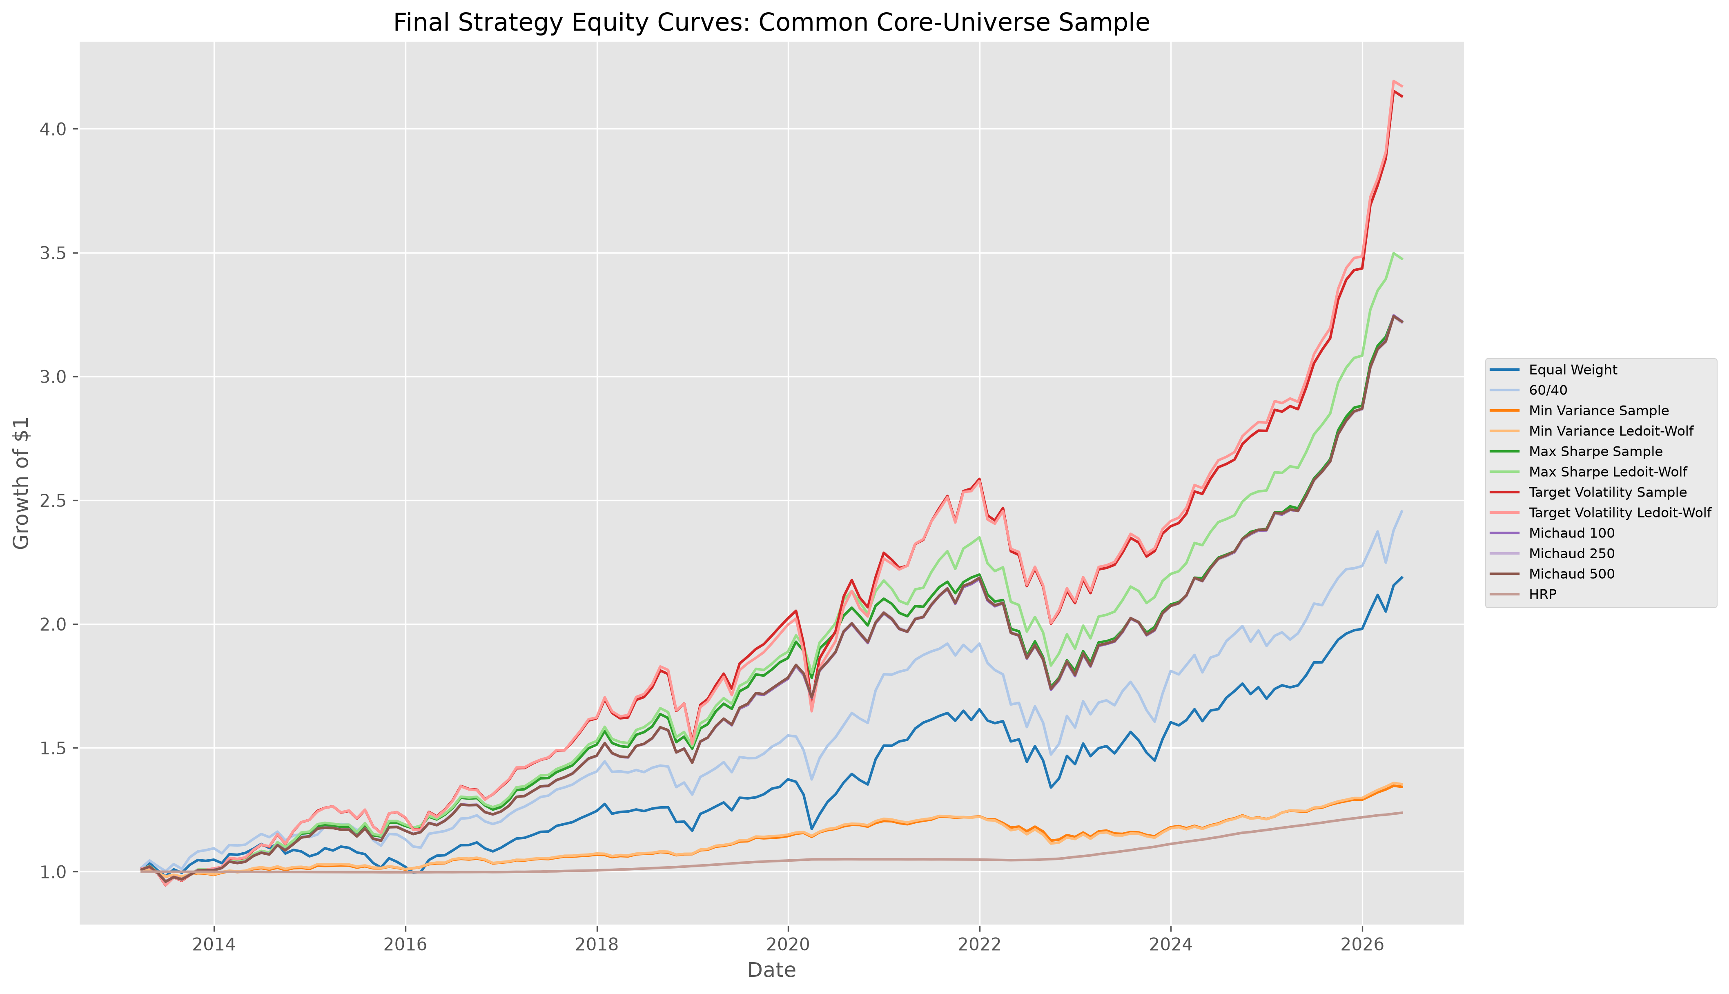
Figure 6. Final strategy equity curves. All twelve strategies are shown over the common 159-month core-universe period.
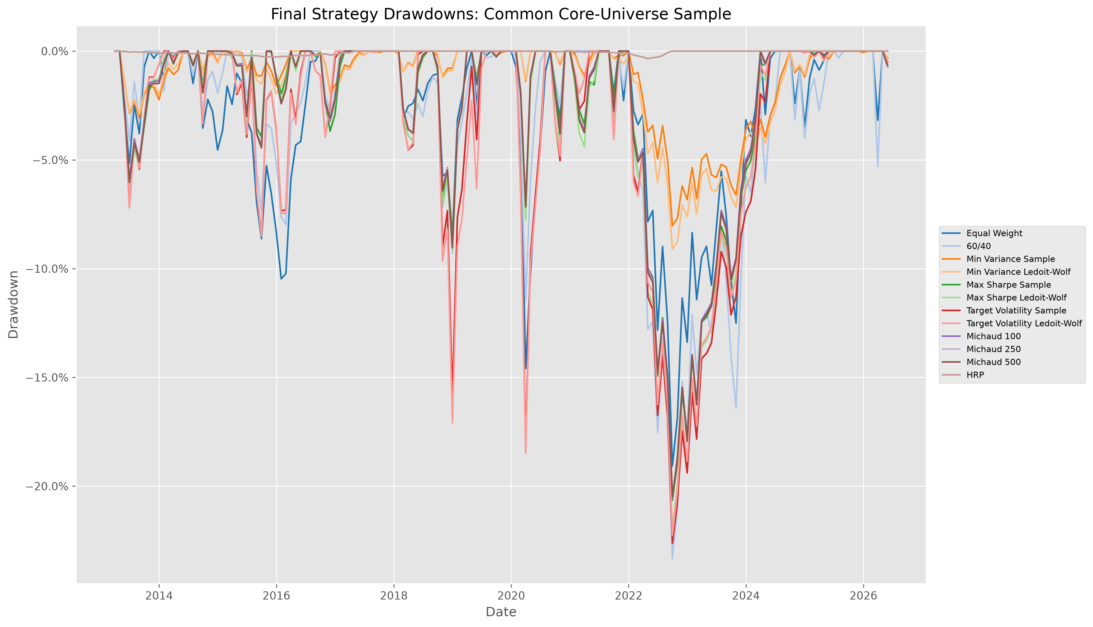
Figure 7. Final strategy drawdowns. The comparison separates risk-bearing strategies from the near-cash HRP outcome.

5.8 Equity curves and drawdowns
The equity curves and drawdowns should be interpreted jointly. High terminal wealth is achieved by accepting higher volatility and deeper drawdowns. The target-volatility strategies are the strongest wealth builders in this realized sample, but their annualized turnover is close to or above 100%, which raises implementation concerns. The benchmarks are simpler and lower-turnover but do not reach the highest Sharpe or terminal wealth. HRP has exceptionally low drawdown, but its portfolio is economically closer to a cash allocation than to a diversified risk portfolio.

5.9 Risk-return and implementation trade-offs
Figure 8 maps the realized risk-return trade-off, Figure 9 relates turnover to Sharpe, and Figure 10 relates effective diversification to Sharpe. Together, these figures show that portfolio evaluation is multidimensional. The highest Sharpe strategies are not the lowest-turnover strategies. The most diversified overall portfolio is Equal Weight by construction, but among optimized strategies Michaud 500 has the greatest average effective number of assets. The practical decision is therefore not simply which strategy has the highest single metric, but which strategy offers the most acceptable balance of performance, concentration, turnover, and interpretability.
The final comparison also illustrates why the common-period restriction is essential. The benchmark-only files and data-policy panels cover different date ranges, but the final table recomputes all benchmark and strategy metrics on the same 159 realized months. This eliminates an otherwise serious source of bias: a strategy beginning later or ending earlier could appear better simply because it avoided a difficult subperiod. By forcing every final strategy to share the same realized dates, the report makes the ranking about allocation rules rather than sample-window selection.
This restriction is especially important because the study period includes very different regimes: post-crisis recovery, low-rate markets, the COVID-19 shock, inflation, and rapid monetary tightening. A strategy that looks attractive in one regime may be less attractive in another. The common-period design does not remove regime dependence, but it ensures that every final strategy experiences the same regime sequence. That is why the report treats the core common-period table as the authoritative performance comparison and treats earlier or extended diagnostic outputs as supporting evidence only.
The same logic applies to transaction costs. A gross return comparison would favor strategies that trade frequently without charging them for the implementation burden. The final comparison instead applies the same 5-basis-point cost convention to benchmarks and optimized strategies. This is particularly relevant for target-volatility and maximum-Sharpe portfolios, whose realized performance is accompanied by higher turnover than the naive benchmarks.
A fair comparison therefore requires three simultaneous controls: the same assets, the same months, and the same cost convention. The project enforces all three in the final table, which is why the reported rankings can be interpreted as differences among allocation rules rather than artifacts of unequal evaluation design. This discipline is central to the academic credibility of the empirical comparison and its portfolio interpretation.
The results also show that diversification should be interpreted carefully. Equal Weight has the highest effective number of assets by construction, but that does not imply it is the best risk allocation. A portfolio can hold many ETFs and still have concentrated economic exposure if the assets are highly correlated. Conversely, a portfolio with fewer positions can have meaningful diversification if the positions have offsetting risk behavior. The effective-number statistic is therefore used as a concentration diagnostic, not as a complete measure of economic diversification. This is particularly important when comparing Equal Weight with Michaud and HRP.
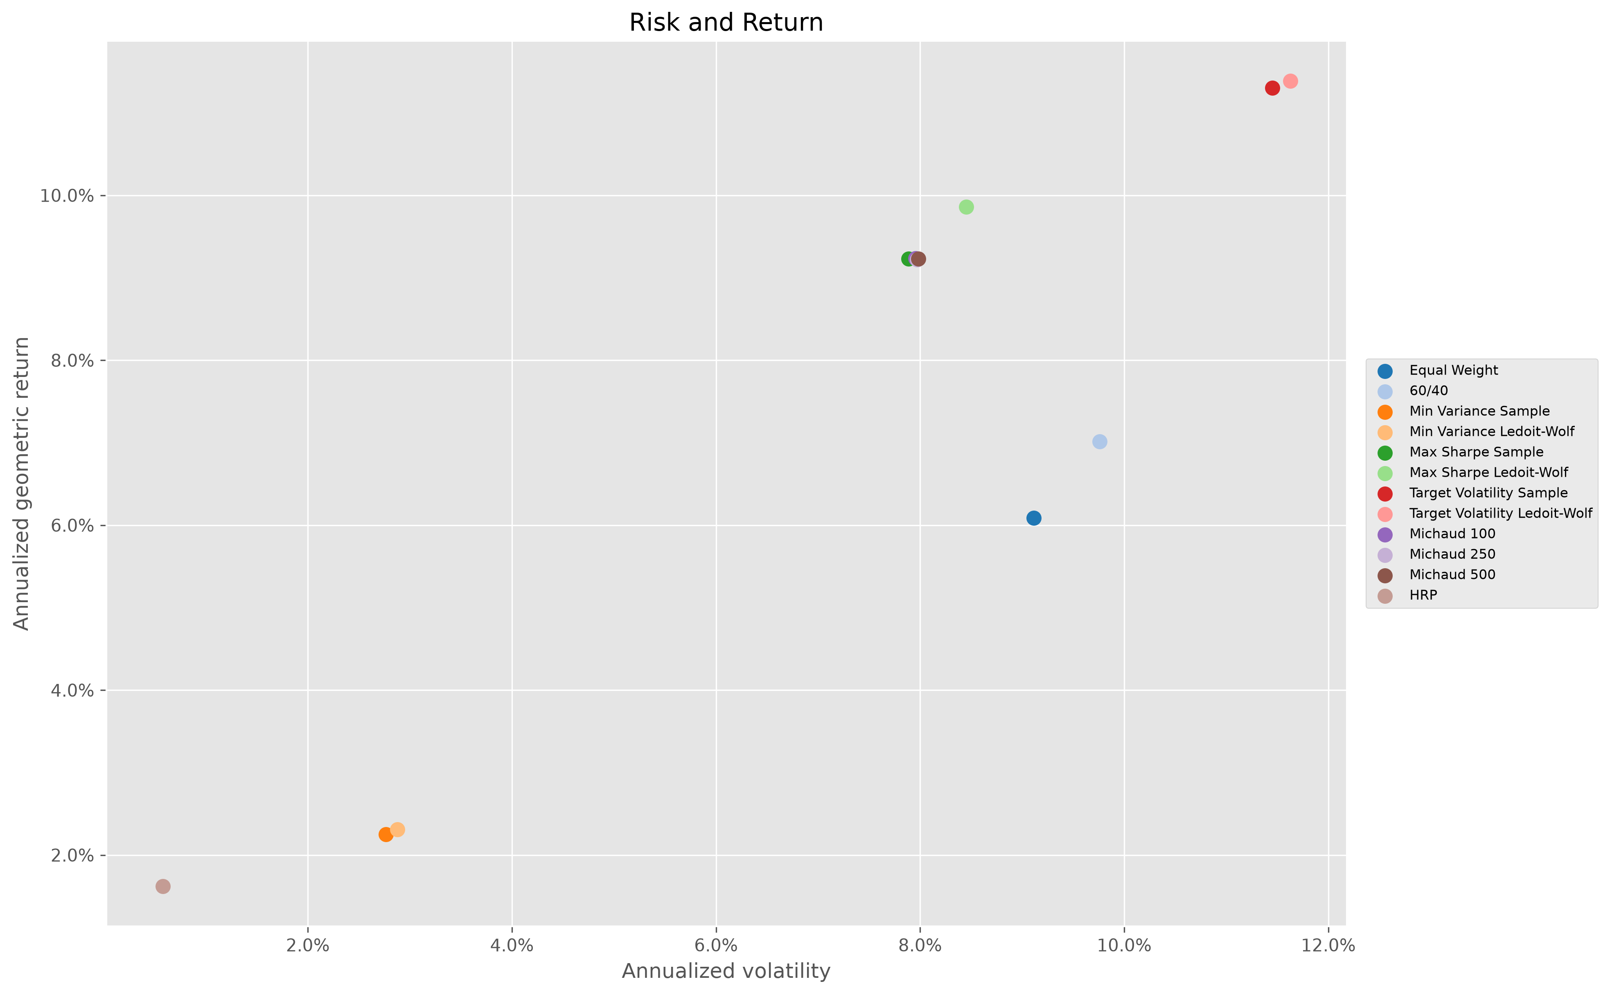
Figure 8. Risk-return scatter. Realized return and volatility reveal the differing objectives of the allocation rules.
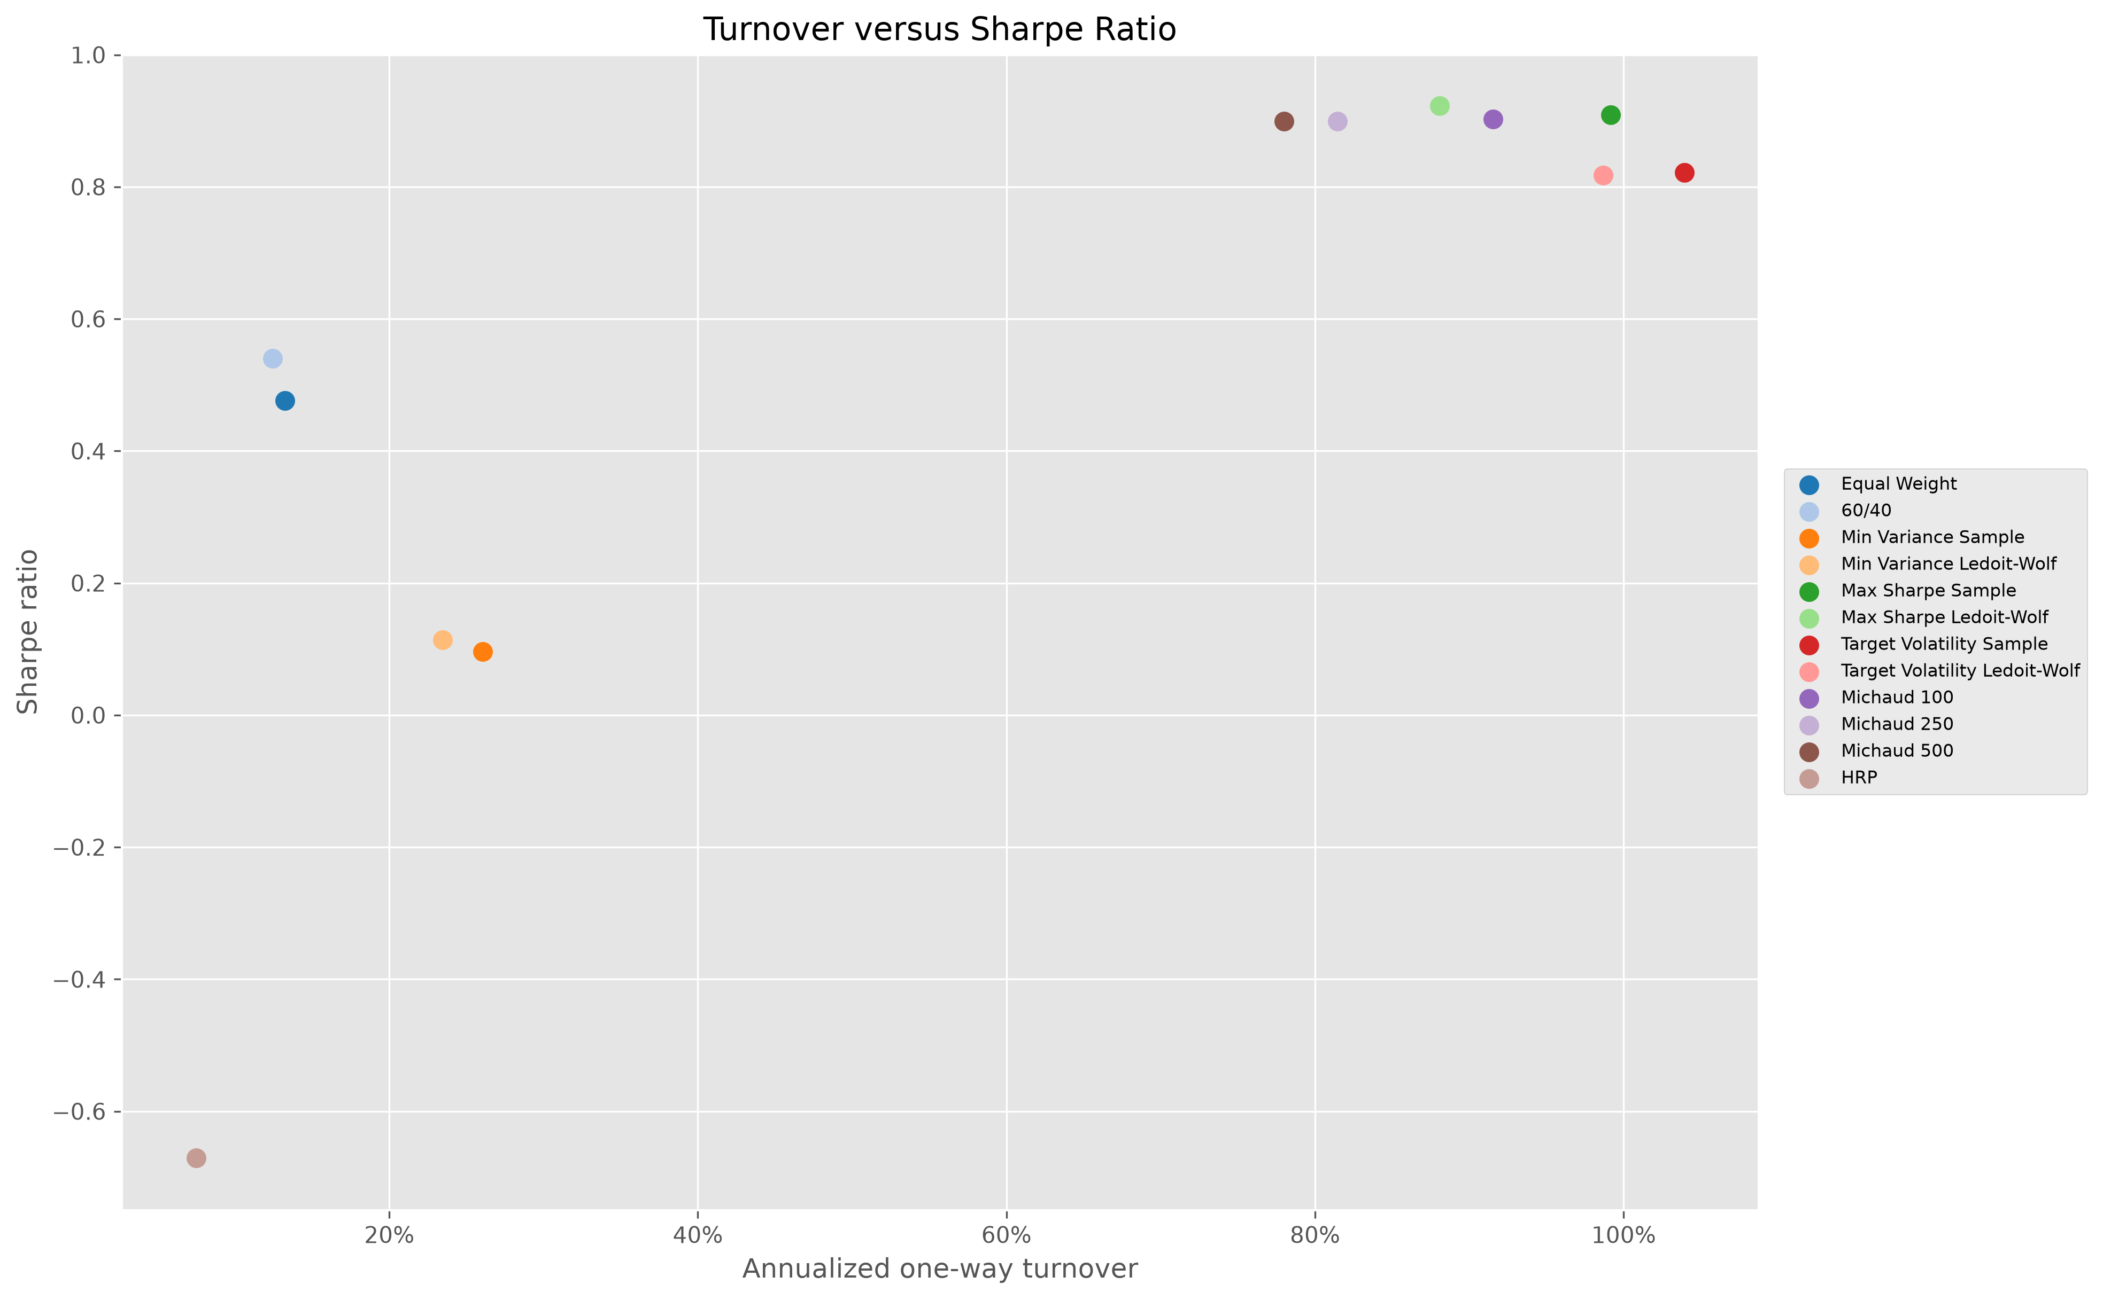
Figure 9. Turnover versus Sharpe. Higher realized Sharpe generally accompanies greater trading intensity.
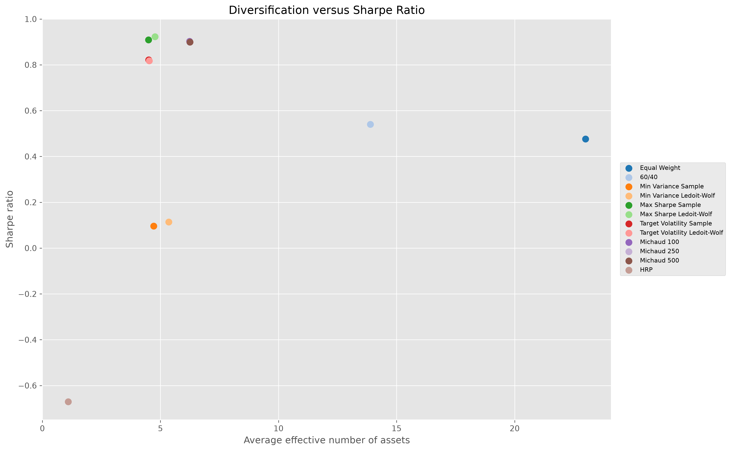
Figure 10. Diversification versus Sharpe. Equal Weight has mechanical breadth; Michaud 500 is the broadest optimized allocation.
Table 10. Key findings summary
Objective | Leading strategy | Reported value / interpretation
Highest Sharpe | Max Sharpe Ledoit-Wolf | 0.922
Highest terminal wealth | Target Volatility Ledoit-Wolf | 4.17
Lowest turnover | HRP | 7.49%
Lowest drawdown | HRP | -0.35%
Most diversified overall | Equal Weight | 23.00
Most diversified optimized | Michaud 500 | 6.25
Easiest implementation | Equal Weight | No estimated inputs; transparent 1/N rule

6. Discussion

6.1 Did optimization add value?
Optimization adds value in some dimensions but not uniformly. Maximum Sharpe Ledoit-Wolf has a materially higher Sharpe ratio than Equal Weight and 60/40. Target Volatility Ledoit-Wolf generates the highest terminal wealth. However, these gains come with higher turnover and reliance on noisy estimates. The naive benchmarks remain competitive because they are transparent, simple, and less exposed to estimation error. A practical investor would not evaluate the optimized strategies by return alone.

6.2 Did shrinkage help?
Shrinkage helped most clearly for maximum Sharpe. It improved Sharpe, reduced turnover, and modestly increased diversification relative to sample covariance. For minimum variance and target volatility, the effects are present but smaller. The correct interpretation is that Ledoit-Wolf shrinkage improved the empirical implementation in this project, not that shrinkage must dominate sample covariance in every universe or period.

6.3 Did Michaud solve the estimation problem?
Michaud resampling did not solve estimation error in the sense of producing the highest Sharpe ratio. It did, however, produce a more balanced implementation. Relative to Maximum Sharpe Ledoit-Wolf, Michaud 500 lowers annualized turnover and increases average effective assets while preserving most of the realized Sharpe. This is a meaningful practical result because it suggests that resampling can moderate unstable optimization without abandoning the mean-variance framework.

6.4 What did HRP reveal?
HRP revealed that robust methods still depend critically on universe design and constraints. In a universe that includes BIL, unconstrained HRP becomes highly defensive. This negative result is informative. It suggests that HRP should be tested with asset-class constraints, without cash, or with minimum risk-asset allocations before being treated as a complete allocation solution in this setting.

6.5 Economic versus statistical significance
The difference between a Sharpe ratio of 0.922 and 0.900 should not be overstated. The sample contains one realized historical path, and several strategies are related variants of the same optimization framework. The results provide comparative evidence about implementation trade-offs, not statistical proof of structural dominance. Economic interpretation should consider turnover, drawdown, concentration, and model risk alongside point estimates of Sharpe.
From a portfolio-management perspective, the most defensible conclusion is conditional. If the objective is maximum realized Sharpe in this sample, Maximum Sharpe Ledoit-Wolf is the leader. If the objective is terminal wealth and the investor accepts higher volatility and turnover, Target Volatility Ledoit-Wolf is more attractive. If the objective is a compromise between optimized performance and implementability, Michaud 500 is compelling because it gives up little Sharpe while reducing turnover and broadening the allocation. If the objective is capital preservation with minimal drawdown, HRP achieves that mechanically through cash concentration, but it no longer resembles a diversified risk allocation. These distinctions are more informative than a single overall winner.
The comparison also highlights the difference between model robustness and portfolio robustness. Ledoit-Wolf and Michaud make the estimation process more stable, but they do not remove exposure to realized market shocks. Target Volatility Ledoit-Wolf compounds most strongly, yet its drawdown and turnover remain substantial. Michaud 500 moderates turnover and concentration, yet it still inherits the assumptions of mean-variance optimization and normal capital-market simulation. HRP avoids covariance inversion, yet its unconstrained form is dominated by cash. Robust methods therefore improve specific weaknesses; they do not eliminate the need for economic constraints and careful interpretation.
The benchmark comparison reinforces this point. Equal Weight and 60/40 do not maximize the headline performance statistics, but they impose very low modelling demands. They do not require estimating expected returns, choosing a covariance estimator, solving a constrained nonlinear problem, or selecting a resampling design. Their role is therefore not merely ceremonial. They represent the performance that an optimization strategy must exceed after accounting for estimation error and implementation complexity. In this sample the best optimized strategies do improve risk-adjusted performance, but the improvement is paired with higher turnover and greater dependence on modelling assumptions. That trade-off is central to the report's conclusion.

7. Limitations
The project uses an ex-post selected ETF universe and may therefore contain survivorship or selection bias. Yahoo Finance adjusted prices are useful for academic reproducibility but are not an institutional total-return database. The backtest observes one realized market path, uses a constant 2% risk-free rate, and applies a constant 5-basis-point transaction cost. Taxes, bid-ask variation, market impact, and liquidity constraints are not modeled. The 60-month estimation window is defensible but subjective. Michaud simulations rely on multivariate-normal capital-market-assumption draws and may understate tail dependence, non-normality, and regime shifts. The long-only 25% cap improves interpretability but is still a modeling choice. The extended 27-ETF universe is not fully optimized in the final comparison. Formal statistical inference is not performed, so small ranking differences should be read cautiously. HRP is sensitive to the inclusion of BIL, and the project does not impose time-varying asset-class constraints.
Another limitation is that the project treats the ETF universe as fixed through time after the sample policy is defined. Real investors may face product closures, changes in expense ratios, liquidity differences, tax considerations, and investment-policy restrictions. The analysis also assumes monthly rebalancing throughout the period. Quarterly rebalancing might reduce turnover but could change realized risk, while weekly rebalancing would require a different data frequency and potentially higher transaction costs. Finally, the project does not attach confidence intervals to Sharpe ratios or drawdowns. The ranking is therefore descriptive and should be interpreted as evidence from one carefully controlled historical experiment rather than a statistically definitive ordering.

8. Conclusion
The project implements and evaluates a dynamic multi-asset allocation framework that satisfies the course assignment requirements while maintaining strict out-of-sample timing. Maximum Sharpe Ledoit-Wolf achieves the highest realized Sharpe ratio. Target Volatility Ledoit-Wolf produces the highest terminal wealth and the strongest Calmar ratio among meaningful risk-bearing strategies. Michaud 500 offers the strongest balance of near-leading Sharpe, lower turnover, and greater diversification among optimized strategies. The simple benchmarks remain important because they are transparent and comparatively easy to implement. HRP becomes cash dominated, showing that robust methods still depend critically on universe design and constraints. Overall, robust estimation can improve portfolio implementation, but it does not remove model risk or justify ignoring turnover, concentration, and economic interpretation.
The most useful lesson is therefore not that one named method permanently dominates the others. The evidence supports a hierarchy of practical conclusions. First, classical optimization can add value when inputs are stabilized and constraints prevent extreme weights. Second, resampling is valuable because it changes the implementation profile of the optimized portfolio, not because it mechanically guarantees a higher Sharpe ratio. Third, robust allocation methods such as HRP still require an economically coherent universe and constraints. Fourth, naive benchmarks remain indispensable because they reveal whether the extra modelling effort is justified. These conclusions are consistent with the broader portfolio literature and with the project's out-of-sample evidence.

9. References
DeMiguel, V., Garlappi, L., and Uppal, R. (2009). Optimal Versus Naive Diversification: How Inefficient Is the 1/N Portfolio Strategy? The Review of Financial Studies, 22(5), 1915-1953.
Idzorek, T. M. (2005). A Step-by-Step Guide to the Black-Litterman Model: Incorporating User-Specified Confidence Levels. Ibbotson Associates.
Ledoit, O., and Wolf, M. (2004). A Well-Conditioned Estimator for Large-Dimensional Covariance Matrices. Journal of Multivariate Analysis, 88(2), 365-411. https://doi.org/10.1016/S0047-259X(03)00096-4.
López de Prado, M. (2016). Building Diversified Portfolios that Outperform Out-of-Sample. The Journal of Portfolio Management, 42(4), 59-69. https://doi.org/10.3905/jpm.2016.42.4.059.
Markowitz, H. (1952). Portfolio Selection. The Journal of Finance, 7(1), 77-91. https://doi.org/10.1111/j.1540-6261.1952.tb01525.x.
Michaud, R. O. (1989). The Markowitz Optimization Enigma: Is 'Optimized' Optimal? Financial Analysts Journal, 45(1), 31-42. https://doi.org/10.2469/faj.v45.n1.31.
Michaud, Richard O., and Michaud, Robert O. (2008). Efficient Asset Management: A Practical Guide to Stock Portfolio Optimization and Asset Allocation (2nd ed.). Oxford University Press. https://doi.org/10.1093/oso/9780195331912.001.0001.
PyPortfolioOpt. (2026). Hierarchical Risk Parity optimizer documentation. https://pyportfolioopt.readthedocs.io/ (accessed 13 July 2026).
yfinance. (2026). Python interface for Yahoo Finance market data. https://ranaroussi.github.io/yfinance/ (accessed 13 July 2026).
Yahoo Finance. (2026). Historical ETF price data. https://finance.yahoo.com/ (accessed 13 July 2026).

Appendix A - Complete ETF Universe
The complete metadata table records every configured ETF, its asset class, region, and economic exposure. It is included to make the opportunity set transparent and reproducible.
Table 11. Complete ETF metadata
Ticker | Asset class | Region | Description
SPY | Equity | US | US Large Cap Equity
QQQ | Equity | US | Nasdaq-100 Large Cap Growth Equity
IWM | Equity | US | US Small Cap Equity
MDY | Equity | US | US Mid Cap Equity
EFA | Equity | Developed Markets ex-US | Developed Markets Equity excluding the US and Canada
EEM | Equity | Emerging Markets | Emerging Markets Equity
VGK | Equity | Europe | European Equity
EWJ | Equity | Japan | Japanese Equity
VPL | Equity | Asia-Pacific ex-US | Developed Asia-Pacific Equity
SHY | Government Bonds | US | Short-Term Treasury Bonds
VGSH | Government Bonds | US | Short-Term Treasury Bonds
IEF | Government Bonds | US | Intermediate-Term Treasury Bonds
TLT | Government Bonds | US | Long-Term Treasury Bonds
TIP | Government Bonds | US | Treasury Inflation-Protected Securities
BWX | Government Bonds | Global ex-US | International Treasury Bonds
IGOV | Government Bonds | Global ex-US | International Government Bonds
LQD | Credit | US | Investment-Grade Corporate Bonds
HYG | Credit | US | High-Yield Corporate Bonds
EMB | Credit | Emerging Markets | US Dollar Emerging Markets Bonds
BKLN | Credit | US | Senior Secured Bank Loans
GLD | Commodities | Global | Gold Bullion
DBC | Commodities | Global | Broad Commodity Basket
GSG | Commodities | Global | Diversified Commodity Basket
VNQ | Real Estate | US | US Real Estate Investment Trusts
RWX | Real Estate | Global ex-US | International Real Estate
VNQI | Real Estate | Global ex-US | International Real Estate Investment Trusts
BIL | Cash | US | One-to-Three-Month Treasury Bills

Appendix B - Data Availability and Sample Policy
The raw panels were inspected before cleaning. Missing values were structural pre-inception gaps; no within-lifetime gaps were identified in the clean panels. No interpolation, backfill, synthetic history, or silent ETF removal was used. The incomplete June 2026 month was excluded.
Table 12. Late-inception ETFs
Ticker | first_date | last_date | Missing
VGSH | 2009-11-23 | 2026-06-29 | 37.35%
IGOV | 2009-01-30 | 2026-06-29 | 34.26%
BKLN | 2011-03-03 | 2026-06-29 | 42.16%
VNQI | 2010-11-01 | 2026-06-29 | 40.89%

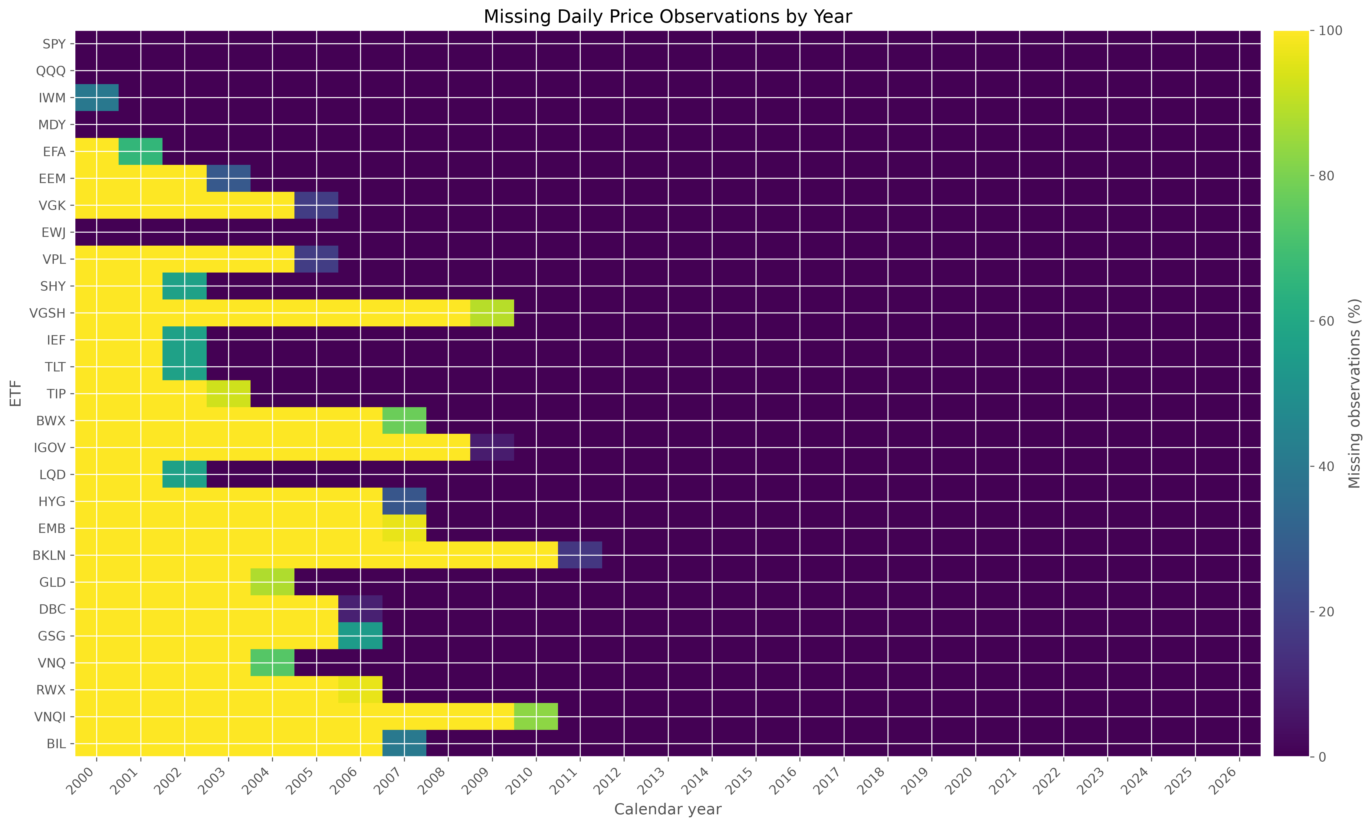
Figure 12. Missing values by year. Missingness is concentrated before ETF inception rather than within observed fund histories.

Appendix C - Optimization Parameters and Reproducibility
The implementation is controlled by src/config.py and by explicit function arguments in the allocation modules. The optimizer validates covariance labels and positive-semidefiniteness, applies long-only bounds, projects small numerical solver errors back to the bounded simplex, and records solver status. Michaud uses deterministic seed 42. HRP uses PyPortfolioOpt and retains a narrow SciPy compatibility guard because a private linkage validation attribute changed in newer SciPy releases.
Reproduction commands from the project root are python main.py, python -m pytest, and the relevant module or executed notebook for each analysis stage. A live data refresh is intentionally not the default because Yahoo Finance may revise adjusted histories. The included raw monthly panel and saved outputs are the submission evidence.
Table 13. Reproducibility configuration
Setting | Value | Evidence
ESTIMATION_WINDOW_MONTHS | 60 | src/config.py
RISK_FREE_RATE | 0.02 | src/config.py
TARGET_VOLATILITY | 0.10 | src/config.py
MIN_WEIGHT / MAX_WEIGHT | 0.00 / 0.25 | src/config.py
TRANSACTION_COST_BPS | 5 | src/config.py
N_RESAMPLES | 500 (plus 100 and 250 diagnostics) | src/config.py and src/michaud.py
RANDOM_SEED | 42 | src/config.py
Core final period | 2013-03-31 to 2026-05-31 | outputs/tables/final_strategy_comparison.csv
Test status | 57 tests passed in the final validation environment | `python -m pytest`

Table 14. Software environment
Technology | Version | Role / status
pandas | 3.0.1 | Pinned submission requirement
numpy | 2.3.5 | Pinned submission requirement
scipy | 1.18.0 | Pinned submission requirement
scikit-learn | 1.9.0 | Pinned submission requirement
cvxpy | 1.9.2 | Pinned submission requirement
PyPortfolioOpt | 1.6.0 | Pinned submission requirement
yfinance | 1.5.1 | Pinned submission requirement
statsmodels | 0.14.6 | Pinned submission requirement
matplotlib | 3.11.0 | Pinned submission requirement
openpyxl | 3.1.5 | Pinned submission requirement
jupyter | 1.1.1 | Pinned submission requirement
pytest | 9.1.1 | Pinned submission requirement
tqdm | 4.67.1 | Pinned submission requirement
joblib | 1.5.3 | Pinned submission requirement
Python | 3.12-compatible project | Validation environment; exact interpreter not pinned
python-docx | 1.2.0 | Pinned submission requirement
reportlab | 4.4.9 | Pinned submission requirement
Pillow | 12.2.0 | Pinned submission requirement
pypdf | 6.10.0 | Pinned submission requirement

Appendix D - Additional Diagnostics
The following concentration, turnover, and asset-level diagnostics supplement the main results without changing the common-period strategy ranking.
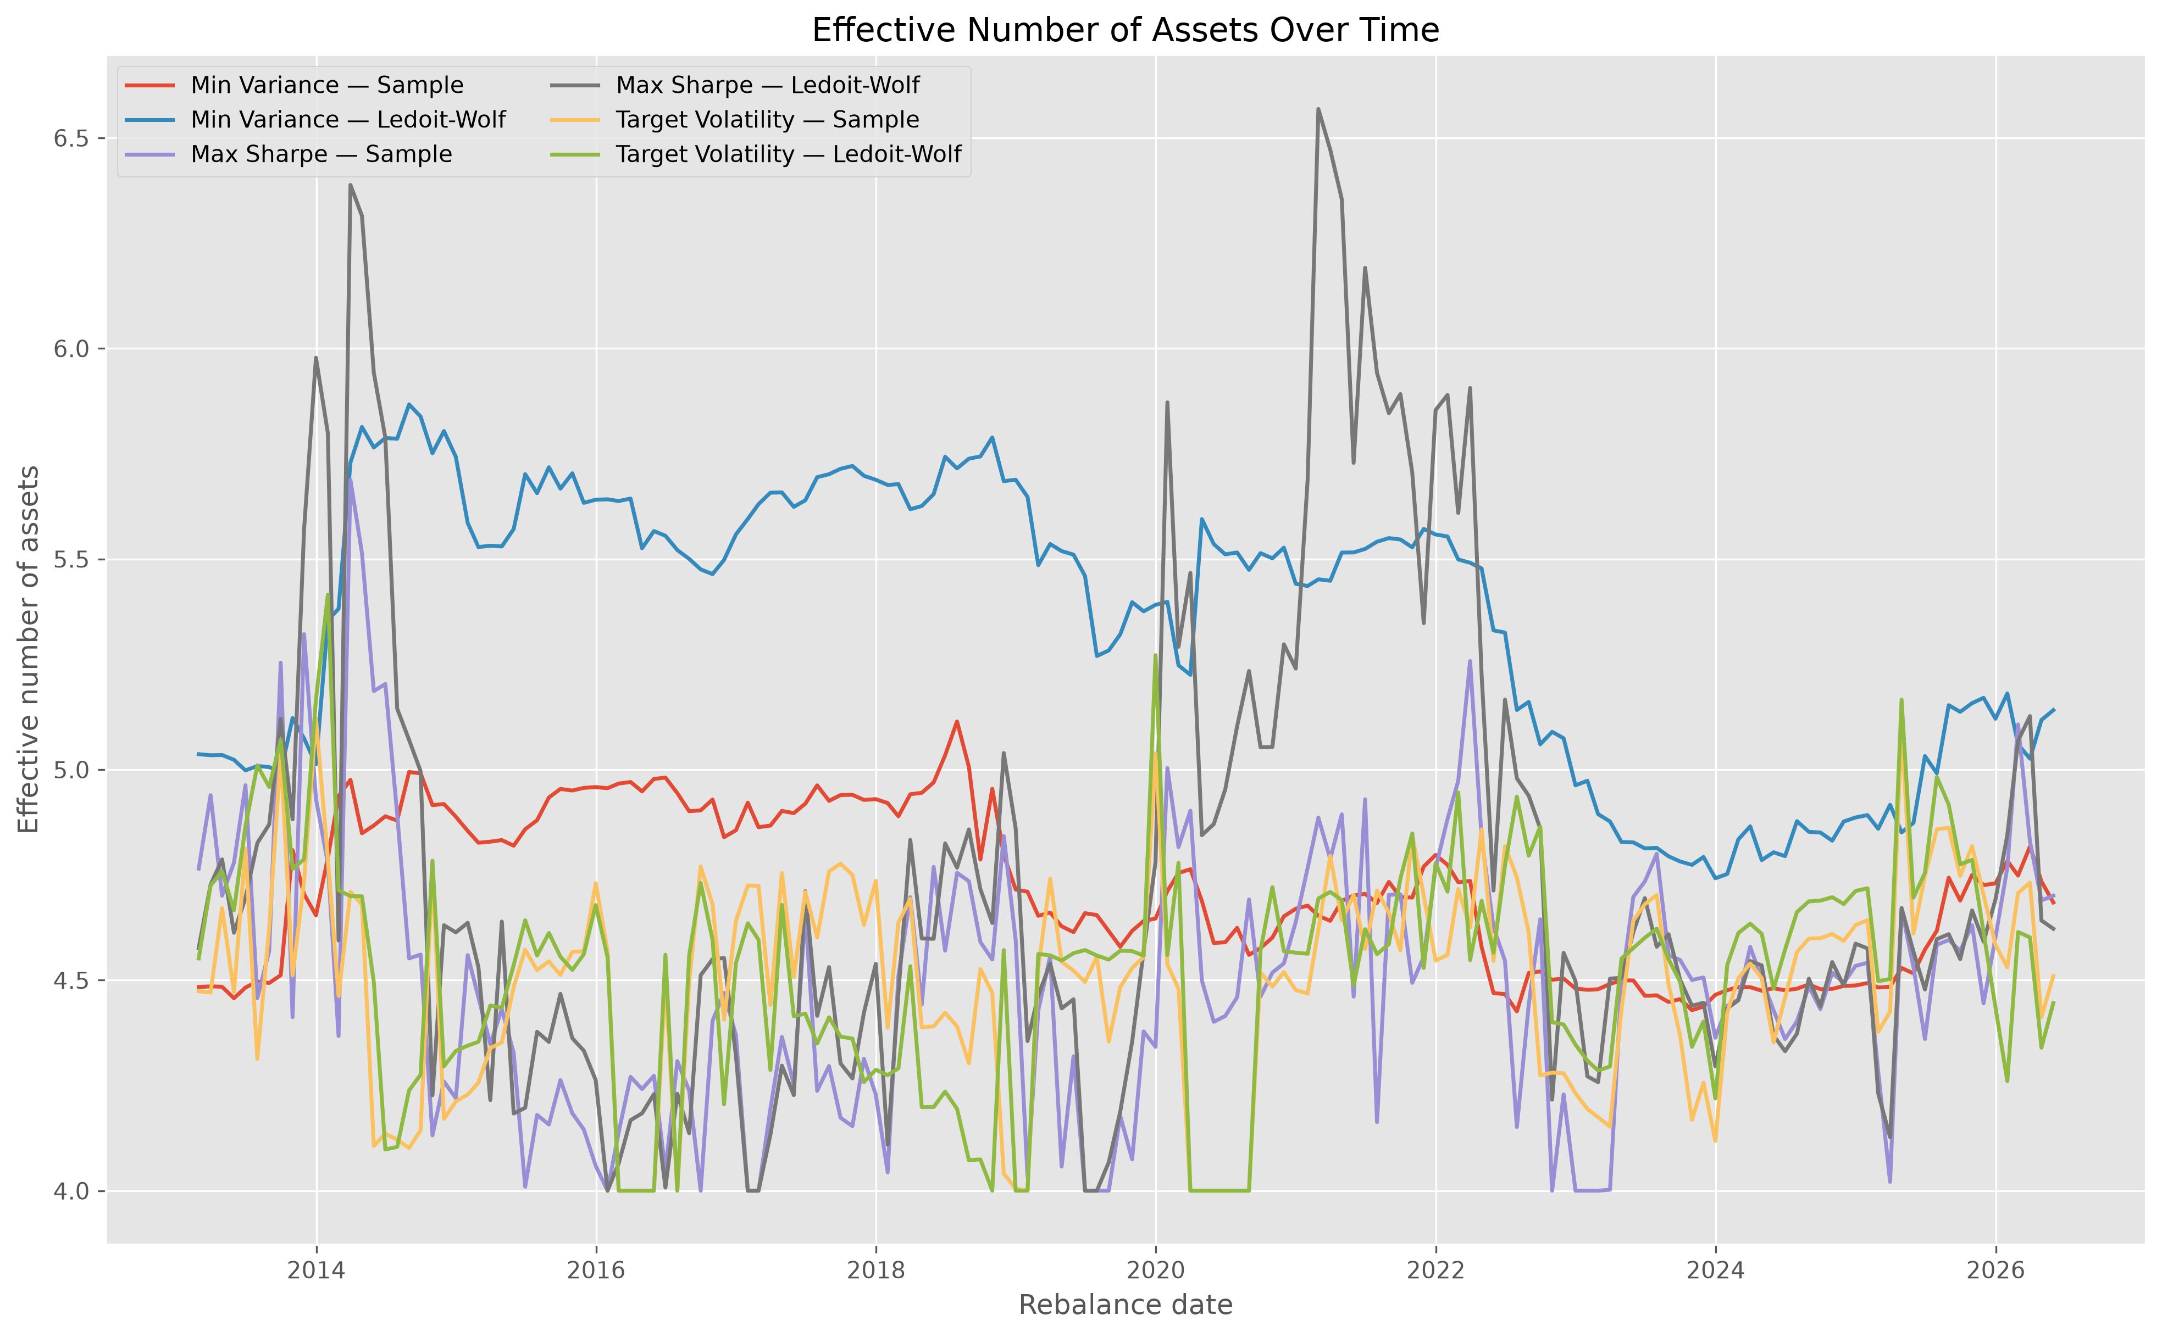
Figure 13. Effective number of assets over time. The time series documents changing concentration across optimized portfolios.
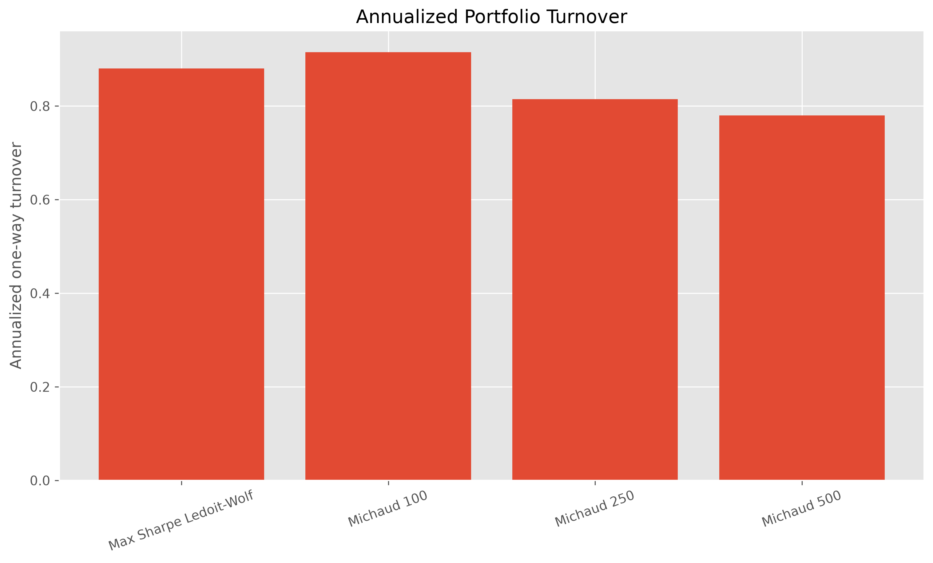
Figure 14. Michaud turnover comparison. Turnover moderates as the number of resamples increases.
Table 15. Top annualized ETF returns
Ticker | Ann. geometric return | Ann. volatility
QQQ | 17.43% | 18.83%
SPY | 11.79% | 15.70%
MDY | 10.12% | 18.69%
IWM | 9.46% | 20.78%
GLD | 8.63% | 17.20%
VNQ | 6.81% | 22.33%
VPL | 6.29% | 16.94%
VGK | 5.28% | 19.47%

Table 16. Highest-volatility ETFs
Ticker | Ann. geometric return | Ann. volatility
GSG | -2.70% | 23.40%
VNQ | 6.81% | 22.33%
EEM | 4.41% | 20.99%
IWM | 9.46% | 20.78%
RWX | 1.24% | 19.83%
VGK | 5.28% | 19.47%
DBC | 0.47% | 19.02%
QQQ | 17.43% | 18.83%

