10/02/2025
Today, we had our first session with the group formed. During this meeting, we answered the questions proposed by the course professor, which allowed us to delve deeper into the objectives, aspirations, and perspectives of each team member. This exercise not only facilitated a mutual understanding but also strengthened the group's cohesion.
Additionally, we began working with the database associated with the problem assigned to us, titled "Hit-or-Flop." To lay the groundwork for the project, we focused on thoroughly understanding each section of the database. This initial analysis enabled us to identify key areas and conduct some preliminary exercises to familiarize ourselves with the data, thus establishing a solid foundation for a more structured approach in the upcoming stages of the work.
14/02/2025
Throughout the week, we have cleaned and processed the dataset, ensuring that all the provided variables were properly handled. Instead of working with pre-filtered datasets that focus on specific aspects of the topic, we decided to use the full dataset from the beginning. We believe that narrowing our scope too early could limit the flexibility of our future project development.
Once the data was correctly formatted, we conducted an initial exploratory analysis to identify the key relationships within the dataset. To visualize these relationships, we created various graphical representations, such as the following heatmap:

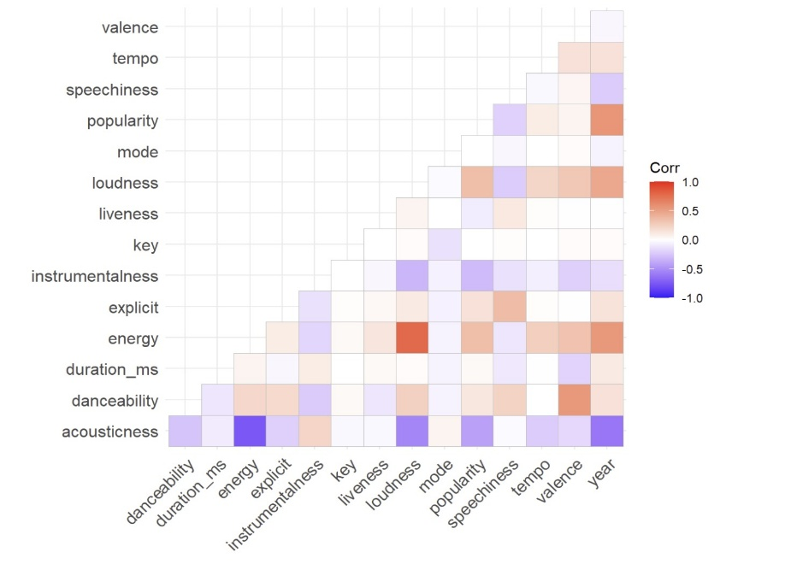
Through this analysis, we observed some expected correlations (such as the strong relationship between a song’s energy and its loudness level) as well as more insightful patterns related to popularity. For instance, songs with higher energy, louder music, or more explicit lyrics tend to exhibit certain trends in popularity.
At the same time, we explored the Spotify API. According to the GitHub repository from the dataset’s creator, the data was originally obtained from this API. Our goal was to extend the dataset, which currently includes songs from 1921 to 2020, with more recent data. However, we encountered a major limitation: Spotify has recently restricted its API, preventing access to specific song attributes such as loudness and acousticness. As a result, updating our dataset with new entries proved impossible.
Next, we investigated the current state of the art related to our project. Spotify’s API is a crucial tool, as it allows access to various song characteristics stored within this widely used platform. However, due to the recent API restrictions, its usefulness for our project has significantly diminished.
Finally, and in connection with our research on related work, we examined a project with a similar goal and dataset: "Predicting Song Popularity." Conducted by professors from the Computer Science Department at Stanford University, this study analyzed over a million songs released between 2010 and 2017. Their findings suggest that a song’s popularity is not strongly influenced by its acoustic characteristics (such as loudness or acousticness) but is instead more dependent on metadata-related factors, such as genre and release year.
This conclusion aligns with some of the correlations observed in our heatmap analysis. Moving forward, given our project's objective (to predict whether a song will become popular based on its attributes and metadata) we will seek to either validate or challenge these findings.
17/02/2025
In today's class, we worked with the 2030 Agenda, aiming to align our project with one of its goals. To delve deeper into the topic, we created a brief presentation to explain to the rest of the class the objective of our work and the specific goals it aligned with. In the end, we concluded that the most relevant goals were number 9 and, to a lesser extent, number 8.
Regarding the project itself, we continued with the exploratory data analysis. Specifically, we aimed to examine the data using a Principal Component Analysis (PCA):
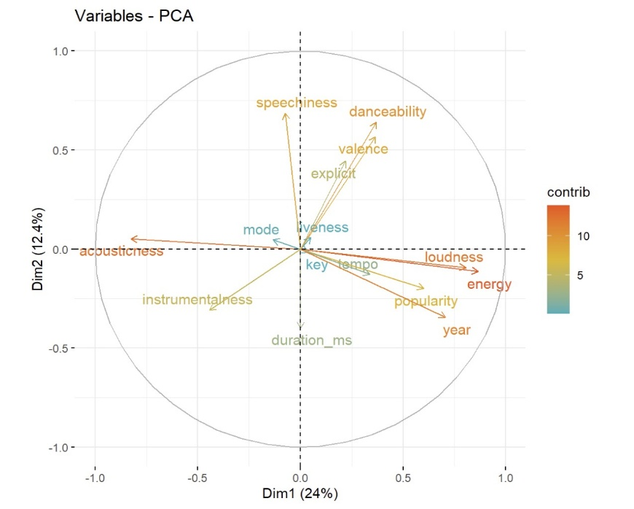
As we can see in the PCA, the assumptions proposed through the heatmap can be confirmed, while also revealing new insights of relative importance, such as those found between danceability, speechiness, and other variables.
Finally, we attempted to solve an issue we discovered in the previous session but had not yet addressed: genre classification. The dataset we are working with includes musical genres associated with artists but not with individual songs. Since our project focuses on determining whether a song will be a success based on its characteristics rather than the artist’s, accurately assigning one or more genres to each song has become a key objective.
To advance toward this objective, we worked with the Last.fm’s API, which allows users to retrieve the defined genres for a given song. Additionally, to finalize the genre classification, we updated the genres associated with the artists using the Spotify API.
21/02/2025
Today, we once again divided tasks among team members to work on different aspects simultaneously.
First, we focused on finalizing the key objectives that will guide our future actions. These four main goals are:
- Developing a predictive model that, given a song's characteristics, can estimate its popularity among users.

- Clustering songs based on intrinsic attributes such as loudness, key, and instrumentalness, rather than metadata (e.g., genre, year, artist). This clustering will allow us to recommend groups of songs to users based on the specific characteristics they prefer.

- Creating embeddings of the most popular songs today and in previous years to analyze how the preferred "vocabulary" of users has evolved over time.

- Generating association rules based on song characteristics, categorizing these attributes as high, medium, or low—similar to how we categorize popularity. We will analyze all rules where the consequent is "high popularity" to provide artists with insights on effective songwriting strategies.
The aim of these objectives is to benefit both consumers and artists alike.
Meanwhile, another part of the team has been working on refining the dataset further. Specifically, we have been exploring ways to assign genres to songs in a consistent and meaningful manner.
Additionally, we have begun tackling another crucial aspect of the project: extracting song lyrics for analysis. The goal is to identify patterns or recurring words in the most and least popular songs.
Given the vast amount of data, retrieving lyrics for all available songs proved impractical. As a solution, we decided to extract lyrics for 400 songs—200 popular and 200 unpopular. To streamline this process, we sorted the dataset by popularity. Regarding the methodology, we queried the AZLyrics API, processed the results, and extracted the relevant information.
Finally, we have been working on categorizing the dataset to facilitate the creation of association rules. We discussed the appropriate thresholds for classifying song characteristics into different categories, such as determining the popularity level required for a song to be considered a "hit."

24/02/2025
Today's main objective was to focus on Milestone 1. To achieve this, part of the team worked on defining and explaining the methodology that best fits our project: CRISP-DM, a more traditional approach. Additionally, we researched how to integrate the Kanban methodology into our daily workflow, as it offers a more modern approach.
Finally, regarding ongoing tasks:
- We successfully completed the association of genres to songs, along with some basic visualizations to analyze which genres are the most and least popular.
- We continued working on categorizing the dataset, addressing new challenges such as determining appropriate cutoff points for grouping songs based on their length.
- We worked on automating the extraction of song lyrics to streamline the process.
27/02/2025
Today, the main priority was the execution of Milestone 1 (M1). We began organizing all the relevant information gathered in previous meetings and integrating it into the presentation that needs to be delivered for M1.
Additionally, we continued working on extracting song lyrics but encountered a limitation with the API, which only allows 10 consecutive requests. An alternative solution will need to be explored to complete this task effectively.
Furthermore, we have now clearly defined the team roles, as they had been previously discussed but not formally established.
· Personality Roles:
- Juan Carlos & Artem: Doers
- Laura: Leader
- Jose: Carer
- Jorge: Thinker
(However, all team members can contribute to any of these roles.)
· Technical Roles:
- Communicator: Laura
- Domain Expert: Juan Carlos
- Programmer: José
- Manager: Artem
- Researcher: Jorge
Despite these role assignments, we maintain flexibility, allowing any team member to take on a different role when necessary, especially in situations requiring collaboration across multiple areas.

