УО «Белорусский государственный университет информатики и радиоэлектроники»

Кафедра ПОИТ

Отчет по лабораторной работе №2

по предмету «Теория информации»

Выполнил:

Шиманчук А.О.

гр. 351001

Проверила:

Болтак С.В.

Минск 2025

Вариант 13

Полином:

**Тест 1**

Тестовая ситуация:

Шифрование и дешифрование короткого текстового файла.

Исходные данные:

* нач. состояние регистра: 11111111111111111111111111111111111;
* название исходного файла: Тест(текст).txt;
* содержимое исходного файла: World.

Таблица генерации ключа:

|  |  |  |  |  |  |  |  |  |  |  |  |  |  |  |  |  |  |  |  |  |  |  |  |  |  |  |  |  |  |  |  |  |  |  |  |  |  |
| --- | --- | --- | --- | --- | --- | --- | --- | --- | --- | --- | --- | --- | --- | --- | --- | --- | --- | --- | --- | --- | --- | --- | --- | --- | --- | --- | --- | --- | --- | --- | --- | --- | --- | --- | --- | --- | --- |
|  |  | Разряды регистра | | | | | | | | | | | | | | | | | | | | | | | | | | | | | | | | | | | xor |
|  |  | 35 | 34 | 33 | 32 | 31 | 30 | 29 | 28 | 27 | 26 | 25 | 24 | 23 | 22 | 21 | 20 | 19 | 18 | 17 | 16 | 15 | 14 | 13 | 12 | 11 | 10 | 9 | 8 | 7 | 6 | 5 | 4 | 3 | 2 | 1 |  |
| Шаги / Состояние регистра | 1 | 1 | 1 | 1 | 1 | 1 | 1 | 1 | 1 | 1 | 1 | 1 | 1 | 1 | 1 | 1 | 1 | 1 | 1 | 1 | 1 | 1 | 1 | 1 | 1 | 1 | 1 | 1 | 1 | 1 | 1 | 1 | 1 | 1 | 1 | 1 | 0 |
| 2 | 1 | 1 | 1 | 1 | 1 | 1 | 1 | 1 | 1 | 1 | 1 | 1 | 1 | 1 | 1 | 1 | 1 | 1 | 1 | 1 | 1 | 1 | 1 | 1 | 1 | 1 | 1 | 1 | 1 | 1 | 1 | 1 | 1 | 1 | 0 | 0 |
| 3 | 1 | 1 | 1 | 1 | 1 | 1 | 1 | 1 | 1 | 1 | 1 | 1 | 1 | 1 | 1 | 1 | 1 | 1 | 1 | 1 | 1 | 1 | 1 | 1 | 1 | 1 | 1 | 1 | 1 | 1 | 1 | 1 | 1 | 0 | 0 | 1 |
| 4 | 1 | 1 | 1 | 1 | 1 | 1 | 1 | 1 | 1 | 1 | 1 | 1 | 1 | 1 | 1 | 1 | 1 | 1 | 1 | 1 | 1 | 1 | 1 | 1 | 1 | 1 | 1 | 1 | 1 | 1 | 1 | 1 | 0 | 0 | 1 | 1 |
| 5 | 1 | 1 | 1 | 1 | 1 | 1 | 1 | 1 | 1 | 1 | 1 | 1 | 1 | 1 | 1 | 1 | 1 | 1 | 1 | 1 | 1 | 1 | 1 | 1 | 1 | 1 | 1 | 1 | 1 | 1 | 1 | 0 | 0 | 1 | 1 | 0 |
| 6 | 1 | 1 | 1 | 1 | 1 | 1 | 1 | 1 | 1 | 1 | 1 | 1 | 1 | 1 | 1 | 1 | 1 | 1 | 1 | 1 | 1 | 1 | 1 | 1 | 1 | 1 | 1 | 1 | 1 | 1 | 0 | 0 | 1 | 1 | 0 | 0 |
| 7 | 1 | 1 | 1 | 1 | 1 | 1 | 1 | 1 | 1 | 1 | 1 | 1 | 1 | 1 | 1 | 1 | 1 | 1 | 1 | 1 | 1 | 1 | 1 | 1 | 1 | 1 | 1 | 1 | 1 | 0 | 0 | 1 | 1 | 0 | 0 | 1 |
| 8 | 1 | 1 | 1 | 1 | 1 | 1 | 1 | 1 | 1 | 1 | 1 | 1 | 1 | 1 | 1 | 1 | 1 | 1 | 1 | 1 | 1 | 1 | 1 | 1 | 1 | 1 | 1 | 1 | 0 | 0 | 1 | 1 | 0 | 0 | 1 | 1 |
| 9 | 1 | 1 | 1 | 1 | 1 | 1 | 1 | 1 | 1 | 1 | 1 | 1 | 1 | 1 | 1 | 1 | 1 | 1 | 1 | 1 | 1 | 1 | 1 | 1 | 1 | 1 | 1 | 0 | 0 | 1 | 1 | 0 | 0 | 1 | 1 | 0 |
| 10 | 1 | 1 | 1 | 1 | 1 | 1 | 1 | 1 | 1 | 1 | 1 | 1 | 1 | 1 | 1 | 1 | 1 | 1 | 1 | 1 | 1 | 1 | 1 | 1 | 1 | 1 | 0 | 0 | 1 | 1 | 0 | 0 | 1 | 1 | 0 | 0 |
| 11 | 1 | 1 | 1 | 1 | 1 | 1 | 1 | 1 | 1 | 1 | 1 | 1 | 1 | 1 | 1 | 1 | 1 | 1 | 1 | 1 | 1 | 1 | 1 | 1 | 1 | 0 | 0 | 1 | 1 | 0 | 0 | 1 | 1 | 0 | 0 | 1 |
| 12 | 1 | 1 | 1 | 1 | 1 | 1 | 1 | 1 | 1 | 1 | 1 | 1 | 1 | 1 | 1 | 1 | 1 | 1 | 1 | 1 | 1 | 1 | 1 | 1 | 0 | 0 | 1 | 1 | 0 | 0 | 1 | 1 | 0 | 0 | 1 | 1 |
| 13 | 1 | 1 | 1 | 1 | 1 | 1 | 1 | 1 | 1 | 1 | 1 | 1 | 1 | 1 | 1 | 1 | 1 | 1 | 1 | 1 | 1 | 1 | 1 | 0 | 0 | 1 | 1 | 0 | 0 | 1 | 1 | 0 | 0 | 1 | 1 | 0 |
| 14 | 1 | 1 | 1 | 1 | 1 | 1 | 1 | 1 | 1 | 1 | 1 | 1 | 1 | 1 | 1 | 1 | 1 | 1 | 1 | 1 | 1 | 1 | 0 | 0 | 1 | 1 | 0 | 0 | 1 | 1 | 0 | 0 | 1 | 1 | 0 | 0 |
| 15 | 1 | 1 | 1 | 1 | 1 | 1 | 1 | 1 | 1 | 1 | 1 | 1 | 1 | 1 | 1 | 1 | 1 | 1 | 1 | 1 | 1 | 0 | 0 | 1 | 1 | 0 | 0 | 1 | 1 | 0 | 0 | 1 | 1 | 0 | 0 | 1 |
| 16 | 1 | 1 | 1 | 1 | 1 | 1 | 1 | 1 | 1 | 1 | 1 | 1 | 1 | 1 | 1 | 1 | 1 | 1 | 1 | 1 | 0 | 0 | 1 | 1 | 0 | 0 | 1 | 1 | 0 | 0 | 1 | 1 | 0 | 0 | 1 | 1 |
| 17 | 1 | 1 | 1 | 1 | 1 | 1 | 1 | 1 | 1 | 1 | 1 | 1 | 1 | 1 | 1 | 1 | 1 | 1 | 1 | 0 | 0 | 1 | 1 | 0 | 0 | 1 | 1 | 0 | 0 | 1 | 1 | 0 | 0 | 1 | 1 | 0 |
| 18 | 1 | 1 | 1 | 1 | 1 | 1 | 1 | 1 | 1 | 1 | 1 | 1 | 1 | 1 | 1 | 1 | 1 | 1 | 0 | 0 | 1 | 1 | 0 | 0 | 1 | 1 | 0 | 0 | 1 | 1 | 0 | 0 | 1 | 1 | 0 | 0 |
| 19 | 1 | 1 | 1 | 1 | 1 | 1 | 1 | 1 | 1 | 1 | 1 | 1 | 1 | 1 | 1 | 1 | 1 | 0 | 0 | 1 | 1 | 0 | 0 | 1 | 1 | 0 | 0 | 1 | 1 | 0 | 0 | 1 | 1 | 0 | 0 | 1 |
| 20 | 1 | 1 | 1 | 1 | 1 | 1 | 1 | 1 | 1 | 1 | 1 | 1 | 1 | 1 | 1 | 1 | 0 | 0 | 1 | 1 | 0 | 0 | 1 | 1 | 0 | 0 | 1 | 1 | 0 | 0 | 1 | 1 | 0 | 0 | 1 | 1 |
| 21 | 1 | 1 | 1 | 1 | 1 | 1 | 1 | 1 | 1 | 1 | 1 | 1 | 1 | 1 | 1 | 0 | 0 | 1 | 1 | 0 | 0 | 1 | 1 | 0 | 0 | 1 | 1 | 0 | 0 | 1 | 1 | 0 | 0 | 1 | 1 | 0 |
| 22 | 1 | 1 | 1 | 1 | 1 | 1 | 1 | 1 | 1 | 1 | 1 | 1 | 1 | 1 | 0 | 0 | 1 | 1 | 0 | 0 | 1 | 1 | 0 | 0 | 1 | 1 | 0 | 0 | 1 | 1 | 0 | 0 | 1 | 1 | 0 | 0 |
| 23 | 1 | 1 | 1 | 1 | 1 | 1 | 1 | 1 | 1 | 1 | 1 | 1 | 1 | 0 | 0 | 1 | 1 | 0 | 0 | 1 | 1 | 0 | 0 | 1 | 1 | 0 | 0 | 1 | 1 | 0 | 0 | 1 | 1 | 0 | 0 | 1 |
| 24 | 1 | 1 | 1 | 1 | 1 | 1 | 1 | 1 | 1 | 1 | 1 | 1 | 0 | 0 | 1 | 1 | 0 | 0 | 1 | 1 | 0 | 0 | 1 | 1 | 0 | 0 | 1 | 1 | 0 | 0 | 1 | 1 | 0 | 0 | 1 | 1 |
| 25 | 1 | 1 | 1 | 1 | 1 | 1 | 1 | 1 | 1 | 1 | 1 | 0 | 0 | 1 | 1 | 0 | 0 | 1 | 1 | 0 | 0 | 1 | 1 | 0 | 0 | 1 | 1 | 0 | 0 | 1 | 1 | 0 | 0 | 1 | 1 | 0 |
| 26 | 1 | 1 | 1 | 1 | 1 | 1 | 1 | 1 | 1 | 1 | 0 | 0 | 1 | 1 | 0 | 0 | 1 | 1 | 0 | 0 | 1 | 1 | 0 | 0 | 1 | 1 | 0 | 0 | 1 | 1 | 0 | 0 | 1 | 1 | 0 | 0 |
| 27 | 1 | 1 | 1 | 1 | 1 | 1 | 1 | 1 | 1 | 0 | 0 | 1 | 1 | 0 | 0 | 1 | 1 | 0 | 0 | 1 | 1 | 0 | 0 | 1 | 1 | 0 | 0 | 1 | 1 | 0 | 0 | 1 | 1 | 0 | 0 | 1 |
| 28 | 1 | 1 | 1 | 1 | 1 | 1 | 1 | 1 | 0 | 0 | 1 | 1 | 0 | 0 | 1 | 1 | 0 | 0 | 1 | 1 | 0 | 0 | 1 | 1 | 0 | 0 | 1 | 1 | 0 | 0 | 1 | 1 | 0 | 0 | 1 | 1 |
| 29 | 1 | 1 | 1 | 1 | 1 | 1 | 1 | 0 | 0 | 1 | 1 | 0 | 0 | 1 | 1 | 0 | 0 | 1 | 1 | 0 | 0 | 1 | 1 | 0 | 0 | 1 | 1 | 0 | 0 | 1 | 1 | 0 | 0 | 1 | 1 | 0 |
| 30 | 1 | 1 | 1 | 1 | 1 | 1 | 0 | 0 | 1 | 1 | 0 | 0 | 1 | 1 | 0 | 0 | 1 | 1 | 0 | 0 | 1 | 1 | 0 | 0 | 1 | 1 | 0 | 0 | 1 | 1 | 0 | 0 | 1 | 1 | 0 | 0 |
| 31 | 1 | 1 | 1 | 1 | 1 | 0 | 0 | 1 | 1 | 0 | 0 | 1 | 1 | 0 | 0 | 1 | 1 | 0 | 0 | 1 | 1 | 0 | 0 | 1 | 1 | 0 | 0 | 1 | 1 | 0 | 0 | 1 | 1 | 0 | 0 | 1 |
| 32 | 1 | 1 | 1 | 1 | 0 | 0 | 1 | 1 | 0 | 0 | 1 | 1 | 0 | 0 | 1 | 1 | 0 | 0 | 1 | 1 | 0 | 0 | 1 | 1 | 0 | 0 | 1 | 1 | 0 | 0 | 1 | 1 | 0 | 0 | 1 | 1 |
| 33 | 1 | 1 | 1 | 0 | 0 | 1 | 1 | 0 | 0 | 1 | 1 | 0 | 0 | 1 | 1 | 0 | 0 | 1 | 1 | 0 | 0 | 1 | 1 | 0 | 0 | 1 | 1 | 0 | 0 | 1 | 1 | 0 | 0 | 1 | 1 | 0 |
| 34 | 1 | 1 | 0 | 0 | 1 | 1 | 0 | 0 | 1 | 1 | 0 | 0 | 1 | 1 | 0 | 0 | 1 | 1 | 0 | 0 | 1 | 1 | 0 | 0 | 1 | 1 | 0 | 0 | 1 | 1 | 0 | 0 | 1 | 1 | 0 | 0 |
| 35 | 1 | 0 | 0 | 1 | 1 | 0 | 0 | 1 | 1 | 0 | 0 | 1 | 1 | 0 | 0 | 1 | 1 | 0 | 0 | 1 | 1 | 0 | 0 | 1 | 1 | 0 | 0 | 1 | 1 | 0 | 0 | 1 | 1 | 0 | 0 | 1 |
| 36 | 0 | 0 | 1 | 1 | 0 | 0 | 1 | 1 | 0 | 0 | 1 | 1 | 0 | 0 | 1 | 1 | 0 | 0 | 1 | 1 | 0 | 0 | 1 | 1 | 0 | 0 | 1 | 1 | 0 | 0 | 1 | 1 | 0 | 0 | 1 | 0 |
| 37 | 0 | 1 | 1 | 0 | 0 | 1 | 1 | 0 | 0 | 1 | 1 | 0 | 0 | 1 | 1 | 0 | 0 | 1 | 1 | 0 | 0 | 1 | 1 | 0 | 0 | 1 | 1 | 0 | 0 | 1 | 1 | 0 | 0 | 1 | 0 | 1 |
| 38 | 1 | 1 | 0 | 0 | 1 | 1 | 0 | 0 | 1 | 1 | 0 | 0 | 1 | 1 | 0 | 0 | 1 | 1 | 0 | 0 | 1 | 1 | 0 | 0 | 1 | 1 | 0 | 0 | 1 | 1 | 0 | 0 | 1 | 0 | 1 | 1 |
| 39 | 1 | 0 | 0 | 1 | 1 | 0 | 0 | 1 | 1 | 0 | 0 | 1 | 1 | 0 | 0 | 1 | 1 | 0 | 0 | 1 | 1 | 0 | 0 | 1 | 1 | 0 | 0 | 1 | 1 | 0 | 0 | 1 | 0 | 1 | 1 | 0 |
| 40 | 0 | 0 | 1 | 1 | 0 | 0 | 1 | 1 | 0 | 0 | 1 | 1 | 0 | 0 | 1 | 1 | 0 | 0 | 1 | 1 | 0 | 0 | 1 | 1 | 0 | 0 | 1 | 1 | 0 | 0 | 1 | 0 | 1 | 1 | 0 | 1 |

Ожидаемый результат:

* ключ: 1111111111111111111111111111111111100110;
* исходный текст: 0101011101101111011100100110110001100100;
* шифро текст: 1010100010010000100011011001001110000010.

Полученный результат:

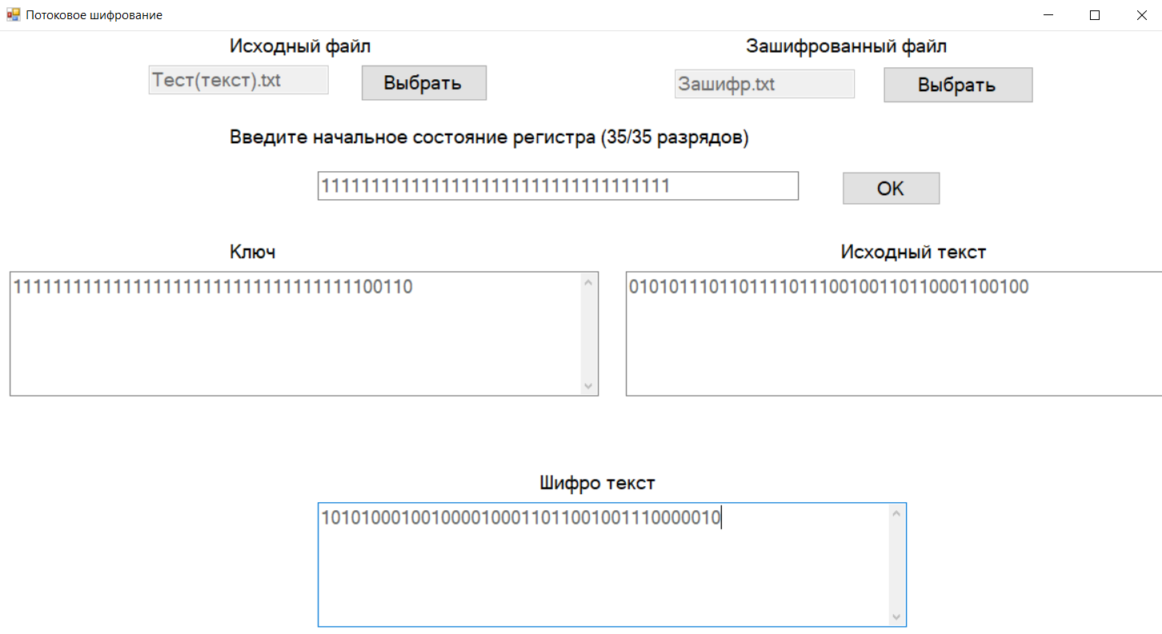

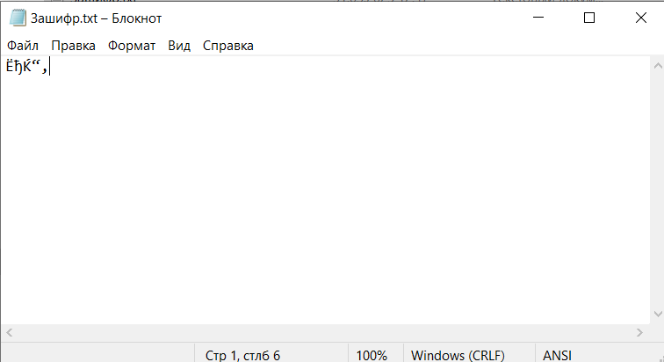

Расшифрование:

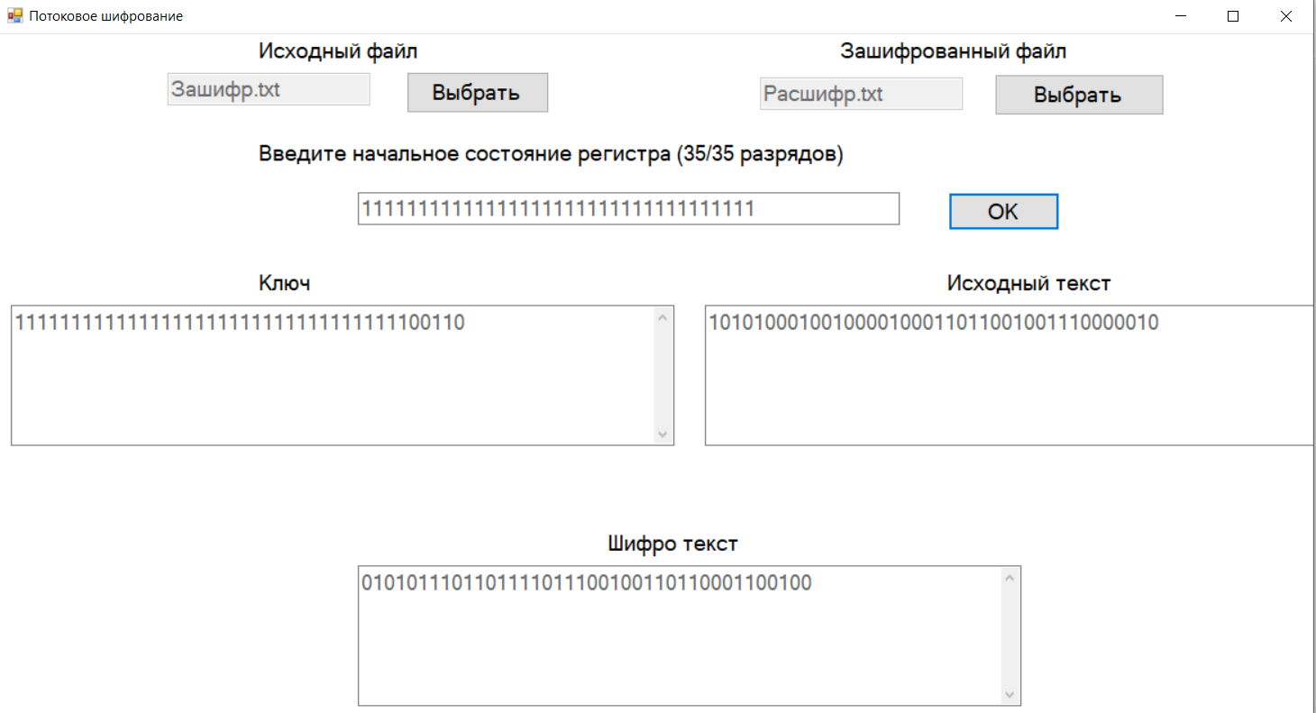

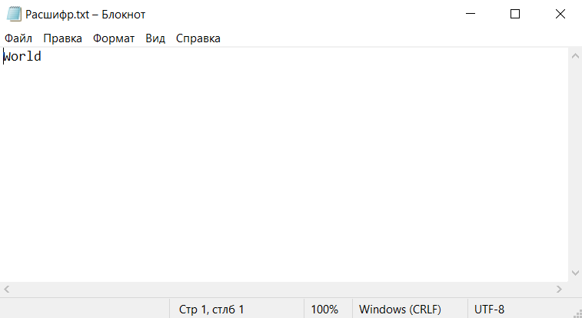

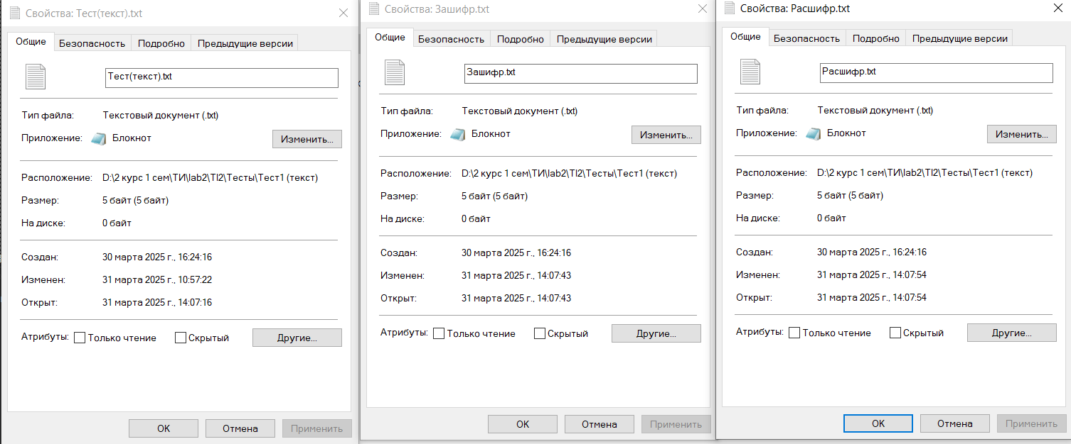

**Тест 2**

Тестовая ситуация:

Шифрование и дешифрование аудио файла.

Исходные данные:

* нач. состояние регистра: 10101010101010101010101010101010101;
* название исходного файла: Тест(аудио).wav.

Ожидаемый результат:

* ключ: 101010101010101010101010101010101011101110111011101110111011101110111001001110010011100100111001001110010111100101111001…;
* исходный текст:

010100100100100101000110010001100010010010011010000010000000000001010111010000010101011001000101011001100110110101110100…;

* шифро текст:

111110001110001111101100111011001001111100100001101100111011101111101110011110000110111101111100010111110001010000001101…

Полученный результат:

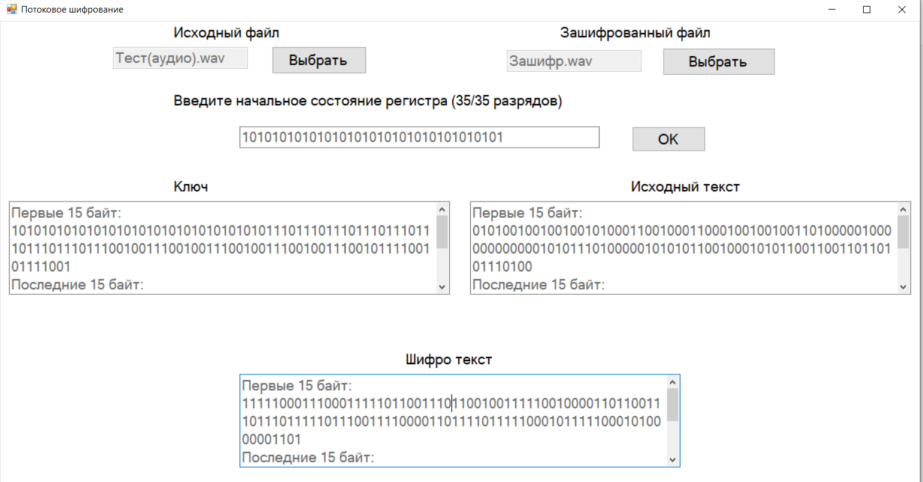

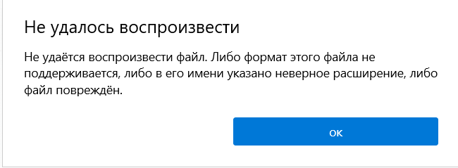

Расшифрование:

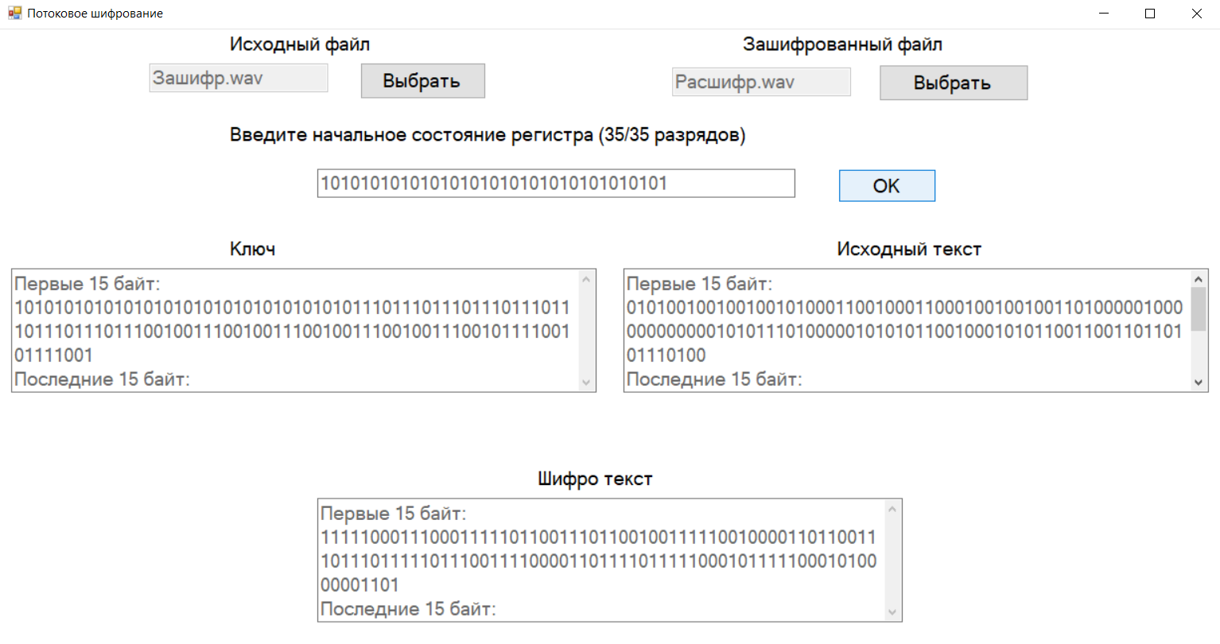

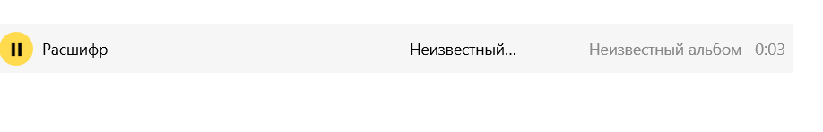

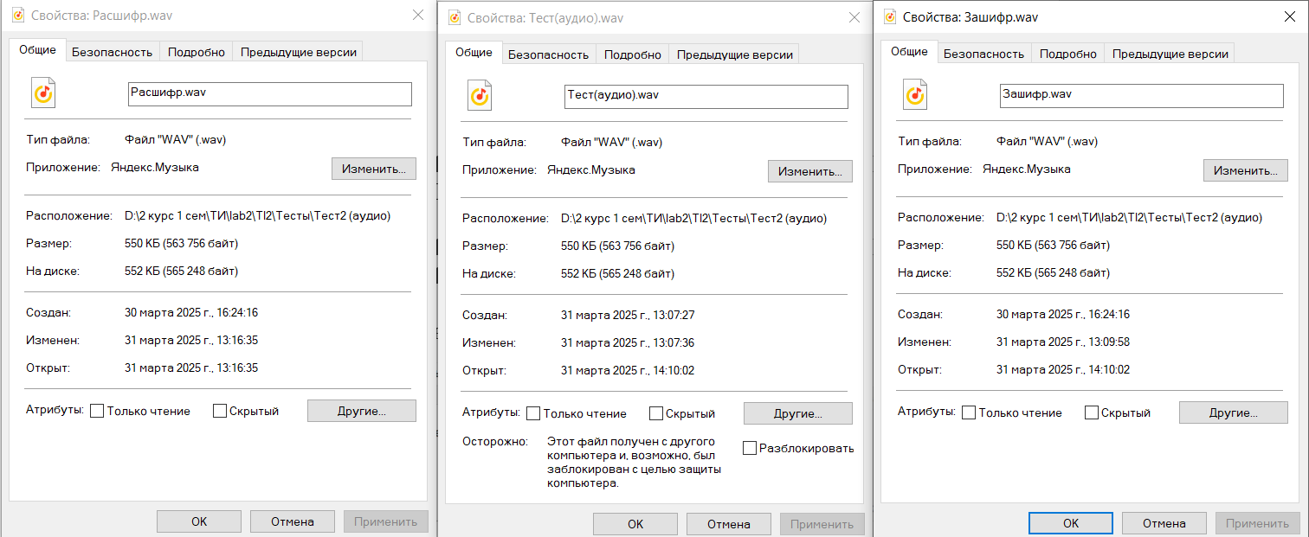

**Тест 3**

Тестовая ситуация:

Шифрование и дешифрование видео файла.

Исходные данные:

* нач. состояние регистра: 10101010101010101010101010101010101;
* название исходного файла: Тест(видео).mp4.

Ожидаемый результат:

* ключ: 101010101010101010101010101010101011101110111011101110111011101110111001001110010011100100111001001110010111100101111001…;
* исходный текст:

000000000000000000000000000110000110011001110100011110010111000001101101011100000011010000110010000000000000000000000000…;

* шифро текст:

101010101010101010101010101100101101110111001111110000101100101111010100010010010000110100001011001110010111100101111001…

Полученный результат:

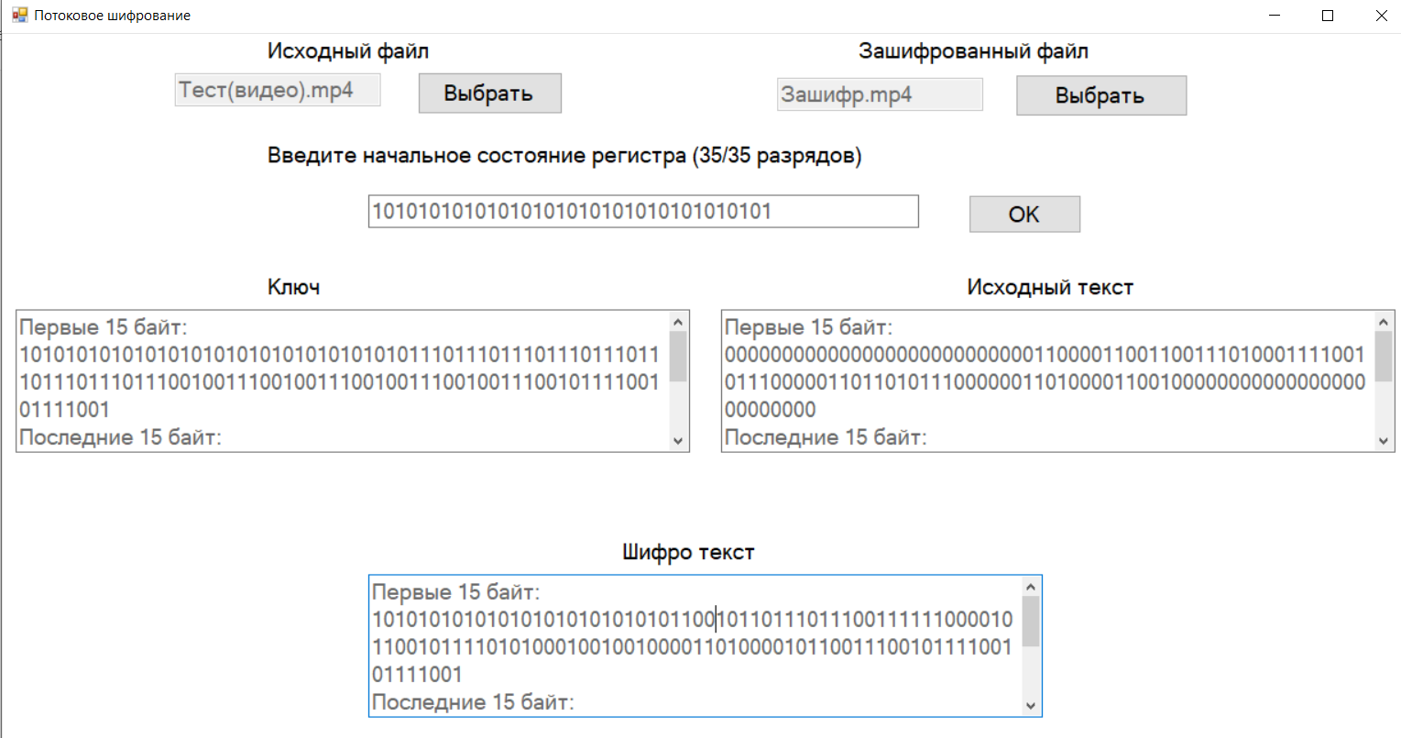

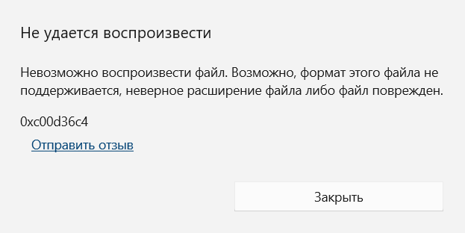

Расшифрованиe:

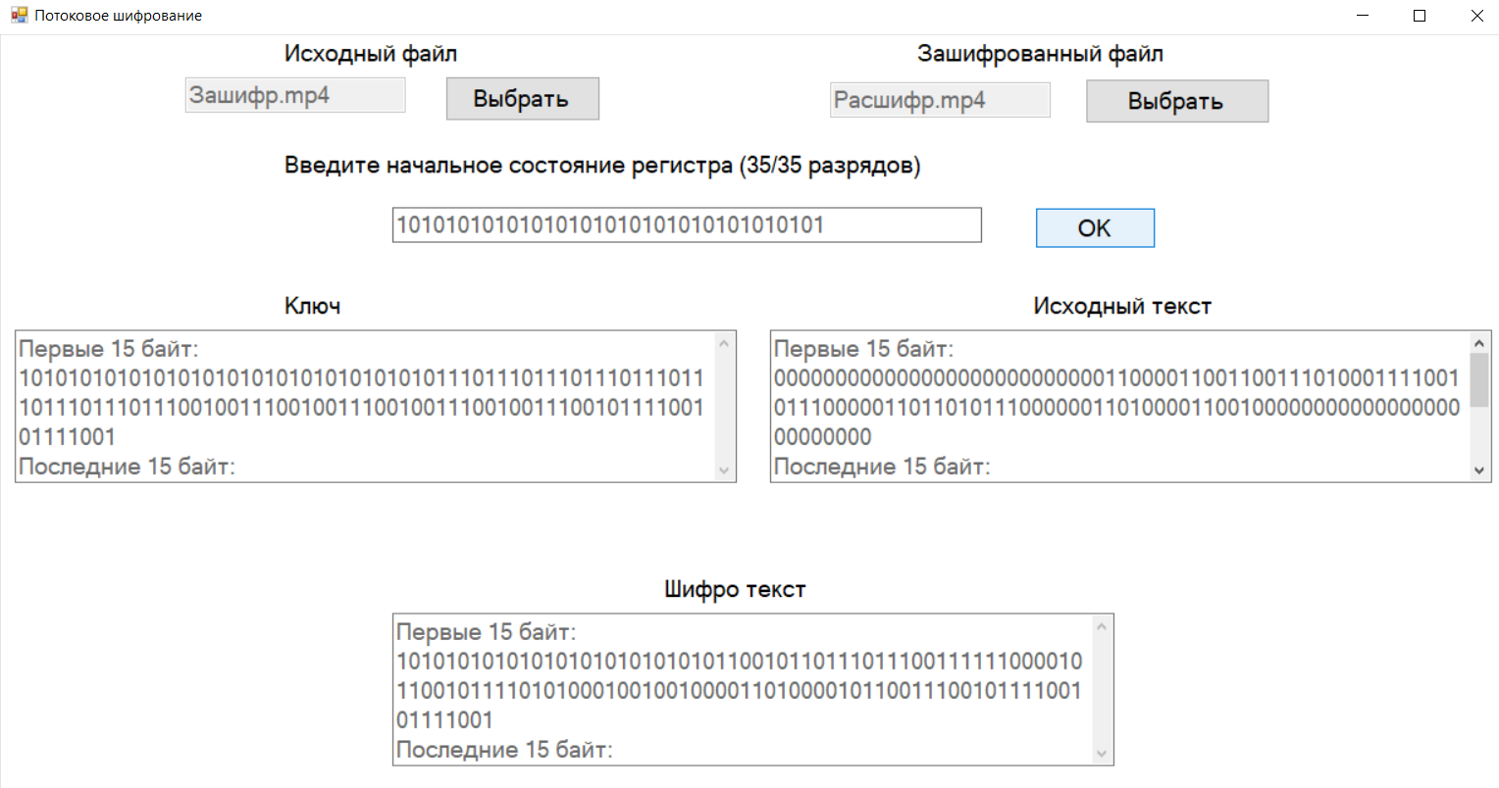

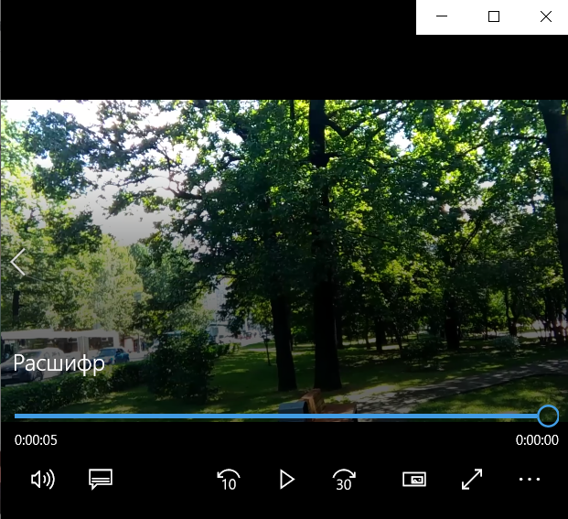

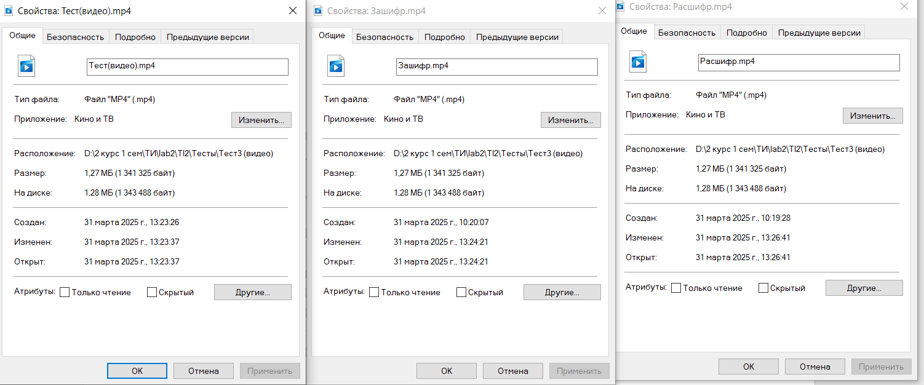

**Тест 4**

Тестовая ситуация:

Шифрование и дешифрование фото.

Исходные данные:

* нач. состояние регистра: 10101010101010101010101010101010101;
* название исходного файла: Тест(фото).png.

Ожидаемый результат:

* ключ: 101010101010101010101010101010101011101110111011101110111011101110111001001110010011100100111001001110010111100101111001…;
* исходный текст:

100010010101000001001110010001110000110100001010000110100000101000000000000000000000000000001101010010010100100001000100…;

* шифро текст:

001000111111101011100100111011011011011010110001101000011011000110111001001110010011100100110100011100000011000100111101…

Полученный результат:

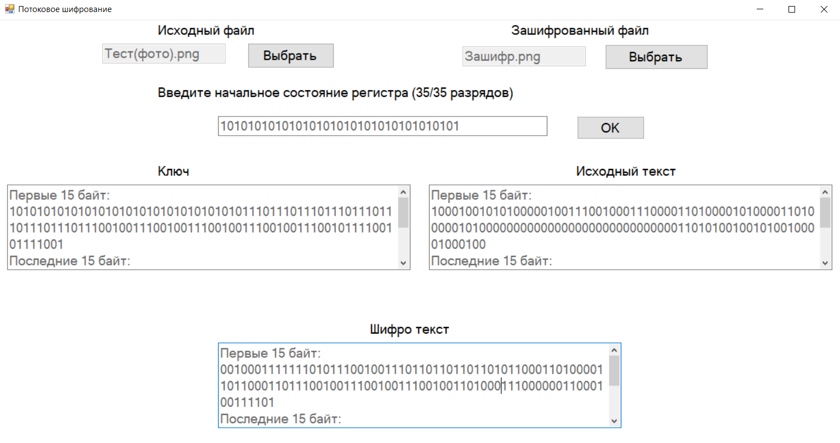

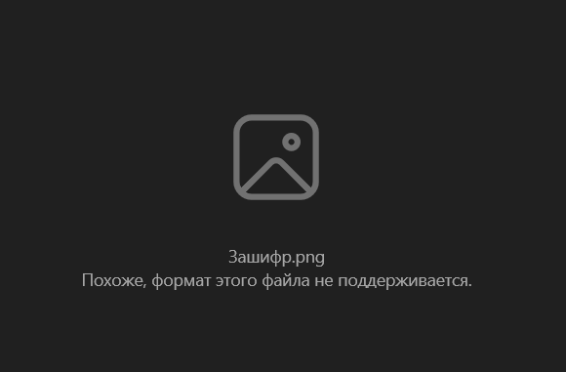

Расшифрование:

