HW1 results commetary

In this assignment, I conducted several calculations with the following results:

These grid resolutions roughly indicate the number of vertices along the diameter of the grid and correspond to the following total numbers of vertices: [100, 1000, 10000]. I could not conduct calculations on grids with higher resolution due to memory constraints because I run fenics from a Docker container.

Here are the plots for exact and numerical solutions, and solution and gradient error distributions. One can clearly see how the error is larger in the center of the grid both for the solution and the gradient. This may be due to large slope of the log function in the center of coordinates. I would suggest improving the accuracy by applying unstructured grid refined in the center.

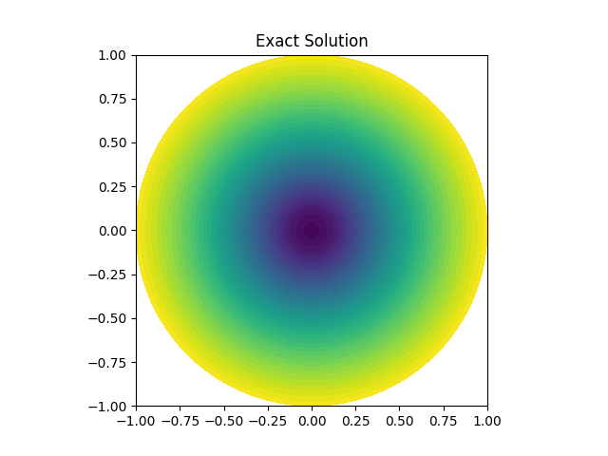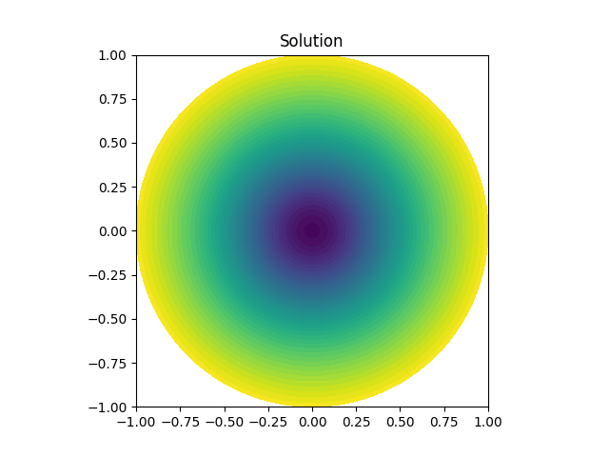

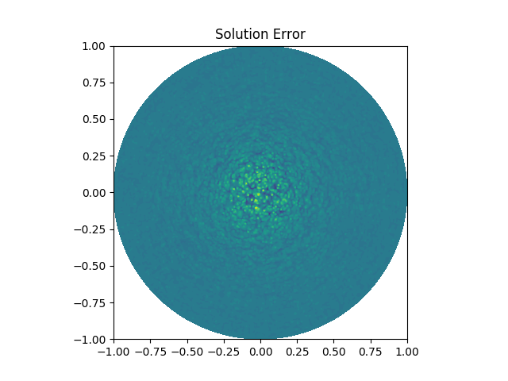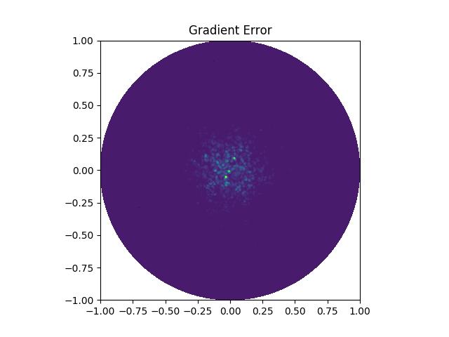

The code necessary to reproduce the results is attached to the assignment. For series of calculations, run main.py in Fenics environment. Then run make_table.ipynb to create an excel table with the results.

For plots, simply run run.py.