MASTER’S THESIS
Articulation Points in Multiplex Networks
Master’s Educational Program: Advanced Computational Sciences
Student: | signature | Artem Vergazov
Research Advisor: | signature | Vladimir Palyulin  Assistant Professor

Moscow 2022

Copyright 2022 Author. All rights reserved.
The author hereby grants to Skoltech permission to reproduce and to distribute publicly paper and electronic copies of this thesis document in whole and in part in any medium now known or hereafter created.
МАГИСТЕРСКАЯ ДИССЕРТАЦИЯ
Критические узлы в многослойных сетях
Магистерская образовательная программа: Современные вычислительные методы
Студент: | signature | Артём Вергазов
Научный руководитель: | signature | Владимир Палюлин  Старший преподаватель

Москва 2022

Авторское право 2022. Все права защищены.
Автор настоящим дает Сколковскому институту науки и технологий разрешение на воспроизводство и свободное распространение бумажных и электронных копий настоящей диссертации в целом или частично на любом ныне существующем или созданном в будущем носителе.

Articulation Points in Multiplex Networks
Artem Vergazov
Submitted to the Skolkovo Institute of Science and Technology on May 24, 2023
Abstract
In mathematical modeling, a concept of a network can represent many of the real-life complex systems. Many of the physical, technological, social, biological etc. phenomena can be described and simulated in terms of networks. Studying networks as a general mathematical object as well as analyzing them in terms of resistance to random node failures is crucial.
Furthermore, more complex phenomena are better described by multiplex networks, rather than simple monoplex networks. A multiplex network is a collection of monoplex networks, or layers, where all the nodes exist simultaneously in all the layers but the links within each layer can differ. An obvious example of such system is a social two-layer multiplex network with Facebook as one layer and Twitter as the other. Nodes represent people participating in these networks, and links represent connections between them in each of the networks. Obviously, classical notion of a network would not be sufficient for describing such system.
One of the notions that come up while studying networks is a notion of an articulation point – a node whose removal disconnects the network. Despite their fundamental importance, a general framework of studying articulation points in multiplex networks is lacking. While articulation points distribution in simple monoplex networks has been studied well enough, this phenomenon in multiplex networks has not been addressed as thoroughly yet.
Dealing with multiplex networks, one should be aware of the fundamental differences in resistance to random node failures between multiplex and monoplex networks. Each complex system is prone to occasional shutdowns of its parts, and monoplex and multiplex networks respond differently to the shutdowns of their nodes. A monoplex system does not lose much of its integrity and remains functioning in case a part of its nodes fails, meanwhile in a multiplex network a process which is known as cascade of failures starts because of interdependence of the layers. This process might cause the network defragmentation.
The purpose of this work is to study and compare the organization of monoplex and multiplex networks. We will be viewing their structure via the articulation points removal process as articulation points turn out to be the most crucial and vulnerable parts of such systems. We will also compare different random graph models in terms of such removal.
Keywords: complex networks, multiplex networks, articulation points, numerical simulation of complex networks, Erdős–Rényi graph, scale-free graph

Research Advisor:
Name: Vladimir Palyulin
Degree, title: assistant professor
Contents
Introduction 5
Literature Review 6
Articulation points in monoplex networks 6
Multiplex networks 6
Literature Review Conclusions 6
Computational Methodology 8
Results and Discussion 9
ER monoplex and multiplex networks comparison 10
Scale-free multiplex network with different exponents 11
Other metrics 12
Discussion 14
Conclusions 15
Author Contribution 16
Acknowledgements 16
Abbreviations 17
References 18
Appendix 19

Introduction

Many of the natural and artificial systems are represented efficiently by a notion of graphs, or networks. Thus, studying network science is important for understanding the underlying principles of behavior of complex systems.
Particularly, it is important to study the articulation points (AP) distribution in graphs. An articulation point in a network is a node whose removal disconnects the network. Being able to find articulation points and understanding the patterns of their behavior can help both prevent crucial systems from destruction (for example, designing more resilient infrastructure networks) or find weaknesses in such systems [1].
There has been some research on articulation points behavior in monoplex networks. However, some phenomena are more naturally described by multiplex networks. A multiplex network is a collection of monoplex networks, or layers, where all the nodes exist simultaneously in all the layers but the links within each layer can differ [2]. An example of such system is a network of Facebook as one layer and a network of Twitter as the other. Nodes represent people participating in these networks, and links represent connections between them in each of the networks.
Many effects found in multiplex networks are not observed in monoplex networks. This also concerns articulation points distribution. For example, removal of one such point from a usual network simply disconnects it leaving two independent clusters. However, removal of an articulation point from a multiplex network can produce an iterative cascade of failures in several interdependent networks. Example of this was observed in 2003 in Italy when the shutdown of power stations directly led to the failure of nodes in the Internet communication network, which in turn caused further breakdown of power stations resulting in electrical blackout [3].
This area is relatively young and there is a necessity and a possibility for research of articulation points behavior in multiplex networks.
The structure of this thesis is as follows.

Literature Review
Reproducing results from papers on AP distribution in mono- and multiplex networks was helpful for understanding the terminology, common approaches, and best practices in these fields. The following is the review of the works considering various network science scenarios which will be of help in this research.

Articulation points in monoplex networks
In [1], authors develop equations governing the dependency of APs proportion in a random network on its parameters. For example, the analytical dependency of APs proportion on the mean degree parameter $c$ in Erdős–Rényi network (ER network) was derived in the paper. For the purposes of this review, these results were tested numerically. One can see the comparison plot in the Figure 1. Authors also come up with strategies of network attack and network decomposition in which AP distributions play the major role. These results are of great importance for budget-limited network construction/destruction but are only applicable for monoplex networks. Generalization of these results to the multiplex networks case is one the goals of this work.

Multiplex networks
In [3], authors consider a cascade of failures scenario which occurs when failure of nodes in one layer leads to failures of dependent nodes in other layers. This leads to iterative process of failures which stops when only the giant connected component (GCC) is left. For this review, the dependency of the size of this final GCC on the fraction of nodes that are left $p$ is obtained numerically and can be found on the Figure 2.

Literature Review Conclusions
Results of the papers listed above have been numerically verified. Comparisons of the plots obtained numerically and the analytical curves are presented in the figures below.
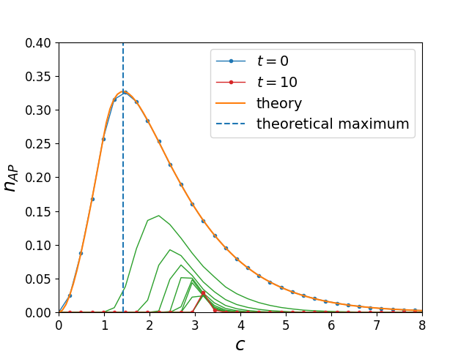
Figure 1. Verification of paper [1] results. Fraction of articulation points in ER network. $c$ is the mean degree of the network nodes.
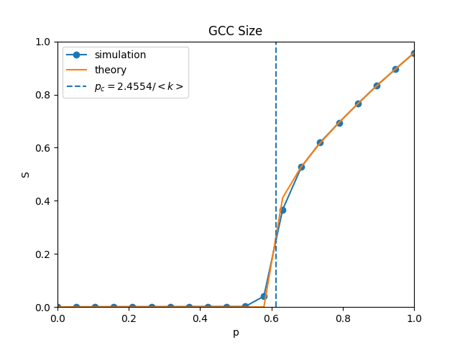
Figure 2. Verification of paper [3] results. Size of the GCC that is left after a cascade of node failures in a two-layer ER network. $p$ is the fraction of nodes that are left after the first failure.

Computational Methodology
The workflow can be described as
- generation of a set of networks from a certain distribution (ER or scale-free)
- application of cascade of failures
- obtaining AP metrics (fraction)
Simulations are done in vanilla C++ because of the extremely high computational cost of those simulations for large networks (millions of nodes). Python is used for prototyping and plotting.

Results and Discussion
The following are the dependencies of the fraction of APs on the mean degree of the network for different random network models (ER and scale-free with different exponents) for different values of t which is the number of steps in the AP removal process. Essentially, these results are generalization of the results from [1] with application of cascade failure process from [3]. Scale-free networks are modeled as in [7-9].

ER monoplex and multiplex networks comparison
Figure 1. Verification of paper [1] results. Fraction of articulation points in ER network. $c$ is the mean degree of the network nodes. Duplicate for comparison
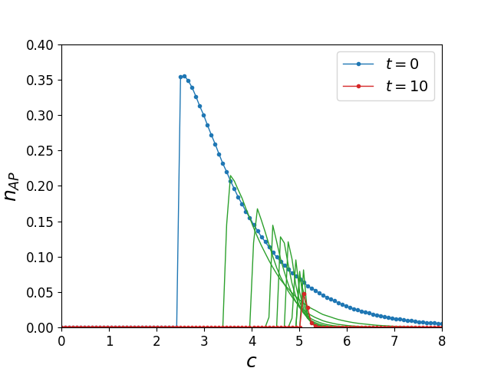
Figure 3. Fraction of APs in a two-layer ER network as function of the mean degree c.

Scale-free multiplex network with different exponents
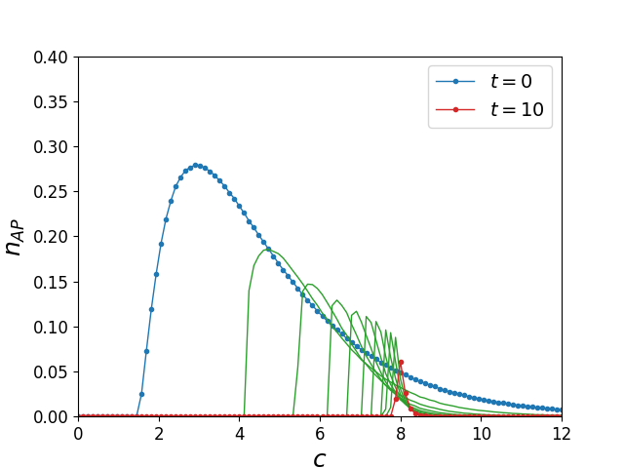
Figure 4. Fraction of APs in a two-layer scale-free network with the degree exponent 3 as function of the mean degree c.
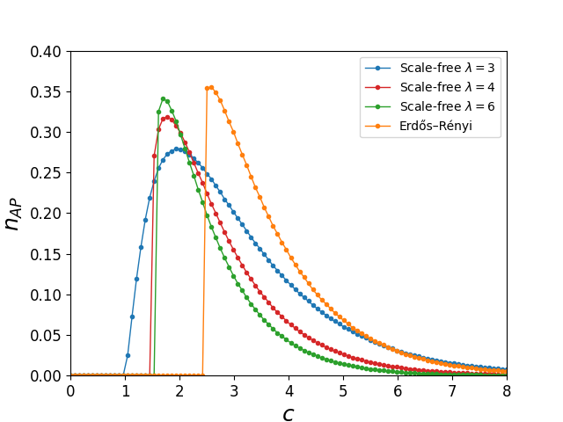
Figure 5. Scale-free networks with different degree exponents $λ$.

Other metrics
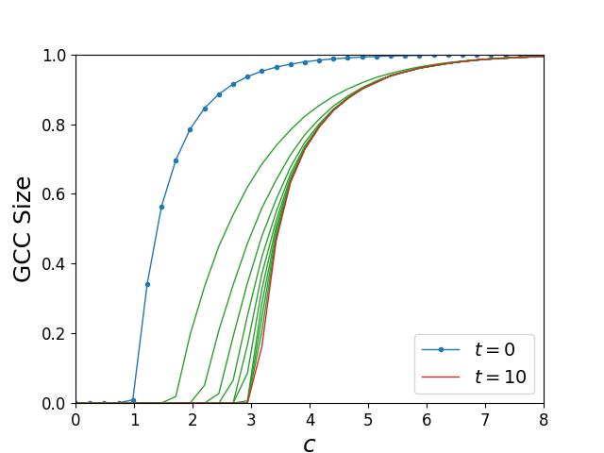
Figure 6. GCC size in a monoplex ER network as function of the mean degree c.
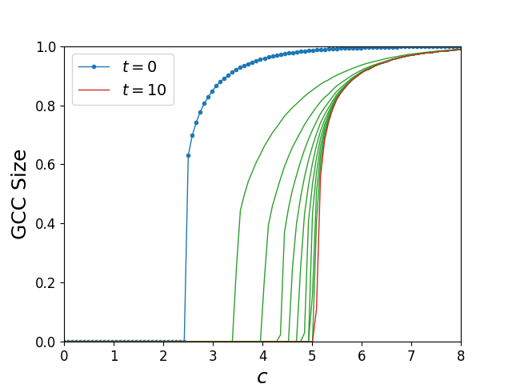
Figure 7. GCC size in a two-layer ER network as function of the mean degree c.
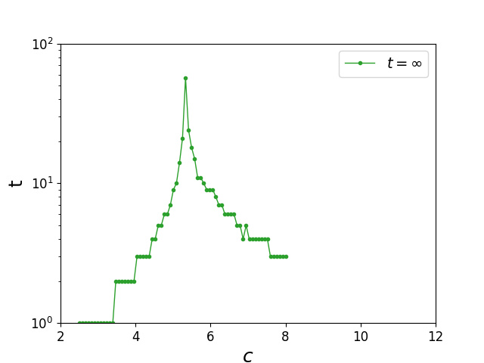
Figure 8. Total number of AP removal steps as function of the mean degree c for ER two-layer multiplex network.
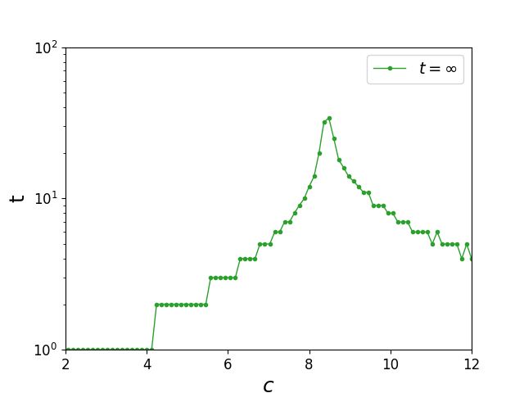
Figure 9. Total number of the AP removal steps as function of the mean degree c for scale-free two-layer multiplex network with the degree of the distribution 3.

Discussion
From the differences in the peaks of the curves in Figures 1, 3, 4 and the differences in phase transitions coordinates in Figures 6-7, it follows that in multiplex networks phase transition is shifted to the higher values of c. This means multiplex networks require more connections to stay connected than monoplex networks do. This needs to be taken into account when building systems with complex underlying structure that can be described by a multiplex network.

Conclusions
In this research, multiplex networks are compared to the monoplex networks in terms of their structure and stability via their articulation points distributions. Scale-free multiplex networks with various degree distribution exponents are analyzed in terms of their AP structure for the first time. Moreover, the AP distributions of ER and SF networks with various degree exponents are compared together.
Results of the research show how percolation phase transition in multiplex networks occurs at larger values of the mean degree $c$ compared to the monoplex networks case. This is caused by the phenomenon of cascade failure of nodes, which is inherent exclusively to multiplex networks. These results need to be considered when constructing and maintaining such networks, as the probability of complete network dismantling due to random failures jumps.

Author Contribution
TBD

Acknowledgements
The author would like to thank Prof. Vladimir Palyulin and Dr. Saeed Osat for their invaluable help and advice.

Abbreviations
AP = Articulation Point
ER network/graph = Erdős–Rényi network/graph
GCC = Giant Connected Component

References
[1] Tian, L. et al. Articulation points in complex networks. Nat. Commun. 8, 14223 doi: 10.1038/ncomms14223 (2017)
[2] Saeed Osat. Percolation on complex networks and its applications (2021)
[3] Buldyrev, S., Parshani, R., Paul, G. et al. Catastrophic cascade of failures in interdependent networks. Nature 464, 1025–1028 (2010). https://doi.org/10.1038/nature08932
[4] Firmani, D., Georgiadis, L., Italiano, G.F. et al. Strong Articulation Points and Strong Bridges in Large Scale Graphs. Algorithmica 74, 1123–1147 (2016). https://doi.org/10.1007/s00453-015-9991-z
[5] Tishby, I., Biham, O., Kühn, R., Katzav, E. Statistical analysis of articulation points in configuration model networks. Phys. Rev. E 98, 062301 (2018) arXiv:1806.04591
[6] Wandelt, S., Sun, X., Feng, D. et al. A comparative analysis of approaches to network-dismantling. Sci Rep 8, 13513 (2018). https://doi.org/10.1038/s41598-018-31902-8
[7] Fasino, D., Tonetto, A., Tudisco, F. Generating large scale free networks with the Chung Lu random graph model. arXiv:1910.11341v3
[8] Miller, J.C., Hagberg, A. (2011). Efficient Generation of Networks with Given Expected Degrees. In: Frieze, A., Horn, P., Prałat, P. (eds) Algorithms and Models for the Web Graph. WAW 2011. Lecture Notes in Computer Science, vol 6732. Springer, Berlin, Heidelberg. https://doi.org/10.1007/978-3-642-21286-4_10
[9] Goh, K.-I., Kahng, B., Kim, D. Universal behavior of load distribution in scale-free networks. arXiv: cond-mat/0106565v2

Appendix

