MASTER’S THESIS
Articulation Points in Multiplex Networks
Master’s Educational Program: Advanced Computational Sciences
Student: | signature | Artem Vergazov
Research Advisor: | signature | Vladimir Palyulin  Assistant Professor

Moscow 2022

Copyright 2022 Author. All rights reserved.
The author hereby grants to Skoltech permission to reproduce and to distribute publicly paper and electronic copies of this thesis document in whole and in part in any medium now known or hereafter created.
МАГИСТЕРСКАЯ ДИССЕРТАЦИЯ
Критические узлы в многослойных сетях
Магистерская образовательная программа: Современные вычислительные методы
Студент: | signature | Артём Вергазов
Научный руководитель: | signature | Владимир Палюлин  Старший преподаватель

Москва 2022

Авторское право 2022. Все права защищены.
Автор настоящим дает Сколковскому институту науки и технологий разрешение на воспроизводство и свободное распространение бумажных и электронных копий настоящей диссертации в целом или частично на любом ныне существующем или созданном в будущем носителе.

Articulation Points in Multiplex Networks
Artem Vergazov
Submitted to the Skolkovo Institute of Science and Technology on June 7, 2023
Abstract
In mathematical modeling, a concept of a network can represent many of the real-life complex systems. Many of the physical, technological, social, biological etc. phenomena can be described and simulated in terms of networks. Studying networks as a general mathematical object as well as analyzing them in terms of resistance to random node failures is crucial.
Furthermore, more complex phenomena are better described by multiplex networks, rather than simple monoplex networks. A multiplex network is a collection of monoplex networks, or layers, where all the nodes exist simultaneously in all the layers but the links within each layer can differ. An obvious example of such system is a social two-layer multiplex network with Facebook as one layer and Twitter as the other. Nodes represent people participating in these networks, and links represent connections between them in each of the networks. Obviously, classical notion of a network would not be sufficient for describing such system.
One of the notions that come up while studying networks is a notion of an articulation point – a node whose removal disconnects the network. Despite their fundamental importance, a general framework of studying articulation points in multiplex networks is lacking. While articulation points distribution in simple monoplex networks has been studied well enough, this phenomenon in multiplex networks has not been addressed as thoroughly yet.
Dealing with multiplex networks, one should be aware of the fundamental differences in resistance to random node failures between multiplex and monoplex networks. Each complex system is prone to occasional shutdowns of its parts, and monoplex and multiplex networks respond differently to the shutdowns of their nodes. A monoplex system does not lose much of its integrity and remains functioning in case a part of its nodes fails, meanwhile in a multiplex network a process which is known as cascade of failures starts because of interdependence of the layers. This process might cause the network defragmentation.
The purpose of this work is to study and compare the organization of monoplex and multiplex networks. We will be viewing their structure via the articulation points removal process as articulation points turn out to be the most crucial and vulnerable parts of such systems. We will also compare different random graph models in terms of such removal.
Keywords: complex networks, multiplex networks, articulation points, numerical simulation of complex networks, Erdős–Rényi graph, scale-free graph

Research Advisor:
Name: Vladimir Palyulin
Degree, title: assistant professor
Contents
Introduction 5
Literature Review 8
Articulation Points Removal in Monoplex Networks 8
Cascade of Node Failures in Multiplex Networks 11
Articulation Points in Configuration Model Networks 13
Approaches to Network Dismantling 13
Articulation Points Identification Algorithm 14
Literature Review Conclusions 14
Computational Methodology 16
Results and Discussion 17
AP removal in ER Multiplex Network 17
AP removal in SF Multiplex Network 20
SF models comparison 22
Conclusions 24
Author Contribution 25
Acknowledgements 25
Abbreviations 26
References 27

Introduction
Many of the natural and artificial systems are represented efficiently by a notion of graphs, or networks [1, 16-20]. A network is a collection of nodes some of which can be connected by links. Nodes serve to represent the building blocks, or components, of the system. These can be participants of a social network, metro stations in a transportation network, power grids in infrastructure network etc. Framework of networks also utilizes the notion of links to capture the node-to-node interactions in the systems. Depending on the nature of these interactions, a network can be directed or undirected. For example, a person following a friend on Twitter would be connected to them by a directed link because this interaction does not have to be mutual. In this case, the Twitter network is considered directed. Meanwhile, the transportation network in the example above would be undirected as one can go both ways between two connected metro stations. In this research, we limit our consideration to undirected networks for the sake of clarity. A basic term in network science is the degree of the node, which defines the number of its neighbors.
Recently the network science community has noted how complex systems evolve their connections in more than one dimension and started singling out a separate type of networks which are called multiplex [2], or multi-layer, and which will be the object of the current research. Multiplex networks can also be viewed as generalization of classical monoplex, or single-layered, networks. Or, in other words, a monoplex network can be viewed as the special case of a multiplex network with only one layer. Multiplex networks are complex systems that consist of multiple layers or networks of nodes, where the same set of nodes are connected by different types of edges or relationships. In such systems, nodes may have different sets of neighbors in different layers, and the interactions between nodes in one layer can affect and be affected by other layers. Studying the properties and dynamics of multiplex networks is essential in various fields, including social media analysis, economic systems, transportation networks, and biological systems. Schematic illustration of a multiplex network is provided below (Fig. 1).
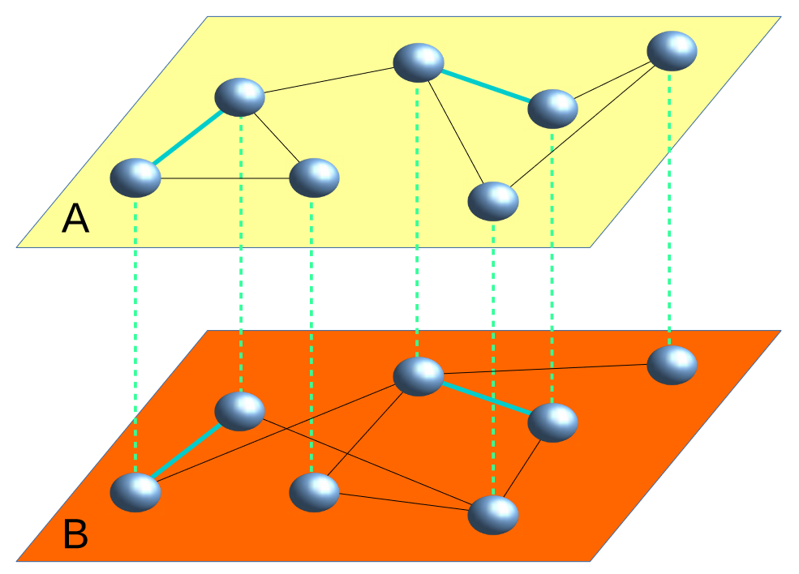
Figure 1. A multiplex network composed of two layers A and B. Each node simultaneously exists in both layers. Each layer represents a different type of interaction between nodes. [5]
The motivation for this research is the fact that any large system is prone to failures of its components and must be designed in a way that allows it to stay functional even with some random shutdown events. The networks concept provides handy framework to model node failures in complex systems. However, some nodes turn out to be more important for the network integrity than others. For instance, usually there are still ways to get from metro station A to metro station B when one of the central metro stations is closed because usually there are more than one path connecting those stations. But there is no way to reach the terminal station if the station before it is closed. It shows how some nodes can be painlessly removed from the network while some others bear critical importance to the network integrity. To compare the behavior of monoplex and multiplex networks in the circumstances of node failures we will analyze their structure via the articulation points distribution.
One important notion of network science is an articulation point (AP), which is a node that, if removed, can partition the network into disconnected components [21-22]. In a multiplex network, we will call a node an AP if it is an AP at least in one of its layers. In this thesis paper, we aim to investigate the implications of removing articulation points on the robustness and resilience of multiplex networks. The findings of this study can provide valuable insights into the structure and dynamics of complex networks and have important practical implications in network design and management. Being able to find articulation points and understanding the patterns of their behavior can help both prevent crucial systems from destruction (for example, designing more resilient infrastructure networks) or find weaknesses in such systems. The AP removal process as the method of decomposing the network has been described in [3] for the monoplex case. In this research, we will follow the same steps for the multiplex network case, but we will have to consider the new physics that arise due to multiplexity, as described in [4].
Many new effects can be found in multiplex networks dynamics that are not observed in monoplex networks case. This also concerns node removal. For example, removal of one node from a monoplex network simply disconnects the paths leading through that node. However, removal of a node from a multiplex network can produce an iterative cascade of failures in several interdependent layers. Example of this was observed in 2003 in Italy when the shutdown of power stations directly led to the failure of nodes in the Internet communication network, which in turn caused further breakdown of power stations resulting in electrical blackout [4, 23]. We will have to consider this effect when applying AP removal process from [3] to multiplex networks.
One more purpose of this research is to investigate the differences in behavior in said AP removal process between various random graph models: Erdős–Rényi random graph model and scale-free random graph model. But first it is important to remind of the definitions of these models in a classical monoplex network case.
Erdős-Rényi (ER) random graph model $G(N,p)$ (also called as Poisson graph) comes with two model parameters. $N$ is a number of nodes and $p$ is a probability of connection. Such graph can be created by generating $N$ nodes and connecting each pair of nodes with probability $p$ [6, 24]. It is shown that, for large $N$, ER graphs have Poisson degree distribution $P\left(k\right)=\frac{{\left(pN\right)}^{k}e^{-pN}}{k!}$, where $pN=<k>$ is the expected, or mean, degree of the network. This fact makes it convenient to generate an ER model graph with the given expected degree, and we will utilize it in our computations.
Another random graph model that will be considered in this research is a scale-free (SF) model. A scale-free network is a network with power law degree distribution $P\left(k\right)\sim k^{-λ}$. The degree of the distribution $λ$ is called the degree exponent. The network properties depend quite heavily on the degree exponent $λ$. For example, networks with $2<λ<3$ have infinite second moment of their degree distribution, and networks with $1<λ<2$ have infinite expected degree (first moment of degree distribution). As we will show later, this fact matters for the AP removal process. Distributions with $2<λ<3$ are more common in real-world systems than Poisson distribution, as they are heavy. Scale-free networks are usually generated from the given degree distribution. For the purposes of this research, we will create such networks using the algorithm described in [7-9], which allows for generation of SF random networks with given expected degree and given degree exponent.
The structure of this thesis is as follows. In the Literature Review section, a more detailed description of the AP removal process is given and reproduction of the results from [3] for the monoplex network case is provided. Also, the cascade of failures effect from [4] is described and the corresponding results for the monoplex network case are reproduced. Reproduction of the previously obtained results is necessary for the further comparison of the multiplex and monoplex network cases. Moreover, it is helpful for understanding the terminology and common approaches.
The main instrument we use in this work are the computer simulations. In the Computational Methodology section, a description of all the steps of the simulation workflow is given with the set of tools used.
Finally, in the Results and Discussion section, the figures showing the main trends discovered in the experiments are presented and the conclusions are made.

Literature Review
The following is the review of the works [3, 4] considering AP removal process and cascade of node failures. After demonstrating these results for the monoplex network case, we will be able to move on to multiplex networks and comparison.

Articulation Points Removal in Monoplex Networks
In [3], authors come up with strategies of network attack and network decomposition in which AP distributions play the major role. Namely, they describe the process of AP removal as a tool for analyzing robustness of a monoplex network to failures of its components. It is found that AP removal provides a new prospective on the organization principles of networks. For example, it is shown how in terrorist communication network of the 9/11 attacks on the US (Fig. 2), each AP (marked in red) can be viewed as a messenger of a certain subnetwork, which is usually its neighborhood, since most of the paths existing in a network are known to lead through APs. The suggested AP removal process is illustrated in Fig. 2 and goes as follows. At step 0, we identify and remove all the APs (messengers, critical nodes) of the network. Such removal leads to the emergence of new APs in the leftover network. At step 1, we remove those APs, too, and we continue these steps until no APs emerge in the network.
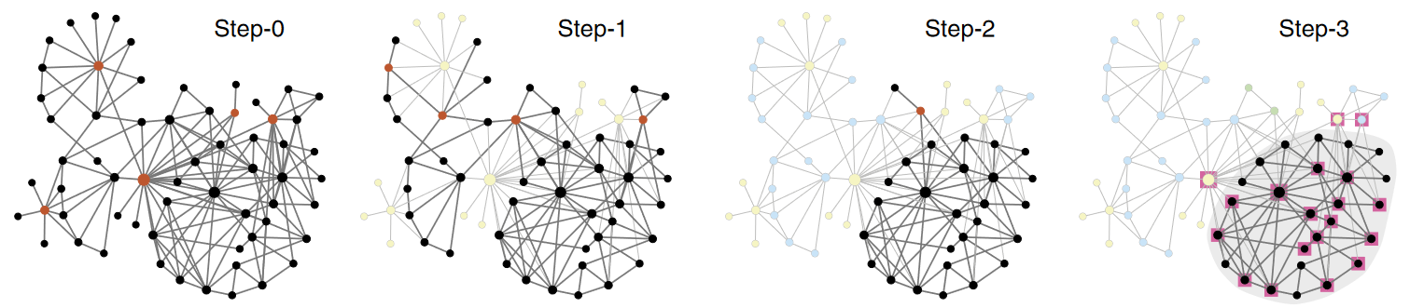
Figure 2. Articulation points and the greedy AP removal process in the terrorist communication network from the attacks on the US on 9.11.2001. APs are highlighted in red. [10]

Depending on the internal network structure, or, more specifically, the mean degree of the network, this greedy AP removal process will lead us to either a completely decomposed network with disconnected tree-like subsets of nodes no larger than three nodes per a tree, or a residual Giant Connected Component (GCC) occupying a finite fraction of the network will emerge with no APs in it. This residual GCC in essence represents the network core responsible for the network integrity and maintaining its functionality.
As we have mentioned earlier, the described AP removal process has two different outcomes which depend on the mean degree of the initial network. Just like the authors of the original paper, we will run simulations of AP removal process and measure three important quantities: the fraction of APs (denoted on plots as $n_{AP}$), the size of the leftover residual GCC (denoted on plots as $s_{GCC}$) as the fraction of the initial network size, and the total number of steps $T$ that the AP removal process takes for the given network. We will treat these three quantities listed above as functions of the mean degree of the network $c$, and we will plot the corresponding curves $n_{AP}(c)$, $s_{GCC}(c)$, and $T(c)$. Moreover, the AP removal process generates a series of network layers for the corresponding time steps $\{0,1,…,T\}$, and for each of these time steps there exist the corresponding $n_{AP}$ and $s_{GCC}$. So, for the first two types of plots – $n_{AP}$ and $s_{GCC}$ – we will plot the corresponding curve for each discrete time step, but we will limit ourselves to the first 10 steps, as this number of steps is enough to get an intuition of the dynamics going on in the network. In this section, we will reproduce the results of the paper in the described manner for ER monoplex networks (Figs. 3-5), and in the results section, we will discuss the results of this process applied to ER and SF multiplex networks. From here and after, we will denote the size of a monoplex network by $N$. The same notation will be used for the size of a layer of a multiplex network. For example, we will say the size of a two-layer multiplex network is equal to $N$, if the size of its single layer is $N$. We will also assume that layers of a multiplex network are of the same size.
Moreover, authors of the original paper develop analytical equations governing the dependency of APs proportion in a random network on its parameters. For example, the analytical dependency of APs proportion on the mean degree parameter $c$ in Erdős–Rényi network (ER network) was derived in the paper. For clarity, the analytical curve is also presented at Fig. 3.
Expectedly, the fraction of APs $n_{AP}$ is trivially zero in the two limits $c→0$ and $c→∞$, so it must reach maximum at some critical mean degree $c_{AP}$. It is shown in the original paper that for ER monoplex networks that value is 1.41868…, and it shifts to the right with each step of the process, approaching the limiting value of 3.4… That value shows what degree the network should have in order to stay connected after the described AP removal process, because the networks with the degree larger than this critical value have a non-zero residual GCC size even after 10 steps of the process (Fig. 4). Of interest to us will be the corresponding critical value in multiplex ER and SF networks – the value of the mean degree required for the core of the network to stay functioning. This question will be answered in the Results section.
These results are of great importance for budget-limited network construction/destruction but are only applicable for monoplex networks. Generalization of these results to the multiplex networks case is one the goals of this work.
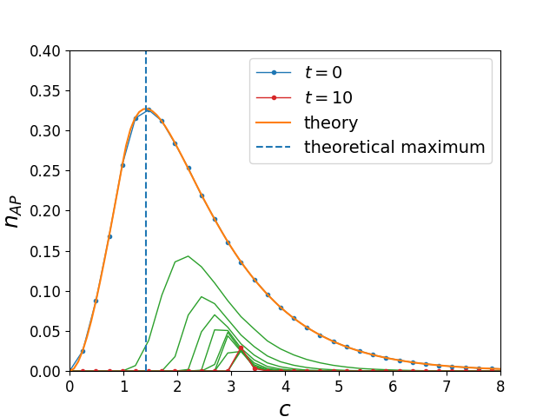
Figure 3. Verification of paper [3] results. Fraction of articulation points $n_{AP}$ in ER monoplex network as function of the mean degree of the network nodes $c$. The blue curve corresponds to the initial state of the network. Each green curve corresponds to a discrete step of the AP removal process. The red curve corresponds to the step of the process $t=10$, which is not yet final for the process, but can quite accurately be viewed as the limiting curve of the process. $N={10}^{5}$.
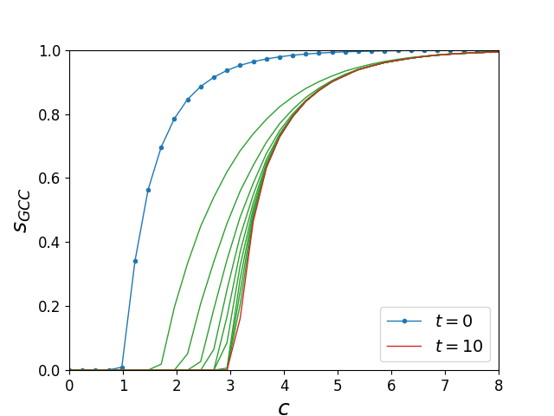
Figure 4. Verification of paper [3] results. Size of the residual GCC $s_{GCC}$ in ER monoplex network as function of the mean degree of the network nodes $c$. The blue curve corresponds to the initial state of the network. Each green curve corresponds to a discrete step of the AP removal process. The red curve corresponds to the step of the process $t=10$, which is not yet final for the process, but can quite accurately be viewed as the limiting curve of the process. $N={10}^{5}$.

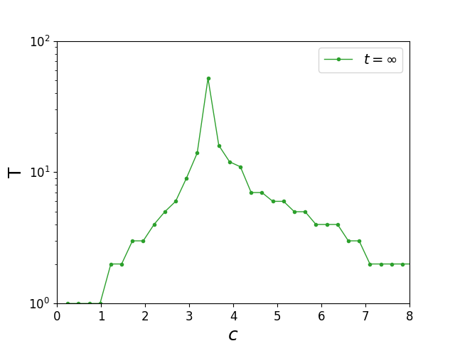
Figure 5. Verification of paper [3] results. Total number of AP removal process steps $T$ in ER monoplex network as function of the mean degree of the network nodes $c$. $N={10}^{5}$.

Cascade of Node Failures in Multiplex Networks
When we carry on with the described AP removal process to the multiplex network case, we will have to deal with effects that arise due to multiplexity. When working with multiplex networks, it is essential to consider the interdependence between layers, as the failure of nodes or edges in one layer can trigger a cascade of failures in other layers, leading to catastrophic consequences. This effect, known as the cascading failure phenomenon, has been studied extensively in the literature. In particular, the paper "Catastrophic Cascade of Failures in Interdependent Networks" (Buldyrev et al., 2010) [4] investigates the cascading failure dynamics in multiplex networks with interdependencies.
The study by Buldyrev et al. is motivated by the recognition that many real-world systems involve multiple layers of networks that are interconnected and interdependent. For example, power grids are connected to communication networks, which in turn rely on power grid networks, and disruptions in one layer can cause failures in other layers. The authors use a model of interdependent networks to investigate the propagation of failures in such systems. In their model (Fig. 6), nodes in each layer are connected to their counterparts in other layers, and if a node fails in one layer, it also causes its neighbors in other layers to fail with a certain probability.
Using simulations, the authors demonstrate that the cascading failure phenomenon in interdependent networks can lead to catastrophic consequences, such as the complete collapse of the entire system, even when only a small fraction of nodes fail initially. They also show that the structure of the interdependence between the layers plays a crucial role in determining the robustness of the network to cascading failures. In particular, they find that networks with interdependence hubs, i.e., nodes that are highly connected in one layer and also have many connections to other layers, are more vulnerable to cascading failures than networks without such hubs.
The study by Buldyrev et al. highlights the importance of considering interdependencies when working with multiplex networks, as the cascading failure effect can significantly alter the behavior of the system. In our study of articulation points in multiplex networks, we need to take into account the possible cascading failures caused by the removal of articulation points in one layer, as it may trigger a cascade of failures in other layers. Therefore, it is necessary to investigate the impact of articulation point removal on the interdependence structure of the network and the potential cascading effects.
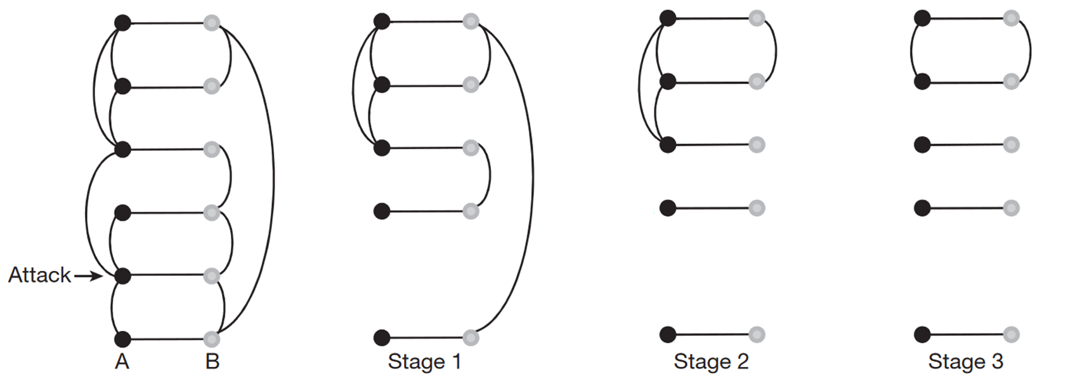
Figure 6. Cascade of node failures in an example two-layer multiplex network. A failure of a node in layer A causes failure of the dependent node in layer B. At stage 1, layer A is divided into 3 clusters. At stage 2, links from layer B that connect nodes dependent on separate A-clusters are removed because such B-nodes are desynchronized from the main mutually connected component of the network. This breaks layer B into 4 clusters. At stage 3, A-links that join nodes dependent on separate B-clusters are removed for the same reason. The process continues until no further link elimination occurs and A-clusters coincide with B-clusters. [4]

In Fig. 6, an example of such cascade of failures is provided. The resulting part of the network is what, in essence, stays functional after a simple node removal in this case. Since, in our further experiments, we will be removing APs from multiplex networks, we will have to apply this process of cascade of failures after each removal in order to respect this effect that only arises due to multiplexity and interdependence. In the Results section, we will discuss how the presence of this effect changed the critical values of the mean degrees $c$, required for the multiplex networks to stay functional after iterative AP removal.

Articulation Points in Configuration Model Networks
The emergence and characteristics of APs in networks have been of interest to researchers for several decades due to their crucial role in network connectivity and robustness. In this paper [13], titled "Statistical analysis of articulation points in configuration model networks", the authors present analytical results for the statistical properties of APs in configuration model monoplex networks, which are random graphs wherein nodes are assigned degrees based on a prescribed degree sequence. Specifically, they investigate the probability that a random node in a network is an AP and the influence of its degree on this probability. The authors evaluated the probabilities presented across the GCCs of configuration model networks with Poisson (ER), exponential, and power-law (SF) degree distributions.
Overall, the authors' analytical results are a significant contribution to the understanding of the statistical properties of APs in configuration model networks. Notably, they present their revelations on AP distribution shape which agree with the results of [3] and the results of “AP Removal in Monoplex Networks” subsection of the current research.

Approaches to Network Dismantling
The paper "A comparative analysis of approaches to network-dismantling" by Wandelt et al. [14] provides a comprehensive review of various methods for network dismantling. The authors compare the efficiency of these methods on different types of networks, including scale-free, random, small-world, and regular networks, as well as real-world networks, such as the Internet.
One of the important to us contributions of this paper is that it demonstrates the effectiveness of the AP removal method for network dismantling. The authors show that removing APs can be an efficient way to disrupt the functioning of a network, particularly in the case of SF and small-world networks.
This finding is highly relevant to the current thesis topic. By removing APs from multiplex networks, we aim to disrupt the functioning of the network and analyze the resulting changes in the network structure and dynamics. The results of the study by Wandelt et al. suggest that the AP removal method may be a promising approach to achieving this aim.

Articulation Points Identification Algorithm
In the paper "Strong Articulation Points and Strong Bridges in Large Scale Graphs," Firmani et al. [15] present novel algorithms for identifying strong APs (nodes whose removal increases the number of strongly connected components) in large scale graphs. Their work builds upon previous research on graph theory and network analysis but focuses specifically on the identification of these critical points in graphs with millions of vertices.
The authors' algorithms are capable of identifying strong APs in real-world graphs, such as online social networks and transportation networks, with high accuracy and efficiency. They also demonstrate the applicability of their algorithms to several practical problems, including network robustness analysis and community detection.
The paper's findings are applicable to the current thesis. Firmani et al.'s work provides valuable insights and techniques for algorithms of identifying APs in large scale graphs. The authors' focus on large scale graphs is particularly useful, as in the current work we deal primarily with large networks. "Strong Articulation Points and Strong Bridges in Large Scale Graphs" offers valuable contributions to network science and will serve as an important reference for the current thesis paper.

Literature Review Conclusions
In conclusion, this literature review has explored the impact of AP removal on the robustness of monoplex networks, specifically focusing on the work [3]. The review showed how AP removal can provide insight into the organization principles of networks, as well as lead to a residual GCC that represents the core responsible for network functionality. The analytical equations governing the dependency of APs proportion in a random network on its parameters were verified for ER monoplex networks.
Moving onto the multiplex network case, the review highlighted the importance of considering interdependencies between layers and the potential cascading effects of AP removal. The study [4] demonstrated how the cascading failure phenomenon in interdependent networks can lead to catastrophic consequences and highlighted the need to investigate the impact of AP removal on the interdependence structure of the network. The review analyzed the proposed process of cascade failures that needs to be applied after each removal of APs in multiplex networks.
Overall, this literature review emphasizes the significance of AP removal as a tool for analyzing network robustness and the need to consider interdependence when studying multiplex networks. The upcoming Computational Methodology section will discuss the tools and practices that were used to obtain the results of this thesis, and the Results section will discuss the implications of the reviewed works for ER and SF multiplex networks.

Computational Methodology
To answer the questions stated in Introduction and Literature Review sections, we ran computer simulations, in which the following workflow was kept.
- Generation of a set of networks from a certain distribution (ER or SF).
In all simulations, we used two-layer multiplex networks of size ${N=10}^{5}$. To obtain an instance of a two-layer network, it is enough to generate two separate instances of simple graphs with the desired degree distribution (these instances represent layers of a multiplex network), label the nodes in each layer with numbers from 1 to $N$, and assume the nodes, which are replicas of each other, from different layers are labeled with the same number.
In the manner described, we generate a multiplex network for each possible value of the mean degree $c$. To create an ER network with the given degree, I used the fast $G_{n,p}$ random network algorithm adapted from [11]. To create a SF network with given degree, I used the configuration network generation algorithm adapted from [7-9].
- Application of cascade of failures which essentially means removing the links from the generated networks according to the cascade of failures procedure described in [4] and in the Literature Review section of the current work.
- Identifying the current GCC size $s_{GCC}$. Identifying the APs using recursive depth-first search-based algorithm [15, 25] and their number $n_{AP}$ and removing them from the network. Repeating steps 2-3 until no more APs emerge in the networks.
- Obtaining the total number of AP removal process steps $T$.
Given the randomness of the network generation, we repeat the procedure 1-4 for 10 independent realizations of the network ensembles and apply averaging to the results.
Simulations were done in vanilla C++ because of the extremely high computational cost of those simulations for large networks (hundreds of thousands of nodes). Python was used for prototyping and plotting. In C++, running steps 1-4 with the network size $N={10}^{5}$ with the averaging over 10 independent realizations takes ~2 hours, meanwhile in the Python realization the same job took a few days.
The code used for simulations and plotting is available at [12].

Results and Discussion
In previous sections, the workflow was suggested that combines the AP removal experiment from [3] with the cascade of failures experiment from [4] and allows to apply the AP removal process to multiplex networks and compare the results with the results of [3]. Based on this workflow, the following numerical experiments involving AP removal in multiplex networks have been conducted: AP removal in ER two-layer networks, AP removal in SF two-layer networks, and comparison of AP distributions in ER and SF networks with different degree exponents. In this section, the results for these experiments are presented and discussed.

AP removal in ER Multiplex Network
In Figs. 7-9, the fraction of APs $n_{AP}$, the size of the GCC $s_{GCC}$, and the total number of AP removal steps $T$ are plotted as functions of the mean degree of the network $c$. Similarly to the monoplex network case (Figs. 3-5), each discrete step of the AP removal process produces a new AP distribution and the GCC size function which are plotted in the same figures as separate curves. In this case, we will as well limit ourselves to $t=10$ curves, as this is enough to define the limiting behavior of the curves, although the process itself might take more steps for some values of $c$.
Let us begin the discussion of the plots with the similarities they share with the monoplex network case plots. Like we have observed in the monoplex network example, $n_{AP}$ is zero when $c→0$ or $c→∞$. It is explained trivially: in case when $c→0$ the network has not yet grown enough connections and consists mainly of disconnected tree-like components with no APs, and in case when $c→∞$ a major part of the network is occupied by the GCC, in which any pair of nodes is connected by at least two paths and no APs exist either. Furthermore, the AP distribution curves, too, have peaks. In general, it is quite safe to say that qualitatively the three Figs. 7-9 look similar to the Figs. 3-5, because the coordinates of the peaks of the $n_{AP}$ curves coincide with the coordinates of the fastest growth points of the $s_{GCC}$ curves. This means that emergence of the GCC produces the largest numbers of APs, but when the GCC has not yet emerged ($c→0$) or has already occupied most of the network ($c→∞$), the fraction of APs is not high in both monoplex and multiplex cases.
However, fundamental differences can be found between the Figs. 3-5 and the Figs. 7-9. First, the coordinates of the AP curves peaks, as well as corresponding to them coordinates of the fastest growth points of $s_{GCC}$, shift to the right compared to the monoplex network case, and the percolation phase transition now happens at larger values of $c$. For ER monoplex networks, we found that the value of the degree the network was required to have in order to stay connected after the AP removal process was equal to 3.4… For the multiplex network case, this value is now 5.1… (the coordinate of the red curve peak, assuming the red curve is close enough to the limiting curve). This is the result of the cascade of failures effect which emerges during the AP removal process. Due to this effect, multiplex networks require more connections to stay functional; Fig. 8 shows that, after 10 steps of the AP removal process, the network does not have a GCC if its initial mean degree was less than 5.1.
Another difference between monoplex and multiplex cases is found in the order of phase transition that the networks undergo. In the monoplex network case (Figs. 3-4), the GCC curves are continuous suggesting a continuous phase transition that is common in monoplex networks percolation. However, in Figs. 7-8, we see AP distribution curves having a discontinuous jump and GCC curves having a jump in their first-order derivatives, which suggests a first-order percolation phase transition. This, once again, emphasizes that multiplex networks are fundamentally different from monoplex networks because of the interlayer dependencies.
It is important to note that the obtained critical value of $c$ and the order of phase transition are only true for ER two-layer multiplex networks. The analogous results for SF networks will be presented in the next subsection.
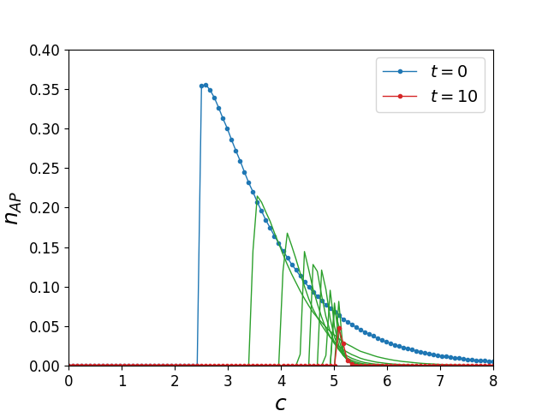
Figure 7. Fraction of articulation points $n_{AP}$ in a two-layer ER network. $c$ is the mean degree of the network nodes. The color symbols are similar to Fig. 3. $N={10}^{5}$

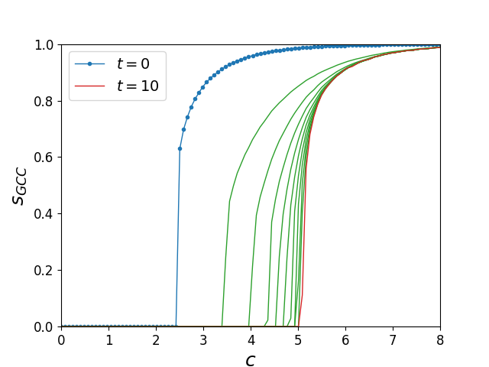
Figure 8. Size of the GCC $s_{GCC}$ in a two-layer ER network as function of the mean degree c. The color symbols are similar to Fig. 4. $N={10}^{5}$

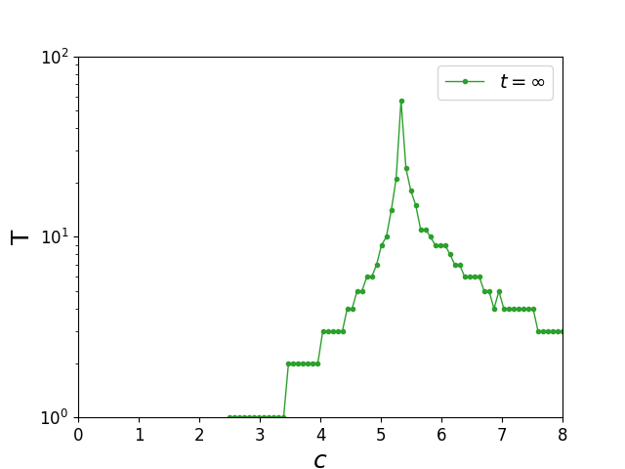
Figure 9. Total number of the AP removal process steps in a two-layer ER network as function of the mean degree c. $N={10}^{5}$

AP removal in SF Multiplex Network
In this subsection, we calculate $n_{AP}$ and $s_{GCC}$ curves and obtain the plots analogous to Figs. 7-9 for another canonical random graph model: scale-free model with power-law degree distribution $P\left(k\right)\sim k^{-λ}$. $λ$ is called the degree exponent. In Figs. 10-12, AP distribution curves, GCC size curves, and the total number of steps of the AP removal process curve are presented for degree exponent $λ=3$. Comparative analysis of $n_{AP}$ curves for SF networks with various exponents can be found in the upcoming subsection.
We will not enumerate the similarities between the monoplex case (Figs. 3-5) and SF multiplex case (Figs. 10-12) since they are completely analogous to ER multiplex figures. Instead, we will focus on comparison between ER multiplex case (Figs. 7-9) and SF multiplex case (Figs. 10-12). To begin with, the curves in all three figures are stretched to the right compared to Figs 7-9. Apparently, ER networks come to steadiness at $c\sim 7-8$, and in SF networks it only happens at $c\sim 10-12$. This might be a consequence of SF networks having power-law degree distribution. For the same reason, the value of the degree the network was required to have in order to stay connected after the AP removal process for SF networks is $c=8$ (red curve peak in Fig. 10), and for ER networks it was $c=5.1$.
Interestingly, the AP distribution curves in Fig. 10 and GCC size curves in Fig. 11 appear to be continuous and indicate a continuous percolation phase transition, which is more typical for ER monoplex networks rather than multiplex networks, in which we observed a clear discontinuous first-order percolation phase transition. This might be due to the chosen value of the degree exponent $λ=3$, which is a known borderline value for SF networks: SF networks with $2<λ<3$ have infinite second moment of the degree distribution.
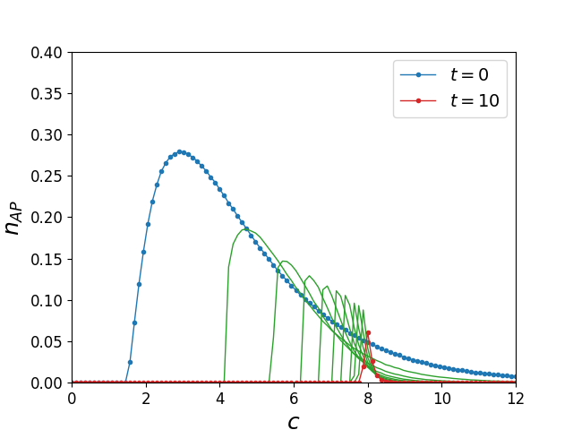
Figure 10. Fraction of APs in a two-layer SF network with the degree exponent $λ=3$ as function of the mean degree c. The color symbols are similar to Fig. 7. $n={10}^{5}$.

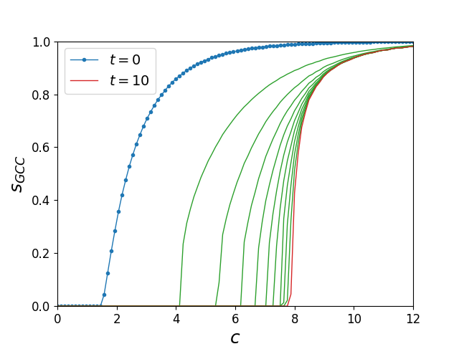
Figure 11. GCC size in a two-layer SF network with the degree exponent $λ=3$ as function of the mean degree $c$. The color symbols are similar to Fig. 8. $n={10}^{5}$.

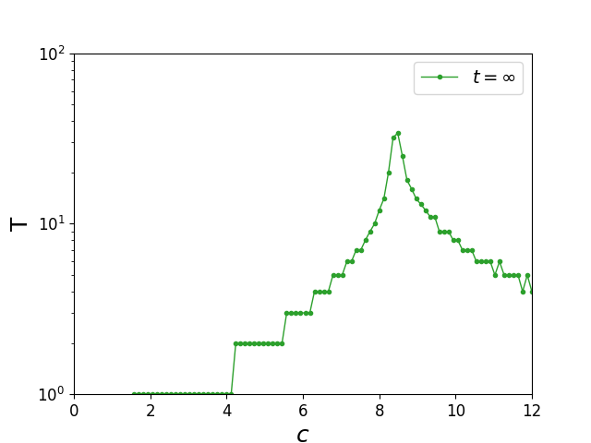
Figure 12. Total number of AP removal process in a two-layer SF network with the degree exponent $λ=3$ as function of the mean degree $c$. $n={10}^{5}$.

SF models comparison
Finally, AP distributions of scale-free two-layer networks with degree exponents 3 and 4 are presented in Fig. 13. For comparison, AP distribution of ER two-layer network is presented as well. In the previous subsection, we made a hypothesis that the probable cause for continuous phase transition in SF networks (Figs. 10-11) is explained by a borderline value of the degree exponent $λ=3$. Fig. 13 confirms our hypothesis: we see a jump in the first order derivative of the red curve that corresponds to SF networks with $λ=4$, as we could have expected based on first order transition of the ER multiplex networks. We once again remind the difference between the two cases: SF networks with the degree exponent of 3 might have infinite second moment of their degree distribution, meanwhile networks with the exponent of 4 have finite second moment. These results suggest that there could be a connection between the network’s degree distribution and the order of the phase transition it undergoes during AP removal process. This leaves avenue for further research.
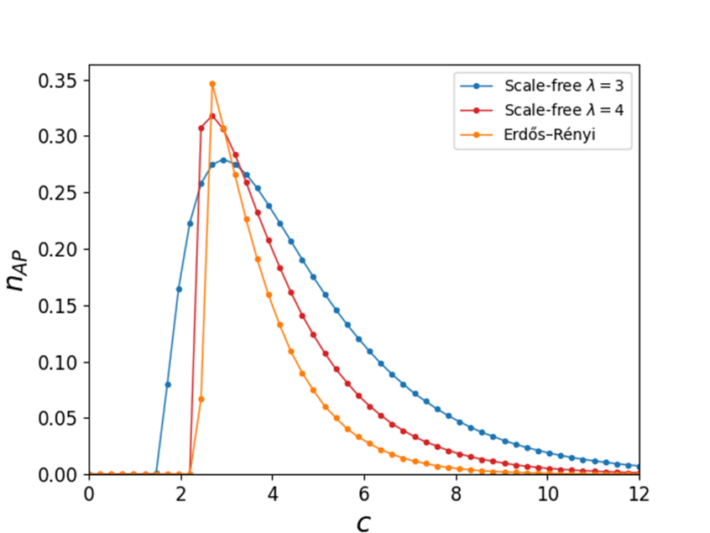
Figure 13. Scale-free networks with different degree exponents $λ$.

Conclusions
In this research, multiplex networks are compared to the monoplex networks in terms of their robustness to articulation points removal. Due to the cascade of failures effect inherent to multiplex networks, such networks are more inclined to complete dismantling during removal process. The critical values of the mean degree are obtained for ER and SF multiplex networks and are shown to be larger than the corresponding values for monoplex networks. These results may have practical applications in various fields, such as transportation systems, power grids, social networks, and communication networks, where the robustness of interdependent networks is crucial for their effective functioning and maintenance.
Scale-free multiplex networks with various degree distribution exponents are analyzed in terms of their AP structure. According to the best author’s knowledge, such analysis is done for the first time for SF networks. Results imply the connection between the network’s degree distribution and the order of the phase transition in the AP removal process. These results may be of importance to theoretical applications as they leave room for interesting further research on this topic.

Author Contribution
In this MSc thesis research, the author verified the analytical and numerical results presented in the Literature Review section of the current work. He also provided the code for numerical simulations described, performed the computations, visualized the results, carried out the analysis of the experimental results and wrote the current manuscript.

Acknowledgements
The author would like to thank Prof. Vladimir Palyulin and Dr. Saeed Osat for their invaluable help and advice.

Abbreviations
AP = Articulation Point
ER network/graph = Erdős–Rényi network/graph
SF network/graph = Scale-Free network/graph
GCC = Giant Connected Component

References
[1] Albert-László Barabási et al. Network science. Cambridge university press, 2016
[2] Ginestra Bianconi. Multilayer networks: structure and function. Oxford university press, 2018
[3] Tian, L. et al. Articulation points in complex networks. Nat. Commun. 8, 14223 doi: 10.1038/ncomms14223 (2017)
[4] Buldyrev, S., Parshani, R., Paul, G. et al. Catastrophic cascade of failures in interdependent networks. Nature 464, 1025–1028 (2010). https://doi.org/10.1038/nature08932
[5] Saeed Osat. Percolation on complex networks and its applications (2021)
[6] Paul Erdős and Alfréd Rényi. “On the evolution of random graphs”. In: Publ. Math. Inst. Hung. Acad. Sci 5.1 (1960), pp. 17–60
[7] Fasino, D., Tonetto, A., Tudisco, F. Generating large scale free networks with the Chung Lu random graph model. arXiv:1910.11341v3
[8] Miller, J.C., Hagberg, A. (2011). Efficient Generation of Networks with Given Expected Degrees. In: Frieze, A., Horn, P., Prałat, P. (eds) Algorithms and Models for the Web Graph. WAW 2011. Lecture Notes in Computer Science, vol 6732. Springer, Berlin, Heidelberg. https://doi.org/10.1007/978-3-642-21286-4_10
[9] Goh, K.-I., Kahng, B., Kim, D. Universal behavior of load distribution in scale-free networks. arXiv: cond-mat/0106565v2
[10] Krebs, V. E. Mapping networks of terrorist cells. Connections 24, 43–52 (2002)
[11] Python NetworkX fast_gnp_random_graph documentation
[12] https://github.com/ArtemVergazov/ap_in_multiplex_networks
[13] Tishby, I., Biham, O., Kühn, R., Katzav, E. Statistical analysis of articulation points in configuration model networks. Phys. Rev. E 98, 062301 (2018) arXiv:1806.04591
[14] Wandelt, S., Sun, X., Feng, D. et al. A comparative analysis of approaches to network-dismantling. Sci Rep 8, 13513 (2018). https://doi.org/10.1038/s41598-018-31902-8
[15] Firmani, D., Georgiadis, L., Italiano, G.F. et al. Strong Articulation Points and Strong Bridges in Large Scale Graphs. Algorithmica 74, 1123–1147 (2016). https://doi.org/10.1007/s00453-015-9991-z
[16] Watts, D. J. & Strogatz, S. H. Collective dynamics of ‘small-world’ networks. Nature 393, 440 – 442 (1998)
[17] Barabási, A.-L. & Albert, R. Emergence of scaling in random networks. Science 286, 509 –512 (1999
[18] Albert, R. & Barabási, A.-L. Statistical mechanics of complex networks. Rev. Mod. Phys. 74, 47 (2002)
[19] Newman, M. E. J., Barabsi, A.-L. & Watts, D. J. (eds) The Structure and Dynamics of Networks (Princeton Univ. Press, 2006)
[20] Newman, M. E. J. The structure and function of complex networks. SIAM Rev. 45, 167–256 (2003)
[21] Behzad, M. & Chartrand, G. Introduction to the Theory of Graphs (Allyn and Bacon, 1972)
[22] Harary, F. Graph Theory (Addison-Wesley, 1969)
[23] Rosato, V. et al. Modelling interdependent infrastructures using interacting dynamical models. Int. J. Crit. Infrastruct. 4, 63 –79 (2008)
[24] Erdős, P. & Rényi, A. On random graphs I. Publ. Math. 6, 290– 297 (1959)
[25] Tarjan, R. E. & Vishkin, U. An efficient parallel biconnectivity algorithm. SIAM J. Comput. 14, 862–874 (1985)

