ISP Research Report – Complex Networks Analysis

*Artem Vergazov*

*Project Advisor: Vladimir Palyulin*

*Main goals of this research* are studying complex and multiplex networks, working with articulation points in random Poisson graphs and repeating results of the referenced papers.

*Importance of studying complex networks.* In mathematical modeling, a concept of a network can represent many of the real-life complex systems. Many of the physical, technological, social, biological etc. phenomena can be described simulated in terms of networks. Hence the importance of studying complex networks as a mathematical object in general and coming up with helpful and convenient tools of analyzing them.

One of the notions that come up while studying complex networks is a notion of an articulation point – a node whose removal disconnects the network. Despite their fundamental importance, a general framework of studying articulation points in complex networks is lacking.

*Articulation points.* A node in graph is called an articulation point (AP) if its removal disconnects the network or increases the number of connected components in the network. APs can be easily identified using a linear-time depth-first search algorithm. It is important to understand APs behavior in complex systems and having efficient algorithms of searching for them because they ensure the connectivity of the network. Smart algorithm of APs removal, if done right, can destroy or disconnect the whole network which becomes important in systems of large infrastructure, anti-terrorist operations etc.

For random Erdős-Renyi (ER) graphs with Poisson degree distribution $P(k)=e^{-c}\frac{c^{k}}{k!}$ we investigate the behavior of the fraction of APs $n_{AP}={N_{AP}}/N$ depending on the parameter of the distribution $c$– the mean degree of a network. For a large range of $c$ values, we create an instance of a random ER graph and calculate $n_{AP}$. We obtain an experimental curve this way.

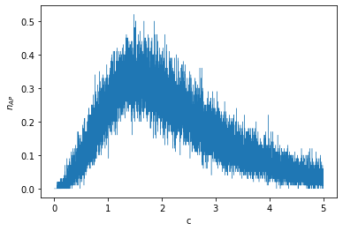

We also need to obtain the analytical dependency $n_{AP}(c)$ by solving the following system of equations (for explanation see the referenced paper):

$$\left\{\begin{aligned}n_{AP}\left(c\right)=1-G\left(1-α_{0}\right)-cα_{0}G(0) \\ G\left(x\right)=\sum_{k}{P\left(k\right)x^{k}} \\ α_{0}=G\left(α_{0}\right)=1\end{aligned}\right.$$

This system of equations has been derived for the case of ER graphs with Poisson degree distribution $P(k)$ from the Supplementary material to the “Articulation Points in Complex Networks” paper.

After averaging the experimental curve, we compare it with the obtained analytical curve for the dependency of $n_{AP}(c)$. We get the following plot and notice that the two curves show similar behavior at small values of $c$ but diverge when $c$ increases. This divergence needs explanation which we are going to provide in our following works. Now we tend to think that this is a miscalculation from our side.

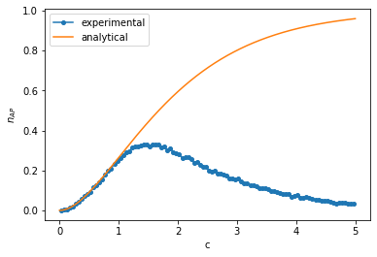

*References.*

Tian, L. et al. Articulation points in complex networks. Nat. Commun. 8, 14223 doi: 10.1038/ncomms14223 (2017)

arXiv:0907.1182 [cond-mat.dis-nn]