Skoltech: Advanced Computational Sciences

Artem Vergazov

Reproduction Report: Collective Phenomena Emerging from the Interactions between Dynamical Processes in Multiplex Networks

Paper by Vincenzo Nicosia, Per Sebastian Skardal, Alex Arenas, Vito Latora

Networks are a powerful tool of modeling phenomena from various fields of science. Network science has found applications in physics, biology, social sciences, etc. The structure of the network (its topology) has effect on the processes that take place over the network. Using networks as a modeling tool opens new possibilities for science in these fields.

In some cases, a simple notion of a network is not enough to describe all the complexity of the observed process. Multilayered networks, called multiplex, come to help. A multiplex network is a network of several layers, meanwhile each layer is itself a simple network. Layers must have the same number of nodes, all nodes representing an entity in its different interactions. A typical example of such network would be a 2-layered network with one layer being Facebook network and the other layer being Twitter network. Nodes in these layers represent people participating in these networks, and edges in both layers would represent existence of connection. If two nodes are connected in the first layer, it means they are friends on Facebook. If they are connected in the second layer, it means they follow each other on Twitter. Mulptiplex networks are very powerful tool of modeling complex phenomena where simple networks are not powerful enough.

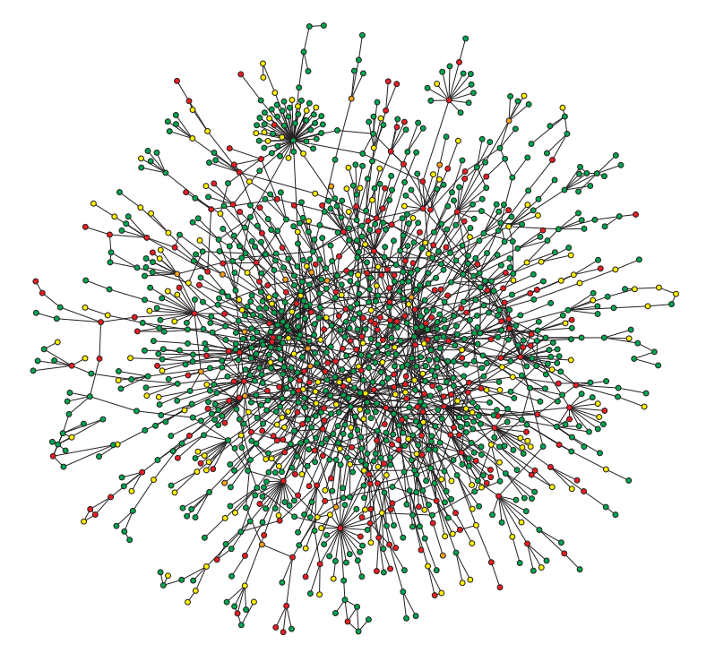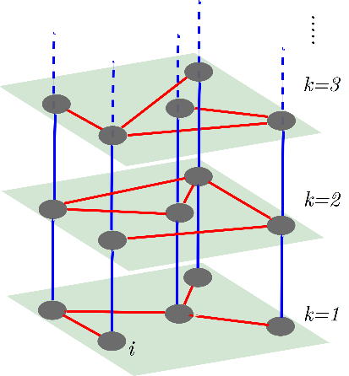

In the reviewed paper, the authors suggest a general multiplex network framework for modeling the coupling of dynamical processes that interact with each other. For simplicity, we consider a network with 2 layers which means we have two processes. We assign different dynamical process to each layer.

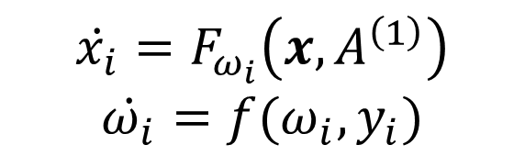

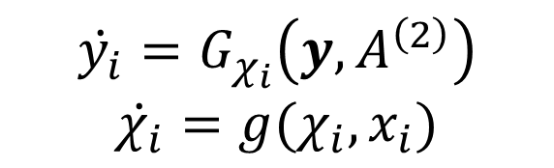

Let $x$ ($y$) be the vector of node states for the first (second) process. We assume the dynamics of the entire system is governed by these equations. $A^{\left(1\right)}$ and $A^{\left(2\right)}$ are adjacency matrices of the two graphs. State $x_{i}$ ($y_{i}$) is a function of states $x$ ($y$) and the first (second) network topology. The key ingredient that connects the two dynamical processes is provided by the functions $ω$ and $χ$. In fact, the parameter $ω$ ($χ$) is itself a function of states of the second (first) layer. This allows to encode the interaction between layers in our model and it is possible only because we are working within the multiplex networks framework.

As a specific example of this type of coupling, we consider a toy model of a human brain. The first layer in this case corresponds to neural activity of brain regions. And the second layer corresponds to energy transport across brain regions. Each node in both layers corresponds to a specific brain region. To apply the suggested multiplex framework to that system, we must specify explicitly all the equations on the right‑hand side.

The equations for neural activity are defined by the Kuramoto model. Kuramoto model is the model for a set of connected oscillators, so in our case every brain region is modeled as a simple oscillator. Here, $x_{i}(t)$ is the phase of the ‑th oscillator at time $t$, $ω_{i}$ is the natural frequency of the ‑th oscillator. Here arises $λ$– coupling strength. This is our first control parameter that must be specified outside of the model manually. In total, we will have 2 of them.

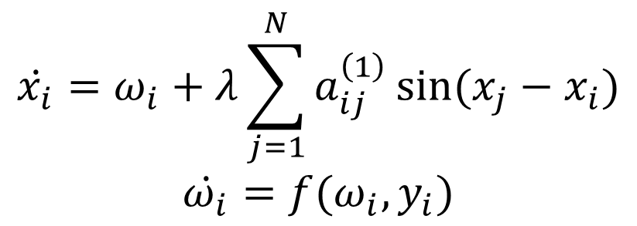

The second dynamical process, energy transport, is modeled by the continuous‑time random walk (RW). The state $y_{i}(t)$ is the fraction of random walkers at node $i$ at time $t$. And $π_{ij}$ is the transition probability from node $j$ to node $i$. $τ_{y}$ is the time scale of the process. We also assume that our RW is biased with the parameter $χ_{i}$, and here arises our second control parameter $α$– the bias exponent. It controls the bias of RW.

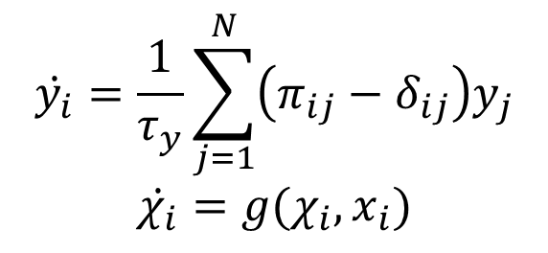

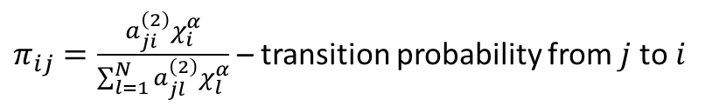

To completely define the model, we must specify how these two processes, the neural dynamics and the diffusion of nutrients, are coupled. We need to assign the functions $f$ and $g$. $f$ will relate the frequency of the oscillator $ω$ to the available energy resource $y$. $g$ will relate the bias property $χ$ to the oscillator phase $x$.

Assuming that frequencies relax to the values proportional to the fraction of RWs at node $i$, we get the following equation. The physical intuition behind that is that firing at a higher frequency usually requires a correspondingly higher amount of energy, in the form of oxygen and nutrients.

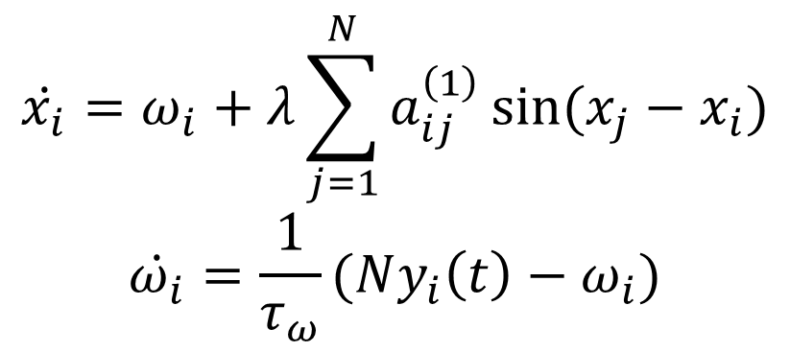

Next, in the similar fashion, we relate $χ$ and $x$. The function $s$ is dependent on $x$ and is the dynamic strength of node $i$. More on its definition can be found in the original paper. The physical intuition behind that is that high electrical activity of a brain area is normally followed by an increase in the blood inflow in the same area.

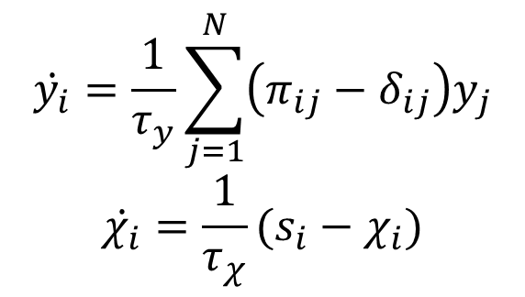

The final simplification to the model is applying the fast relaxation approximation. In all aquations we consider the limit as the relaxation times $τ_{y}, τ_{ω}, τ_{χ}$ approach zero. After some research, I ended up with the following final set of equations (more on derivation can be found on my slides).

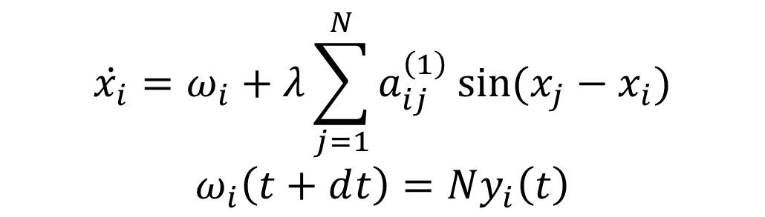  
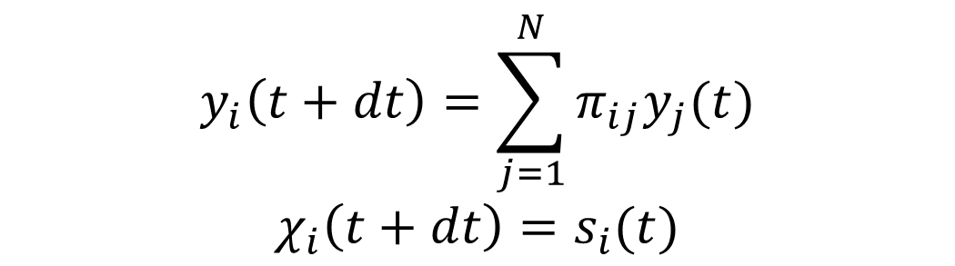

After we specified all the equations of the framework, to run the simluations, we consider a multiplex network of 1000 nodes. We will model the layer corresponding to neural activity as a scale free network with power law degree distribution $P∝k^{-γ}, γ=3$ given the prevalence of such topologies in real neural systems. We will model the transport layer as a simple ER graph. Mean degrees for each graph are set to 10.

The metric that we are going to evaluate during the simulations is the absolute value of the centroid of all the oscillators on the complex plane. It is called Kuramoto order parameter and is the degree of the global synchronization of the neural activity. Its values vary between 0 and 1. The closer it is to 1, the more synchronized the oscillators are.

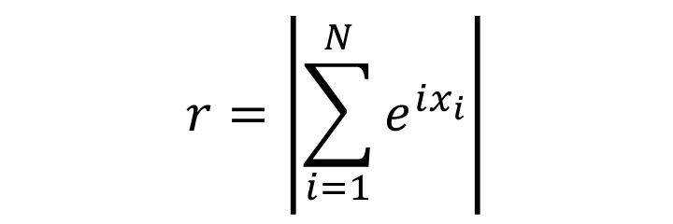

We have two control parameters in our model – $α$ and $λ$. We simulate the networks by adiabatically increasing and then decreasing the coupling strength $λ$ at fixed values of the bias parameter $α$. In the figure, one sees the plot of the synchronization degree $r$ vs. $λ$. Important to note that we see a hysteresis loop emerging here between the forward (circle markers) and backward (triangle markers) branches.

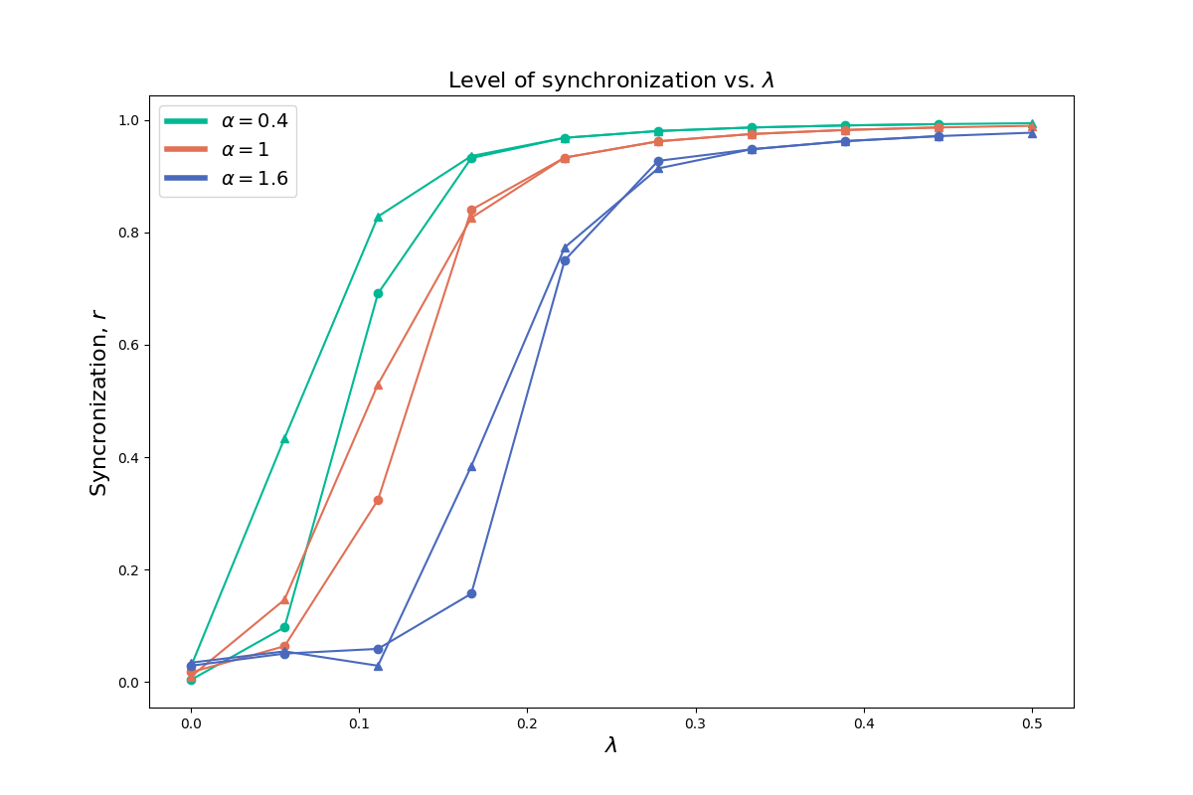

For comparison, these are the results of the same experiment conducted by the authors of the paper.

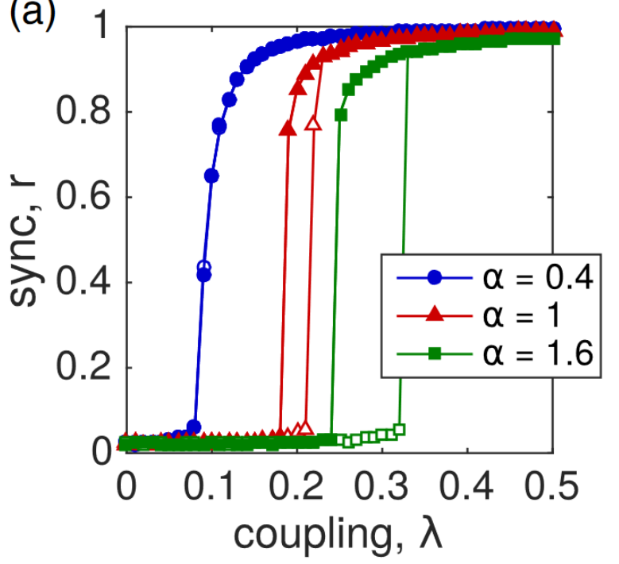

One can see insignificant quantitative differences between the two plots. More importantly, there is also a significant qualitative difference between them. For α=0.4, the hysteresis loop did not emerge in the original experiment which is an example of a typical continuous phase transition of the Kuramoto model. The bistability only appears in the 2nd and the 3rd cases meanwhile it is observed in all 3 cases in my experiment. This might be explained by the slightly different nature of approximations that have been done to the model at the fast relaxation approximation step.

These results indicate that the interconnected nature of diffusion process and synchronization dynamics gives rise to the emergence of phenomena which would never occur in any other simple model rather than multiplex networks framework which once again proves the usefulness of multiplex networks approach.

References.

Vincenzo Nicosia, Per Sebastian Skardal, Alex Arenas, and Vito Latora. Phys. Rev. Lett. 118, 138302 (2017)