
ArtemiS3
Year 2025-26 Northern Arizona University Computer Science Capstone Project

Requirements Version 2.0
November 26, 2025

Sponsor: | Trent Hare
Mentor: | Md Nazmul Hossain
Team Members: | Joseph Laity (jbl265@nau.edu)  Jeffrey Hoelzel (jmh2338@nau.edu)  Samuel Bodenheimer (swb79@nau.edu)  Travian Lenox (tjl379@nau.edu)

Client’s Signature:
Table of Contents
Table of Contents | 1
Introduction  Context  Problem  Goal  Impact | 2  2  2  2  3
Problem Statement  Current Workflow Diagram | 4  5
Solution Vision  Architecture Diagram | 7  8
Project Requirements  - Domain-level Requirements  - Functional Requirements  - Performance (non-functional) Requirements  - Environmental Requirements | 10  10  11  18  20
Project Plan | 24
Conclusion | 27

Introduction
Context
The Astrogeology Science Center, part of the United States Geological Survey (USGS), provides support for several NASA satellite and robotic missions to various planets and moons (i.e., Mars, Earth’s moon, Europa, Titan, etc.). Not only supporting the data processing software but also the infrastructure required to archive and serve the data to researchers, students, and the general public. To handle such vast amounts of data, USGS makes use of Amazon’s AWS Simple Storage Service (S3) cloud storage. AWS S3 buckets are powerful, foundational tools in the modern cloud infrastructure. Their simplicity and scalability have led to their adoption across industries and organizations, including NASA. However, AWS S3 buckets have critical limitations in their ability to be visible, searchable, and secure in cloud-native environments.
Problem
Our sponsor, Trent Hare, shared a link to the current solution to this problem, which is a simple S3 browser (https://pdsimage2.wr.usgs.gov/) that provides the foundation to our solution. However, Mr. Hare showed us there is no capability to search over files in this browser; essentially a user must click through files and folders like you would in your personal machine’s file explorer. There is very limited filtering functionality within each folder, but no ability to search or index.
Goal
Our solution is to develop a web application from scratch, utilizing what we can from the current solution, to allow users of NASA mission data to properly search and index files from USGS’s AWS S3 buckets in a fast and secure manner. The web app will have the following features:
● Full-text and metadata search across files.
● User-friendly dashboard with visualization tools.
● Tagging and organization for easier collaboration.
● Automated checks for risky security configurations.
Impact
Since many scientists, students, and other independent parties rely heavily on NASA mission data to conduct their studies and research, our solution has the potential to positively impact thousands of people by providing a simple and intuitive web app to properly search, index, and visualize mission data. Mr. Hare also requested ArtemiS3 be open source, so other organizations utilizing AWS S3 buckets can benefit from our project free of cost.
At this early stage in the development of ArtemiS3, we are in the process of analyzing the key Technological Challenges, identifying possible alternatives, and selecting which of those alternatives are the most promising solutions. In the next section, we provide a brief Overview of the processes that went into identifying challenges and making design decisions.

Problem Statement
Current Workflow
NASA and USGS publish planetary mission data to public AWS S3 buckets. End-users visit a simple S3 bucket browser and navigate folders to locate items. There is very limited filtering within folders and there is no search capability across files. Below we have provided a diagram of our client’s current workflow. The biggest problem being a lack of search capabilities; if the user does not know the exact location of a specific file or folder they are looking for, they must manually click through folders to find the data they are looking for.

Current Workflow Diagram
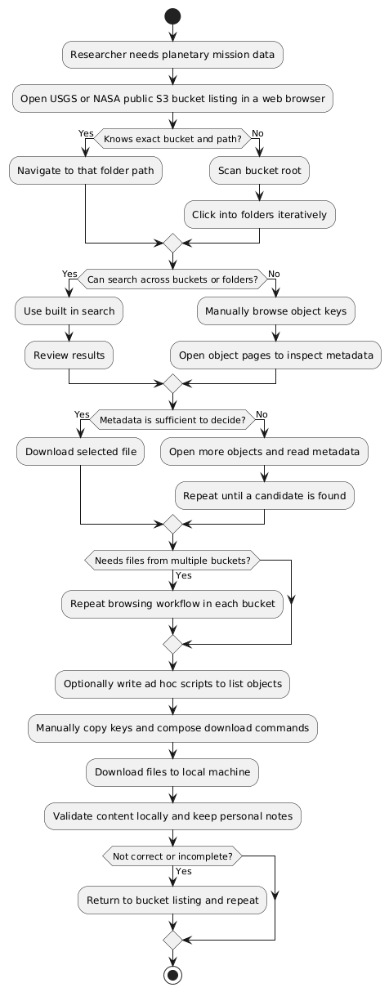

Problem Summary
Researchers cannot run effective discovery or retrieval from the existing browser solution. They must navigate buckets and folders manually which is time consuming, brittle, and error prone. Our client needs a secure and fast way to index and search public S3 content with filtering, visualization, and possibly collaboration features.
Exact Deficiencies
- No full text search over object contents where text is available.
- No metadata search across buckets such as by type, size, last modified date, or keywords.
- No global filtering options across folders, forcing repetitive manual search through deep file structures.
- No cross-bucket indexing catalog or relevance ranking.
- No previews or summaries to assess results before downloading.
- No user tagging or saved search workflow for collaboration.
- Limited or no caching which causes repeated, costly calls to S3 buckets, also posing a huge risk for DoS attacks.
- No integrated security configuration insights for bucket policies.
- No geospatial view for items with coordinates.
- Limited observability for performance and failures which reduces reliability and trust.
- Unclear path for user authentication if private buckets are added in the future.
- No routine index backup strategy which risks reindexing work when services restart.

Solution Vision
Our proposed solution, ArtemiS3, is an intelligent web-application designed to index, search, and visualize publicly accessible NASA and USGS AWS S3 buckets. This system will transform the manual, time-consuming process or browsing through nested S3 directories into a simple and seamless searching experience. Users will be able to perform full-text and metadata searches, preview results, visualize data, and collaborate through tagging and saved searches, all from an intuitive, web-based interface.
At its core, ArtemiS3 bridges the gap between massive public data repositories and the researchers who rely on them, making planetary mission data more accessible, analyzeable, and secure.
Key Features
- Full-text and metadata search: Search across millions of S3 objects by keyword, type, size, or date using Meilisearch.
- Automated metadata indexing: Crawl and index object keys, file sizes, MIME types, and last modified dates for efficient retrieval.
- Interactive dashboard: Built with Svelte and Tailwind CSS, providing responsive filters, summaries, and file previews.
- Tagging and collaboration: Users can annotate and organize files, share tags, and save search sessions for future use.
- Caching and rate control: Utilize Redis and FastAPI middleware to minimize redundant AWS calls and optimize performance.
- Open-source accessibility: Designed to be reusable and modifiable for other scientific institutions or organizations managing public S3 bucket data.
- Geospatial visualization (optional): Integrate Leaflet to visualize planetary datasets containing coordinate metadata.
- Security auditing (optional): Automatically detect risky bucket configurations, such as public writes or missing encryption logic.

System Overview
At a high-level, ArtemiS3 operates as a three-tiered model:
- Frontend: A lightweight Svelte + Tailwind CSS dashboard where users input new or previous search queries, apply filters, and view results or visualizations when applicable.
- Backend: A FastAPI-based service that communicates with AWS through Python’s Boto3 API, retrieving object metadata and text content when available. The backend handles indexing through Meilisearch and manages user data in PostgreSQL.
- Infrastructure: Dockerized containers deployed on an AWS EC2 instance, monitored through CloudWatch and maintained via GitHub Actions CI/CD pipeline. Redis handles temporary caching for hot searches to reduce cost and latency.
Architecture Diagram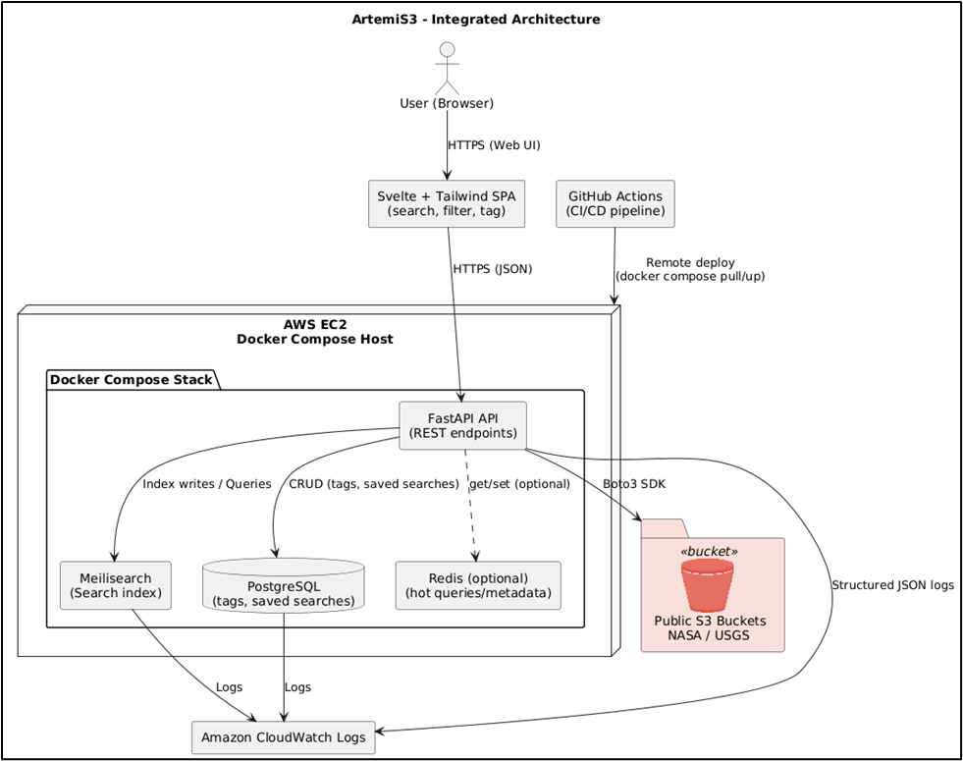
This solution directly addresses every challenge identified in the Problem Statement, introducing robust search, collaboration tools, visualization, and caching mechanisms while maintaining simplicity, security, and scalability for our USGS sponsor and the broader research community.
Data Sources and Processes
- Input Data: Public AWS S3 buckets used by the USGS Astrogeology Science Center and the NASA Planetary Data System. The system retrieves object keys, metadata, and optionally parses text from readable files (i.e., TXT, XML, JSON, PDF, etc.).
- Generated Data: The system produces searchable indices, usage logs, and user-generated tags and filters. These datasets improve discovery and collaboration over time.
- Transformations: Metadata normalization and text extraction prepare data for indexing, ensuring consistency across heterogeneous datasets.
Impact and Trade-offs
By automating indexing and search, ArtemiS3 will drastically reduce the time researchers spend locating mission data. The trade-off is an initial indexing process that requires high-computational resources and AWS requests, but this overhead is quickly offset by the use of caching, incremental indexing, and backup capabilities. For our client, the new workflow enables faster discovery, collaboration, and data quality oversight with minimal maintenance.
Alternative solutions, such as extending the existing S3 browser or relying on static catalogs, were considered but lack scalability, interactivity, and security visibility. ArtemiS3’s modular and open-source design makes it reusable for other scientific datasets beyond NASA and USGS, potentially transforming how public research is accessed worldwide.

Project Requirements
1. Domain-level Requirements
From our sponsor’s perspective, ArtemiS3 must enable scientists, engineers, and students to efficiently locate, preview, and manage NASA and USGS planetary data hosted on AWS S3. The following high-level requirements support all subsequent technical and functional requirements.
DR1. Efficient Data Discovery
Users must be able to search and filter through millions of S3 files quickly and accurately using both metadata and file content search.
DR2. Intuitive User Experience
The interface must present complex scientific information in a clear, organized, and interactive way that supports both novice and experienced users.
DR3. Collaboration and Tagging
The product must allow users to save searches, tag files, and share insights with colleagues for repeatable research workflows.
DR4. Scalable and Reliable Architecture
Our solution must handle large-scale data indexing without severe performance degradation and provide both backup and recovery capabilities to ensure reliability.
DR5. Security and Privacy
The system must ensure all S3 operations and any user data follows AWS security best practices, including read-only access to buckets and optional bucket policy audits.
DR6. Open-Source and Reusability
The entirety of the application must be designed as an open-source, containerized system, easily deployable by other organizations managing public S3 data.
DR7. Optional Visualization Features
Where metadata includes spatial or coordinate data, users should be able to visualize data points on an interactive map.
2. Functional Requirements
The following functional requirements implement and expand upon the domain-level goals above. They are grouped in order of importance using the MoSCoW prioritization model.
Must Have
FR1. File Retrieval from Search
A backend process by which the search query will be provided to the search engine and results will be gathered and sent back to the frontend.
US1: As a user, I want my search queries to be efficiently processed by the application so that I can view the results quickly.
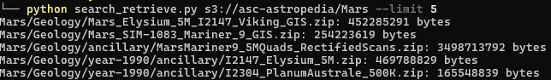
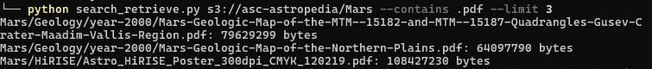
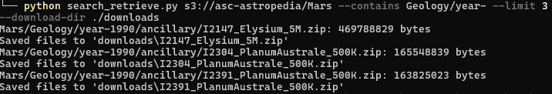
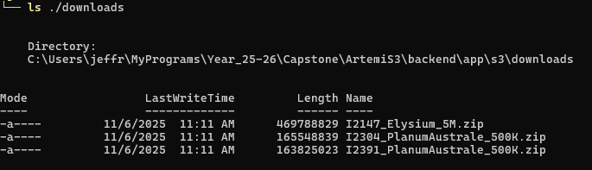
US1: Above are the command-line outputs of accessing S3 bucket data using limits, search flags, and showcasing downloading to your local machine. Demonstrating efficient S3 retrieval.
FR2. Metadata/Text Extraction and Indexing
A Python script to automate the extraction of file metadata and text content from S3 and add it to the Meilisearch index.
US2: As a user, I want the web application to automatically complete any required processes on my files so that they are ready to be searched at my convenience.
US2: Above is the command-line output of extracting metadata/textual data from S3 buckets (textual data is not always available because of file types).
FR3. Search Page
The “main page” of the web-application. Includes a search bar, filtering and sorting options, and a location to view search results.
US3: As a user, I want a simple and usable search page where I can input search queries and receive results that has a clear and responsive UI design that I can understand at first glance so that I can find my files quickly.
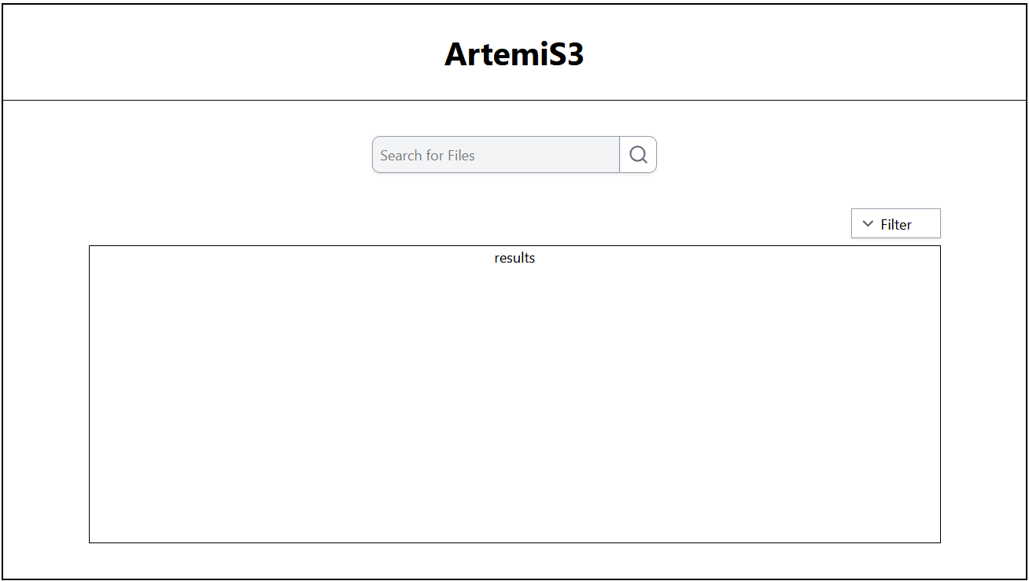
FR4. Interactive Search Results
Provide a user dashboard (Svelte + Tailwind CSS) that displays search results, metadata summaries, and filtering options in real time.
US4: As a user, I want to be able to see the results of my search, including any relevant information about the listed results including metadata summaries and previews when applicable.
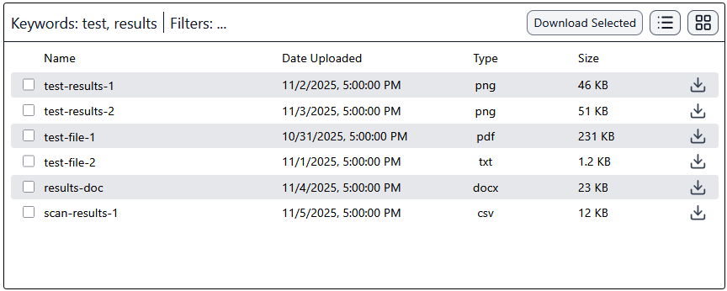
FR5. Search Filtering and Sorting
The web UI should include options for advanced filtering and sorting of search results, the backend API should be able to add filters to the search queries according to the selected filters. Sorting can most likely be done from the front end.
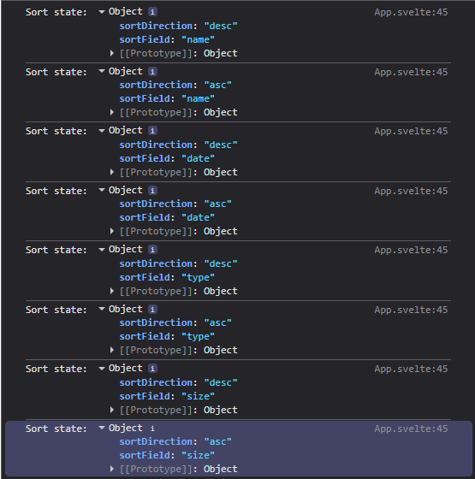
US5: As a user, I want to be able to apply various filters and sorts to the search results so that I can find the specific files I’m looking for more easily.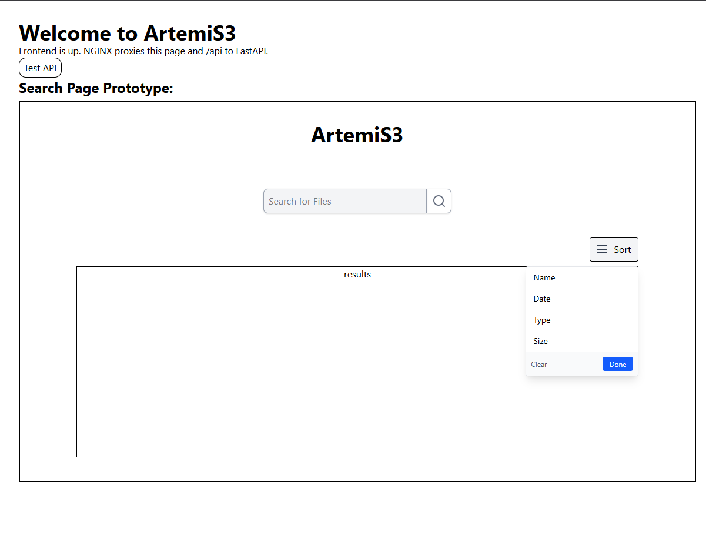

FR6. Search Engine Index Refresh
The ability to refresh the search index when new files are added to the S3 bucket, or otherwise highlighted for inclusion in the search.
US6: As a user, I want to be able to add files to the search index and refresh the index when those files are added so that I can have control over what files are included in the search data.
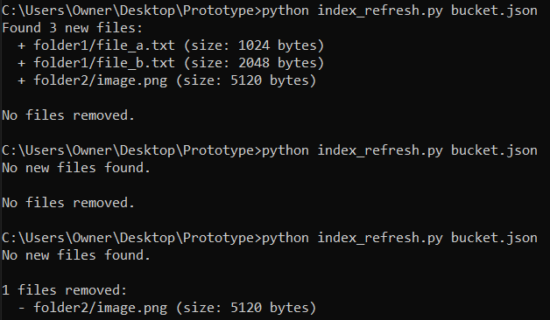
US6: Above is the command-line output of a search index refresh in which files may be added or removed.
Should Have
FR7. File-directory style search result browsing
File/folder browser similar to Windows’ file explorer for browsing the files and folders in the search results, or the entire bucket if no search query was entered.
US7: As a user, I want to be able to explore the file and folder structure of the search result so that I can find related files and folders.
FR8. Downloadable files from within UI
A single button for each file which will facilitate a download of the file from within the web application.
US8: As a user, I would like to download files directly from the web application so that my workflow is as streamlined as possible.
FR9. Meilisearch instance snapshot caching
Automatic search engine backups to minimize reindexing in the event that the search engine needs to be shut down for whatever reason.
US9: As a user, I want my file indexes to be saved across different use sessions so that the time spent on indexing files is as limited as possible.
FR10. User File Tagging
The ability for users to tag specific files with various tags that could be used for collaboration, filtering, or sorting.
US10: As a user, I want a mechanism for personal annotation or shared discovery so that I can tag, organize, and optionally share meaningful subsets of data.
Could Have
FR11. User account system
User accounts to facilitate separate indexes for each user, many additional optional requirements rely on a user account system.
US11: As a user, I want to be able to create an account that I can log into at any time so that the web application remembers the specific settings and actions I have set in the past.
FR12. Recent search history storage
A method to temporarily store search history for efficient search retrieval.
US12: As a user, I want the site to remember the searches I have made previously so that I can find the same results again quickly.
FR13. Geospatial file visualization
View map data from the returned files directly within the web application through a mapping plugin such as Leaflet.
US13: As a USGS employee, I want to be able to view the map data file contents returned from the search results within the web application so that I don’t have to download the files to view their content.
FR14. Security Configuration Analysis
A feature to analyze the bucket policies, access control lists, and encryption settings of the S3 buckets that are being searched.
US14: As a user, I would like to ensure that the S3 buckets I am searching through are configured securely so that I can be sure that no security breaches are present.
FR15. Hot Path Caching
Caches of popular or frequently entered queries to reduce repetitive search engine calls and system latency.
US15: As a user, I want the site to cache frequently searched paths so that when I want to enter a popular search the results will be provided much faster than normal.
Won’t Have
FR16. Private Bucket Access
Private or unauthenticated S3 buckets will not be supported in initial release, but may be added in later releases if necessary.
US16: As a user, I want to be able to access private S3 buckets to search for classified or hidden files and data.
FR17. Hosted Search Engine
Meilisearch provides a search engine hosting service that incorporates many useful tools, increases search and indexing speed, and provides storage for large indexes. However this service is very expensive and not conducive to open source software.
US17: As a developer, I want Meilisearch to host the search engine so that I do not have to host the service myself and to improve search performance.
3. Performance (non-functional) Requirements
PR1. Pending UI (loading spinner) on high latency operations
When a user triggered action takes time to retrieve results, such as an API call, the site should render a loading spinner to inform the user that a process is taking place behind the scenes.
US18: As a user, I want a responsive pending UI so that I know when my action has been read and that I should expect a response soon.
PR2. Response Time
Search queries must return results in under 3 seconds on average for up to 10,000 indexed objects.
US19: As a user, I expect search results to populate my screen in no less than 3 seconds on average per 10,000 indexed objects so that I can conduct research in an efficient manner.
PR3. Indexing Speed
The system should be able to index at least 1,000 objects per minute during its initial and subsequent (weekly or monthly) crawl stages.
US20: As a user, I should not have to experience a very long downtime during initial and subsequent crawl stages.
PR4. Uptime
The hosted web-application must maintain 99% uptime under normal AWS EC2 availability.
US21: As a user, I should always be able to access ArtemiS3 and should expect it to rarely be down.
PR5. Security Compliance
All data must be transferred using HTTPS, and all S3 operations must comply with AWS IAM read-only policies.
US22: As a user, I want all of my downloads and searches to be secure and I should not be able to make arbitrary writes, updates, or deletes to any S3 buckets.
PR6. Scalability
ArtemiS3’s backend must be built with scalability in mind so as to handle large or an increasing number of user traffic.
US23: As a user, I should be able to access ArtemiS3 even if hundreds of other users are using the web-app simultaneously.
PR7. Usability
A user should be capable of completing a successful search within two minutes of navigating to the homepage.
US24: As a user, I want the homepage to be simple enough such that I can successfully complete a search within two minutes.
4. Environmental Requirements
ER1. Hosting Platform
ArtemiS3 must run on AWS EC2 using Docker Compose.
US25: As a developer, I want the system to be deployable on AWS EC2 using Docker Compose so that all components can run reliably in a consistent and containerized environment.
ER2. Open Source
It has been specified that the source code for the project must remain completely open source and publicly available on GitHub.
US26: As the Client, I want ArtemiS3 to be an open source software so that any S3 user who desires an intelligent search for S3 buckets can make use of it.
ER3. Development Stack
ArtemiS3’s backend will be developed in Python using FastAPI for handling API endpoints and the Boto3 SDK for efficient AWS S3 interaction, the frontend will be developed using Svelte + Tailwind CSS, the database will be PostegreSQL, and search will be handled by Meilisearch.
US27: As a full-stack engineer, I want to build the backend in FastAPI and the frontend in Svelte with Tailwind CSS, supported by PostgreSQL and Meilisearch, so that the application is performant, maintainable, and scalable.
ER4. Integration
Must use GitHub Actions for CI/CD pipeline automation.
US28: As a DevOps engineer, I want the system to use GitHub Actions for CI/CD so that deployment, testing, and data integrations are automated and secure.
ER5. Monitoring
Logging and metrics must integrate with AWS CloudWatch for observability.
US29: As the system administrator, I want all logs and performance metrics to be sent to AWS CloudWatch so that I can monitor application health and detect issues in real-time.
ER6. Accessibility
The web-application should be accessible in all modern browsers (i.e., Chrome, Firefox, Safari, Edge, etc.).
US30: As a user, I want to be able to access the web-application in all major browsers so that the platform is accessible to everyone regardless of their device.

Potential Risks
While our product certainly does not contain any extreme or life threatening risks, there is still potential for a loss of availability or data that could massively inconvenience the users. Most of the potential mistakes the program could make amount to little more than a temporary delay in response, however there are a few that could massively impact users. One such risk is in the correctness of the program output. The program will be providing results to user queries by relevance, and if some error occurred in the search engine, it is possible that the top results could not be very relevant to the search query. With a big enough mistake it could even be possible that the results have no relation to the search query at all. In this event it is possible that a user would mistakenly download one of the incorrect files with the belief that it is the file they were searching for. The likelihood of this error occurring is almost entirely dependent on the search engine implementation, as with thorough error detection and request handling it is unlikely that such a mistake would happen.
Another potential risk is a loss of availability of the program, whether that be an AWS outage shutting down the EC2 instance, or an automation error that fails to redeploy the resources, this error could prevent users from accessing the web application. This risk is dangerous mostly because we have little control over it. In the event of an AWS outage, we as developers would have no ability to restore availability of the web application to users until that outage was resolved. The only method we could use to mitigate the risks is to thoroughly test our automation software to ensure that no errors occur, or that if an error does occur it would gracefully abort and reattempt deployment.
One more impactful risk that has potential to occur is a loss of data, specifically a loss of file indexes. The indexing of files is the most time intensive aspect of our web application, and our goal is to expose the user to as little of that waiting time as possible. However if the search index is somehow lost, it would mean that the entire S3 bucket would have to be reindexed before any search queries could be entered. This process could take a large amount of time, multiple hours at a minimum, and our users would be locked out of the web application during this time. This does have the potential to occur rather easily, as indexes do not persist between Meilisearch instances. This problem can be mitigated by taking periodic backups of the Meilisearch indexes in the form of “snapshots” to ensure that in the event that a Meilisearch instance unexpectedly ends, the data stored within will not be lost.

Project Plan
The actual development of ArtemiS3 will take place over six months (November 2025 - May 2026) following an incremental, milestone-based plan aligned with our functional requirements. Each milestone will correspond to a major subsystem in the architecture defined during the technological feasibility phase.
Milestones and Timeline
- Project Setup, Finish-up Requirements, Present Feasibility (Nov 10 - Dec 1)
  - Initialize GitHub repository, project structure, and Docker Compose environment.
  - Work with our client to finish ironing out the requirements of our web-application.
  - Design simple proof-of-concept prototypes.
  - Present our design review at Engineering Fest.
  - Present our Tech Demo in class, showcasing ArtemiS3 in MVP form.
Deliverables: A containerized skeleton of FastAPI + Svelte application. Requirements that address all the client’s wants and needs with prototypes. High quality presentations delivered in class and at Engineering Fest.
- Environment Configuration (Dec 2 - Jan 10)
  - Migrate repository to NASA/USGS-hosted AWS EC2 instance.
  - Configure GitHub Actions CI/CD pipeline and CloudWatch logging.
  - Work with our client to set up domain name and get necessary certificates to exchange data via HTTPS.
Deliverables: Fully operation skeleton containerized and hosted on AWS EC2 with CloudWatch logging, a fully operational CI/CD pipeline, and secure data exchange.
- Core Backend Development and Search Engine Integration with Testing Suites (Jan 11 - Feb 2)
  - Implement FastAPI endpoints for S3 metadata extraction using Boto3.
  - Establish PostgreSQL (SQLite for local development) schema for user tags, search history, and file metadata when appropriate.
  - Integrate Pydantic models for data validation and typed metadata ingestion.
  - Connect backend to Meilisearch for full-text and metadata indexing.
  - Implement indexing jobs and periodic dumps within the EC2 instance.
  - Optimize query performance and semantic ranking.
  - Implement robust dynamic testing suites to ensure correctness of backend.
Deliverables: Operational backend API and a working search engine that supports keyword and metadata filtering all fit with a robust set of testing suites.
- Frontend Interface Development and Visualizations with Testing Suites (Feb 3 - Mar 1)
  - Build out responsive Svelte + Tailwind CSS dashboard for search, filtering, and tagging.
  - Implement data visualization panels where appropriate (i.e., file counts, MIME distributions, file trees, etc.).
  - Ensure full connectivity between frontend and backend.
  - Implement robust dynamic testing suites to ensure correctness of frontend.
Deliverables: Functional user interface with live search results and display pages fit with a robust set of testing suites.
- Reliability, Monitoring, and Automated Testing (Mar 2 - Mar 23)
  - Implement end-to-end automated testing to ensure nearly full code coverage (within reason).
  - Enable CloudWatch dashboards and failure recovery mechanisms.
Deliverables: Fully tested and observable system with automated CI/CD validation.
- Final Integrations and Optional Features (Mar 24 - Apr 13)
  - Integrate all optional features possible in order of priority (i.e., Redis caching, Leaflet map view, and security audits).
  - Conduct end-to-end evaluations and have our client review our product.
Deliverables: Production-ready product with plenty of time to refactor if necessary, document code, and begin finalizations.
- Finalize, Document, and Present ArtemiS3, an Intelligent Search for AWS S3 (Apr 14 - May 4)
  - Ensure our client is happy with the product outcome and that we have met all the requirements: functional, performance, and environmental.
  - Write up technical and nontechnical documentation detailing how to use ArtemiS3, future improvements/features, local development, requirements, code-level documentation, and more.
  - Develop all necessary documents required to make our product open-source and hand over ArtemiS3 GitHub organization to our client.
  - Present at required conferences, classes, and market ArtemiS3.
Deliverables: A fully finished product that meets all our requirements fit with technical and nontechnical documentation. Ready for open-source use and modifications. Presentations done at required events.
Gantt Chart Overview
Because our Gantt Chart is very large, it could not be properly displayed within this document. To access it, please click here. Currently, the Gantt Chart only has the 7 major milestones, but we plan to populate it further as logistics become more clear.
This phase-approach ensures each functional requirement is developed, tested, and integrated sequentially. Early development on AWS EC2 allows for iterative development and testing of FastAPI endpoints and Meilisearch indexing before full UI integration. By May 2026, ArtemiS3 will be a fully functional, open-source platform enabling NASA and USGS researchers to search, tag, and visualize public S3 data.
Conclusion
This document has outlined the key requirements and features necessary for ArtemiS3 to address the challenges faced by the USGS team. As we have identified, the current workflow is hindered by inefficiencies in the cloud data accessing system currently used by the team, impacting overall productivity and performance. Our proposed solution, ArtemiS3, aims to address these issues by providing an advanced search for AWS S3 buckets, that includes full-text and metadata search, a user-friendly dashboard, and tagging, organization, and filtering tools. Our hope is that our system will streamline operations and improve operational efficiency for the USGS team.
In this document, we have analyzed and detailed the functional, performance, and environmental requirements necessary to support the successful implementation of this solution. We identified and prototyped must-have requirements in the front-end dashboard, file and metadata indexing, and S3 file retrieval. We additionally investigated the optional or lower priority requirements which can be implemented once the main requirements are complete. In addition to functional requirements, we also outlined the environmental and performance requirements for our project. Lastly we outlined the potential risks that could arise from our solution and outlined the roadmap for future development. Through this analysis, we have determined the most feasible and effective methods to deliver a solution that meets both the specific needs of our sponsor and the broader objective of the project.
The requirements outlined in this document will serve as the foundation for the next stages of the project, where we will focus on translating these specifications into actionable design and development plans. By addressing the critical aspects of the system’s functionality and performance, we are confident that our approach will provide a robust solution that delivers long-term value to the USGS team and potentially to other stakeholders in the industry.

