
ArtemiS3
Year 2025-26 Northern Arizona University Computer Science Capstone Project

Software Design Version 2.0
February 27th, 2026

Sponsor: | Trent Hare
Mentor: | Md Nazmul Hossain
Team Members: | Joseph Laity (jbl265@nau.edu)  Jeffrey Hoelzel (jmh2338@nau.edu)  Samuel Bodenheimer (swb79@nau.edu)  Travian Lenox (tjl379@nau.edu)

Table of Contents
Table of Contents | 1
Introduction  Context  Problem  Goal  Impact | 2  2  2  2  3
Implementation Overview  Existing System  Performance and Scale Expectations  Operations and Security Constraints  Availability and Observability | 4  4  4  4  4
Architectural Overview  System Architecture  Presentation Layer  Edge Layer  Application Layer  Search and Data Layer  Event-Driven Reindexing with AWS Lambda  Architectural Decisions and Rationale  Summary | 6  6  7  7  7  7  8  8  8
Component-Level Design  FastAPI Backend  Svelte Frontend | 10  10  11
Implementation Plan  Technical Risks | 14  16
Conclusion | 18
Introduction
Context
The Astrogeology Science Center, part of the United States Geological Survey (USGS), provides support for several NASA satellite and robotic missions to various planets and moons (i.e., Mars, Earth’s moon, Europa, Titan, etc.). Not only supporting the data processing software but also the infrastructure required to archive and serve the data to researchers, students, and the general public. To handle such vast amounts of data, USGS makes use of Amazon’s AWS Simple Storage Service (S3) cloud storage. AWS S3 buckets are powerful, foundational tools in the modern cloud infrastructure. Their simplicity and scalability have led to their adoption across industries and organizations, including NASA. However, AWS S3 buckets have critical limitations in their ability to be visible, searchable, and secure in cloud-native environments.
Problem
Our sponsor, Trent Hare, shared a link to the current solution to this problem, which is a simple S3 browser (https://pdsimage2.wr.usgs.gov/) that provides the foundation to our solution. However, Mr. Hare showed us there is no capability to search over files in this browser; essentially a user must click through files and folders like you would in your personal machine’s file explorer. There is very limited filtering functionality within each folder, but no ability to search or index.
Goal
Our solution is to develop a web application from scratch, utilizing what we can from the current solution, to allow users of NASA mission data to properly search and index files from USGS’s AWS S3 buckets in a fast and secure manner. The web app will have the following features:
- File retrieval from search (FR1).
- Metadata and text extraction and indexing (FR2).
- An intuitive landing page functioning as our main search page (FR3).
- Interactive search results (FR4).
- Search filtering and sorting (FR5).
- Recurring search engine index refresh (FR6).
- A pending UI component on high-latency operations (PR1).
- With a low response time, search queries should take no longer than 3 seconds on average for 10,000 indexed objects (PR2).
- The hosted web app must maintain at least 99% uptime under normal AWS EC2 availability (PR4).
- All data must be transferred via HTTPS, and all S3 operations must comply with AWS IAM read-only policies (PR5).
- The web-app must be built with scalability in mind to handle an ever-growing amount of users (PR6).
- The web app must run on AWS EC2 with Docker Compose (ER1).
- The web app must be open-sourced and publicly accessible after the team is finished (ER2).
- Metrics and logging must integrate with AWS CloudWatch for simple observability (ER5).
- The web app should be accessible in all modern browsers (Chrome, FireFox, Safari, Edge, etc.) (ER6).
Impact
Since many scientists, students, and other independent parties rely heavily on NASA mission data to conduct their studies and research, our solution has the potential to positively impact thousands of people by providing a simple and intuitive web app to properly search, index, and visualize mission data. Mr. Hare also requested ArtemiS3 be open source, so other organizations utilizing AWS S3 buckets can benefit from our project free of cost.
FR: Functional Requirement - a specific feature or behavior the system must perform; for example, recurring search engine index refresh.
ER: Environmental Requirement - a required condition external to the software itself, required technical stack, or any standard a system must adhere to when operating; for example, ArtemiS3 must be deployed on AWS EC2.
PR: Performance Requirement - a non-functional requirement that defines how a system is expected to operate under a specific condition; for example, search queries should take no longer than 3 seconds on average for 10,000 indexed objects.
Implementation Overview
Existing System
The current solution (pdsimage2.wr.usgs.gov) functions as a standard file explorer, requiring users to navigate folders manually. It lacks global search, indexing, and advanced filtering, which creates a significant bottleneck for researchers. ArtemiS3 transforms this experience by serving as an intelligent search layer that indexes metadata and extracts text directly from S3 buckets. This creates a searchable database without moving original data, allowing for an intuitive landing page with interactive search results and sophisticated filtering and sorting capabilities that streamline file retrieval.
- Design Impact: Our system, ArtemiS3, must act as an intelligent search layer on top of S3. It is designed not just to browse, but to index metadata and extract text, transforming unstructured buckets into a searchable database without moving the original data.
Performance and Scale Expectations
With a requirement to return search results within 3 seconds for 10,000 objects, the design cannot rely on "live" S3 API calls for every search. To meet these performance standards, the system utilizes a recurring index refresh and local metadata caching, allowing for high-speed searches and complex sorting locally on the backend rather than waiting on high-latency cloud responses.
- Design Impact: We are implementing a recurring index refresh (FR6) and local metadata caching. This allows the system to perform high-speed searches and complex sorting (by date, size, and type) locally on the backend rather than waiting on high-latency cloud responses.
Operational and Security Constraints
The system must be hosted on AWS EC2 via Docker Compose and comply with IAM read-only policies. It must also be fully open-sourced for the wider scientific community. This architecture ensures the platform is inherently scalable to handle a growing user base while maintaining a portable, containerized environment. By adhering to read-only policies, the app provides a reliable and universal search interface that functions seamlessly across all modern web browsers.
- Design Impact: The architecture is built to be portable and containerized. By using a Svelte/FastAPI/Python stack within Docker, we ensure that the app is easy to deploy, secure by design, and accessible for future open-source contributors to extend.
Availability and Observability
The web app requires 99% uptime and integration with AWS CloudWatch for metrics and logging. This robust monitoring allows for real-time tracking of system health to ensure the search engine remains reliable and responsive under heavy loads. It specifically enables the system to manage high-latency operations gracefully by triggering pending UI components, ensuring users are never left in the dark while the backend processes complex metadata or performs its recurring index refreshes.
- Design Impact: To meet these reliability standards, the design includes a decoupled architecture. By separating the indexing engine from the user interface, we ensure that metadata processing can happen in the background without affecting the responsiveness or uptime of the main search page.

Architectural Overview
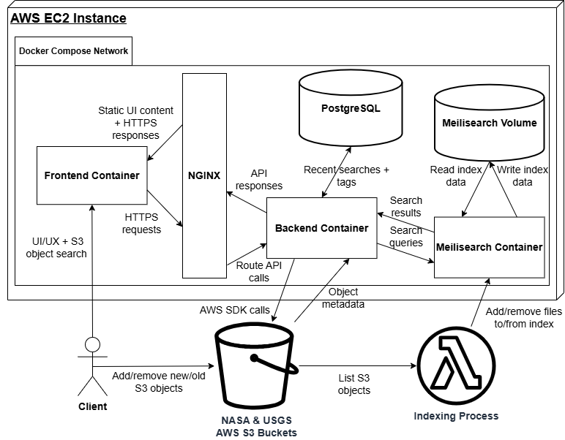
Fig.1: ArtemiS3’s architecture diagram, showcasing a containerized, three-tiered, client-server web application implemented as a modular monolith while supporting infrastructure services to AWS S3 and Lambda.
System Architecture
Figure 1 illustrates the high-level architecture of ArtemiS3. The system is deployed on a single AWS EC2 instance and orchestrated using Docker Compose. As shown in the diagram, four primary containers communicate over the internal Docker Compose network: Frontend, NGINX, Backend, and Meilisearch. Persistent storage is provided through a PostgreSQL volume and a Meilisearch volume. External NASA and USGS AWS S3 buckets serve as the authoritative data source. ArtemiS3 follows a three-tier client-server architecture that separates the presentation, application logic, and data services.

Presentation Layer
The Frontend container hosts the Svelte application written in TypeScript and styled with TailwindCSS. It serves static UI assets and provides the search and object interaction interface as seen in the above diagram. The frontend does not communicate directly with S3, PostgreSQL, or Meilisearch. All client HTTPS traffic flows through the NGINX reverse proxy, enforcing a strict client-server relationship.
Edge Layer
The NGINX container, positioned at the network edge in the diagram above, routes HTTPS traffic between the client, frontend, and backend. It provides TLS termination, centralized routing, and a single public entry point. This design was chosen to isolate network transport-level concerns from application logic and improve overall security.
Application Layer
Implemented in Python using FastAPI, the backend container servers as the system’s orchestration layer. As illustrated in the above diagram, it exposes RESTful APIs that handle search queries, index management, metadata extraction, and user data persistence. The backend communicates synchronously with Melisearch over HTTP for search and indexing operations and synchronously with PostgreSQL for structured data such as recent searches and tags. AWS S3 buckets are accessed exclusively from the backend using Boto3, ensuring that credentials and access logic remain server-side. Long-running tasks such as bucket indexing are handled asynchronously within the backend to avoid blocking request handling. FastAPI was selected specifically for its native asynchronous support, which aligns with the system’s I/O-bound workload.
Search and Data Layer
The Meilisearch container, as shown in the diagram, stores indexed metadata and extracted content. A dedicated Docker volume persists index data across restarts to prevent costly reindexing. Meilisearch is accessed only through its HTTP API by the backend. The PostgreSQL volume provides transactional storage for structured application data. A relational database was selected due to predictable schema requirements and ACID compliance. S3 serves as the external object storage layer as seen above. Objects are never mirrored locally, instead, metadata and content are retrieved dynamically, reducing storage overhead and preserving the integrity of public datasets.
Event-Driven Reindexing with AWS Lambda
In addition to startup indexing, ArtemiS3 supports event-driven reindexing to keep Meilisearch consistent with changes in the supported S3 buckets. When new objects are added, removed, or updated, reindexing is executed through AWS Lambda rather than the EC2 hosted backend. This decouples continuous index management from the primary API service and reduces the likelihood of API slowdowns or AWS request throttling on the EC2 host, helping to reduce costs for our client. In this workflow, S3 change events trigger Lambda functions that list the affected objects and update the Meilisearch index by adding, removing, or updating objects. Offloading to Lambda improves scalability and reliability because indexing workloads can scale independently and run in short-lived execution contexts without competing with user traffic.
Architectural Decisions and Rationale
Modular monolith over microservices
Although multiple containers are used, the backend is deployed and versioned as a single service. A distributed microservices architecture was unjustifiable given the system score and would introduce unnecessary operational complexity for our client.
Docker Compose over Kubernetes
Since ArtemiS3 runs on a single EC2 instance and does not require dynamic horizontal scaling, Docker Compose provides sufficient orchestration with lower operational overhead for our client.
Reverse proxy boundary
NGINX enforces a very strict client-server separation and centralizes routing and TLS management, improving security and maintainability.
Meilisearch vs. Elastisearch
Meilisearch was selected largely due to its lightweight footprint, simple API service, and very strong search relevance without requiring complex cluster management.
Summary
As shown in the above architecture diagram, ArtemiS3 is a containerized three-tiered client-server application deployed on a single AWS EC2 host. It consists of a Svelte frontend, a FastAPI backend, a Meilisearch search engine, and a PostgreSQL database, all connected via an internal Docker network, where communication between client and server is facilitated through NGINX. This design balances simplicity, security, and maintainability while leaving clear extension points for future scaling or architectural evolutions.
Component-Level Design
FastAPI Backend
Description
The fastAPI backend (the large box in the center of fig.2) sits within the backend docker container, it is accessed by the frontend via the nginx reverse proxy docker container (the small box on the left side of fig.2). This component is responsible for facilitating communication between AWS S3 (the small box on the top of fig.2), Meilisearch (the small box on the right side of fig.2), and the frontend (not visible in fig.2). Its two main responsibilities are refreshing the Meilisearch index, which is performed automatically on a periodic basis via an indefinite loop in main, and sending search queries and their results between the frontend and Meilisearch.
The index_refresh module is responsible for reading the objects in a designated S3 bucket, extracting their metadata and text content, constructing Meilisearch index documents, and sending those documents to the Meilisearch container. The search module parses API queries from the frontend, extracts the filter and sorting options, and then sends the reformatted query to the Meilisearch API, once it receives the response it sends found S3 object keys and metadata back to the frontend (facilitated by the connection between the NGINX component and the s3_routes module in fig.2).
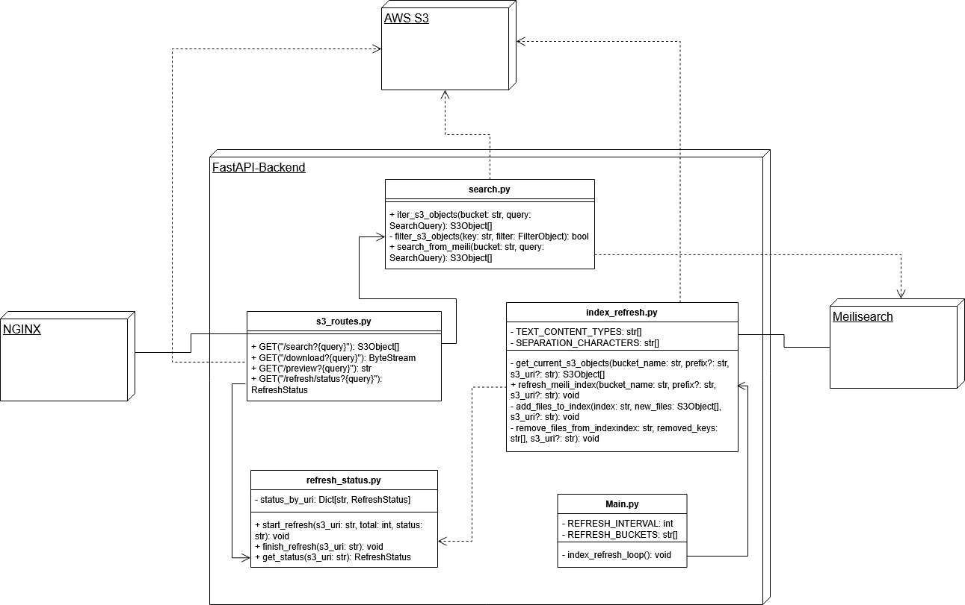
Visual Model
Fig.2: A UML Class diagram that describes the layout of the site’s backend and its connections to other services.
Public Interface
The s3_routes module creates the API endpoints to be used by the frontend, the endpoints include “/s3/search” which runs a smart or manual search depending on whether a Meilisearch index for that bucket exists. The “/s3/refresh/status” endpoint calls functions from the refresh_status module to read the progress of an ongoing index operation. The “/s3/download” endpoint sends the S3 object to the frontend for download, and the “/s3/preview” endpoint generates and sends a S3 preview URL to the frontend.
These endpoints can be reached via the backend URL with the /api prefix, for example on local development “localhost:8000/api/s3/search” to perform a search.
Cross Component Concerns
One important concern that arises from this component is error handling. The component relies on two separate third party APIs (Meilisearch and AWS S3) and thus must include robust error handling and the ability to send reliable and informative error reports to the front end. Sometimes however an error may arise which should not stop the entire program, such as if an s3 object that is in the index queue does not have public read permissions. Rather than stopping the entire process in this case the component should simply skip this file and move on to the next one in the queue. Another important consideration is how much information this component should send to the frontend in order for the web page to display loading information and prevent overloading the component with tasks. Lastly, as this component serves as an API, all endpoints should be properly documented with the proper query format to ensure ease of use.
Svelte Frontend
Description
The svelte frontend (the large box in fig.3) is within the frontend docker container and uses nginx (the small box on the right of fig.3) to access the backend using RESTful API calls. The App.svelte component serves as the container for the main site content, displaying the header and S3SearchSection components. The App.css component defines style classes to be used throughout the site. The api folder contains the s3.ts script which defines the API functions to be called by other components. Additionally, the schemas folder contains typescript interfaces that define the object types used within the site and returned from the API calls.
The components folder contains the actual content of the site with the components S3SearchSection.svelte, FilterPanel.svelte, S3ResultsTable.svelte, and S3IndexRefreshProgress.svelte. The S3SearchSection contains the other components within itself and handles the main logic that is used by all of the components. Meanwhile, the other three components are more focused on their respective purposes, such as the S3ResultsTable.svelte which simply handles displaying and formatting the search results into a paginated table and displaying object previews when applicable.
Visual Model
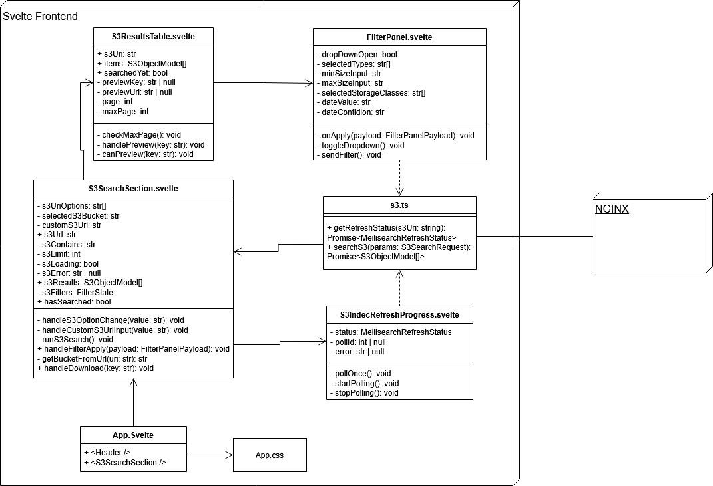
Fig.3: A UML Class diagram that describes the layout of the site’s frontend.
Public Interface
As the frontend of the application, this component will be directly accessible to the user, and thus its possible interactions with the rest of the site must be carefully controlled. For that purpose it is only able to send specific predefined API calls to the backend accessible via the user interface. The frontend is not directly accessible from other components either, communication between the components will only ever occur as a result of an API call.
Cross Component Concerns
One large concern for this component is error handling, the frontend must be able to recognize different errors that can be sent from the backend and decide how much information should be shown to the user. For example if an error arose due to user error, the component must be able to recognize that and provide meaningful feedback so the user can edit their request. Meanwhile if the error resulted from an internal server error, the frontend should be able to inform the user of this without revealing any potentially sensitive information to the user.
Another concern with this component is overloading the backend with requests. It should be impossible for the user to crash the server with too many requests or invalid requests either accidently or purposefully. To that effect, proper protections must be in place both internally and within the UI itself. This may look like disabling buttons while certain requests are being processed or using modals to limit a user’s ability to access different features concurrently.

Implementation Plan
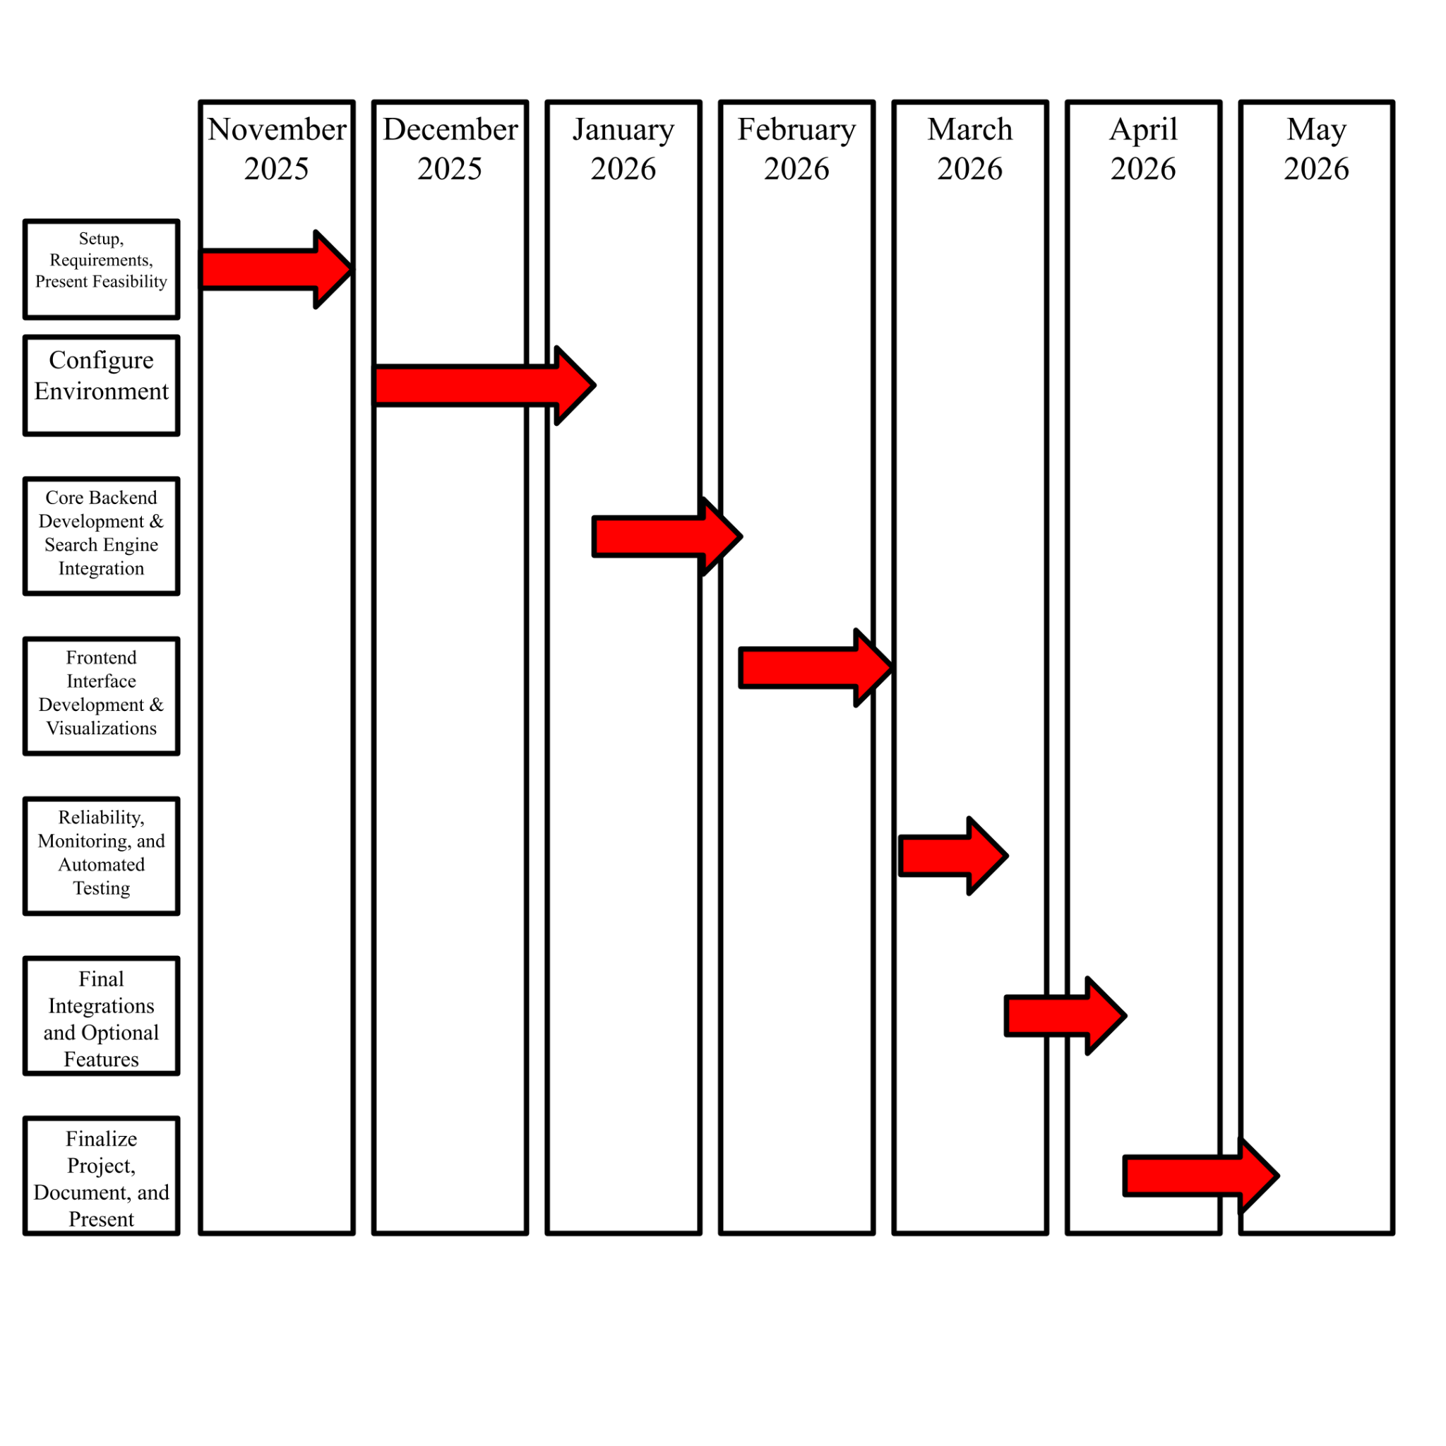
At this time, ArtemiS3 has completed the majority of its core architecture and backend functionality. The system is capable of indexing S3 buckets, executing search queries through Meilisearch, and serving results to a functional frontend. The implementation plan below focuses on the remaining development work leading up to the Alpha demonstration and final delivery, including feature completion, user experience refinement, testing, and deployment hardening.

Fig.4: A gantt chart describing the project milestones timeline
Setup, Requirements, and Feasibility (Nov 2025)
The project begins by defining the overall scope, gathering requirements, and assessing feasibility for integrating S3 search functionality. The core architecture and initial system design are established, ensuring the project goals are realistic and achievable. A feasibility presentation is delivered to demonstrate that the project approach is viable.
Configure Environment (Dec 2025 - Jan 2026)
Development and deployment environments are set up, including backend, frontend, and Meilisearch configurations. CI/CD pipelines, and other supporting tools are put in place to ensure smooth development workflows.
Core Backend Development & Search Engine Integration (Jan - Feb 2026)
The backend system is finalized, completing indexing, search engine integration with Meilisearch, and asynchronous handling for performance.
Frontend Interface Development & Visualizations (Feb - Mar 2026)
The frontend interface is developed to consume the stable backend APIs, including search query submission, results display, and visualizations. Iterative refinement is performed to improve usability and stability, ensuring the UI is ready for Alpha demonstrations without disrupting backend functionality.
Reliability, Monitoring, and Automated Testing (Mar 2026)
The system is made robust through monitoring, reliability enhancements, and automated testing. Edge cases are identified and addressed, ensuring that both backend and frontend operate correctly under realistic usage scenarios. Testing results are used to fix bugs and stabilize the system.
Final Integrations and Optional Features (Mar - Apr 2026)
Remaining features or enhancements are integrated if feasible, and the system undergoes final integration testing. The backend and frontend are fully synchronized, ensuring all components work together seamlessly and the system meets the project objectives.
Finalize Project, Document, and Present (Apr - May 2026)
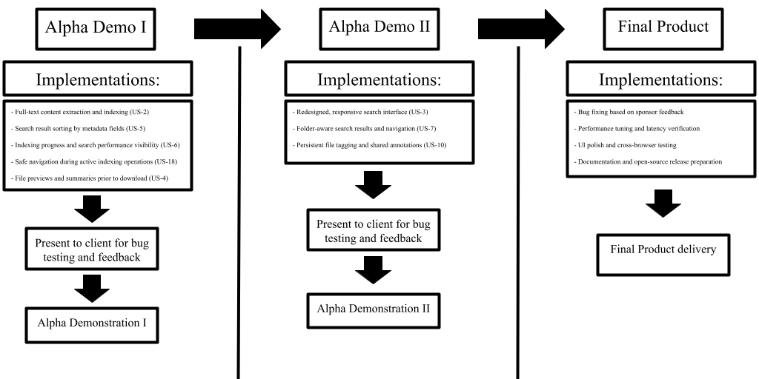
The project is finalized with complete documentation, final system validation, and preparation for the final presentation. A handover-ready version of ArtemiS3 is delivered, demonstrating all functionality, stability, and usability goals achieved throughout the development timeline.

Fig.5: A timeline of all alpha milestones to final product delivery
Each Alpha milestone results in a fully integrated and deployable system. Backend features are integrated with Meilisearch and validated through API testing before being exposed to the frontend. Frontend changes consume stable API contracts, minimizing integration risk and allowing UI development to proceed independently once endpoints are finalized.

Technical Risks
Indexing Performance
Extracting and indexing text from large or complex files may increase indexing time.
Mitigation: Indexing is performed asynchronously, and only supported text-based formats are processed to limit overhead.
User Interface Stability
Late-stage UI changes may introduce bugs or inconsistencies.
Mitigation: Backend APIs are kept stable during UI refinement, and changes are validated during Alpha demos.
Edge Cases Discovered During Client Testing
Unexpected usage patterns may reveal bugs near the end of development.
Mitigation: Time is reserved after Alpha Demo II for bug fixing and stabilization.

Trade-offs
ArtemiS3 prioritizes system stability and usability over adding additional features late in development. The system is deployed on a single EC2 instance to reduce operational complexity, accepting limited scalability in favor of simplicity and reliability within the project scope.

Conclusion
The ArtemiS3 project provides a vital modernization of the USGS and NASA data-retrieval workflow. By moving beyond a simple "click-through" file structure, this solution empowers researchers, students, and the public to interact with vast S3 datasets in a way that was previously impossible without specialized cloud expertise.
The design presented in this document relies on a 3-tier containerized architecture specifically optimized for high-volume cloud storage:
- The Interface: A responsive Svelte and Tailwind CSS frontend provides a modern, intuitive search experience with real-time feedback.
- The Orchestration: A FastAPI backend leverages asynchronous Python to handle metadata extraction and S3 communication without blocking user interactions.
- The Search Engine: Meilisearch serves as a high-performance indexing layer, allowing the system to meet the critical 3-second response time threshold for thousands of objects.
This proposed design directly supports the project’s success by balancing performance with operational simplicity. By deploying via Docker Compose on AWS, we ensure a portable, "local-first" environment that is easy to maintain and secure under AWS read-only policies. Furthermore, the modular, open-source nature of the codebase fulfills the sponsor’s vision of a tool that can be adopted and extended by any organization utilizing AWS S3.
Ultimately, ArtemiS3 provides a stable, scalable, and cost-effective blueprint for making cloud-native data visible and searchable, ensuring that the wealth of information within NASA’s mission archives remains accessible to all.

