VC8编译器在编译可能发生缓冲区溢出的函数时，会定义一个很特别局部变量用来最为缓冲区溢出的判断。这个局部变量叫做SECURITY_COOKIE，编译器增加的这个局部变量时紧挨着EBP的存放地址的。顺序就是：VAR COOKIE EBP RET ARGS。下面看一下最初的值：

#ifdef _WIN64  
#define DEFAULT_SECURITY_COOKIE 0x00002B992DDFA232  
#else

#define DEFAULT_SECURITY_COOKIE 0xBB40E64E  
#endif

所以从Export的Start进去就是：

**int start()**

**{**

**__security_init_cookie();**

**return __tmainCRTStartup();**

**}**

**__security_init_cookie**中可以看出来，为了取得好的随机性，先是取出时间，异或之，然后是分别跟其他一些列具有随机性的数据（进程ID，线程ID，TickCount和性能计数器）进行异或运算。VC编译器的版本不同，release文件中的mainCRTSartup函数也可能会有所不同，IDA中将mainCRTSartup函数命名为___tmainCRTStartup。

main函数有三个参数，分别为命令行参数个数、命令行参数信息和环境变量信息。根据main函数调用的特征会将3个参数压入栈内作为函数的参数。所以查找用户入口main()前必然会有3个push指令。所以进入___tmainCRTStartup函数以后，结合下面的void __noreturn start()函数，找到应该是main的函数，可能会有参数传递吧（是IDA的解析问题）：

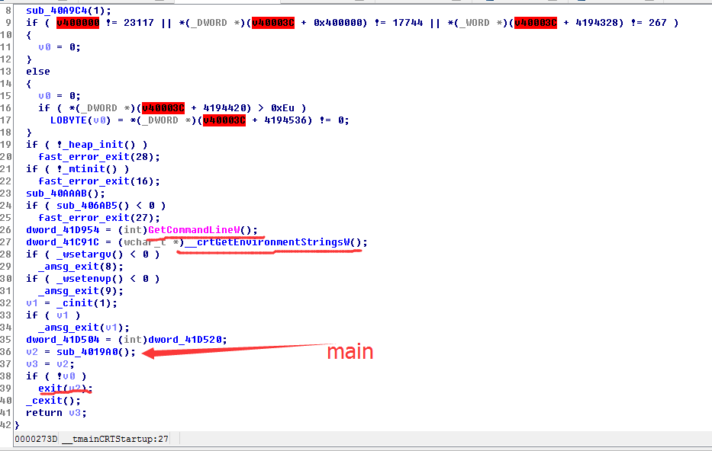

Microsoft Visual C++ 5.0[调试] 这种在IDA中F5以后会自动帮你定位到main函数，或者从Export标签页的start函数进入：

void __noreturn start()

{

unsigned int v0; // eax@1

int v1; // eax@4

v0 = GetVersion();

dword_441CD0 = (unsigned __int16)v0 >> 8;

dword_441CCC = (unsigned __int8)v0;

dword_441CC8 = dword_441CD0 + ((unsigned __int8)v0 << 8);

dword_441CC4 = v0 >> 16;

if ( !sub_414FD0(0) )

fast_error_exit(28);

_ioinit();

dword_442330 = (int)GetCommandLineA();

dword_441CAC = __crtGetEnvironmentStringsA();

_setargv();

_setenvp();

_cinit();

dword_441CE4 = (int)envp;

v1 = main(argc, (const char **)argv, (const char **)envp);

exit(v1);

}

如果要想最后什么都不保存的话：

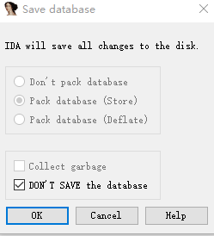

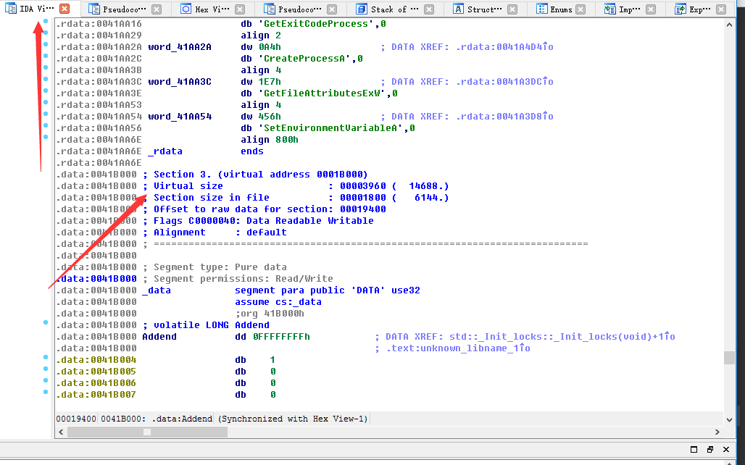

如果使用Cygwin，那么export标签页中的函数有TlsCallback_0, TlsCallback_1, _mainCRTStartup。

void __noreturn mainCRTStartup()

{

___set_app_type(1);

__mingw_CRTStartup();

}

void __noreturn __mingw_CRTStartup()

{

const char ***v0; // eax@5

int v1; // ebx@5

char v2; // [sp+28h] [bp-14h]@3

int v3; // [sp+2Ch] [bp-10h]@3

if ( __dyn_tls_init_callback )

__dyn_tls_init_callback(0, 2, 0);

SetUnhandledExceptionFilter(_gnu_exception_handler);

__cpu_features_init();

fpreset();

v3 = 0;

__getmainargs(&_argc, &_argv, &v2, _CRT_glob, &v3);

if ( _CRT_fmode )

{

_fmode = _CRT_fmode;

_setmode(__iob[0]._file, _CRT_fmode);

_setmode(__iob[1]._file, _CRT_fmode);

_setmode(__iob[2]._file, _CRT_fmode);

}

*(_DWORD *)__p__fmode() = _fmode;

_pei386_runtime_relocator();

__main();

v0 = (const char ***)__p__environ();

v1 = main(_argc, (const char **)_argv, *v0);

_cexit();

ExitProcess(v1);

}

进入到main发现自己编写的函数名字都是在的….没有一点混淆… 这是因为处于debug模式算是，加载了DWARF information.

int __cdecl main(int argc, const char **argv, const char **envp)

{

int v3; // eax@1

__main();

v3 = getLocalMac();

printf("%d", v3);

return 0;

}

QT:

int WinMainCRTStartup()

{

mingw_app_type = 1;

__security_init_cookie();

return __tmainCRTStartup();

}

int __tmainCRTStartup()

{

char *v0; // edx@1

int v1; // ecx@1

void *v2; // esp@1

void *v3; // esp@1

unsigned int v4; // eax@1

signed __int32 v5; // ebx@3

signed __int32 v6; // eax@6

signed __int32 v7; // ebx@7

CHAR *v8; // eax@14

char v9; // cl@15

CHAR v10; // dl@20

signed int v11; // eax@28

int v12; // esi@31

int v13; // ebx@32

char **v14; // esi@32

size_t v15; // eax@33

size_t v16; // edi@33

char *v17; // eax@33

char *v18; // ecx@33

int v19; // eax@34

char **v20; // esi@35

int result; // eax@35

size_t v22; // [sp+14h] [bp-74h]@31

int v23; // [sp+18h] [bp-70h]@1

char **v24; // [sp+1Ch] [bp-6Ch]@31

char v25; // [sp+2Ch] [bp-5Ch]@1

char v26; // [sp+58h] [bp-30h]@28

unsigned __int16 v27; // [sp+5Ch] [bp-2Ch]@29

v0 = &v25;

memset(&v25, 0, 0x44u);

v1 = 0;

v2 = alloca(48);

v3 = alloca(48);

v4 = ((unsigned int)&v23 + 3) & 0xFFFFFFF0;

*(_DWORD *)v4 = -858993460;

*(_DWORD *)(v4 + 4) = -858993460;

*(_DWORD *)(v4 + 8) = -858993460;

*(_DWORD *)(v4 + 12) = -858993460;

*(_DWORD *)(v4 + 16) = -858993460;

*(_DWORD *)(v4 + 20) = -858993460;

*(_DWORD *)(v4 + 24) = -858993460;

*(_DWORD *)(v4 + 28) = -858993460;

if ( mingw_app_type )

GetStartupInfoA((LPSTARTUPINFOA)&v25);

v5 = *(_DWORD *)(__readfsdword(24) + 4);

while ( 1 )

{

v6 = _InterlockedCompareExchange((volatile signed __int32 *)&__native_startup_lock, v5, 0);

if ( !v6 )

{

v7 = 0;

if ( __native_startup_state == 1 )

goto LABEL_40;

goto LABEL_8;

}

if ( v6 == v5 )

break;

Sleep(0x3E8u);

}

v7 = 1;

if ( __native_startup_state == 1 )

{

LABEL_40:

_amsg_exit(v1, v0);

if ( __native_startup_state == 1 )

goto LABEL_41;

LABEL_11:

if ( v7 )

goto LABEL_12;

goto LABEL_42;

}

LABEL_8:

if ( __native_startup_state )

{

has_cctor = 1;

}

else

{

__native_startup_state = 1;

_initterm(v1, v0);

}

if ( __native_startup_state != 1 )

goto LABEL_11;

LABEL_41:

_initterm(v1, v0);

__native_startup_state = 2;

if ( v7 )

goto LABEL_12;

LABEL_42:

_InterlockedExchange((volatile signed __int32 *)&__native_startup_lock, v7);

LABEL_12:

if ( __dyn_tls_init_callback )

__dyn_tls_init_callback(v1, v0, 0, 2, 0);

_pei386_runtime_relocator(v1, v0);

__mingw_oldexcpt_handler = (int)SetUnhandledExceptionFilter(_gnu_exception_handler);

_set_invalid_parameter_handler(__mingw_invalidParameterHandler);

fpreset();

__mingw_winmain_hInstance = (HINSTANCE)0x400000;

v8 = (CHAR *)__acmdln;

if ( !__acmdln )

goto LABEL_27;

v9 = 0;

while ( 1 )

{

v10 = *v8;

if ( *v8 <= 32 )

break;

if ( v10 == 34 )

v9 ^= 1u;

LABEL_19:

++v8;

}

if ( !v10 )

goto LABEL_26;

if ( v9 & 1 )

{

v9 = 1;

goto LABEL_19;

}

do

++v8;

while ( *v8 <= 32 && *v8 );

LABEL_26:

__mingw_winmain_lpCmdLine = v8;

LABEL_27:

if ( mingw_app_type )

{

v11 = 10;

if ( v26 & 1 )

v11 = v27;

__mingw_winmain_nShowCmd = v11;

}

v23 = argc;

v12 = argc;

v22 = 4 * argc + 4;

v24 = (char **)malloc(v22);

if ( v12 <= 0 )

{

v19 = 0;

}

else

{

v13 = 0;

v14 = argv;

do

{

v15 = strlen(v14[v13]);

v16 = v15 + 1;

v17 = (char *)malloc(v15 + 1);

v24[v13] = v17;

v18 = v14[v13++];

memcpy(v17, v18, v16);

}

while ( v13 != v23 );

v19 = v22 - 4;

}

v20 = v24;

*(char **)((char *)v24 + v19) = 0;

argv = v20;

__main();

___initenv = envp;

result = main(argc, (const char **)argv, (const char **)envp);

mainret = result;

if ( !managedapp )

exit(result);

if ( !has_cctor )

{

_cexit();

result = mainret;

}

return result;

}

int __cdecl main(int argc, const char **argv, const char **envp)

{

__main();

return WinMain(__mingw_winmain_hInstance, 0, __mingw_winmain_lpCmdLine, __mingw_winmain_nShowCmd);

}