DEPARTMENT OF COMPUTER STUDIES

**(Applications Development and Emerging Technologies)**

**TECHNICAL-SUMMATIVE ASSESSMENT**

**2**

**PHP ARRAYS AND PRE-DEFINED FUNCTIONS**

**Student Name / Group**

**Name: Patrick Andrew Tria**

**Name** **Role**

**Members (if Group):**

**Section: TN31 1A**

**Professor: Mr. Abraham Magpantay**

1. **PROGRAM OUTCOME/S (PO) ADDRESSED BY THE LABORATORY EXERCISE**
   * Design, implement and evaluate computer-based systems or applications to meet desired needs and requirements.

**II. COURSE LEARNING OUTCOME/S (CLO) ADDRESSED BY THE LABORATORY EXERCISE**

* + Understand and apply best practices and standards in the development of website.

**III. INTENDED LEARNING OUTCOME/S (ILO) OF THE LABORATORY EXERCISE**

At the end of this exercise, students must be able to:

* + - To know the different approach of using arrays in PHP.
    - To use PHP lazy function foreach to iterate through array elements.
    - To implement one dimensional and multi-dimensional in the program.
    - To know use variables that is globally declared and locally declared.
    - To know how to include separate PHP code in the main page for code enhancement.
    - To be familiar with the use of common predefined function such as define, include, and require.
    - To use different available mathematical function for manipulating numbers.

**IV. BACKGROUND INFORMATION**

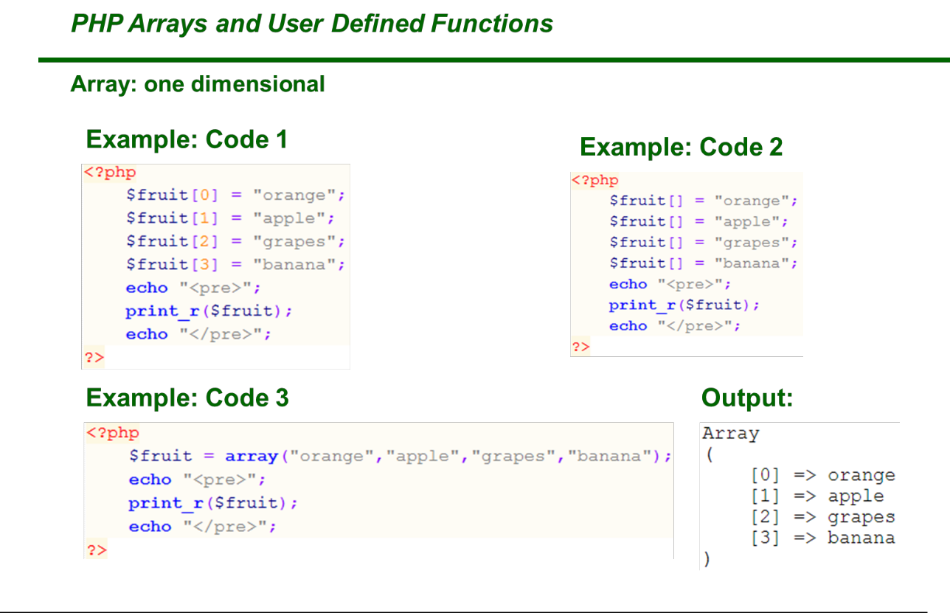

**Applications Development and Emerging Technologies** **Page 2 of 8**

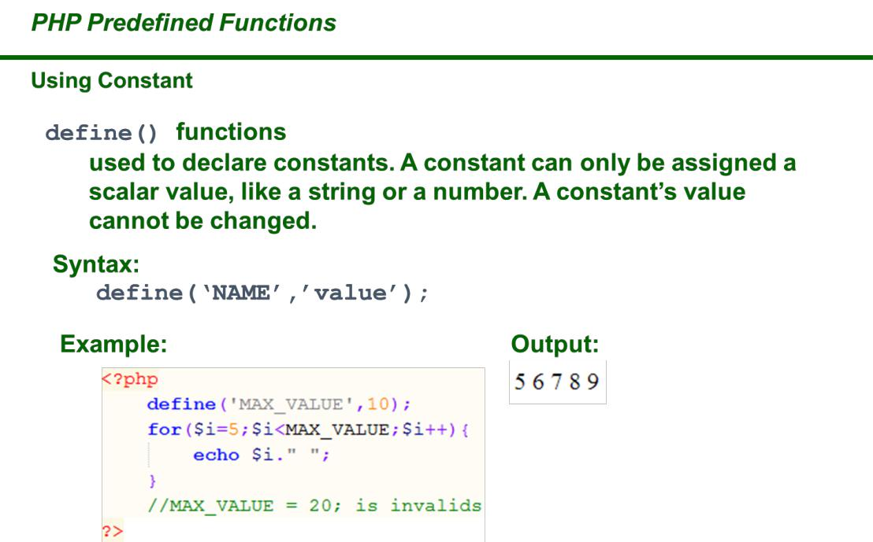

1. **GRADING SYSTEM / RUBRIC (please see separate sheet)**

**VI. LABORATORY ACTIVITY**

* 1. **USING ARRAYS**, create a program using PHP that will display the number of days available for aspecific month in a calendar view. Assuming that every month the 1st day starts every Monday. Also, the cell of your birthday must be RED. Please see sample output below:

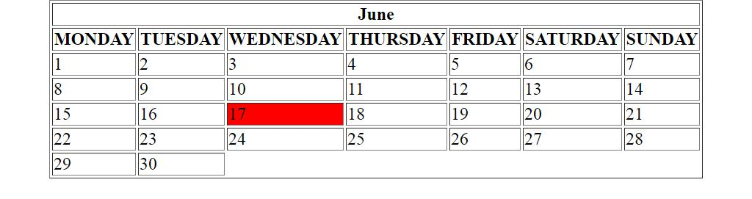

1. **Using ARRAYS**, create a fruit directory that will show the image, name, description and facts aboutthe fruit (create at least 10 fruits sort in alphabetical order). Implement a HTML and CSS code for the structure and design of the webpage. Please see the sample output below.



**Applications Development and Emerging Technologies** **Page 3 of 8**

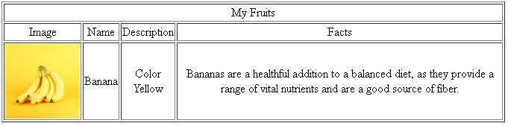

1. **USING USER DEFINED FUNCTION.** Create a formula for each volume of shapes (Cube, RightRectangular Prism, Prism or Cylinder, Pyramid or Cone and Sphere) then display the result. Please see the sample below:
2. Convert your Student Resume into a web based form, used include() and require() functions to connect all pages

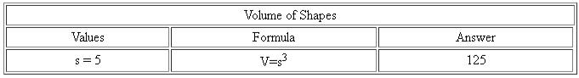

Include and create the following pages:

* Career Objective page
* Personal information page
* Educational Attainment page
* Skills page
* Affiliation page
* Work Experience Page

Please see the sample below:



**Applications Development and Emerging Technologies** **Page 4 of 8**

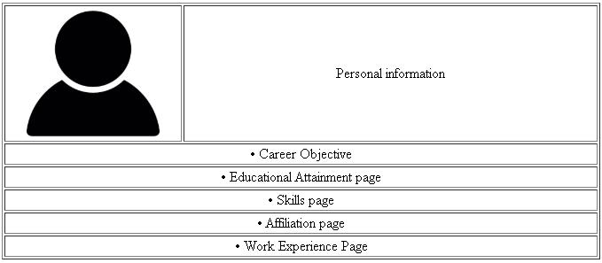

5. Creation of String Function in PHP

1. For the final output, apply all the necessary PHP string functions to produce the required result as stated in the next page. Use the variable ***$string*** as the main parameter for the functions. Use HTML table. Do not process if the string is empty. Use ***var_dump( )*** for item no. 16 and 17.

***Sample code for Item no 2:***

**echo '<tr><td>2.</td><td>Number of characters</td>'; echo '<td>*', *strlen($string)*, '*</td></tr>';**

1. For test data, enter the text **an online guide to html form <input> tag** (with one leading and trailing space). Compare the result below and make sure the output is the same.



**Applications Development and Emerging Technologies** **Page 5 of 8**

String Functions

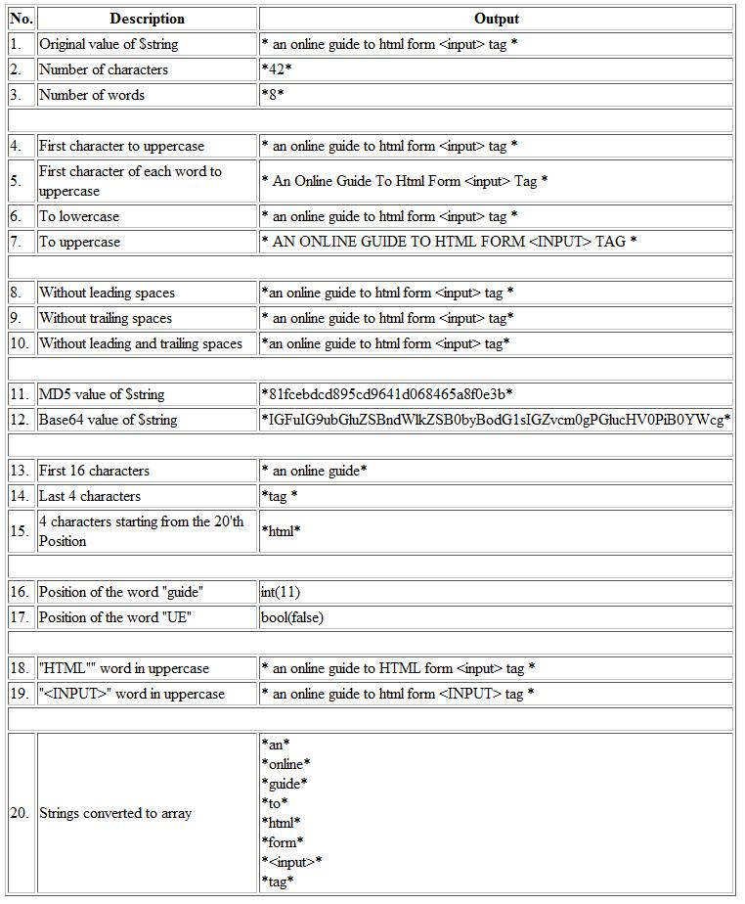

**Applications Development and Emerging Technologies** **Page 6 of 8**

***Snip and paste your source codes here. Snip it directly from the IDE so that colors of the codes are preserved for readability. Include additional pages if necessary.***

**VII. QUESTION AND ANSWER**

1. **What is Array?**

Array is a data structure that consists collection of elements either it be values or variables that are each identified by an array index or key.

1. **What is function in PHP?**

A function is a block of statements that can be used repeatedly in a program and will be executed if called.

1. **Differentiate the one-dimensional array to multi-dimensional array**

One dimensional array represents multiple data items in a list in one or single dimension. Meanwhile, two-dimensional array stores data in a format consisting of rows and columns.

1. **Describe the difference between Global Variable to Local Variable**

Global variable can be called, accessed and altered anywhere in the code whilst the local variable is only accessible on the local function or place it has been set or initialized.

1. **What is the difference between function without parameter and a function with parameter?**

Function with parameters or arguments means that we are defining the value at the time of the function is called. Meanwhile functions without parameters or arguments are when we define the value first and then call the function.

1. **What are the different common predefined functions? Describe each and give example**

Function – is the keyword used to declare a function. One example would be **function *name* (*parameter*) {** // code to be executed **}.** Another example of predefined functions are String Functions which are powerful and best for manipulating strings, strtolower(), strotoupper(), trim() and etc. Array Functions for accessing and manipulating values of your arrays, i.e array(), sort(), explode() and etc.

1. **Is it useful to use an include or require function on a webpage? Why?**

Yes, especially if you’re re repeatedly displaying or outputting a certain code. This will provide you the ease of readability and accessibility of the code.

1. **What is the importance of a function?**

A function is a block of organized, reusable code that is used to perform a specific task or action. This means that functions provide better modularity of code for your application as well as high degree of code reusing. Function also helps keep your codes clean and readable.

1. **What is the importance of a string function?**

String functions are very useful and powerful when it comes to the manipulation of strings. It gives you the freedom to easily edit and access certain words in a sentence just like in the last required output for this laboratory.

**VIII. REFERENCES**

1. <https://www.w3schools.com/css/>
2. <https://www.w3schools.com/html/>
3. <https://www.w3schools.com/php/php_variables.asp>
4. <https://www.w3schools.com/php/php_arrays.asp>
5. <https://www.w3schools.com/php/php_arrays_indexed.asp>
6. <https://www.w3schools.com/php/php_arrays_associative.asp>
7. <https://www.w3schools.com/php/php_arrays_multidimensional.asp>
8. <https://www.w3schools.com/php/php_arrays_sort.asp>
9. <https://www.w3schools.com/php/php_functions.asp>
10. <https://www.w3schools.com/php/php_constants.asp>
11. <https://www.w3schools.com/php/php_includes.asp>
12. <https://www.w3schools.com/php/php_string.asp>

**Note: The following rubrics/metrics will be used to grade students’ output.**



**Applications Development and Emerging Technologies** **Page 7 of 8**

|  |  |  |  |  |
| --- | --- | --- | --- | --- |
| **Program (100** | **(Excellent)** | **(Good)** | **(Fair)** | **(Poor)** |
| **pts.)** |  |  |  |  |
| **Program** | Program executes | Program executes | Program executes | Program does not |
| **execution (20pts)** | correctly with no | with less than 3 | with more than 3 | execute **(10-** |
|  | syntax or runtime | errors **(15-17pts)** | errors **(12-14pts)** | **11pts)** |
|  | errors **(18-20pts)** |  |  |  |
| **Correct output** | Program displays | Output has minor | Output has | Output is incorrect |
| **(20pts)** | correct output | errors **(15-17pts)** | multiple errors | **(10-11pts)** |
|  | with no errors |  | **(12-14pts)** |  |
|  | **(18-20pts)** |  |  |  |
| **Design of output** | Program displays | Program displays | Program does not | Output is poorly |
| **(10pts)** | more than | minimally | display the | designed **(5pts)** |
|  | expected **(10pts)** | expected output | required output |  |
|  |  | **(8-9pts)** | (**6-7pts)** |  |
| **Design of logic** | Program is | Program has | Program has | Program is |
| **(20pts)** | logically well | slight logic errors | significant logic | incorrect **(10-** |
|  | designed **(18-** | that do no | errors **(3-5pts)** | **11pts)** |
|  | **20pts)** | significantly |  |  |
|  |  | affect the results |  |  |
|  |  | **(15-17pts)** |  |  |
| **Standards** | Program code is | Few inappropriate | Several | Program is poorly |
| **(20pts)** | stylistically well | design choices | inappropriate | written **(10-11pts)** |
|  | designed **(18-** | (i.e. poor variable | design choices |  |
|  | **20pts)** | names, improper | (i.e. poor variable |  |
|  |  | indentation) **(15-** | names, improper |  |
|  |  | **17pts)** | indentation) **(12-** |  |
|  |  |  | **14pts)** |  |
| **Delivery** | The program was | The program was | The program was | The program was |
| **(10pts)** | delivered on time. | delivered a day | delivered two | delivered more |
|  | **(10pts)** | after the deadline. | days after the | than two days |
|  |  | **(8-9pts)** | deadline. **(6-7pts)** | after the deadline. |
|  |  |  |  | **(5pts)** |



**Applications Development and Emerging Technologies** **Page 8 of 8**