1. Wmic

Win+R: wmic

memorychip get capacity

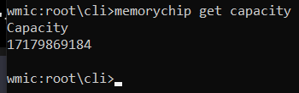

1. Powershell

Get-CimInstance Win32_PhysicalMemory | Select-Object Capacity

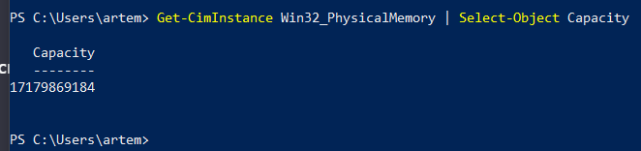

1. Systeminfo

Win+R: cmd

systeminfo | find "Полный объем физической памяти"

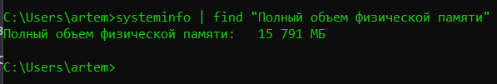

1. 