**Opening a New York Pizza Place In Chicago**

Artem Moshkin

August 31st, 2019

**1. Introduction**

**1.1 Background**

Chicago is known worldwide for its take on pizza. Offering up an alternative to New York Style pizza, Chicago is famous for its deep dish pizza. While many in the area consider deep dish pizza to be the only way to go, many people prefer the thin crust variant known as New York Style pizza. Having found much success in the Big Apple, the thin crust variant of pizza is ready to make its appearance on the streets of Chicago.

**1.2 Problem**

A suitable location for opening the new NY style pizza place is extremely important. It should be opened in an area where there are some pizza places nearby, however, not overrun by competition. Likewise it is important to find a neighborhood that would provide a decent amount of people relative to the amount of pizza places nearby.

**1.3 Interest**

The interest is garnered by the restaurateurs that are seeking a viable location for the opening of their new pizza parlor. They want to make a lasting impression on the windy city and are looking for a premier starting location for their New York Style Pizza Parlor.

**2. Data Acquisition and Cleaning**

**2.1 Data Sources**

For gathering neighborhood data I relied upon the Wikipedia page of Chicago Neighborhoods located [here](https://en.wikipedia.org/wiki/List_of_neighborhoods_in_Chicago). In addition to the neighborhood information I required information about already existing pizza locations in Chicago and this data I was able to retrieve through multiple queries to the Foursquare API. Finally I needed to utilize a data set that would give me the size of the neighborhood so that I would be able to see what the concentration of pizza is per area of the neighborhood and that data was provided by the data.cityofchicago.org portal.

**2.2 Data Cleaning**

However, this information lacked the necessary longitude and latitude coordinates for working with the data set. In order to append these coordinates I utilized the Open Cage Geocode package to loop through the data set and provide the coordinates for each of the neighborhoods in Chicago. From here, I searched through Foursquare’s API to find all the pizza locations found in the Chicago area. I then cleaned that data to ensure that only actual pizza locations were included and not sandwich shops and the like.

**3. Methodology**

**3.1. Preliminary Findings**

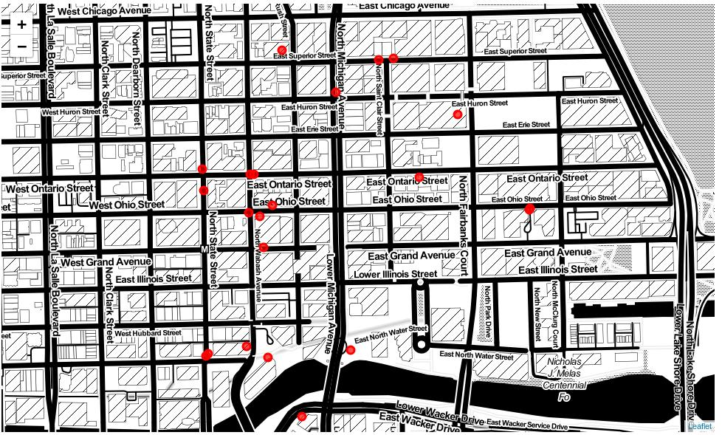After searching through the FourSquare data it appeared that the Chicago area is filled with Pizza places, boasting well over 500 locations across the city. However, it was important to look for areas of opportunity for the new proprietors of the pizza place. In order to do so, I wanted to take a look at the amount of pizza locations already established in various locations around the city. Taking a look at the most established I found that a neighborhood called the Gap had the largest concentration of pizza locations boasting 22 locations across the neighborhood.

**3.2. Calculating Possible Locations**

Looking over the Pizza location data, it became apparent that it was necessary to overlay some data about the size of the neighborhood in order to better assist with figuring out how concentrated the pizza locations were. In order to do so, we draw upon the neighborhood area data provided by the city of Chicago. From here we merge the table containing the counts of pizza places in a particular neighborhood with the area data of the neighborhood. From here we can calculate the approximate pizza places per area for each neighborhood. Removing neighborhoods with less than three pizza places and sorting by Pizza per Area we get the following table:

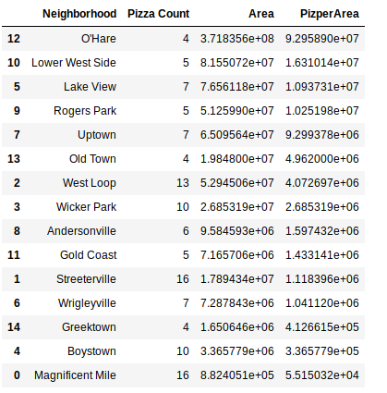

**3.3. Locations**

It seems that our best option is going to be the O’hare neighborhood with the lowest concentration of pizza places per area in that neighborhood. However, after taking a look at what the neighborhood actually is, it becomes apparent that it would be near impossible to open a pizza place there. It is the O’Hare airport and the surrounding area. Therefore it would be extremely difficult to open a pizza restaurant in the airport. Rather I chose to take a look at the next three options, the Lower West Side, Lake View and Rogers Park.

**4.Results**

**4.1 Rogers Park**

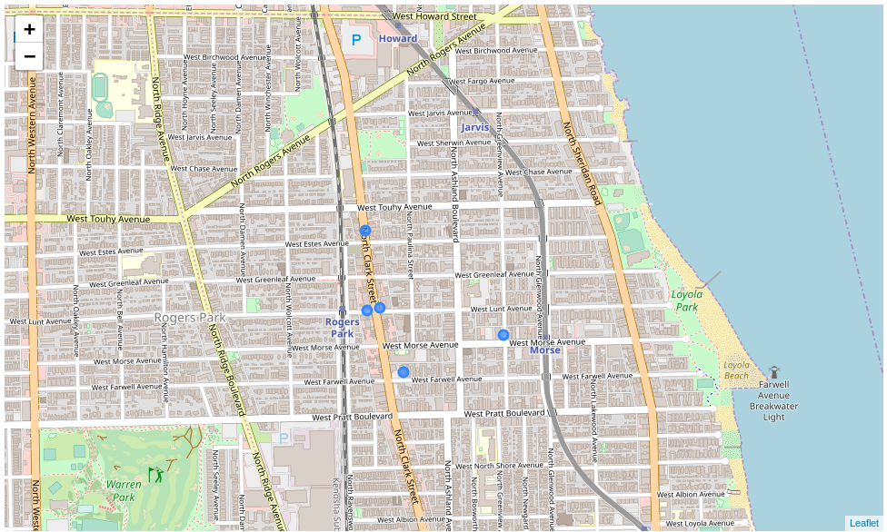One of the locations that we’re able to identify as being a possible location for opening a pizza place is Rogers Park. Taking a look at the pizza locations already open in rogers park it is visible along one of the maps that a majority of pizza locations are only found on the main road with one outlier located outside of North Clark Street.

**4.2 Lake View**

Taking a look at Lakeview we see that a similar trend emerges with all the pizza locations being along North Clark Street. This wouldn’t provide an optimal location for a new pizza place as all the competition would be readily available while driving down the street. Additionally this neighborhood contains Wrigley Field which would limit our ability to capture a majority of possible clients as they would be going to or coming from a baseball game during which they are likely to have consumed food.

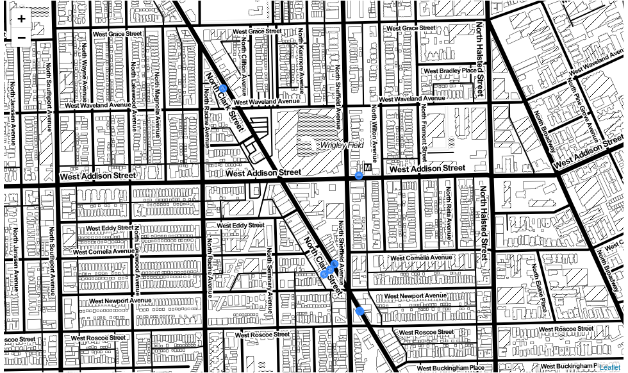

**4.3 Lower West Side**

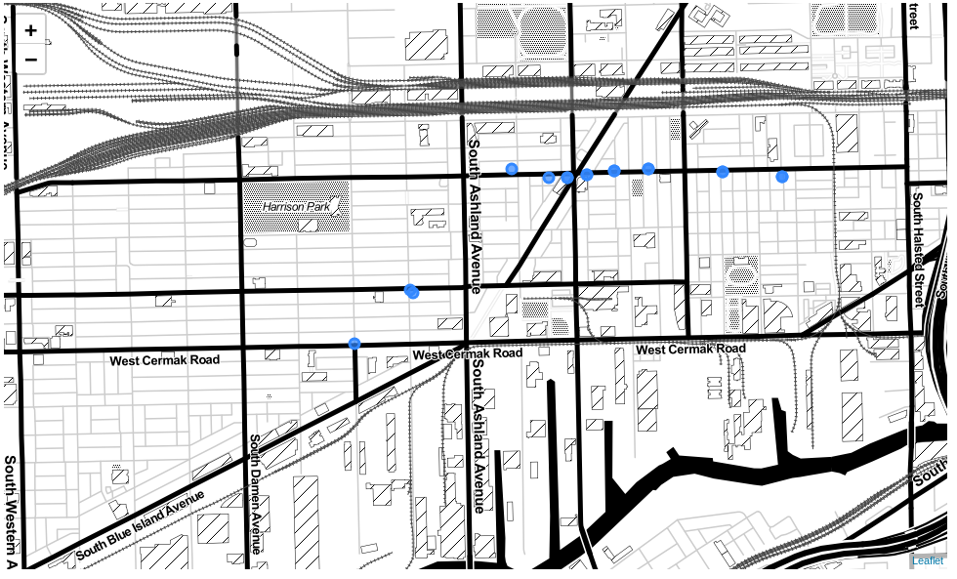Our final location has a concentration of pizza locations open along west 18th street. However, there is a lack of pizza locations around Harrison Park. This seems to be the most advantageous of the neighborhoods. It provides a location with a number of established pizza locations but a large area giving us a number of clients.

**5. Results**

During our examination of the Chicago area, we have found a number of unsuitable locations for opening up a pizza place. Unfortunately the O’Hare neighborhood would be too complicated to establish ourselves in due to the fact that it is an airport location. Likewise the Lake View neighborhood would have the added complexity of the location of Wrigley Field where a number of clients would not be receptive to our pizza since they would be already entertained and nourished at the baseball game. Roger’s Park also does not seem a suitable location as the majority of pizza locations are along the main road and stiff competition for those traveling to our pizza location would prove difficult in the long run.

**6. Discussion**

During our examination of the Chicago area, we have found a suitable location for opening a new pizza restaurant. Taking a look at different neighborhoods, we can conclude that the Lower West Side is going to be the best balance between already establish pizza locations nearby and a suitable client base that would appreciate some pizza. The ideal location would be opening a pizza place around the red location in the Lower West Side.

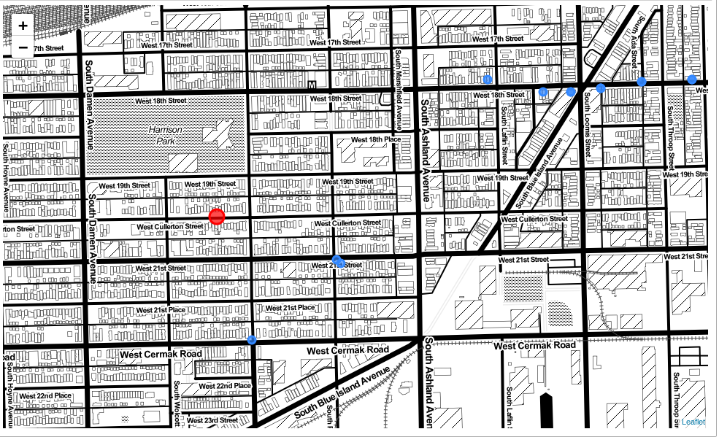

**7. Conclusion**

In conclusion we have taken a look at the already established pizza locations in various Chicago neighborhoods and found a location where the pizza locations are not are crowded as in some of the other neighborhoods. From here we have designated a location for a new pizza parlor to be opened to acquaint the Chicago area with the delicious New York Style Pizza they’ve been missing out on.