Belt drive

©Faraday Predictive 2018

Belt drives are a common transmission element that are particularly prone to wear. Whilst replacement of the belt itself is usually inexpensive, a poor condition belt may lead to large unnecessary vibrations elsewhere in the system, causing fatigue, and significant energy losses.

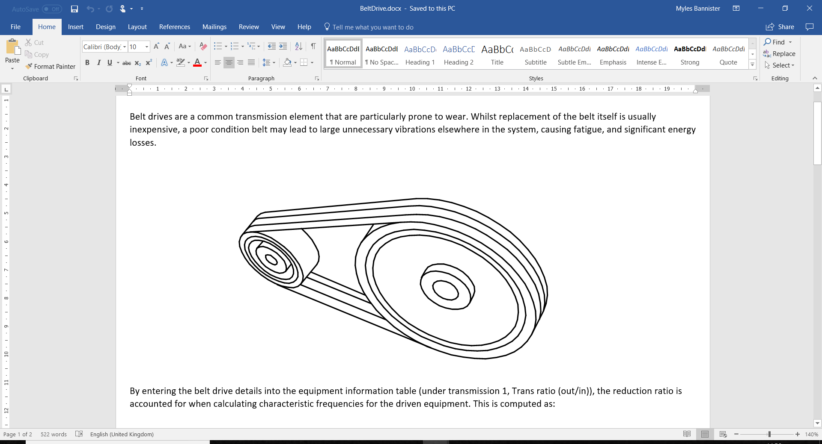

By entering the belt drive details into the equipment information table (under transmission 1, Trans ratio (out/in)), the reduction ratio is accounted for when calculating characteristic frequencies for the driven equipment. This is computed as:

$$R = {D_{driven}}/{D_{driver}}$$

From the entered information, the length of the belt is used to calculate belt pass frequency. The following formula is used:

$$L=2C+\frac{π\left(D_{driver}+ D_{driven}\right)}{2}+ \frac{{(D_{driver}-D_{driven})}^{2}}{4C}$$

Here R is the reduction ratio, and Ddriver, Ddrven, are the diameters of the driver and driven pulleys respectively. C is the distance between the centres of the pulleys, and L is the length of the belt. The ratio L/Ddriver determines belt pass frequency – BPF = driven shaft speed x Ddriver/L.

The P100 uses the input data from the equipment information table to identify features in the frequency spectrum caused by the belt drive and assess their severity.

Problems such as loose or worn belts, sheave misalignment, and belt resonance can be detected.

# Cause

Belt drive problems can be caused by poor installation or adjustment (such as incorrect alignment), excessive loads, or incorrect tensioning. Over-tensioning can put a strain on the bearings whilst under-tensioning causes inefficiency in the system, and higher vibration.

Belts which have been badly stored – such as hanging up on a hook or a nail for an extended period, or which have been tied into too tight an oval shape in storage – can take on a permanent distortion and will show significant belt pass frequency signals.

Wear, which is inevitable over time in belt-drive systems, results in loss of tension, which in turn leads to slip and more rapid wear, so keeping belts correctly tensioned can significantly extend their life.

# Effect

Belt drive problems lead to lack of efficiency and frequent repair costs if not properly addressed. The belts themselves are cheap to replace but poor alignment can lead to premature wear and hence loss of tension.

Insufficient tensioning leads to more rapid wear, requiring un-necessarily early replacement. It also allows greater “flapping” of the belts, which will show up as very noticeable peaks in the P100 spectrum plot, indicating torsional oscillation of the driver and driven equipment, which can in turn put extra stresses on the rotating equipment.

Insufficient tensioning can also lead to large energy losses (up to 10%).

Overtensioning can put excessive loads on bearings of the motor or driven equipment, and lead to accelerated wear of the belts.

# Diagnosis

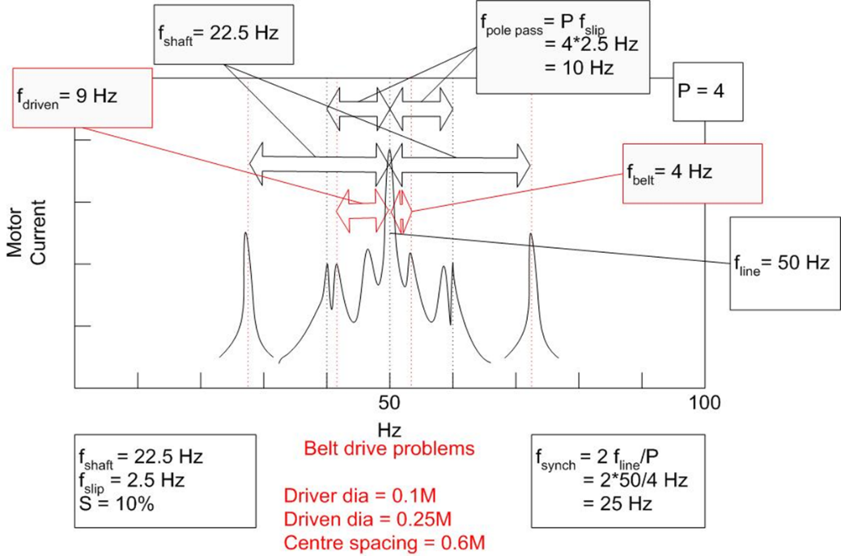

Diagnostic parameter - Belt/blade/trans element/driven equipment

In the PSD, belt problems typically show characteristic frequency peaks at 1/3.5-3.6X input shaft speed, depending on the geometry and trends may vary considerably over time. Sheave misalignment shows up at shaft speed, and belt resonance at the belt resonant frequency.

# Action

Maintenance tasks should start with the simplest (alignment and tensioning) then monitor before considering belt replacement. More sophisticated belt tensioning systems are also available to take the guesswork out of belt tensioning.