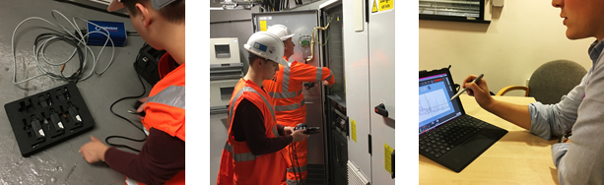Diagnostic information

The P100 Series software displays detailed diagnostic information based on the analysis of measured data using your equipment profile. Click on frequency peaks and fault bars to explore the condition of your asset in more detail.

For more information visit: [www.faradaypredictive.com](http://www.faradaypredictive.com)

Contact us at: +44(0) 333 772 0748 or [info@faradaypredictive.com](mailto:info@faradaypredictive.com)