Electrical Even Harmonics

©Faraday Predictive 2018

Motor even harmonics appear at even multiples of line frequency – 100Hz, 200Hz, 300Hz etc. for UK and European supplies.

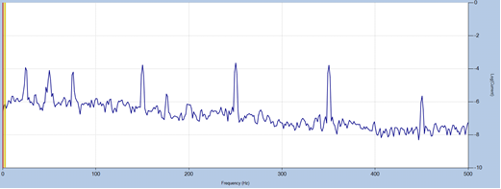

In theory, even harmonics should not occur in the supply because for an odd signal of period T (i.e. a signal where - f(t) = f(T-t)), there are no even components of the spectrum. In practice, we do see even harmonics appear, of approximately 1% amplitude compared to line frequency. Even harmonics are often smaller in amplitude than odd harmonics but produce more detrimental effects on power systems.

A signal comprising an infinite set of even harmonics will tend to correspond to a spike shaped waveform – in contrast to an infinite set of odd harmonics which correspond to a square wave. Square waves, or squaring off of the wave form, is a much more common phenomenon in most rotating electrical equipment

Cause

Even harmonics are usually caused by so called space harmonics rather than time harmonics; i.e. asymmetries in the spatial distributions of the stator windings (due to slot spacing, for instance) rather than due to distortions in the time varying waveform of the input voltage. Asymmetrical or sinus shaped waveforms from an inverter can also produce even harmonics.

Effect

High harmonics in the stator dissipate energy as heat and can damage the insulation of the windings, eventually leading to short circuits that can cause them to burn out. There are also significant energy losses; 1% is not unusual and extremely highly distorted voltage supplies (12% THD) can produce a 5% energy loss; energy which goes into the stator and rotor windings, increasing temperatures and damaging winding insulation.

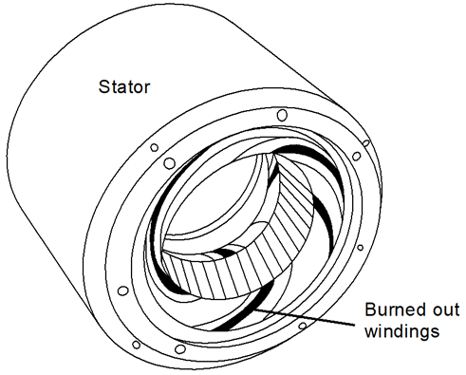

Diagnosis

Even harmonics are easily identified- at 2, 4, 6 etc. times line frequency. The resolution of the FFT should be high enough that peaks at exact multiples of line frequency can be distinguished from signals that appear at exact multiples of rotational speed (eg in a 2-pole induction motor, shaft speed signals will appear very close to, but just below, 100Hz ) or from other resonances that appear close to the even multiples of line frequency. Trends can be spotted in the Electrical Even Harmonic trend parameter, which tracks the worst even harmonic peak (in terms of standard deviations) over time. THD also gives an overall measure of harmonic content (both odd and even harmonics). High harmonic distortion can be spotted in the time domain as a signal very far from being sinusoidal, tending towards a series of spikes.

Action

Preventative measures are far cheaper and more effective than waiting for damage to occur to the windings and rewinding the motor.

Active filters can be used to reduce total harmonic distortion, as will selecting a suitable inverter to power the equipment.