Electrical Odd Harmonics

©Faraday Predictive 2018

Odd line harmonics appear in the spectrum at odd multiples of line frequency – 150, 250, 350Hz etc. for UK and European supplies.

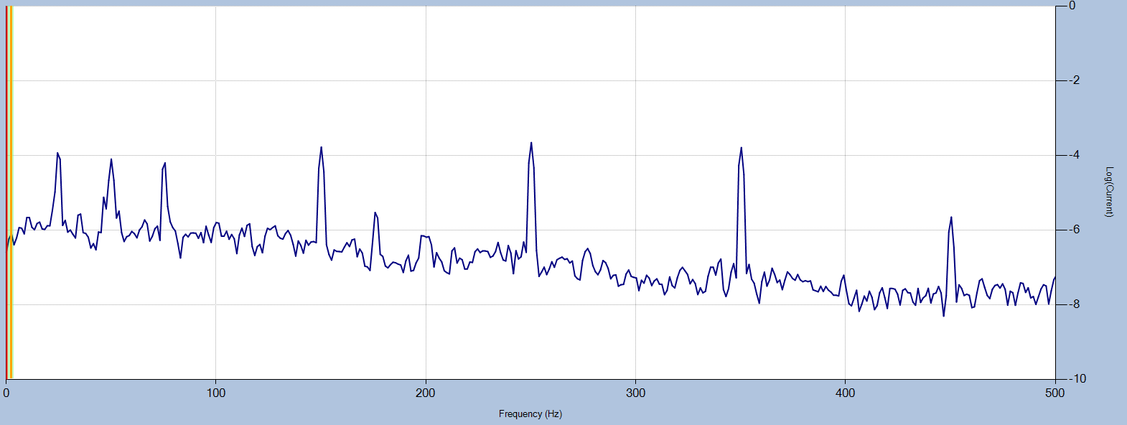

Line harmonics seen in a spectrum of the full line current are distortions in the electrical supply to the motor, which may be due either to the external supply or to distortions caused by inverters, or to geometric properties of the motor windings, or various other reasons.

The main spectrum displayed in the P100 is a residual current spectrum, which corresponds to the distortion on the current waveform that have not been caused by distortions on the voltage waveform. This means that distortions coming from the electrical supply are not a major cause of high odd harmonics in this spectrum, rather, the causes are other factors, mainly related to the design and construction of the motor.

There are two kinds of harmonic that appear in the power spectral density (PSD) plots like the one shown above. The first kind are time harmonics – these are distortions in the current due to fluctuations of the voltage supply over time, and as described above these are effectively removed from the residual current signal. The second are space harmonics, which are produced by magnetic effects in the windings, stator slottings, and magnetic saturation of the rotor core. These induce currents in the stator, which appear on the PSDs at multiples of line frequency.

Odd harmonics tend to indicate a squaring off, or a flattening, of the current waveform. A perfect square wave is effectively composed of an infinite series of odd harmonics. So, the causes of odd harmonics are those factors that tend to result in clipping or squaring off of the current waveform.

# Cause

Odd harmonics can appear due to magnetic effects in the windings, such as magnetic saturation of the stator and rotor cores. As the current varies sinusoidally from zero to peak, the iron core of the stator windings becomes magnetised. If the magnetisation approaches saturation, the flux will be flattened off.

Odd harmonics are also created by the geometry of the rotating poles in the rotor as they pass the stator windings. Because the stator windings have a finite number of turns, as the pole of the rotor passes the end coil on the stator, the magnetic flux drops off in a step-wise manner, rather than following a perfectly smooth drop off. This could be thought of as creating squared-off corners on the magnetic flux permeating the rotor, and hence creating distortions on the rotor current, and hence distortions on the stator current – which show up as odd harmonic peaks. 7th harmonic peaks can often be caused in this manner.

# Effect

High harmonics in the stator dissipate energy as heat and can damage the insulation of the windings, eventually leading to short circuits that can cause them to burn out. A rule of thumb is that every 10-degree C rise in winding temperature halves the life of the insulation and windings. There are also significant energy losses; 1% is not unusual and extremely highly distorted voltage supplies (12% THD) can produce a 5% energy loss; energy which goes into the stator and rotor windings, increasing temperatures and damaging winding insulation.

In delta connected circuits, third harmonics do contribute to the current in the windings (therefore torque) as the voltage signals between lines are in phase. 5th harmonics cause an opposing current compared with the line, and therefore an opposing torque on the rotor, and 7th harmonics cause a current in the same direction as the line. However, the 7th harmonic could cause crawling of the motor, if motor torque falls below the load torque.

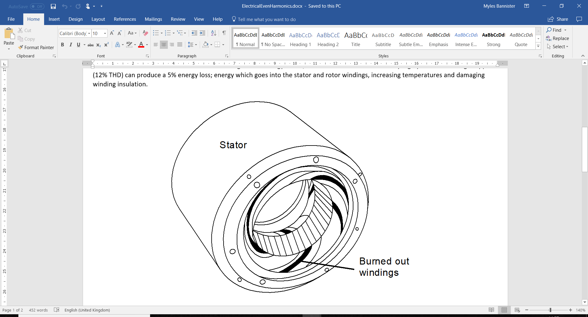

# Diagnosis

Peaks at odd multiples of line frequency are easily identified (150Hz, 250Hz… etc for a 50Hz supply), and THD gives an indication of overall harmonic content. The Electrical Odd Harmonics parameter is useful for trending possible deterioration, this measures the worst odd harmonic (in terms of standard deviations) over time.

# Action

Preventative measures are far cheaper and more effective than waiting for damage to occur to the windings and rewinding the motor.

Active filters can be used to reduce total harmonic distortion, as will selecting a suitable inverter to power the equipment.