Motor Rotor

©Faraday Predictive 2018

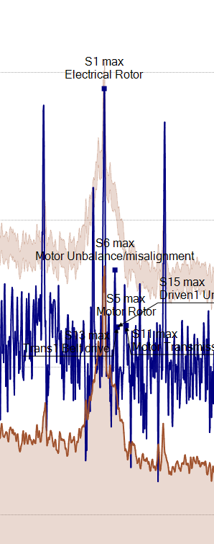

An increased response at the fundamental frequency is most often caused by a load condition not seen while measuring the baseline. It typically indicates operational variations, and sudden changes can indicate a problem with the process (like blocked filters or process fluid density increases).

However, there are a number of faults that can be associated with changes in the Rotor response and these should be checked if an alert persists in the absence of operational or process variations:

* **Supply distortion**

# Cause

May be a fault with the substation supply, local motor control system (clipping, card defects, loose connections, shorts), or may indicate motor faults.

# Effect

Stator heating, reduced motor life, vibration affecting bearings or seals.

# Diagnosis

Physical parameters include readings of THD and each harmonic, Ext Electrical alarms, Watch line alarm, PSD shows changing line harmonics. Even harmonics resistive, odd harmonics capacitive typically.

# Action

Check motor control system for defects, loose connections. Fit harmonic filter to inverter drives. Get supplier to check power supply quality.

* **Unbalanced supply phases**

# Cause

May be a fault with the substation supply or local motor control system. Commonly, current imbalance may be caused by an unbalanced load such as large single-phase service feed.

# Effect

Voltage imbalances are less common but more severe. For a 5HP motor a 1% voltage imbalance or 10% current imbalance can increase stator temperature by 10C, reducing motor life by 50% (EPRI).

# Diagnosis

Physical parameters include current and voltage imbalance. Can also be checked using the voltage and current waveform plots.

# Action

Check motor control system for defects, loose connections. Check load balancing with electrical services group. Get supplier to check power quality.

* **Isolation, compensation, connection faults**

# Cause

Physical damage to conductors or insulation, fatigue, water ingress, incorrect installation or maintenance, or just time-related deterioration.

# Effect

Short- or open-circuits including connection faults can result in high levels of local heating (can even be a fire hazard), as well as being a source of current and voltage imbalance.

# Diagnosis

Model parameters are sensitive to these defects, as are current and voltage imbalance parameters. Voltage and current waveform analysis will show imbalance clearly, as well as transient effects.

# Action

If a thermography camera is available this can be used to localise problems detected by the system quickly. Otherwise a physical inspection should be made. Testing and (if necessary) replacing compensation capacitors can save a lot of money compared with a rewind (which is often mistakenly ordered).