Motor Stator

©Faraday Predictive 2018

The stator is the stationary part of the motor (or generator). It is one of the two key components in an electric motor, the other being the rotor, and as a result its physical condition is of the utmost importance in the safe operation of an electric motor. Two separate studies [1][2] have found that stator faults account for 28% and 36% of all induction motor faults respectively.

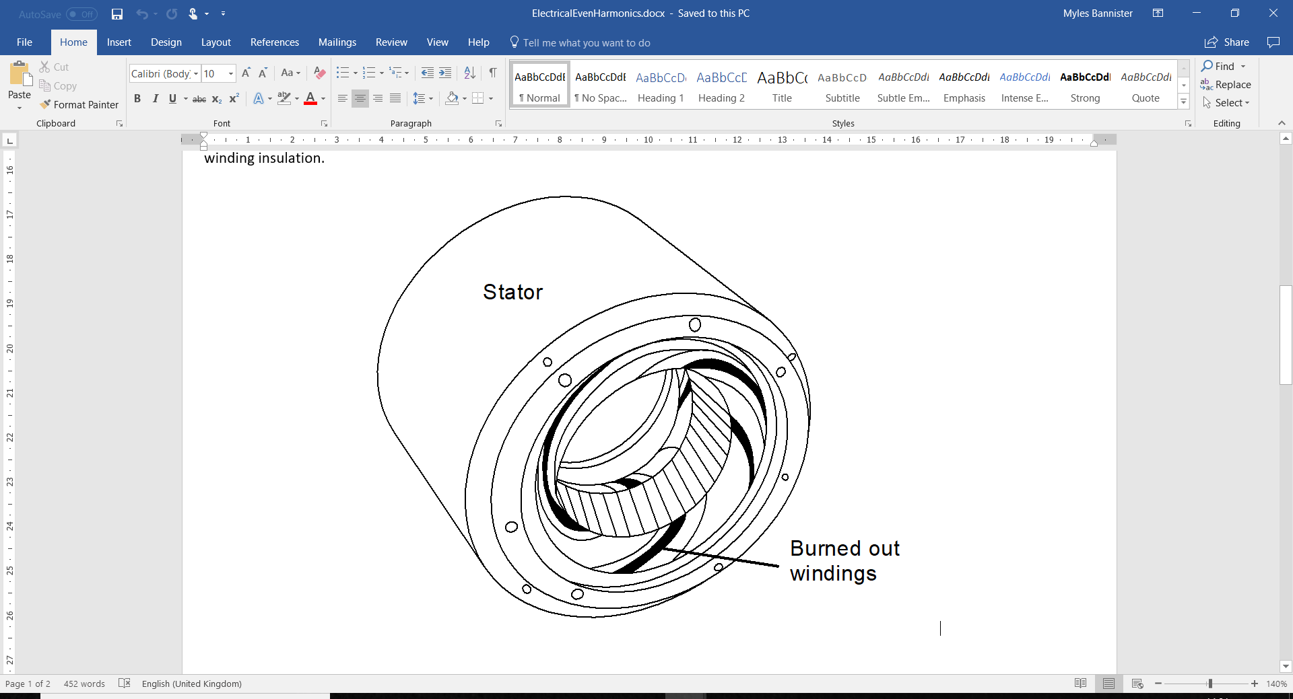

# Cause

A stator winding fault occurs when the insulation of the windings deteriorates. This is usually caused by thermal stresses which can often be due to a sustained overloading of the motor or a voltage or current unbalance or high levels of harmonic distortion of the supply, such as may be experienced in motors driven by an inverter. Stator problems can also be associated with mechanical causes resulting from loose windings that are then able to move or vibrate under the influence of electromagnetic effects that are inevitably present in the motor system.

Thermal damage to the stator windings is usually done in one of three ways:

1. From over currents during start-up leading to intense but short-term temperature rise;
2. From recurring transient voltage spikes, which over time damage the winding insulation by causing inter-turn currents, directly damaging the dielectric properties of the insulation;
3. Through chronic overheating, whether from operating at too high a load, from high current imbalance, from high THD, from environmental effects such as operating in an area of high ambient temperature, or from defective cooling, such as can be caused by a blocked fan inlet grille, or a damaged or loose fan impeller.

Loose windings lead to mechanical damage to the windings and insulation, as the windings flex and potentially rub against one another or against fixed parts of the motor.

During start-up, high currents are produced in the stator, which can damage the windings. The effects of this can be limited by properly following good practice when starting up or shutting down equipment (e.g. using a VSD to ramp up the motor speed slowly) and only turning the motor off when necessary.

Transient voltage spikes can be filtered out, using an overcurrent protection system, if these are causing a problem.

Overheating is caused by running the motor at too high a load, or by improper ventilation of the motor. This could be caused by the ventilation fan of the motor being blocked.

# Effect

Stator winding faults can lead to a short circuit in or between the windings. If the short circuit is to ground or between phases of the supply this can cause instant shutdown of the motor. A short circuit within a phase (ie a turn to turn fault) can lead to a partial burnout of a section of the windings; the shorted section will act as an open circuit inside which current will flow, dissipating heat. Once one section of windings has burnt out in this manner it is likely that all sets of windings will rapidly deteriorate.

# Diagnosis

Mechanical looseness of windings shows up at 2x line frequency, as the magnetic effect operates on both positive and negative halves of the cycle.

Stator winding faults can be identified by first calculating the slot passing frequency, found by multiplying the shaft frequency by the number of slots on the stator. The PSD plot would look like that in the example (below). Peaks appearing at slot pass frequency and particularly as a family of peaks as sidebands on the slot pass frequency, separated by shaft speed, could indicate a stator winding fault.

A second way of monitoring stator winding faults is to look at the RMS current values of each phase over time. Generally these should track one another – however in cases where there is inter-turn short circuiting, or current passing between different phases, these values will start to cross one another.

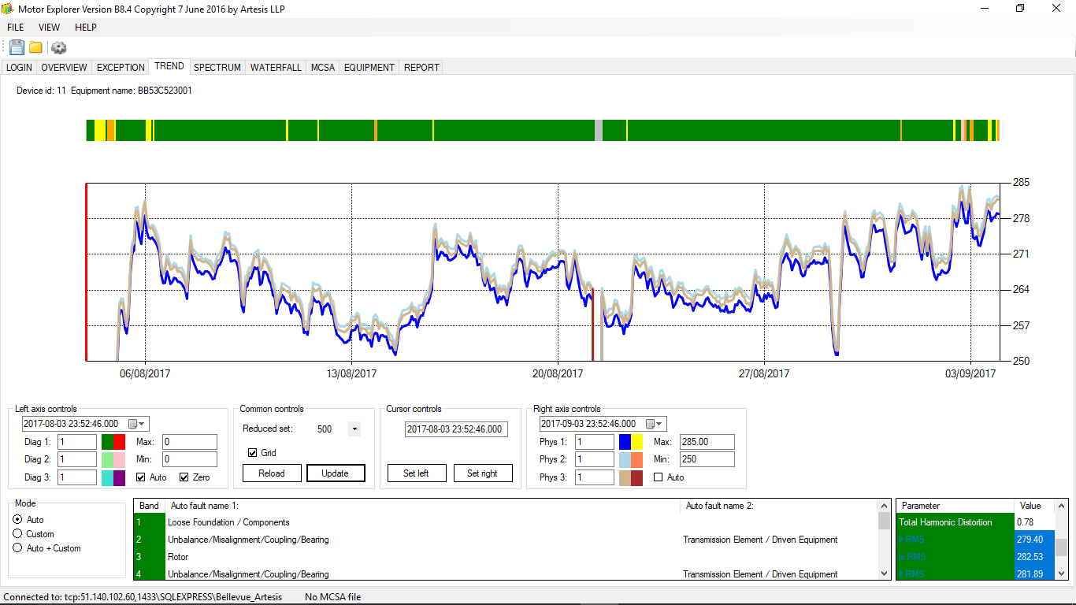

The three colours here show the RMS values of current on each phase over time. Here you can see they track one other without crossng – were they to cross, when the voltage is not also changing in similar manner, this indicates a change in the relative resistance of the 3 phases to one another, and may be a sign of a short circuit between the phases.

# Action

Aged or damaged insulation can be replaced by rewinding the stator windings. If damage has already been done to the stator itself, then it may need replacing.

When contemplating a motor rewind, be aware that the process often involves heating the stator to high temperatures to remove the old windings, and this has been reported in some cases to lead to damage to the magnetic properties of the core, leading to premature saturation and lower maximum power output from the motor.

[1.] Allbrecht PF, Appiarius JC, McCoy RM, Owen EL (1986) Assessment of the reliability of motors in utility applications—updated. IEEE Trans Energy Convers EC-1(1):39–46

[2.] Singh GK, Al Kazzaz SAS (2003) Induction machine drive condition monitoring and diagnostic research—a survey. Electr Power Syst Res 64(2):145–158