Fan Blades/ Pump Impeller Vanes

©Faraday Predictive 2018

Centrifugal or axial flow pumps and fans all have impellers, fitted with a number of blades or vanes, and as such these are very common components in rotating machinery. Although most centrifugal pumps and most fans are reasonably robust, damage to the impeller can impair the overall performance, reducing the efficiency of the equipment and reducing the overall capability, eg reducing the max pressure and / or flowrate available. In addition, some impeller problems can lead to imbalance, which can put excessive loads on bearings and cause other problems for both this item of equipment and other equipment in the neighbourhood.

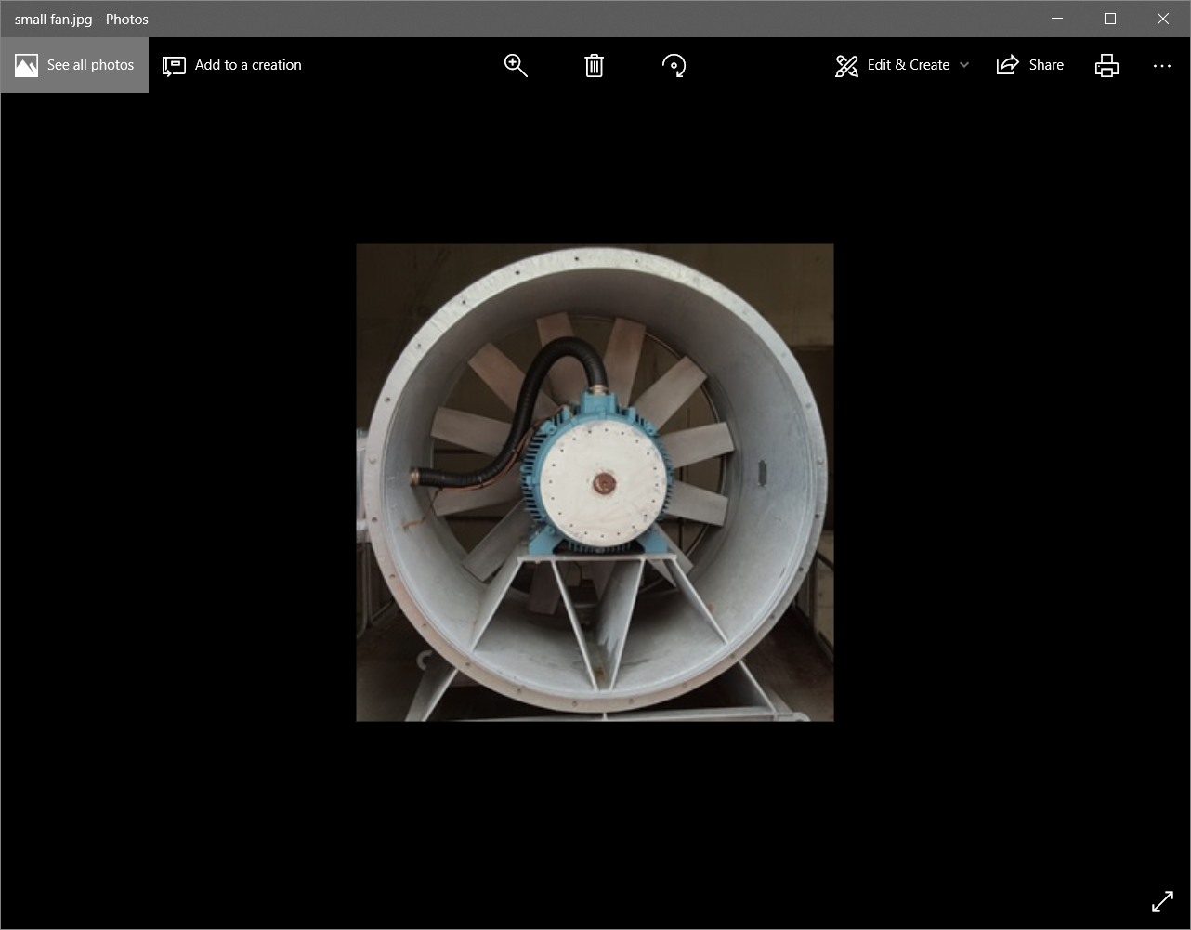

The main types of fault in impellers are:

* Build-up of material, leading to imbalance; this may be gradual build-up of dust or other particulate material on fan blades, or it may be sudden build up of tramp material on a pump impeller, such as rag build up on a waste water pump.
* Gradual loss of material, caused by either erosion or corrosion; This may lead to imbalance and may also affect the flow patterns of the fluid over the surface of the blades, leading to different spectral frequencies being displayed.
* Sudden loss of material, either as the result of fatigue over an extended period, or as the result of sudden impact of tramp material; this will generally result in very high vibration starting suddenly, and associated with a drop off in the performance of the pump or fan;
* Distortion of one or more individual blades or vanes caused by impact with tramp material, bending the blade(s) it comes into contact with. This is likely to result in both imbalance and a loss in performance and efficiency of the fan or pump.

Other phenomena that can show up as an effect related to vane pass frequency include:

* Damage to the casing of the pump or fan, typically from erosion or corrosion;
* Flow turbulence (this can also cause high levels of noise at a very wide range of frequencies, and, particularly in axial flow fans, potentially causing such a high “carpet” on the spectrum that other faults may be hidden)
* Off-curve running (operating a centrifugal pump well away from the design point (best efficiency point or BEP) leading to turbulent flow patterns of vortices being shed from either the front or rear face of the pump vane, leading to signals at a wide range of frequencies, often as a “hump” of frequencies around vane pass frequency

If the number of blades on the impeller is known, this should be entered into the equipment information table of the P100 (under Driven 1, No of blades/vanes).

# Cause

The cause of a peak at vane pass rate is a pulsation in pressure in the pump chamber as each vane passes the throat of the discharge. When the pump or fan chamber is well designed, the flow through the volute (the spiral shaped part of the pump chamber) should be uniform and steady, and very little variation in pressure occurs on the impeller blades as they pass the throat. However if significant wear takes place on the impeller or the casing this can affect the internal geometry, and the pressure on the vane can vary as the blade passes the throat. This pressure difference shows up as a variation in torque at vane pass frequency, and hence shows up in the motor current at that same frequency.

When a centrifugal pump or fan is operating at the design point, the fluid should pass smoothly along the line of the vanes. If the flow is much greater or less than this, the radial component of the fluid flow is different whereas the rotational speed of the blade stays the same. Instead of flowing smoothly along the line of the blade, the flow will spill off the blades and create eddies. If the flow is too high, the flow will spill off the leading edge on the outside of the blade, if too low, it will spill off on the inside edge. Either way, a series of vortices or eddies are created, which represent a dynamic changing pressure on the blade, which can show up as a signal at a wide range of frequencies. Whilst it is not easy to predict the frequencies that such eddies will occur at, once a pattern has been established for a particular pump on a particular duty (fluid density and viscosity and flow rate) then the pattern can itself be used as an indication of internal flow behaviour in the pump. Quite often they result in the spectrum showing a “hump” of signal around vane pass frequency.

Flow turbulence in axial flow fans can sometimes be observed particularly in large diameter fans with a long inlet duct with no flow straighteners. Turbulent flow in this inlet duct means the fan blades see variations in pressure at a whole random range of frequencies, and these can show up as an elevated “carpet” on the spectrum. This does not indicate the cause of a problem affecting the effectiveness or reliability of the fan, but it can impair the ability to identify and diagnose problems that become effectively hidden beneath this high carpet.

Cavitation in a pump occurs when the pressure somewhere inside the pump drops below the vapour pressure of the liquid, or of any dissolved gases in the liquid. Gas bubbles, either of air or other dissolved gases, but more importantly, of boiling liquid, are created in this low-pressure zone. As the liquid containing these vapour bubbles passes through the pump, once it reaches a point where the pressure is not quite so low, these bubbles condense and collapse. Even though these can be very small vapour bubbles, as they collapse or implode, they can create shock waves that can do real damage to the metal surface that they are in contact with. Over time, the metal surface can be eroded, typically showing a pattern of small circular pits in the zone where the bubbles collapse.

If left untreated, this can result in serious loss of material from the impeller, leading eventually to catastrophic failure.

Cavitation can often be heard as a rattling or tinkling or rumbling noise. On the residual current PSD spectrum, it can show up in a number of different ways, and sometimes not at all. Most commonly it shows as an extended hump at higher frequencies, eg at vane pass frequency and above.

Cavitation can be caused by a wide range of things, but easy items to check for are a partially blocked inlet to the pump (eg inlet valve not fully open; tramp material blocking the pump inlet pipework); other cause of low pressure at inlet (eg level of liquid on inlet vessel too low); elevated temperature of pump inlet, causing the liquid to be nearer to its boiling point.

Internal corrosion in a pump can be caused by many things – one common cause is in pumps designed for salt water duty that are fitted with a sacrificial anode, and where the anode has all been corroded away and not replaced, leading to corrosion of the pump itself.

The example below is from a seawater pump where corrosion has attacked the location where a grub screw was locating a wear ring. The result has been a hole perforating the casing from the high-pressure zone of the pump back into the low-pressure area. The result showed up very clearly on the PSD spectrum as a big hump around vane pass frequency.

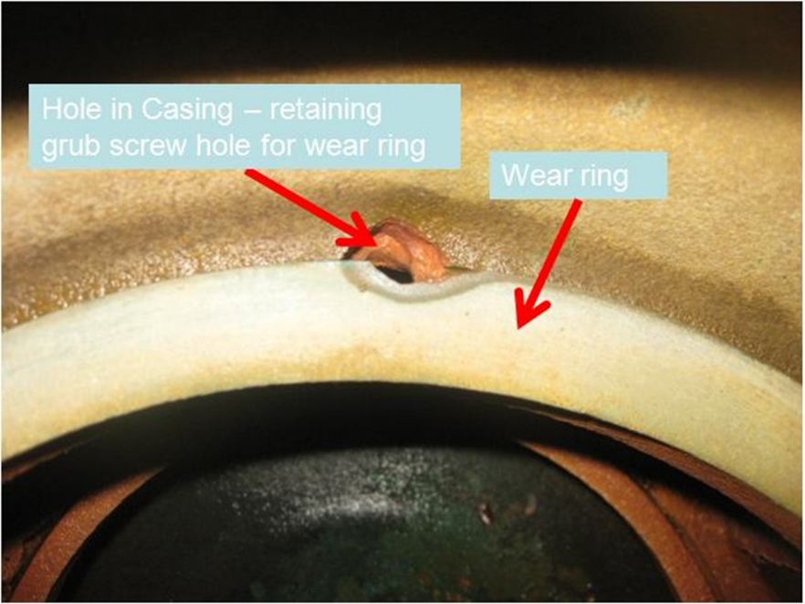

# Effect

Under normal operating conditions the material design of the equipment means that hydrodynamic forces do not normally lead to faults. However, problems can arise when these forces excite resonant frequencies of the equipment, causing large amplitude vibrations. These have the potential to cause fatigue damage to components and eventually lead to failure.

Both cavitation and recirculation lead to erosion and vibrational damage on the impeller. These appear as little circular impact marks on the impeller and will quickly cause irreversible damage.

# Diagnosis

On the residual current spectrum, blade faults are characterised by an increase in amplitude at a frequency that is equal to the number of blades times the shaft frequency (fshaft) or a “hump” of frequencies around this. On the modulated spectrum peaks appear as sidebands of line frequency as shown below.



# Action

Turbulence is largely avoided at the design stage however a flow straightener can be used to reduce turbulence.

Cavitation can be reduced by ensuring the net positive suction head available (NPSHA) is always a safe margin above the net positive suction head required (NPSHR) during operation. The NPSHA is independent of the pump and depends on the rest of the system, but can be increased in various ways, such as increasing the liquid level in the suction vessel. The NPSHR can be decreased by decreasing the flow rate or operating speed of the pump. Installing a pump inducer can reduce cavitation without reducing system output.