Foundation Looseness / soft foot

©Faraday Predictive 2018

Foundation looseness refers to a loose attachment between the equipment and the baseplate it is situated on, due (for example) to untightened bolts. Soft foot is a common term for machine frame distortion, when the heights of the feet that support the equipment differ; for example, due to a squashy footage on one of the feet.

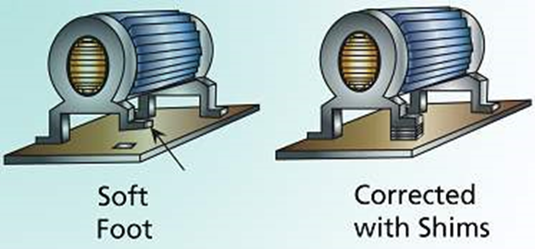

# Cause

Looseness is typically the result of bolt or attachment cracking, untightened bolts, fragmenting base, or weak grouting. Soft foot can be caused by incorrect installation of the equipment, a bent foot, or sometimes due to a failed attempt to correct looseness. It could also be caused by excessive tension on the feet of the machine, or a warping of the baseplate that the equipment is mounted on.

# Effect

Looseness can give rise to excessive vibration, damaging bearings and seals, causing misalignment, and further damaging the foundation. Soft foot also causes excessive vibration and can change internal tolerances leading to rubbing or interference.

# Diagnosis

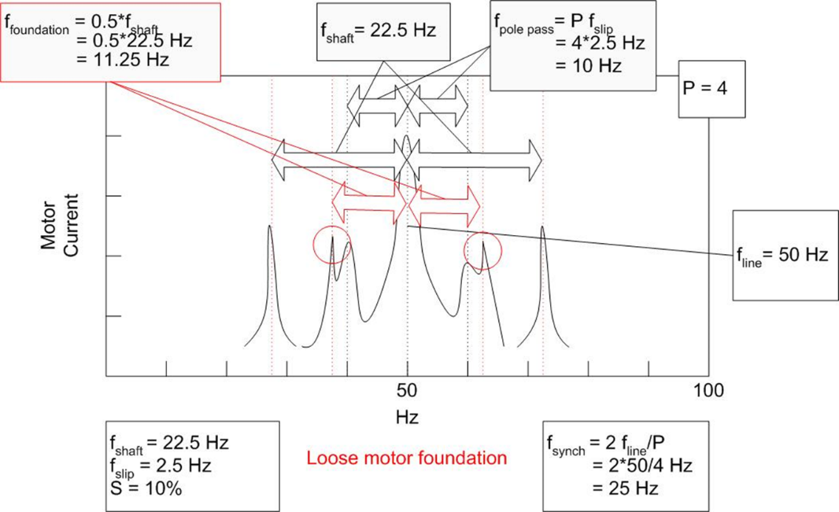

Diagnostic parameter - Loose foundation/components

In the PSD, foundation looseness shows characteristic frequency features at shaft speed (translational movement) or at multiples of shaft speed and ½ shaft speed (rocking movement). Latter case is much easier to distinguish from other faults. It also generally shows up on the spectrum as a large low frequency peak, close to DC.

# Action

Not always a conclusive diagnosis, so should be confirmed by inspection. Fatigue cracks typically show red oxide fretting slurry. In difficult cases confirmation may require Operating Deflection Shape (ODS) or modal test.

Correction of soft foot may be as simple as introducing shims to bring each of the feet to the same height, and often foundational looseness can be corrected by re-tightening or properly replacing the foundation bolts. After these simple corrective actions, the equipment should be revisited (preferably within 4-6 weeks) and inspected to ensure that the problem has not relapsed. It may be that the root cause of the problem is to do with softness in the structural foundations, which would require further corrective action. It might be necessary to stiffen the foundations or completely reposition the equipment.