Current Unbalance

©Faraday Predictive 2018

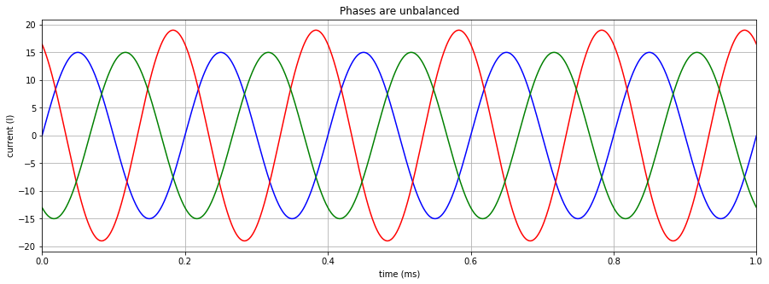For a three-phase supply, current unbalance is defined as the maximum deviation of any current phase from the average current, divided by the average current, often expressed as a percentage.

Clear current unbalance - Red phase has a different RMS value compared with the other 2 phases.

# Cause

Most often a current unbalance is directly caused by an unbalance in voltage which is explained in detail in the voltage unbalance diagnostic sheet. In these cases, the current unbalance is usually higher than the voltage unbalance. If there is not a voltage unbalance, then a current unbalance is due to either a resistive or inductive (i.e. reactive) unbalance in the motor.

There is always some voltage and current unbalance present in the supply, which is generally greater during the day when the grid is supporting a larger number of domestic applications that tend to be connected to a single phase.

The ratio of current unbalance to voltage unbalance depends on how heavily loaded the motor is. At full load, current unbalance is typically 5 x the voltage unbalance (ie 1% voltage unbalance will lead to 5% current unbalance). At light loadings, this factor could increase to 10. At extremely light loadings, it may even be as high as 20 x, ie, the 1% voltage unbalance could result in a 20% current unbalance. However such a low level of loading is very unusual.

The P100 as a default identifies 1% voltage unbalance and 5% current unbalance as threshold levels beyond which a problem exists.

# Effect

Current unbalance generates excess heat which can reduce insulation life, leading to stator winding faults and hence a further current unbalance, as discussed in the Electrical Stator diagnostic sheet. As a rule of thumb 1% voltage unbalance leads to 5% current unbalance which causes a 10°C temperature rise in the windings. 10°C rise in temperature is generally recognised to halve the life of the motor windings.

Current Unbalance also results in an oscillating torque being produced by the electric motor. If plotted on a polar chart, the motor should produce a steady torque, which would be represented as a perfect circle on the polar plot. With a current unbalance, the plot will be elliptical, ie a torque oscillation at twice line frequency. Oscillating torque puts additional torsional loads on the driven equipment, particularly elements like couplings that may reduce their life, and may result in increased vibration.

In 3 phase applications, unbalanced currents could potentially overflow into the neutral wire and could trip a RCD if the unbalance exceeds the RCD threshold.

# Diagnosis

Voltage and current unbalance are both displayed as electrical parameters in the P100 system. A threshold of 1% has been set, above which the unbalance is considered high. The IEEE standard for voltage and current unbalances in industrial applications is set a threshold of 1%.

If a very high current unbalance is present without a corresponding voltage unbalance, then this could be a sign of a fault in one of the phases.

# Action

If the current unbalance is due to a reactive unbalance in the stator windings, they will have to be re-wound or replaced if damaged. If it is due to a voltage unbalance the incoming supply system should be checked for faults. See the voltage unbalance diagnostic sheet for more information on this.