Current THD

©Faraday Predictive 2018

When an AC power supply is used to drive a motor, it is only the fundamental (eg 50Hz or 60 Hz) component that does useful work causing the motor to rotate at the desired speed. Current occurring at any other frequencies just represents current that flows in and out of the motor, doing no useful work, but creating losses that heat the motor up, from resistive (I2R or “copper” losses) and hysteresis (“iron”) losses. Heat is bad, as increased temperature causes premature ageing of the insulation of the motor windings. The rule of thumb is that a 10-degree C rise in temperature halves the life of the motor windings.

The total harmonic distortion, or THD, of a signal is a measurement of the harmonic distortion present and is defined as the ratio of the root square sum of the power of all harmonic components compared to the power of the fundamental frequency. Harmonics or harmonic frequencies of a periodic voltage or current are frequency components in the signal that are at integer multiples of the frequency of the main signal. Harmonic distortion is the distortion of the signal due to these harmonics. THD is used to characterize the power quality of electric power systems and also the linearity of audio systems. In power systems, lower THD means reduction in peak currents, heating, emissions, and core loss in motors. The injection of harmonics, even in small quantities, can adversely affect the machines, motors and the power electronics.

# Cause

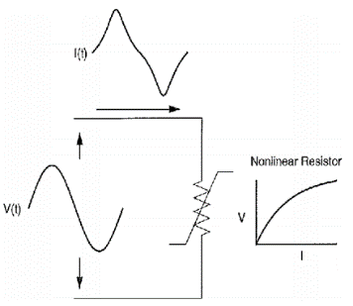The usual waveform of an alternating current (AC) is a sinusoidal wave. Linear loads draw current in proportion to the sinusoidal voltage. Non-linear loads, such as fluorescent lights or inverters (drives), change their impedance by conducting current only near the peak of the wave. Switching loads on and off during the waveform results in non-sinusoidal current pulses. These pulses also introduce reflective currents (harmonics) back into the power distribution system.

The figure to the right illustrates the sinusoidal applied voltage to a simple nonlinear resistor in which the applied voltage and current vary according to curve shown. While the applied voltage is perfectly sinusoidal, the resulting current is distorted.

The sources of harmonics can be broadly classified as follows[1]:

A) Harmonic originated at high voltages by supply authorities. 1. HVDC systems, 2. Back to back systems, 3. Static VAR compensation system. 4. Wind and solar power converters with interconnection

B) Harmonics originated at medium voltages by large industrial loads like Traction equipment, variable speed drives, Thyristor controlled drives, Induction Heaters, Arc furnaces, Arc welding, Capacitor bank, electronic energy controllers.

C) Harmonic originated at low voltages by consumer end like single phase loadings, uninterrupted power supplier, semiconducting devices, CFL, solid state devices, domestic appliances and accessories using electric devices, electronic fluorescent chokes, electronic fan regulator, light dimmers.

# Effect

High levels of harmonic distortion can cause several effects such as increased transformer, capacitor, motor or generator heating, false operation of electronic equipment, incorrect readings on meters, false operation of protective relays, interference with telephone circuits etc. Since harmonic distortion is caused by nonlinear elements connected to the power system, any device that has non-linear characteristics will cause harmonic distortion. Examples of common sources of power system harmonics, some of which never cause serious problems, are: transformer saturation and inrush, transformer neutral connections, MMF distribution in AC rotating machines, electric arc furnaces, fluorescent lighting, computer switch mode power supplies, battery chargers, imperfect AC sources, variable frequency motor drives (VFD), inverters, and television power supplies.

THD which is greater than 5% can create sufficient stator heating to can halve the life of the motor.

# Diagnosis

Harmonic distortion is easily spotted in the spectrum, as high harmonic peaks (multiples of line frequency) and in some cases can be seen in the time domain, where the plots of current are noticeably different from sinusoidal.

THD is also calculated automatically as one of the physical parameters.

${THD}_{i}= 100\%* \sqrt{\frac{{(I}_{2}^{2}+ I_{3}^{2}+…)}{I_{1}^{2}}}$

The above formula shows how to calculate current THD as a percentage. Here the subscript represents the harmonic – I1 is the fundamental whilst I2, I3, …etc are the second, third, and subsequent current harmonics. The sum theoretically goes on forever but practically the harmonics and negligible above a certain order – around 13 times line frequency.

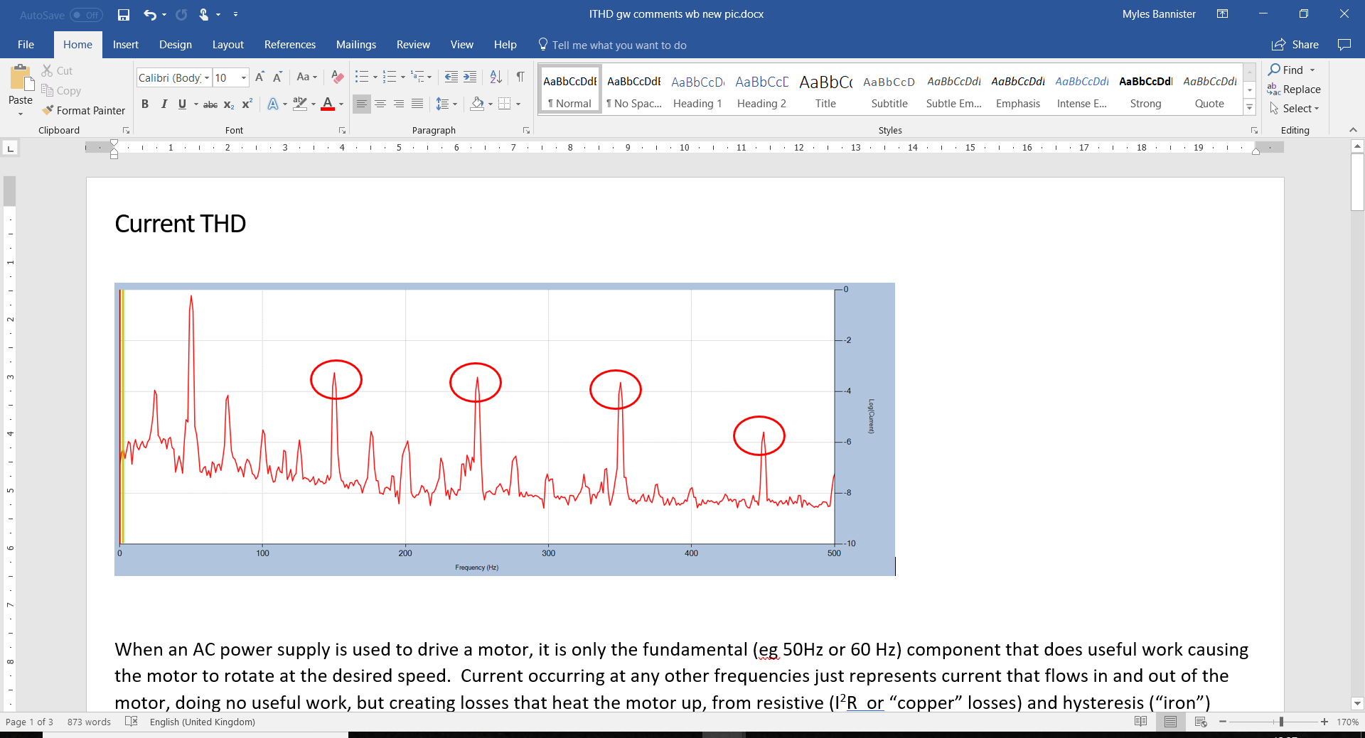

Harmonic peaks seen in the frequency domain, y axis in dB.

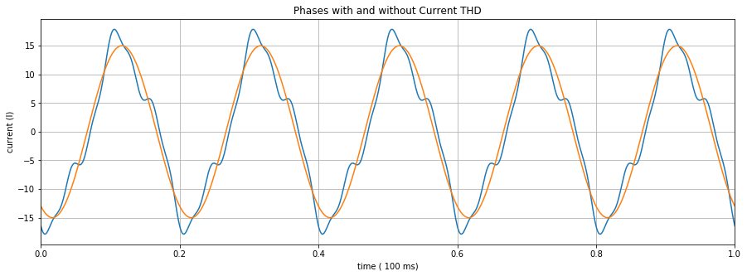

Harmonic distortion seen in the time domain

# Action

There are several approaches that can be taken to compensate for or reduce harmonics in the power system, with varying degrees of effectiveness and efficiency.

* *Oversize the neutral wiring:* The neutral wiring should always be specified to be the same, or larger than, the capacity of the power wiring. This will allow the power system to tolerate potentially large 3rd harmonics, which could otherwise cause a problem in 3 phase circuits with large harmonic content.
* *Avoid using VSDs if possible, or use a high quality VSD:* Variable speed drives can often generate a lot of harmonic content, which is fed back into the grid and affects the performance of the driven equipment.
* *Use active (harmonic) filters:* These are active components that can be used to filter out the harmonic content of a signal.

[1] A.Priyadharshini, N.Devarajan, AR.Uma saranya, R.Anitt: Survey of Harmonics in Non Linear Loads