Power Factor

©Faraday Predictive 2018

The power factor is defined as the ratio of the actual electrical power dissipated by an AC circuit to the product of the RMS values of the current and voltage (apparent power). It should be as close to 1 as possible since when the power factor is less than 1 there is net reactive power, which represents power that does no useful work.

In electromechanical systems, especially ones involving an inductive component such as a motor, a power factor of exactly 1 is never attainable, and a more typical power factor for a large motor would be 0.9. 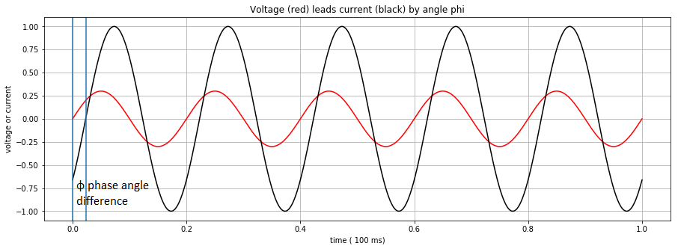

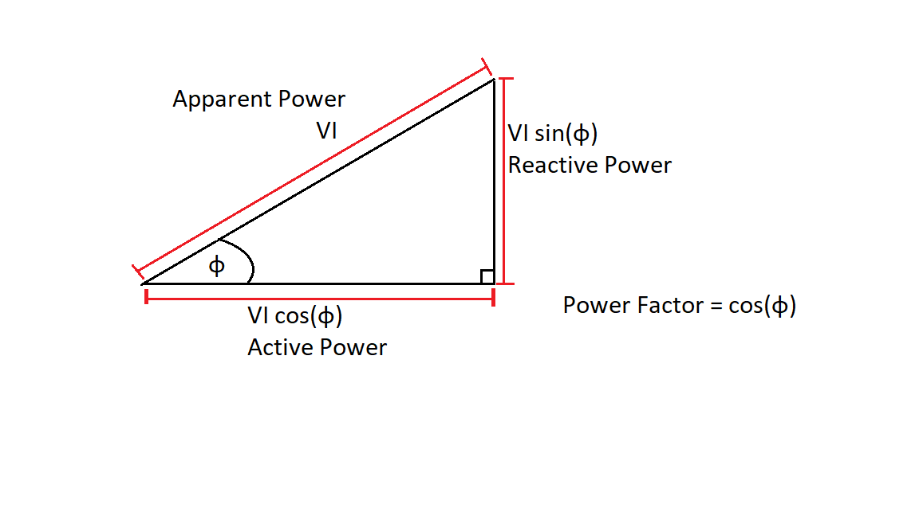Diagram showing voltage leading current by angle phi. Power factor is the cosine of this angle.

V * I * cos(phi) and V * I * sin(phi) are called the active power and reactive power respectively.

Low power factor is not a direct cause of problems with the equipment per se, but it can be a cause of additional cost. This is because although electricity supply companies generally charge by the real power used (kWHrs), and a low power factor does not represent any additional kWHrs, the supply company has to size its equipment to deal with the apparent power (kVA), because current whether real or apparent, cause I2R losses in the wires, switchgear and transformers. Tariffs generally have some means of charging the customer more if the power factor goes below pre-determined limits. So improving the power factor, whether by reducing un-necessary reactive power, or by installing power factor correction capacitors, can have a direct financial payback.

# Cause

A low power factor as measured by P100 mainly indicates that the motor being monitored is not very highly loaded. In principle the reactive power drawn by a motor is used to magnetise the core of the motor, the active power is used to do work. So a lightly loaded motor will draw less active power but the magnetising current will be unchanged, hence the ratio between the two will be lower.

Low power factor is therefore not a major indicator of a problem, but it may indicate that equipment is oversized. Changing to a smaller motor could improve the power factor and save money by reducing the charges for power factor described above.

No normal system will have a power factor of 1; most industrial systems are motor driven and so are inductive and have a power factor of less than 1. A motor running at low load will have a smaller power factor. Small induction motors also have a smaller power factor compared to larger ones. Furthermore, over-sized equipment will have a lower power factor than equipment that is properly sized for its intended application.

# Effect

A low power factor means large amounts of power wasted (through reactive power) which is undesirable. Though reactive power is measured and charged differently to active power, it is still effectively wasted power since it is power consumed that does no constructive work and may be charged for.