Resonance

©Faraday Predictive 2018

All structures have range of specific frequencies at which they tend to vibrate. Designers avoid excitation frequencies that are close to these natural frequencies, but if they coincide resonance can result. The excitation of resonances is not a common problem, but can have severe consequences.

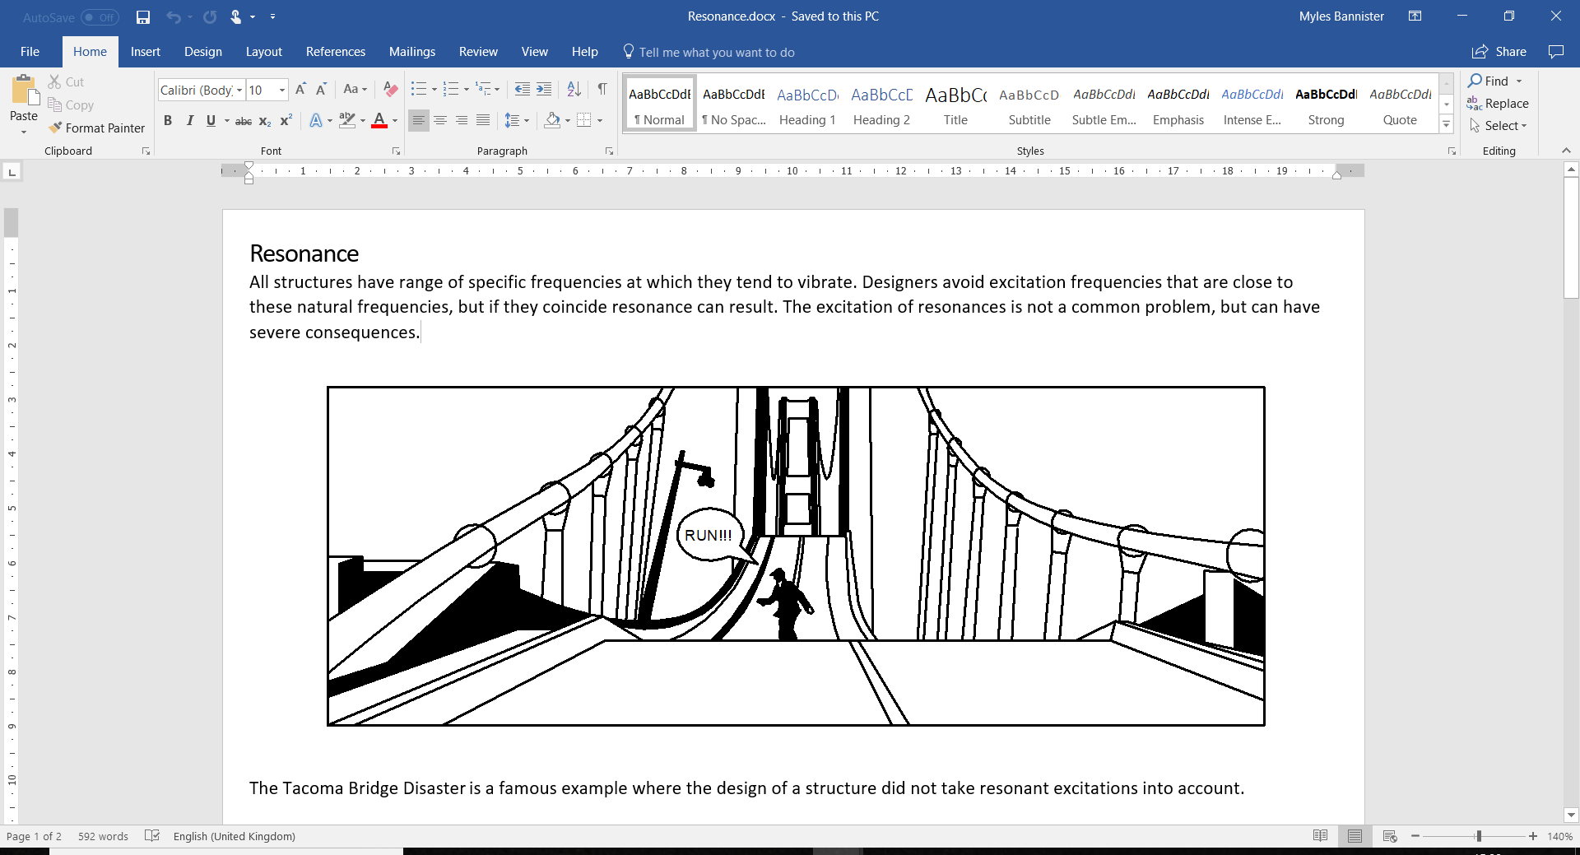

The Tacoma Bridge Disasteris a famous example where the design of a structure did not take resonant excitations into account.

# Cause

In well-designed equipment, typical operating conditions will not excite a resonant frequency. However, it is possible to excite a resonant frequency even in perfectly good equipment, simply by running the equipment at a load/ speed outside of its usual operating range.

Changing the equipment in a way that might affect the mass, stiffness, or damping of a component may have the unintended consequence of altering its natural frequency, and therefore possibly causing it to resonate in response to normal load conditions. These changes could have been corrective (a change to a baseplate for example) or could be due to wear, for example as damage coming about through a rubbing, or from looseness.

# Effect

The effects of an excited resonance are unpredictable, but force magnification may be 30X or more so can be very destructive. Resonances can damage static components such as brackets as well as rotating parts.

Equipment may have been perfectly well designed and maintained but may still deteriorate very quickly if the operating conditions excite a resonant frequency – for example a resonance of the baseplate, or of the motor itself.

# Diagnosis

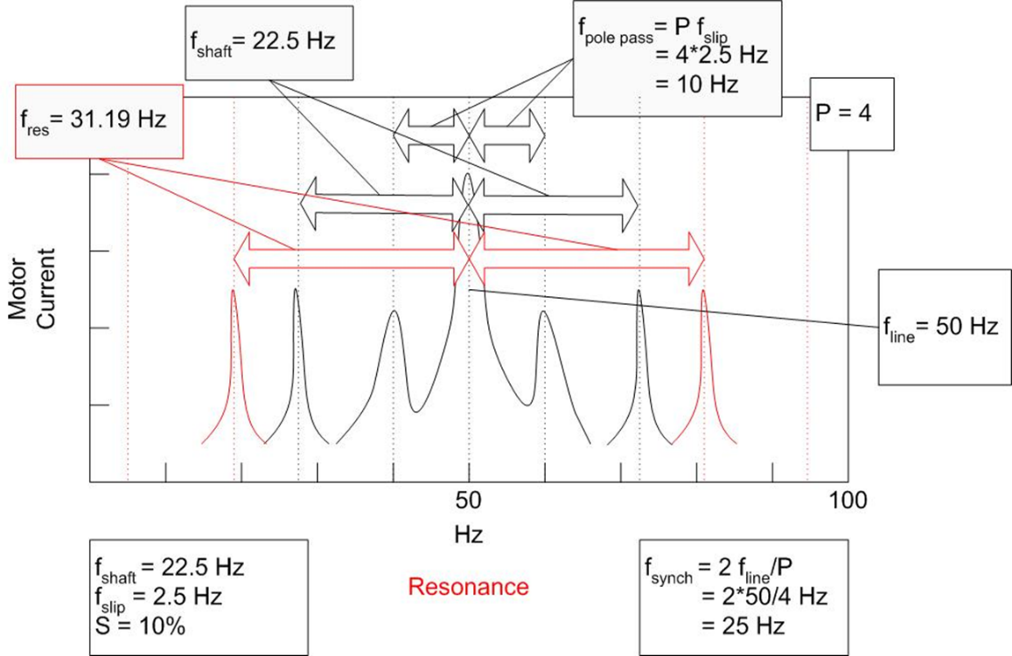

In the PSD resonance appears as a characteristic frequency peak that is not related to shaft speed, although the magnitude may vary as shaft speed changes. The instantaneous PSD snapshot is a very valuable tool for monitoring this problem.

Whereas most faults appear on the PSD as sidebands on a carrier frequency (usually line frequency) at multiples of the rotational speed of that component, resonances can appear as unidentified single peaks that cannot be ascribed to a particular fault type, and are static, i.e. do not change frequency when the speed of the equipment changes (though they may increase or decrease in magnitude with changes in speed). If an unidentifiable peak appears on the spectrum only when the equipment is running at a certain load condition, it is likely that this operating condition is exciting a resonance somewhere in the system.

# Action

Identification of a resonant condition requires immediate and careful monitoring and inspection for external damage. Detailed analysis may require Operating Deflection Shape (ODS) or (better) modal testing.

Once a resonance has been identified as the root cause of a problem, there are two main ways to mitigate its effect. The first is to change the excitation frequency by running the equipment at a different speed, or different flow rate (for a pump/ compressor). If this is possible, it may be the easiest way to prevent damage due to extreme vibration from the resonance.

The second corrective option is to change the structure in some way, either by applying a damping force, or by changing the frequency of the resonating component. For example, if the normal running speed of a fixed speed motor excites a natural resonant frequency of the baseplate, then one option is to replace the baseplate, but it may be possible to stiffen or extend the baseplate or weigh it down to dampen the effect of the resonance. Since the resonant frequency is determined by the square root of the stiffness divided by the mass, changing either the stiffness or the mass can have the desired effect.