Rolling Element Bearings

©Faraday Predictive 2018

# Rolling element bearings are ubiquitous in small to medium sized equipment. Detecting faults in them is a major justification for monitoring. The major components of a rolling element bearing are the inner race, outer race, bearing cage, and the rolling elements themselves. Faults may appear on any of these components.

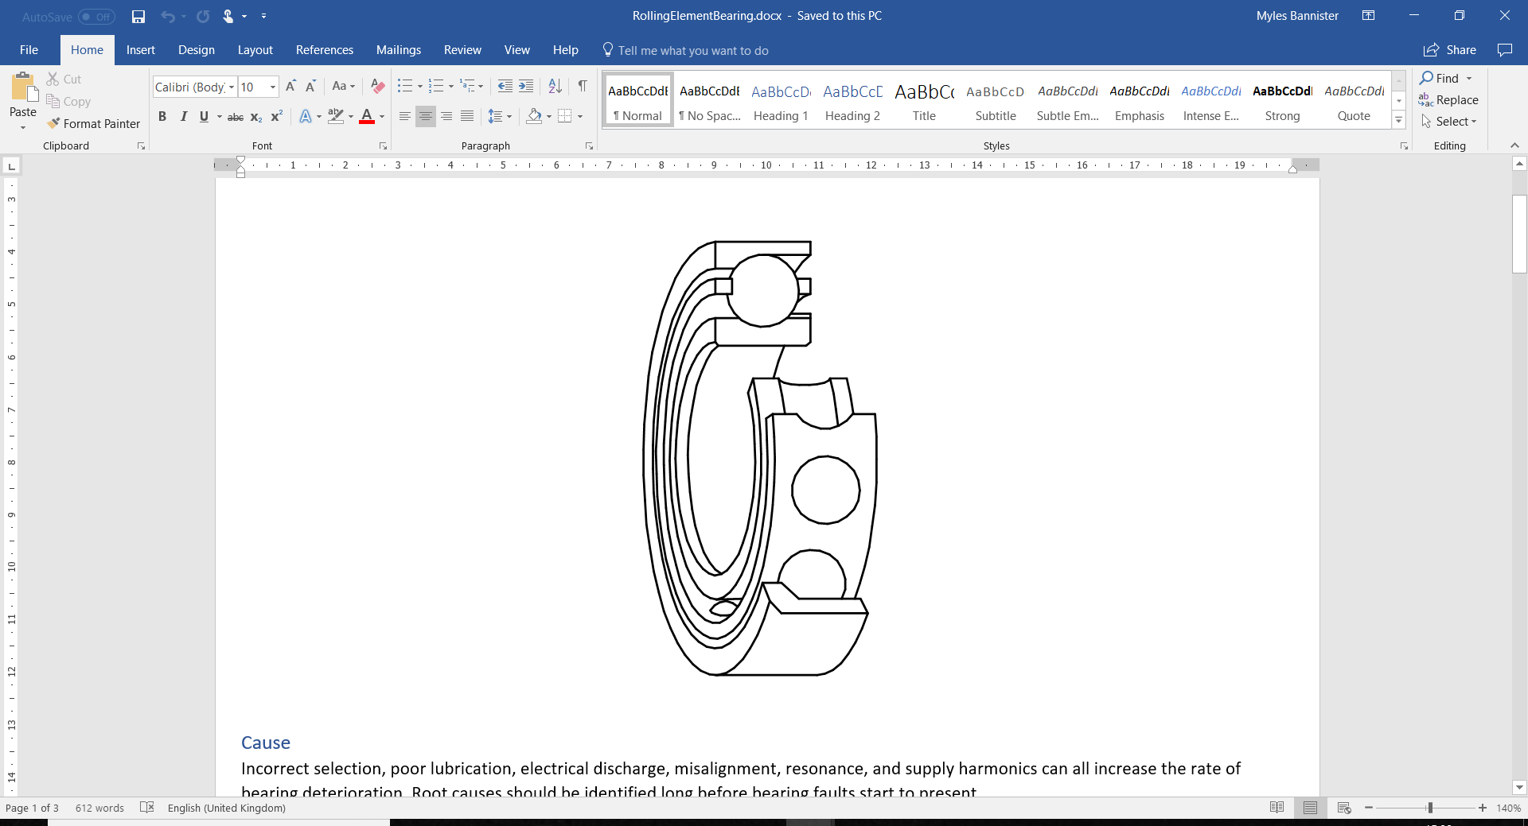

# Cause

Incorrect selection, poor lubrication, electrical discharge, misalignment, resonance, and supply harmonics can all increase the rate of bearing deterioration. Root causes should be identified long before bearing faults start to present.

# Effect

Bearing problems cause excitation forces that may affect other components, as well as local heating and contamination of any lubrication in the bearing, which will accelerate the rate of bearing failure. Complete failure of the bearing will prevent the equipment from rotating and will cause further secondary damage.

# Diagnosis

Bearings have a number of characteristic frequencies, including inner/ outer race ball pass frequency (the rate at which the rolling elements pass a fixed point on the race, abbreviated to BPFI and BPFO), ball spin and train frequency (the rotational rate of the bearing cage/ train). These numbers are usually given as a multiple of rotational speed.

These characteristic frequencies can be obtained from datasheets or through bearing calculators and where the relevant bearing type code has been entered into the equipment information sheet, P100 will use this specific information.

Where no specific bearing codes have been entered into the equipment information sheet, P100 uses approximations. Approximations are typically valid (outer race frequency is 0.4 * shaft speed * number of elements, inner race frequency 0.6 * shaft speed * number of elements, train frequency 0.4 * shaft speed). The exact coefficient used to calculate these frequencies precisely depends on the shape of the rolling elements, the shape of the races, and the degree of endthrust on the bearing, but for the outer race this number is always below 0.5 and generally above 0.35; this number represents the relative rate of movement between the outer race and the rolling element. In a perfect roller this would be 0.5 exactly, but this is never achievable in practice. In a ball bearing it will always be lower than this number because the effective rolling radius of the balls is not right on the outer diameter but part way up the sides of the balls.

Where there is a fault, these frequencies appear on the spectrum as *sidebands on a carrier frequency*, e.g. at line frequency + BPIR * rotational speed. The complete formula for this kind of fault is:

$$n f_{line }±m f_{Bearing}$$

Here n and m are integers, and most often n = 1 and m=1, which means bearing faults appear either side of line frequency. F_bearing is the bearing frequency, either BPIR, BPOR or train frequency, described above. Visually on the PSD this looks like two or more smaller peaks centred around a line harmonic.

As long as the correct bearing information is entered into the P100, peaks at these frequencies are detected automatically.

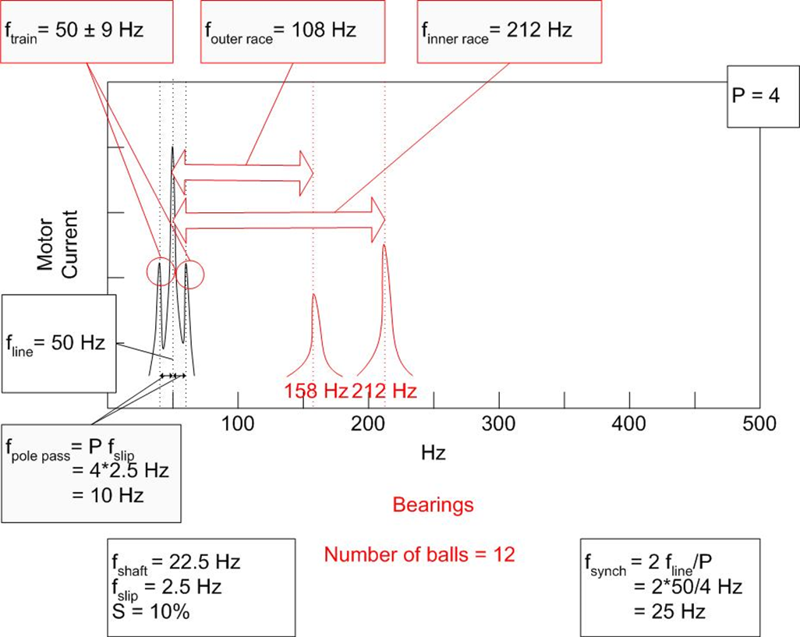

Diagnostic parameter – Bearing

Bearing information can be entered into the equipment information table under driver, driven 1 or driven 2. If the bearing numbers are known, this should be entered, and the P100 will use a bearing database to complete the bearing information.

Rolling element deterioration is classically described as passing through 4 stages:

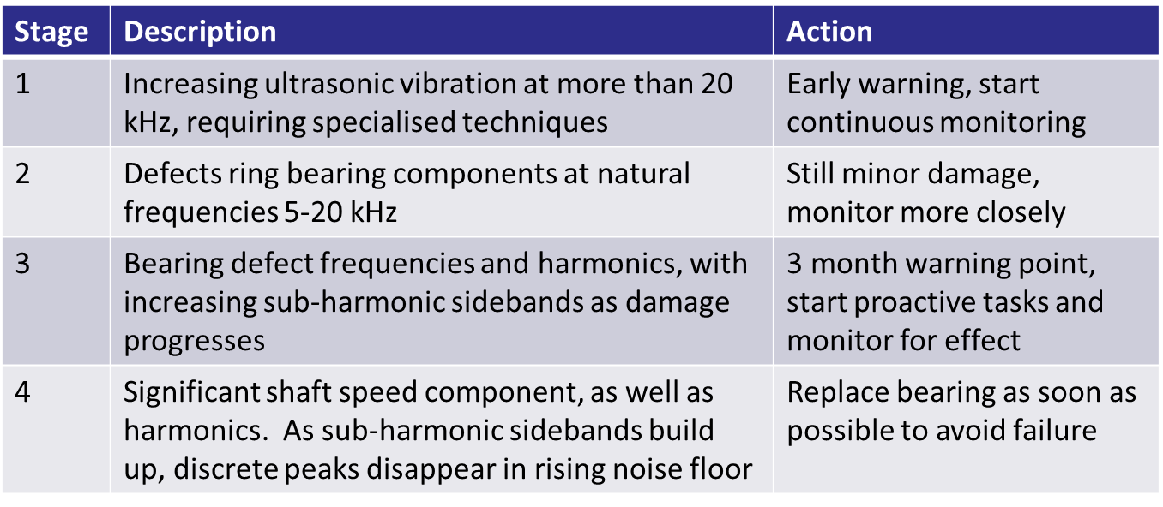

# Action

Actions should be proactive, dealing with root causes in time to prevent bearing damage. Once damage begins, offline oil filtering may extend bearing life with careful monitoring so that replacement can be carried out at minimum cost. Thermal imaging may be able to detect late stage bearing problems – but at this point the bearing may need replacement asap.