Rotor Bars

©Faraday Predictive 2018

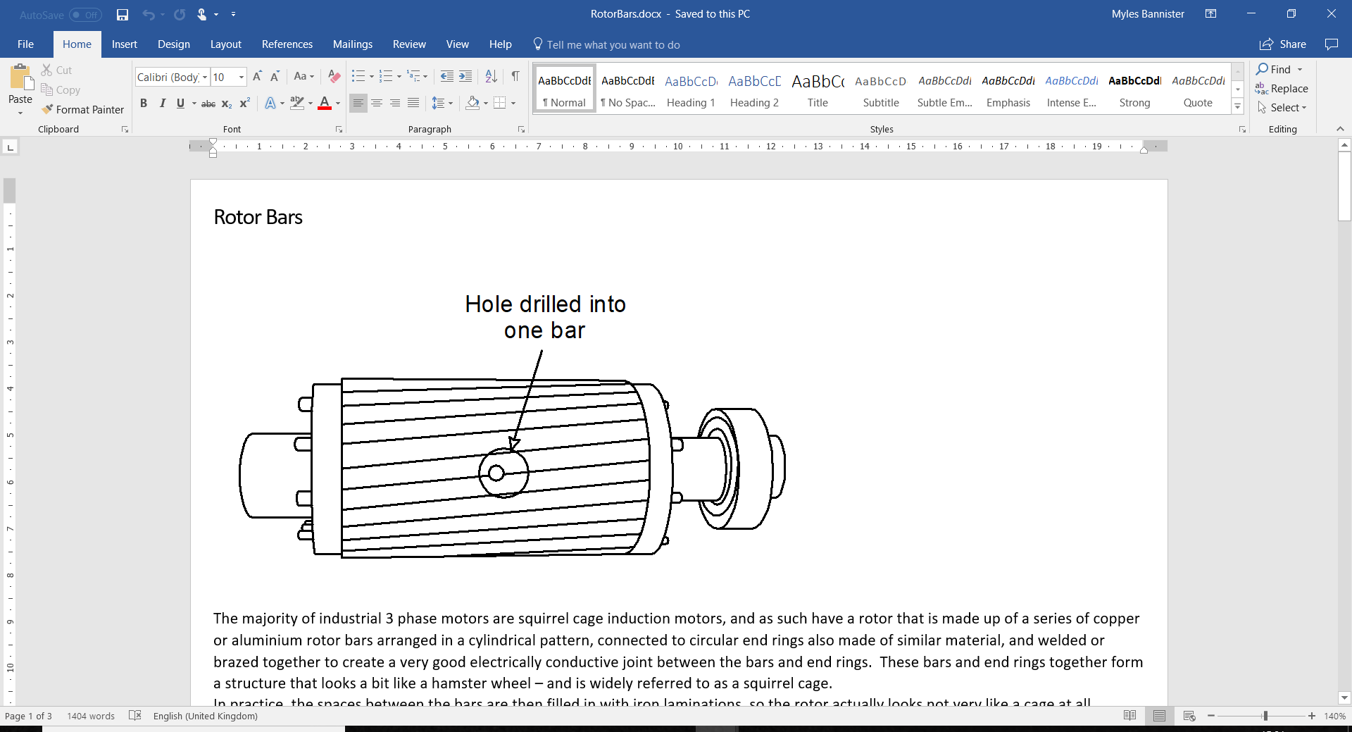

# The majority of industrial 3 phase motors are squirrel cage induction motors, and as such have a rotor that is made up of a series of copper or aluminium rotor bars arranged in a cylindrical pattern, connected to circular end rings also made of similar material, and welded or brazed together to create a very good electrically conductive joint between the bars and end rings. These bars and end rings together form a structure that looks a bit like a hamster wheel – and is widely referred to as a squirrel cage.

In practice, the spaces between the bars are then filled in with iron laminations, so the rotor actually looks not very like a cage at all.

When there is no voltage or current applied to the stator, the rotor is free to rotate inside the stator of the motor, running on bearings at each end, with a small air gap between the outside diameter of the rotor and the inside diameter of the stator.

When a three-phase supply is connected to the stator, the three-phase currents create a rotating magnetic field. If the three phase currents are all equal (ie we have a perfectly balanced supply), and the stator windings are all equal and symmetrical, this rotating magnetic field is of a constant strength, and rotates at constant speed.

The rotor, sitting inside the stator, is swept by this rotating magnetic field. If the motor is starting from rest, as soon as the electrical supply is connected, the rotating magnetic field will be rotating at synchronous speed, and the rotor will be stationary, so the rotor bars will experience a high rate of cutting lines of flux. This will induce high currents to flow in the rotor bars, in a direction up one bar, around or across the end ring, and down the rotor bar(s) on the opposite side of the rotor, and back across the other end ring (the above description assuming a two pole motor; if the stator is wound to create a four pole magnetic field, then the current will flow up one side and down the bars one quarter of the way around the rotor; and likewise for higher numbers of poles in the stator, the current in the rotor will create flow patterns with an equivalent number of paths).

The current flowing in the rotor creates its own magnetic field, and the interaction of this field with the rotating field created by the stator drags the rotor round, causing it to accelerate. As it accelerates, the difference in speed between the rotor and the magnetic field created by the stator decreases, reducing the rate at which the rotor bars cut lines of flux, and so reducing the current induced in the rotor. In turn this reduces the strength of the magnetic field created by the rotor, which reduces the forces which are causing the rotor to turn. Ie the force causing it to rotate (ie the torque) decreases as the rotor speeds up. The rotor will keep accelerating as long as the forces causing the rotor to turn exceed the forces holding it back. In an unloaded motor, this is just the frictional drag from the bearings and the aerodynamic drag (“windage”) on the rotor, so an unloaded rotor will run at a speed very close to synchronous. Note it can never run exactly at synchronous speed, as the rotor bars would then be rotating at the same speed as the rotating magnetic field created by the stator, and therefore the rotor bars would not be cutting any lines of flux, and there would therefore be no rotor current and hence no torque. There will always be some difference in speed between the rotor and the synchronous speed, and this difference in speed is called SLIP. Increasing load on the motor, eg from the torque required to turn the driven equipment, will result in the rotor slowing down. The design conditions of the motor, which are shown on the motor plate, give the rotational speed and current corresponding to the full design load. Typical values of slip for industrial motor are in the range from ½% to 5%, with larger motors generally having lower design slip.

The magnetic field created by the rotor has an effect on the magnetic field created by the stator, creating an emf that affects the current drawn by the stator. It is this effect that causes a motor to draw more current when it is under greater load. In fact, this phenomenon is one of the key features used by the Faraday Predictive system to identify and diagnose motor behaviour.

If the rotor is in perfect condition, then the current that flows in it as it is swept by the magnetic field created by the stator, will be of constant magnitude as the stator field sweeps around the rotor. (Note the speed that the stator field sweeps the rotor is the slip speed). Because the current is constant as the field sweeps the rotor, the strength of the magnetic field created by the rotor will also be constant, and hence the back emf into the stator will be constant and therefore the current drawn by the motor will be constant (disregarding any other phenomena that may also be going on).

However, if the electrical resistance of the rotor is in any way asymmetrical then the current, and therefore the magnetic field strength, will vary as the stator field sweeps around the rotor. This in turn will result in variations in the emf induced back into the stator, and therefore will result in variations in the stator current. These variations will occur every time the magnetic field sweeps past the asymmetric feature, and since the effect happens equally when either a North pole and a South pole sweep past the feature, the variation in emf will occur at the pole pass frequency, which is calculated as the number of poles multiplied by the slip frequency.

Factors that cause asymmetry in the rotor resistance are most commonly cracks developing in the rotor bars or in the connection between the rotor bars and the end rings. These cracks can develop as the result of a fatigue process over an extended period of time. When the motor first starts up, the rotor is subject to extremely high currents, which in turn lead to a very rapid heating of the rotor. These in turn lead to thermal expansion and distortion, and thermal stresses. A motor that is subject to very frequent starts, particularly starting under a heavy load, are subject to much higher stresses and therefore are more at risk of developing cracks in the rotor structure.

# According to EPRI (Electric Power Research Institute, based in the USA) cracked or displaced rotor bars lead to around 6% of failures of motors up to 4kV and around 13% of failures of motors above 4kV.

# Cause

# Progressive damage is typically caused by frequent starts, especially where the start load is high. The rotor bars can also become damaged by high load variations, and time-related deterioration.

# Effect

Progressive loss of function and failure of motor.

# Diagnosis

# In the P100 system, rotor health is given by the Rotor diagnostic trend parameter. In the PSD, rotor bar problems show as pole pass frequency sidebands on all line harmonics, but mostly on the fundamental. A high resolution FFT will separate the fundamental peak from pole pass frequency, the exact value of which can be seen more clearly seen on the residual spectrum.

To carry out this analysis, the following processing settings are recommended:

* 65,536 points FFT
* 5 averages
* 90% overlap
* 2.5 kHz sampling rate

These can be found by clicking “show processing settings” on the main form.

Using these settings, the dB drop can be found using the PP checkbox in the frequency chart, the values displayed in the boxes marked PPHi and PPlow. Precisely gauging pole pass frequency may require tuning the motor rated speed so that the decibel drop aligns precisely with the peaks corresponding to pole pass frequency. Rotor bar health can be gauged using the table below.

For further help on how to conduct an MCSA, please consult the relevant help pages.

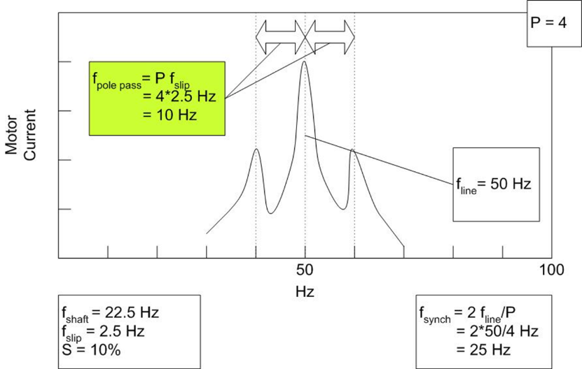

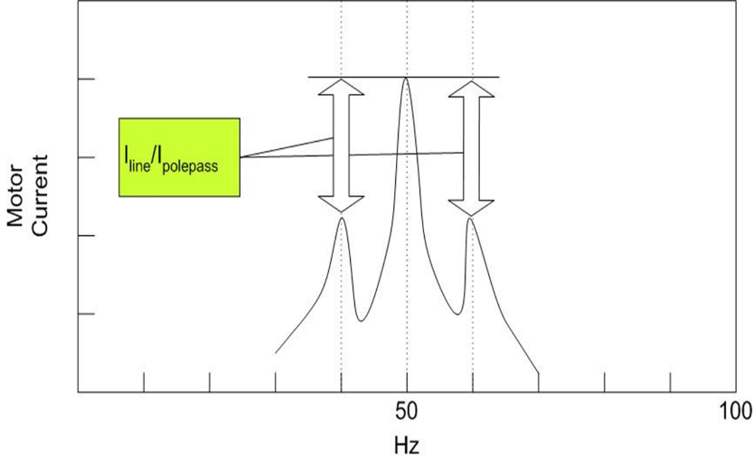

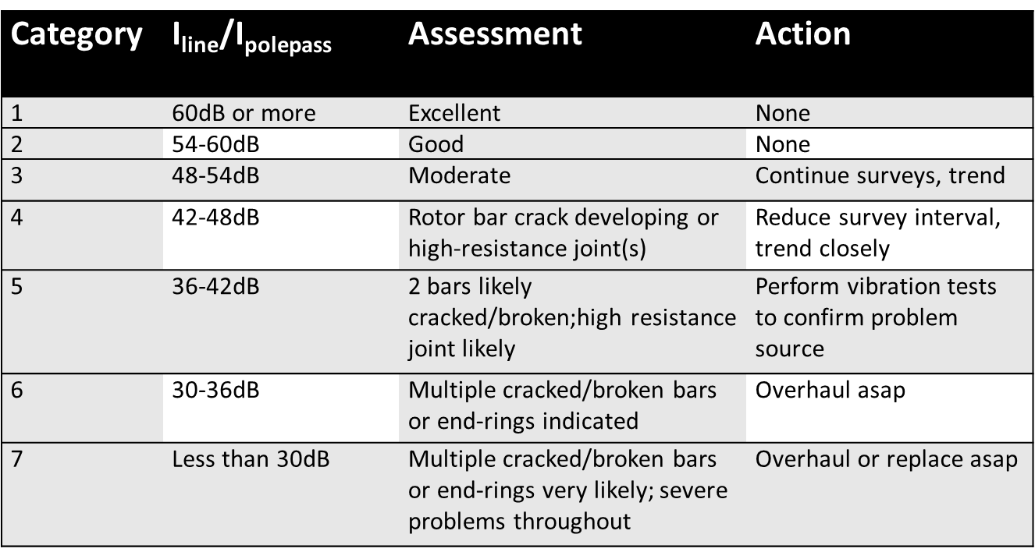

# Action

Early diagnosis of rotor bar problems may allow the adjustment of operating conditions (reduced starts/stops or load variations) to increase the time to failure. Results of such changes can be monitored in the usual way.