Sleeve/ Journal Bearings

©Faraday Predictive 2018

Sleeve (or journal) bearings are common in larger equipment and although they are mechanically simple, faults can cause serious and expensive damage. When used in motors they must have sufficiently tight clearances to avoid rotor/stator contacts and this can cause special problems.

In a journal bearing the load on the shaft is carried by the oil film inside the journal, that separates the rotating shaft from the stationary bearing. There is a small difference in diameter between the shaft and the bearing, and the shaft is free to move around anywhere within the orbit that is defined by the size of the gap between the shaft and bearing. When stationary, the shaft will normally sit at the bottom of the bearing, under the weight of the shaft and whatever is mounted on it. The lower part of the journal bearing will normally contain oil. When stationary, the oil is squeezed out from underneath the shaft, leaving only a one or two molecule thick layer at the thinnest part, which is enough to provide boundary lubrication where a single molecule thick layer of oil is effectively bonded to the metal of the shaft, and to the metal of the bearing.

As the shaft starts to rotate, the shaft tends to drag oil into this narrow gap, in accordance with the no-slip condition (oil in direct contact with the shaft tends to go at the same speed as the shaft). The geometry of the shaft sitting on the bottom of the bearing creates a convergent gap which is effectively filled with an oil “wedge”. The rotation of the shaft is trying to drag more oil into this wedge. The viscosity of the oil being dragged in, and trying to be squeezed out, creates a pressure that is sufficient to physically lift the shaft up, off the bottom of the bearing. As the shaft speed increases, the shaft moves up and across, tending towards, but never exactly hitting, the geometric centre of the bearing. This movement of the shaft is normal with journal bearings, in contrast to rolling element bearings, where there is virtually no movement expected of the centreline of the shaft. The movement of the shaft in journal bearings is sometimes measured and monitored by proximity sensors mounted in the bearing itself. Typically, two such proximity sensors are used in combination, mounted at 90 degrees to one another, to give a position of the centre of the shaft

The 3 main problems that occur with sleeve bearings are:

1. Clearance/Wear Problems
2. Oil Whirl
3. 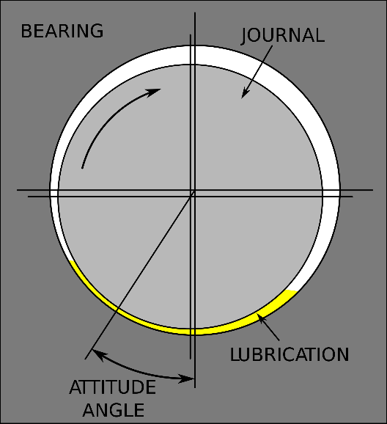Oil Whip

# Cause

In a typical journal bearing, the oil does not form a complete film all around the circumference of the shaft, rather there is “solid” oil on the side where the oil is being dragged into the narrow gap at the bottom, which corresponds to a zone of high pressure in the oil. On the opposite side, where the gap between shaft and bearing is increasing, there is a low-pressure area, and in this space the oil may not be continuous, but instead there may be air or vapour present. This could be thought of a bit like cavitation inside a pump.

If instead, the oil was continuous all around the shaft, and if the bearing were almost exactly central in the bearing (which it could be if the weight or other radial load on the shaft were small), then the oil would be rotating around in a uniform manner. The no slip condition would apply at both the shaft and the bearing, so there is a velocity gradient across the oil thickness from zero velocity at the bearing to shaft speed at the surface of the shaft. On average, the oil will be rotating around at just less than half the nominal speed of the shaft.

Under certain circumstances, which are perhaps exacerbated by lower viscosity oil, larger gap, and lighter loads on the shaft, this rotating oil can start to create a vibration, known as oil whirl. Typically, this may be initiated by a sudden shock load on the shaft (a radial load) that causes the shaft to move within the bearing, creating an (increased) oil wedge. This wedge, if sufficiently strong, can then push the shaft ahead of it, around and around the bearing, typically at a speed in the range 0.42 – 0.48 x shaft speed.

This will normally die away owing to damping from the oil, but if there is insufficient damping (eg if oil viscosity is too low) it can continue for an extended period.

If this oil whirl happens to occur at a frequency close to the first natural resonant frequency of the shaft, it can create a much more serious vibration, known as oil whip, where an oil whirl (described above) becomes locked in cycle with a resonant frequency of the system.

Thus, oil whip may occur if the machine is operated at a speed such that the critical frequency coincides with the oil whip frequency. It is more likely for oil whip to occur during transient load conditions such as on start-up, and therefore is not easy to spot in the PSD. As long as the motor accelerates quickly through the critical frequency, oil whip will not cause a problem.

# Effect

Oil whirl (or more seriously, related oil whip) can cause high levels of vibration that may damage other components as well as progressive failure of the bearing itself.

Large vibrations are produced with oil whip as the vibrations due to oil whip are now at the rotor’s resonant frequency.

We have also observed oil whirl responses in situations where the oil has been contaminated by water, and the space in the journal is effectively filled with an oil water emulsion, which probably forms an oil-water emulsion foam in the low-pressure area. This has been associated with catastrophic failure in some cases, and not always shown up on proximity probes.

# Diagnosis

In the PSD, oil whirl shows as a characteristic frequency peak at 0.42-0.48 * shaft speed, as a sideband of one of the line harmonics (usually as sidebands of line frequency).

# Action

If proximity sensors are fitted, check the readings for indications of shaft movement. Check lubricant for contamination (eg with water) or serious loss of viscosity.