Transmission Looseness / Rubbing

©Faraday Predictive 2018

Both looseness and rubs are common faults and some judgement is required to determine the level of each at which intervention is justified. In many types of equipment these conditions are part of normal operation at some level.

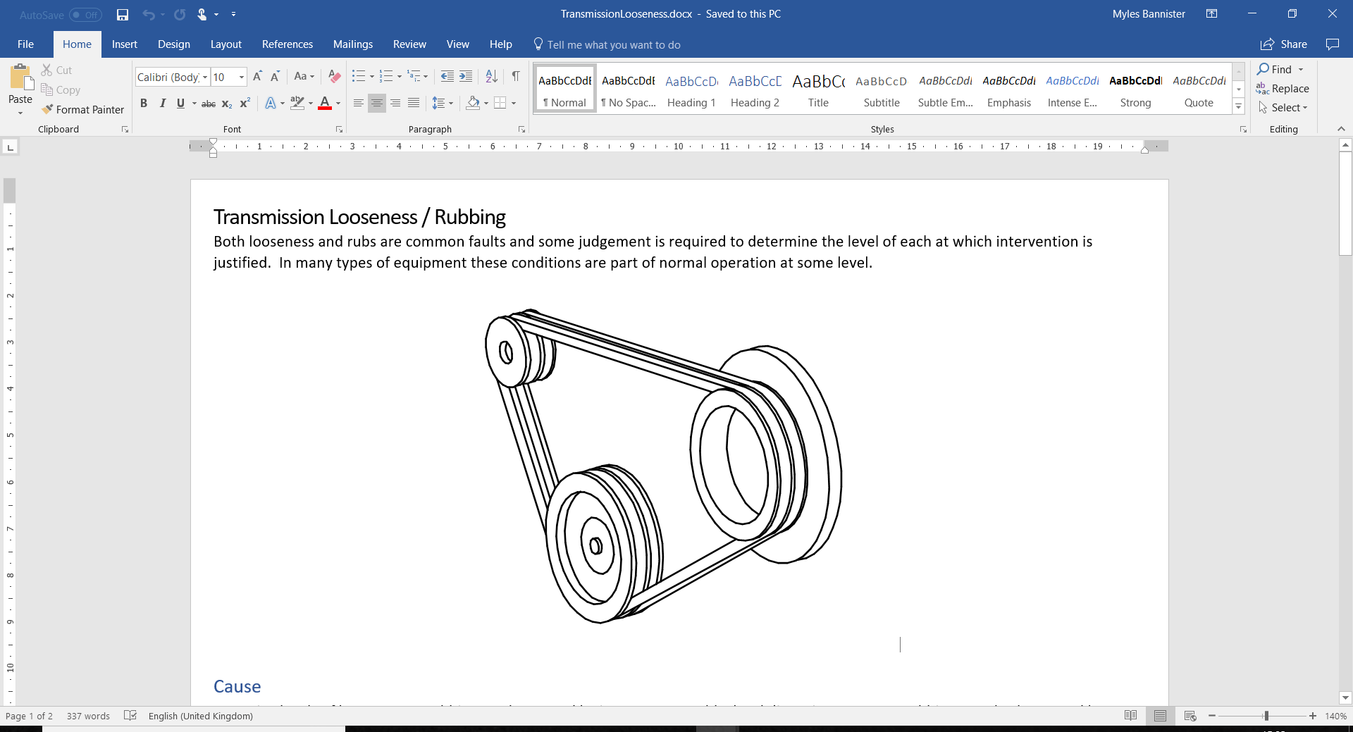

# Cause

Excessive levels of looseness or rubbing can be caused by incorrect assembly, local distortion, or wear. Rubbing can also be caused by misalignment or fouling.

Rubbing can appear on any rotating component, though is more likely in equipment where clearances need to be very tight. For example, rubs can occur between the rotating scrolls of a gas compressor and the compressor housing, or in a vacuum pump. Transmission looseness is more likely to be found in belt drives that are becoming worn or are incorrectly tensioned.

# Effect

Looseness can cause excessive wear to affected components, as well as possible detachment and secondary damage. Transmission looseness also causes large energy losses.

Rubs tend to be either minor (in which case they clear themselves) or major (in which case local heating results in more rubbing or seizure). Where tight clearances are vital, signs of rubbing need to be carefully monitored since wear will cause these clearances to increase, and the worn components may need replacing for the equipment to function properly.

# Diagnosis

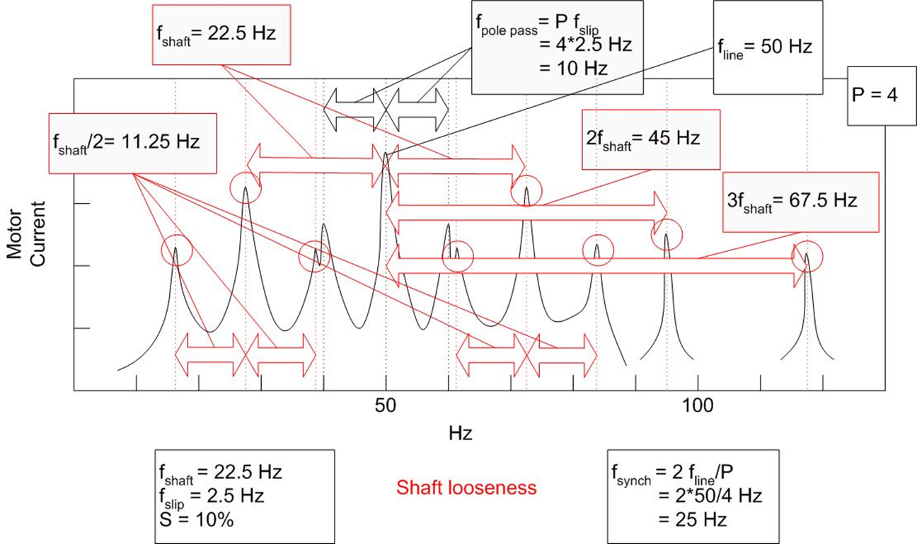

Diagnostic parameter - Loose foundation/components

In the PSD, looseness shows frequency peaks at multiples of shaft speed, as well as half shaft speed and sometimes other subharmonic frequencies. Rubbing typically shows as a wider range of subharmonics, notably the 1/5 subharmonic.

When analysing trend plots, rubbing trends show a characteristic *wear/relief* profile, and need careful interpretation. A *decrease* in the rubbing signals in equipment where rubbing was previously increasing may indicate that the components that were rubbing have worn away, and in some cases, this would require corrective action.

# Action

Transmission looseness in belt drives is easy to rectify through correct tensioning.

Since the potential consequences of rubbing is major, and the rectification intrusive, rubbing trends should be monitored very closely before recommending intervention.