Unbalance / Misalignment

©Faraday Predictive 2018

Unbalance and misalignment are the most common mechanical faults (probably 40% of total mechanical problems). They can cause considerable damage and loss of efficiency but are simple to correct once identified.

Unbalance can be either static or dynamic. Although the diagnosis of both types is the same, the correction is different. In the case of static unbalance (including a single point of unbalance) the forces generated have the same direction and angular location:

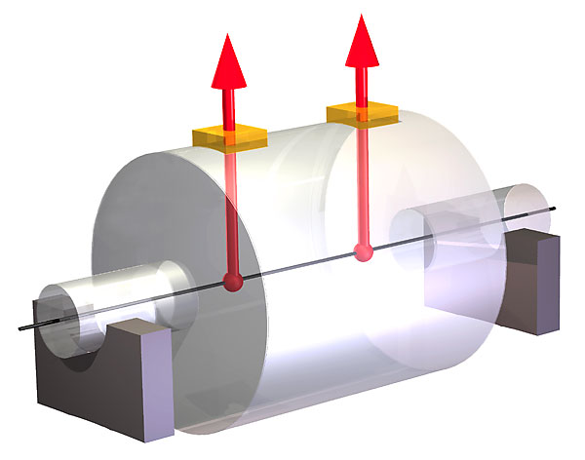

A static unbalance has an effect even when the shaft is not rotating. It can be corrected by adding or subtracting mass from the shaft.

Dynamic unbalance is very common, and is the result of multiple unbalance forces acting in different directions and angular locations:

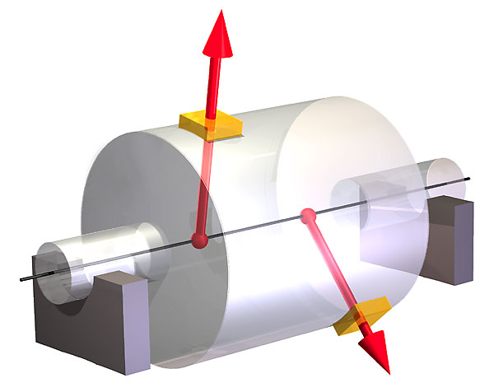

Correction of dynamic unbalance is more complicated than static unbalance. It can only be measured when the shaft is rotating, and each unbalance plane must be adjusted at the same time so that the final effect can be assessed.

Misalignment can take a number of different forms. There are two major types: parallel, in which the axes of the shafts are parallel but displaced laterally; and angular, in which the shafts can have both lateral and angular displacement:

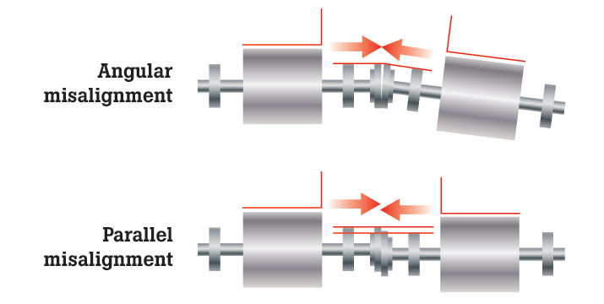

Cause

Unbalance can be caused by manufacturing or assembly errors, physical damage, wear, fouling, or loss of balance weights. Misalignment can have similar causes but can also result from settlement or physical movement.

These faults most commonly develop over a period of time, allowing their severity to be monitored and predicted. However, rapid onset can result from physical damage or shedding of material or incorrect maintenance or installation work. In such cases quick detection and diagnosis is essential to enable simple rectification and to prevent expensive damage to other components.

# Effect

Forces and couples caused by misalignment and unbalance can be very large, leading to damage to components like bearings, seals, and couplings. Energy efficiency can be reduced by up to 10%.

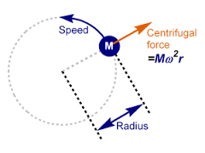

# Diagnosis

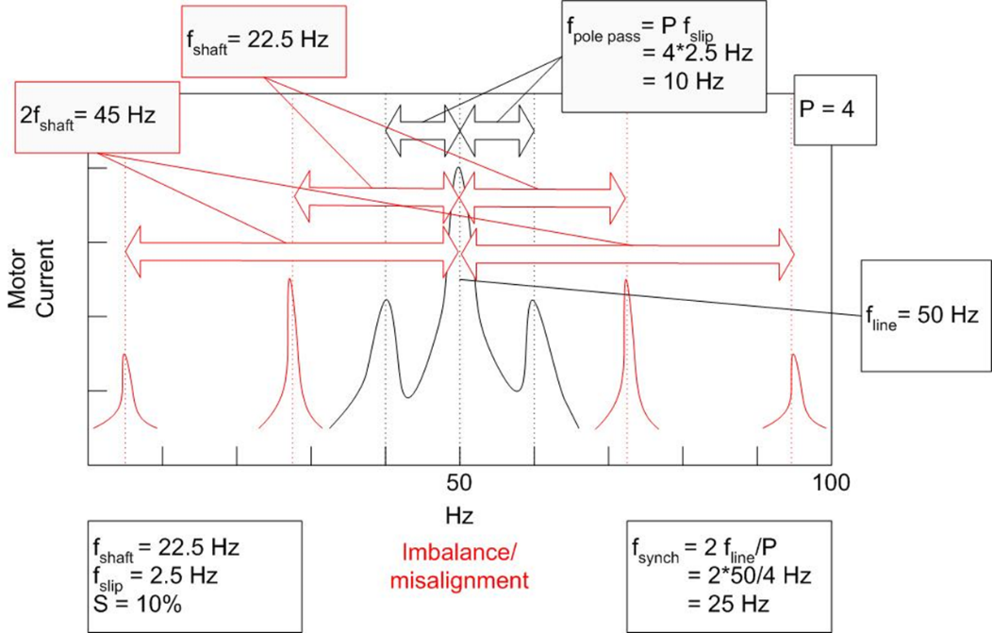

In the PSD, unbalance shows a characteristic frequency peak at shaft speed, and misalignment usually adds a peak at twice shaft speed. As long as the rated speed and line frequency are correctly entered into the P100, these peaks will be identified automatically.

# Action

Alignment is typically easier to check and correct than unbalance, using a precision alignment kit (eg laser).

Static and dynamic imbalance can be checked with a balance analyser and corrected on a field or lab balancing machine.