Voltage Unbalance

©Faraday Predictive 2018

For a three-phase supply, voltage balance is defined as the maximum deviation of any voltage phase from the average voltage divided by the average voltage, usually expressed as a percentage. A higher voltage unbalance represents a worse voltage supply quality.

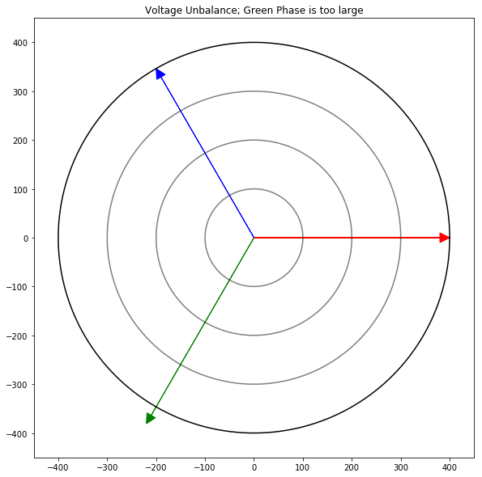

Unbalance shown above in a phasor diagram. The unbalance is closely represented by the distance of the green phasor from the edge of the outermost circle. Shown below is a different system shown in the time domain – in this case the red phase is clearly greater than the blue and green.

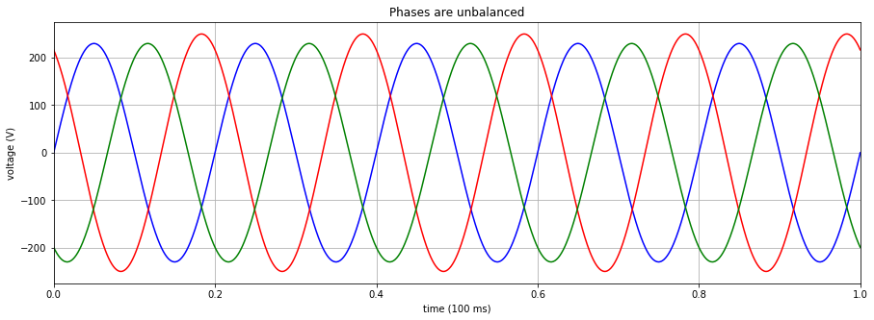

# Cause

A voltage imbalance is caused by imperfections in the incoming supply to the motor. These imperfections could be caused by faults, including unequal impedance in the supply wiring, faults in a power transformer or a blown fuse in a bank of power factor improving capacitors. For a high voltage unbalance (5% or more), this kind of problem is a possible cause. However, some voltage unbalance is a natural part of the supply. Voltage unbalance typically increases during the day (as the grid supplies more power to domestic single-phase applications) and is lower at night. Uneven single-phase loads are a likely culprit for this kind of voltage unbalance (less than 1%).

If a voltage unbalance is seen on just one piece of equipment rather than the whole plant, other causes of unbalance should be investigated. This includes defects in the power circuit connections, the motor contacts, or in the motor windings.

# Effect

A small voltage imbalance will lead to a larger current unbalance (typically 5 – 10 times), the effects of which are described in the current balance diagnostic sheet. The main overall effect is unnecessary heating, which is damaging to the polyphase equipment.

# Diagnosis

Voltage unbalance is calculated and displayed by the P100 system as one of the electrical parameters.

Utilities in the US restrict the voltage unbalance to 2.5%, whilst ANSI C84.1 suggest a maximum voltage unbalance of 3%. Typical values of voltage unbalance range between 0.5% and 2.5%.

As a rule of thumb 1% voltage unbalance leads to 5% current unbalance which causes a 10° temperature increase. This temperature increase can half the life of the motor windings.

# Action

As previously mentioned, if a voltage imbalance is caused by the incoming supply system then this should be checked for faults. Data like power factor and active power are useful here, a reduced power factor can be indicative of a blown fuse in a bank of capacitors. Single phasing on a different piece of equipment may cause an unbalance in nearly equipment.

If an unbalance is seen on just one piece of equipment, then the connections /contacts should be checked for damage, and if no defects are found, then the resistances and inductances of each set of windings should be checked.