Voltage THD

©Faraday Predictive 2018

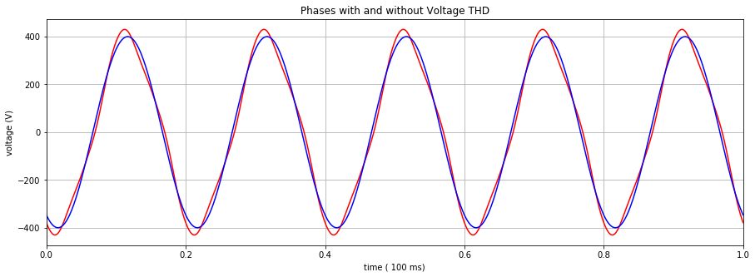

Voltage Total Harmonic Distortion (THD) is the summation of all the harmonic components of the voltage waveform compared to the fundamental component of the voltage waveform. The sum theoretically continues forever, but in practice the harmonics are negligible from around the 13th harmonic onwards.

$$THD=\frac{\sqrt{{V_{2}}^{2}+{V_{3}}^{2}+{V_{4}}^{2}+⋯}}{V_{1}}*100\%$$

THD is used to characterise the power quality of electronic power systems. A higher THD means more heating, higher peak currents, and higher core losses.

# Cause

Voltage THD is usually caused by an imperfect supply voltage. Non-linear loads in a plant (for example thyristors or inverters) will also increase the THD seen by the surrounding equipment.

# Effect

Generally, even a small amount of voltage THD can cause a noticeable amount of current THD. Increase in current distortions in the system causes overheating, which wastes energy and damages winding insulation, eventually causing the windings to burn out. Higher frequency harmonics can cause excessive heating of the motor core. Further problems caused by harmonics are possible neutral overloading (caused by large 3rd harmonics) causing circuit breakers to trip unwantedly, and problems on sensitive equipment due to electromagnetic noise.

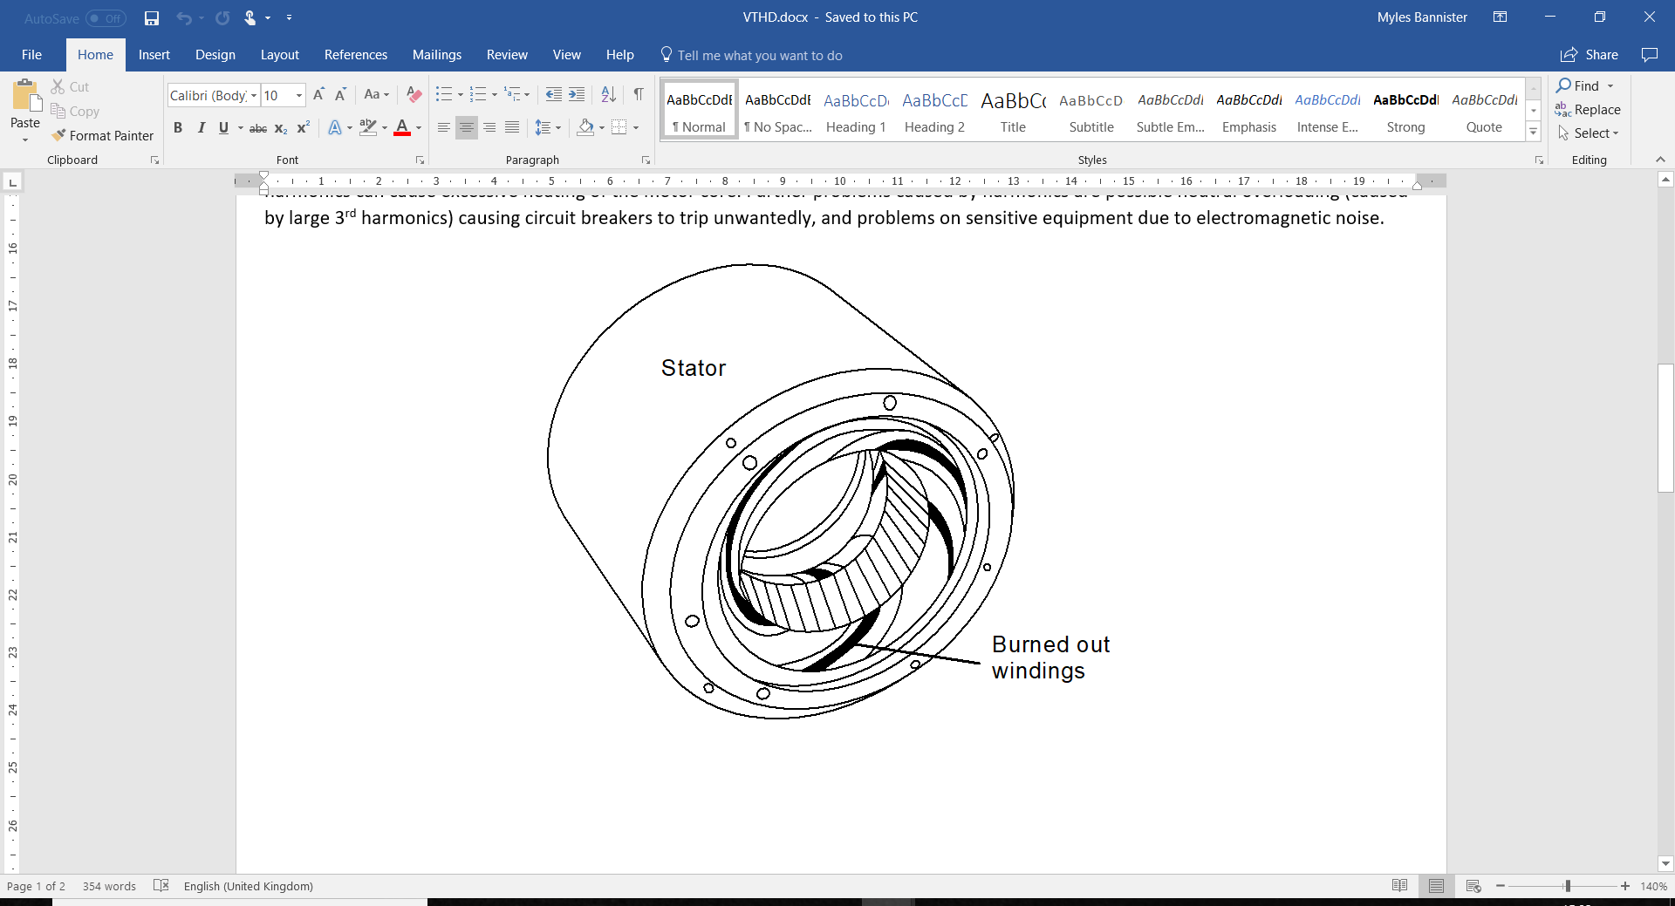

# Diagnosis

THD is calculated by the P100 using the formula at the top of the page, and is displayed as one of the electrical parameters. High harmonic peaks in the voltage spectrum also indicate a high THD, though there is some need for careful interpretation since the spectrum shown is a log plot, so peaks that look quite large in the frequency spectrum may well be within safe limits. Some harmonics (especially odd harmonics) are an inevitable part of any power system involving rotating machinery.

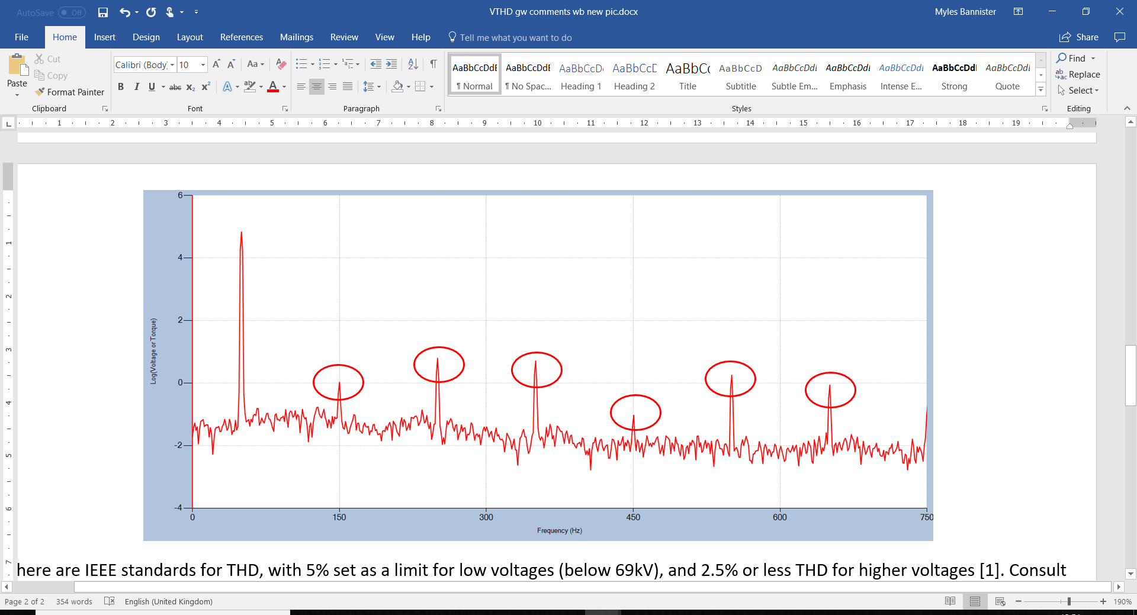

There are IEEE standards for THD, with 5% set as a limit for low voltages (below 69kV), and 2.5% or less THD for higher voltages [1]. Consult the most recent IEEE standards for more information on this.

# Action

Preventative measures are far cheaper and more effective than waiting for damage to occur to the windings and rewinding the motor.

Active filters can be used to reduce total harmonic distortion, as will selecting a suitable inverter to power the equipment.

[1] IEEE Std 519-1992 Harmonic Limits Discussion