Operation overview

# Overall system

The 200 Series system consists of portable or installed devices and server software that can be used with either device or any combination of devices.

Each 200 Series system is configured to meet specific requirements, but is typically either portable or installed.

# Typical system (portable)

A typical portable 200 Series system (P100) combines the P100 data unit with device software running on a connected laptop PC. P100 systems are supplied with all the components required to make condition assessments:

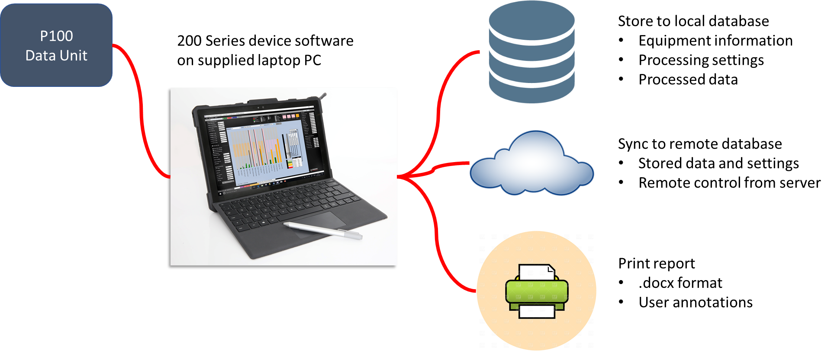

A P100 system stores measurements in a database on the connected laptop PC, but can also synchronise those measurements to an external server. The 200 Series server software is then used to view and analyse measurements on the external server. Additionally, the 200 Series server software can be used to control the portable 200 Series system remotely:

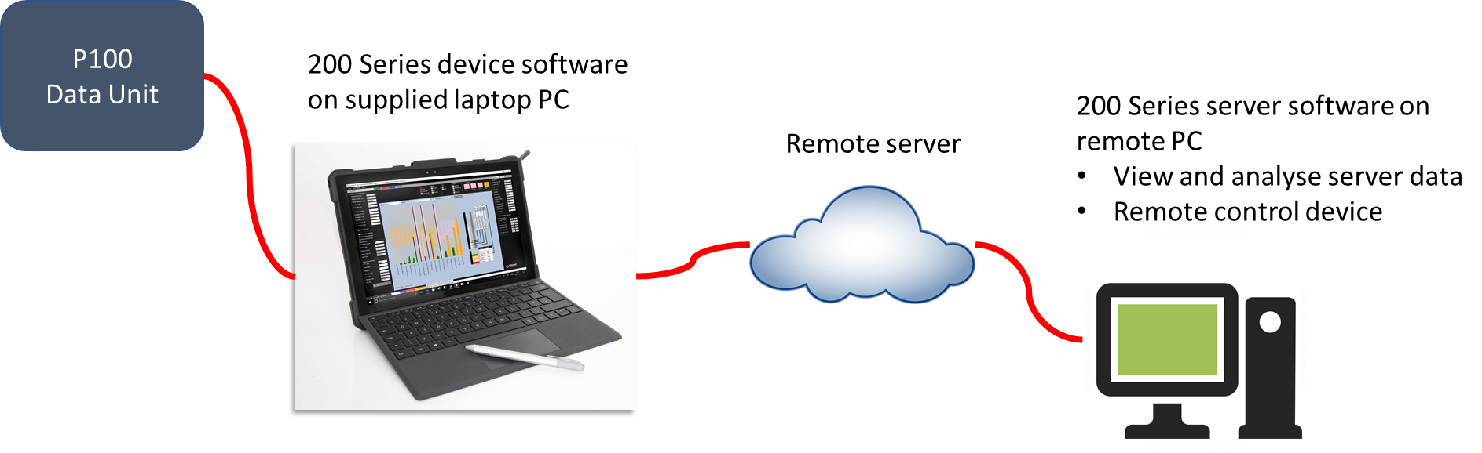

# Typical system (installed)

A typical installed 200 Series system consists of one or a number of S200 devices, each of which runs the same device software as a P100. Each of these devices stores measurements in a database on the S200, and also typically synchronises those measurements to an external server. The 200 Series server software is then used to view and analyse measurements on the external server, and to control them remotely:

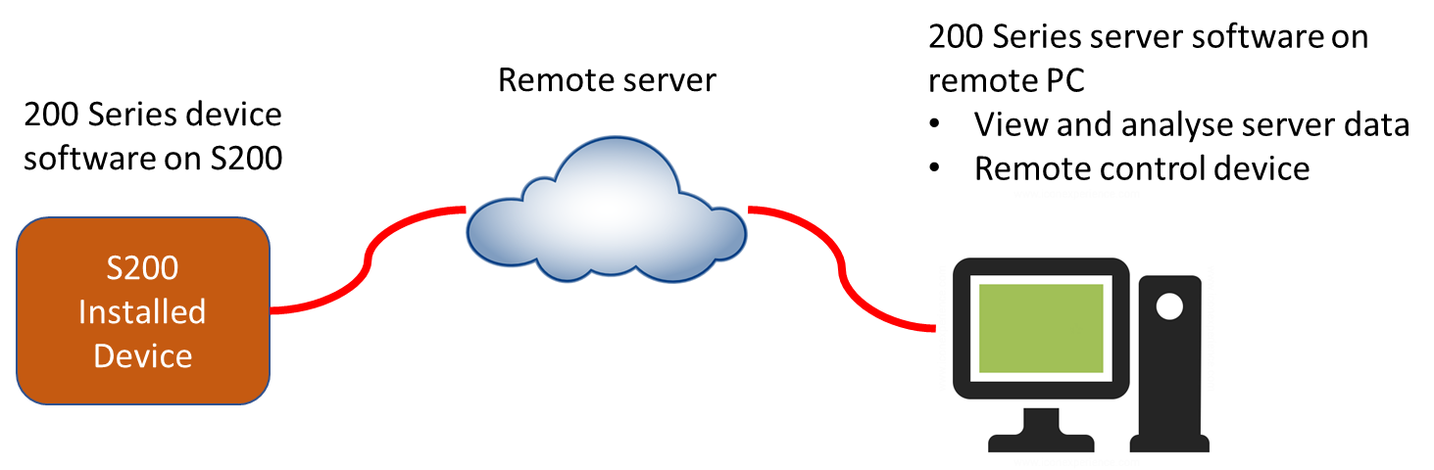

For initial configuration, troubleshooting, and local analysis each S200 device can be operated in the same way as a P100 by connecting a monitor and keyboard, or using remote desktop from a connected PC:

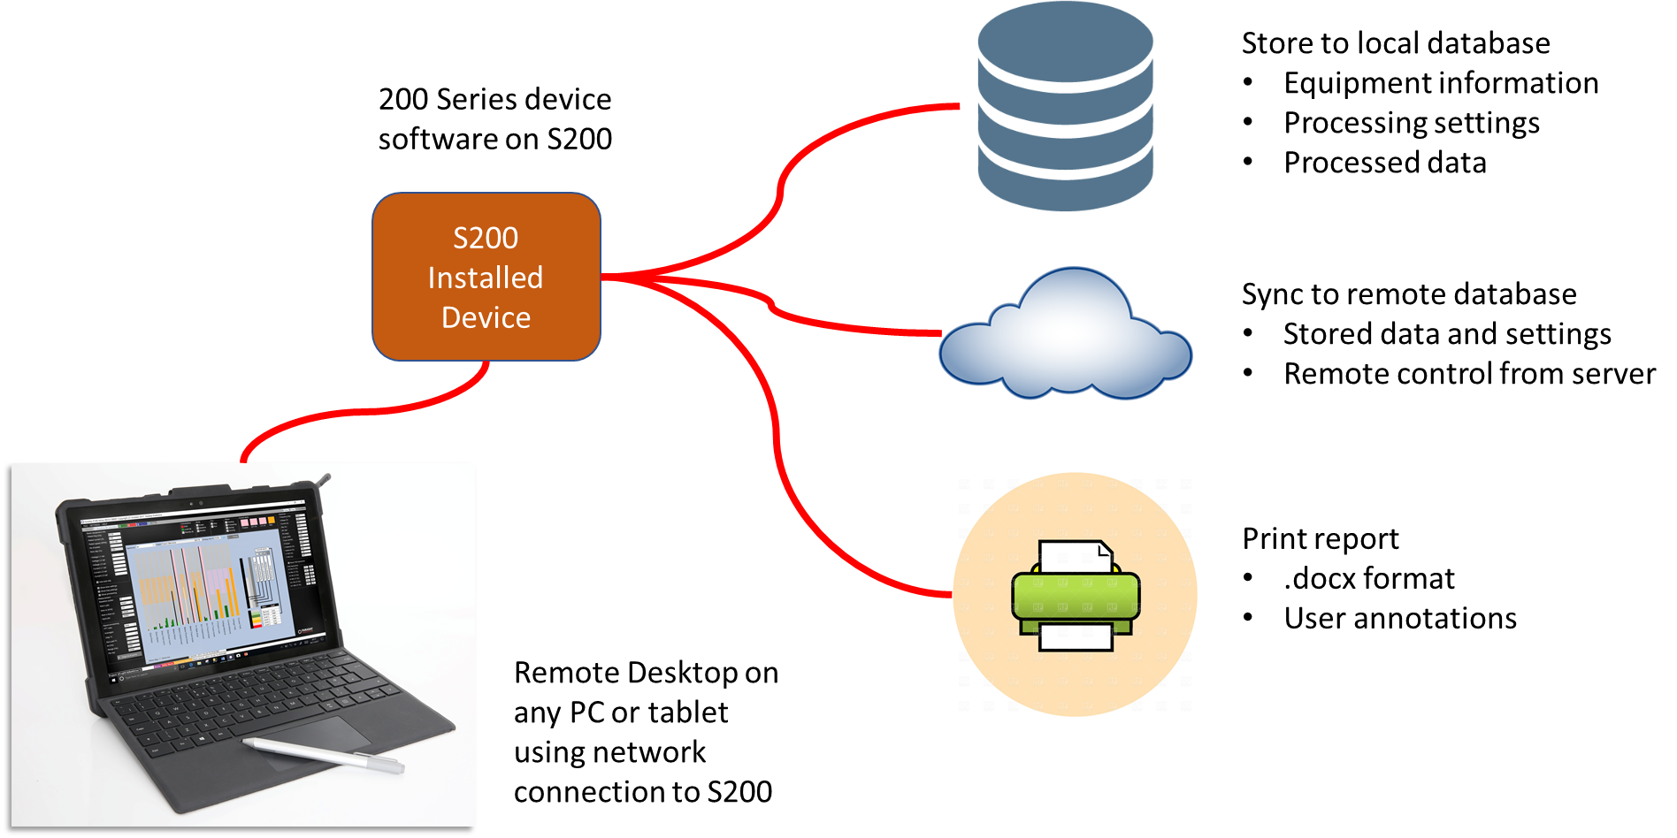

**Local operation of both P100 and S200 devices is described in the ‘Device operation’ section of these Help pages and operation of the 200 Series server software is described in the ‘Server operation’ section.**