Baseline mode

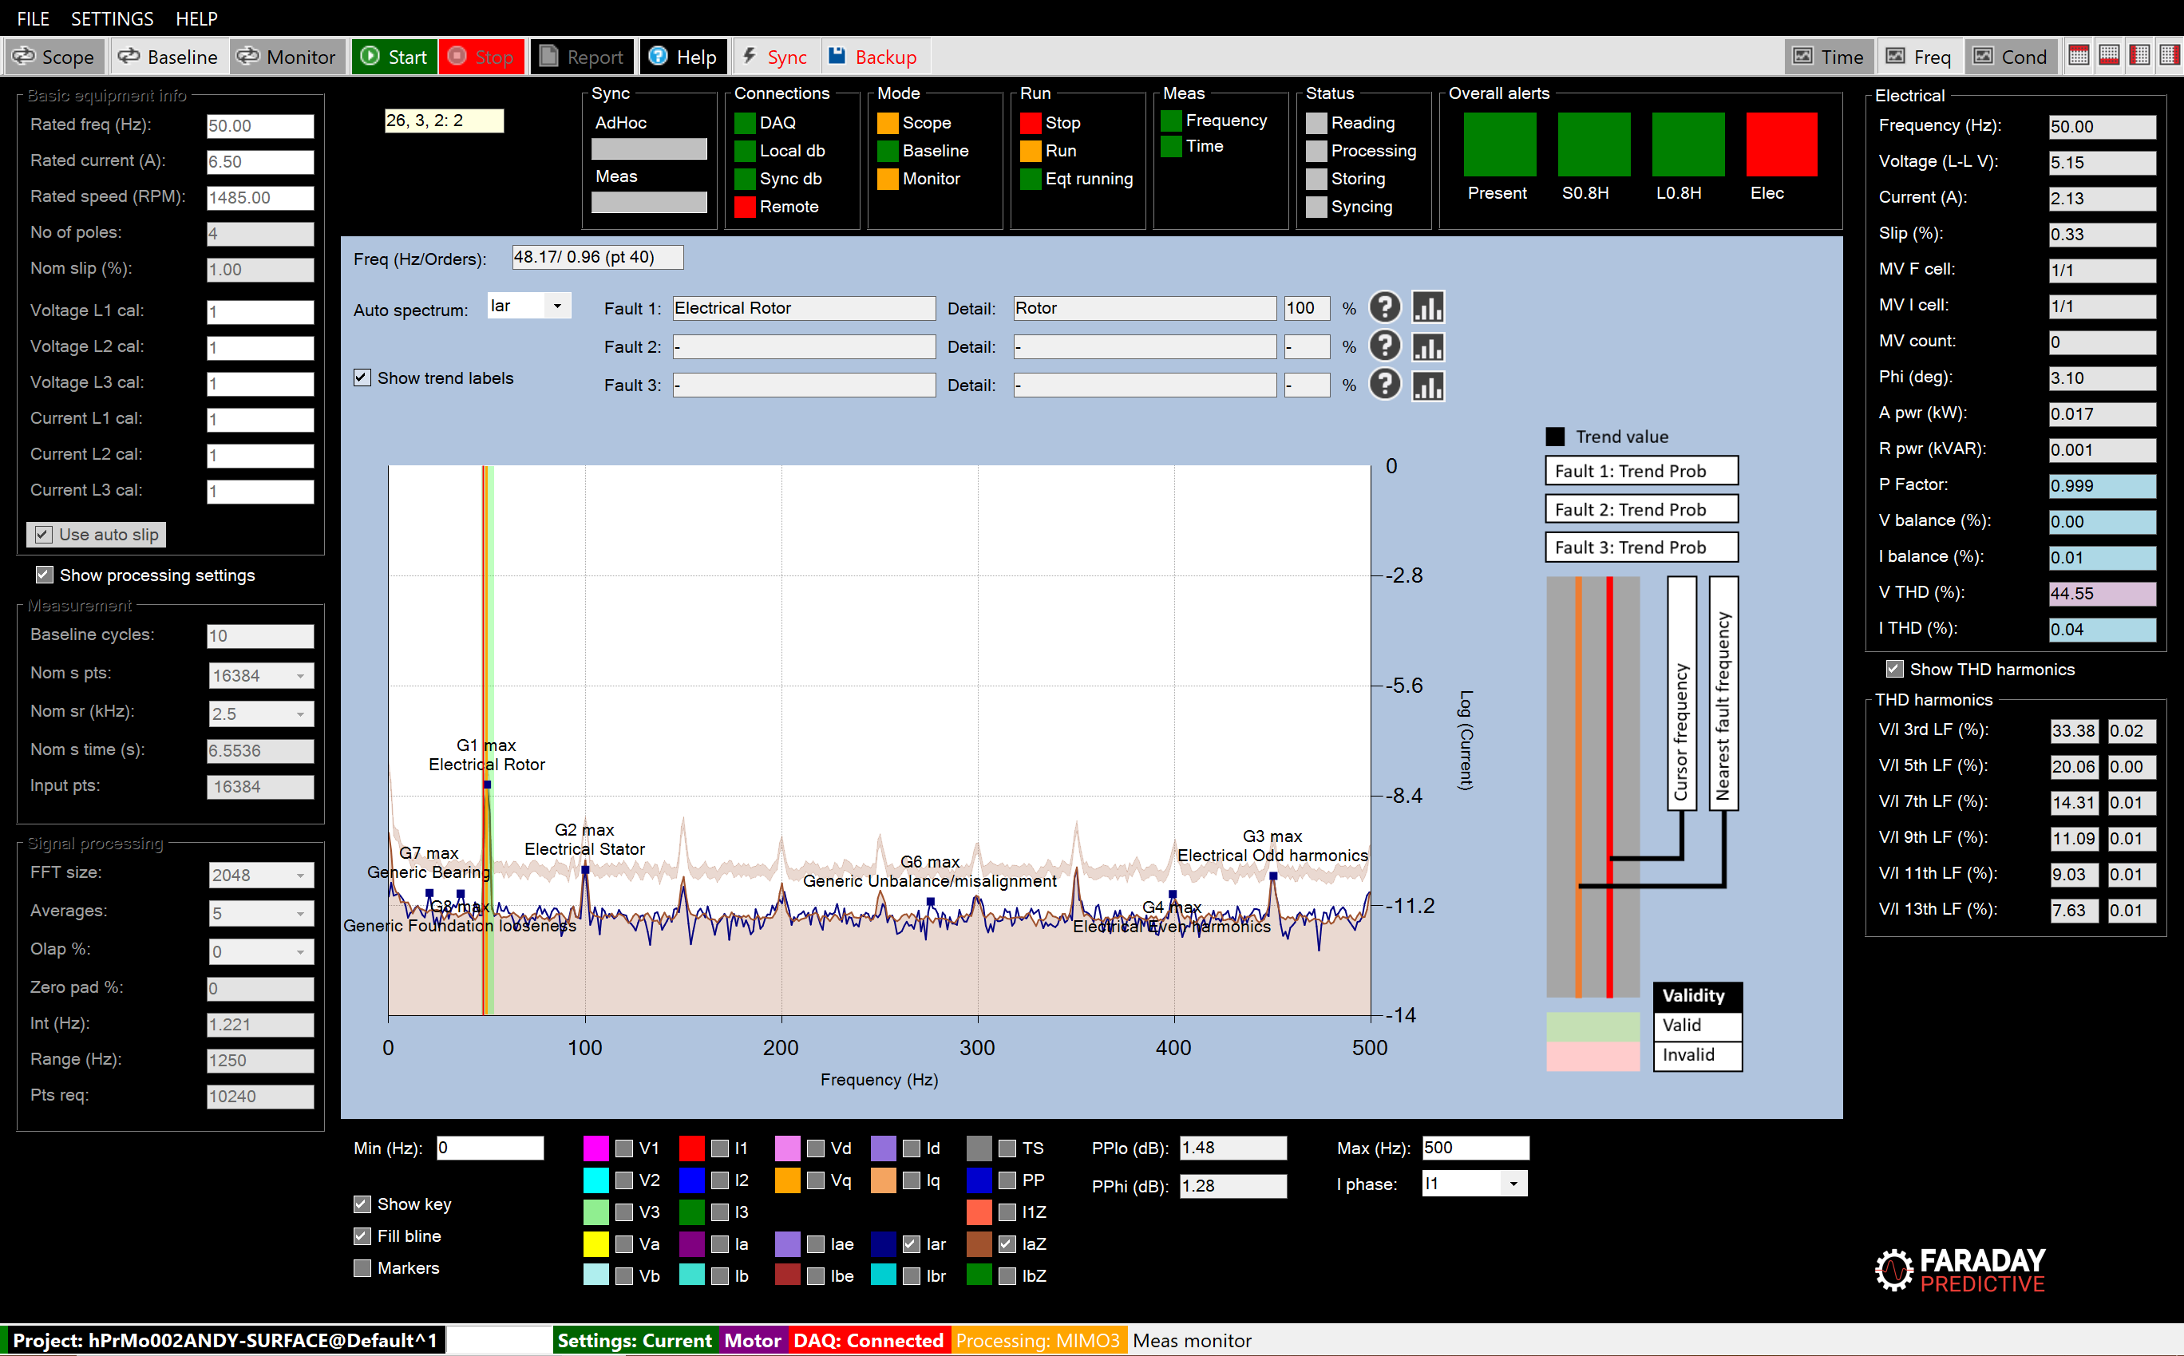

# Mode summary

Baseline mode is typically used after assessing the condition of the equipment in Scope mode. If a potential problem is identified the user often needs to monitor deterioration over a period to get a clearer understanding of best timescale for intervention. In order to do this, a reference measurement is required and this is carried out in Baseline mode.

Baseline mode is most often used with the Frequency chart in order to have a clear view of the developing results and to watch for specific faults.

# Operation

If the equipment is expected to show variations in speed or load then multivariate processing must be set up in the Multivariate settings form before starting the baseline measurements. This will then allow the system to set up a grid of baselines, each of which corresponds to a range of speeds and loads. In Monitor mode the system will automatically select the baseline closest to the present speed and load when tracking condition changes over time.

Baseline mode can be used with either Generic or Specific equipment information, where the latter is recommended for more detailed analysis.

Before starting baseline measurements, the number of baseline cycles should be set:

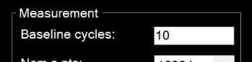

For equipment with fixed speed and load, a small number of cycles can be set. For more complex equipment and especially with wide variations in speed and load, this number should be increased. At this end of Baseline mode, multivariate cells containing less than the minimum number of measurement cycles will be overwritten with interpolated and extrapolated values from neighbouring cells.

Once Baseline mode has been completed, the system switches to Monitor mode and starts Monitor measurements.