Condition chart

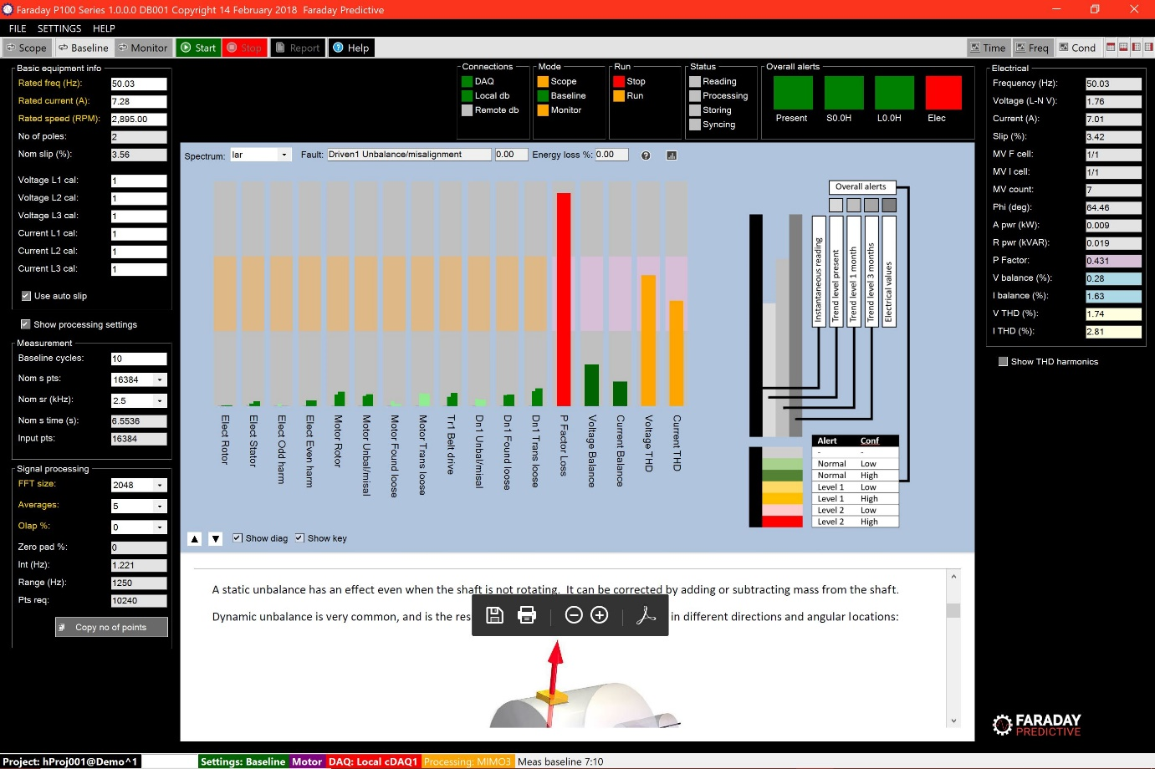

# Chart summary

The Condition chart is used to provide an overview of the present and future condition of the equipment being monitored.

# Controls

The user can select the parameter used for automated fault identification using the drop-down box above the chart.

# Condition bars

One condition bar is presented for each validated fault. In addition, there are always five electrical condition bars to the right. Each bar shows an alarm band (tan for faults and pink for electrical values) which indicates high and low alarm values in each case.

# Parameter values

Fault parameter values are shown as four narrow bars clustered within the same condition bar. The left-hand (black) bar shows the instantaneous measured value for that fault. These values are subject to significant variations caused by noise and other factors, and are supplemented by the other three bars which are all based on statistical analysis of these fault values over time. The first of these (next to the black bar) shows the averaged value of the fault parameter at the same time as the instantaneous reading (linear regression of a past data window). The next bar shows the predicted value for that fault parameter in the short term (up to 1 month, but never longer than the timespan of available trend data). The last bar (on the right of the cluster) shows the predicted value of the fault parameter in the long term (up to 3 months, but also never longer than the timespan of available trend data). Each band (except the instantaneous value) has a color to indicate its alarm condition.

# Fault information

Information about individual faults can be selected by clicking on the information symbol next to each fault:

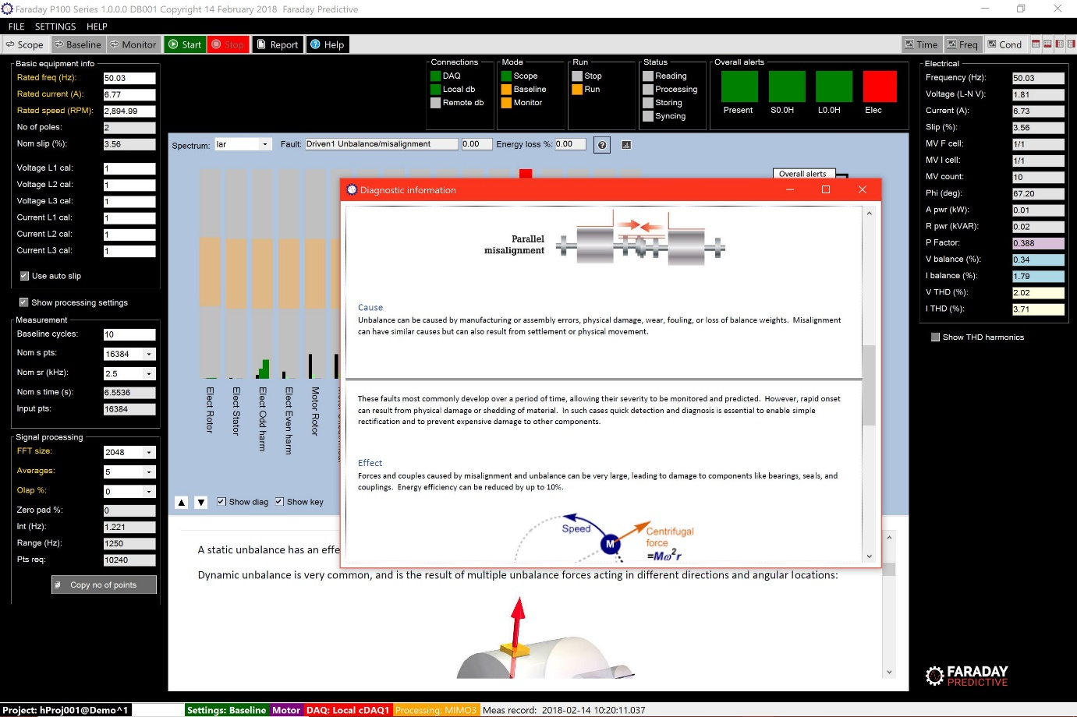

# Trend plots

Trend plots for any parameter can be selected by clicking on the Trend plot button next to each fault:

