Hierarchy Information

# Hierarchy structure

Each device in a 200 Series system has a unique name, known as the Data System Name. The Data System Name is configured when the device is built, and is never changed.

In an installed system, the device is connected to a specific item of equipment (a motor or generator) and that item of equipment has a location in the plant. In order to identify the location of each device the user can assign the following attributes to the device:

Device name: The item of equipment to which the device is connected (such as Pump1)

Segment name: The area of the plant in which the equipment is located (such as Room 1)

Plant name: The plant in which the segment is located (such as Scarborough A)

Enterprise name: The company owning the plant

The hierarchy information is used in the server software to group results from many devices so that overall condition within a segment, plant, or enterprise can be conveniently assessed. The user can change any of these attributes to match established naming conventions.

# Changing hierarchy information

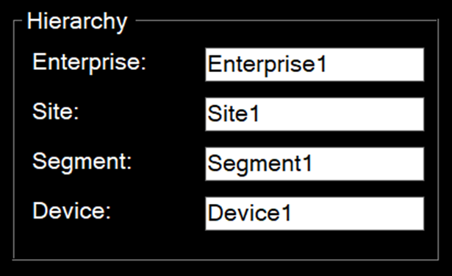

The hierarchy group is located in the left-hand panel, and is only visible when Show processing settings is unchecked.

Each attribute can be changed by clicking inside the text box, entering the new text, and the pressing return. The system will check for invalid characters in the text before accepting the new name.