Device Synchronisation

# Synchronisation overview

Each 200 series device can be set up to operated stand-alone or connected to a remote server. In general, portable systems will be operated stand-alone and installed systems will be connected to a remote server. However, when the user of a portable system returns to the office after a period in the field it is very valuable to be able to sync the latest data to the remote server for backup, viewing and analysis. There may also be occasions where it is necessary to fit an installed system in a location where no remote connection is available, and in this case it is possible to run the system stand-alone until connection to a remote server is possible.

# Synchronisation off

The sync button is located on the left-hand side of the toolstrip. It is greyed out when off:

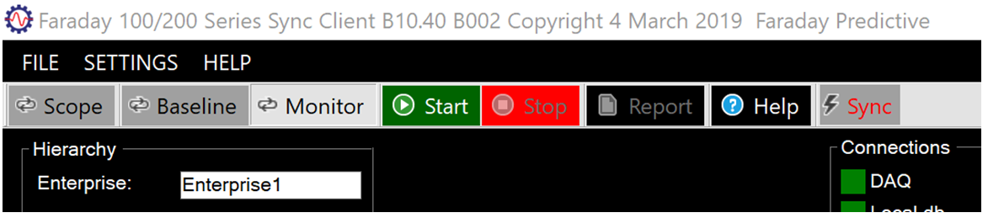

The full range of functions is available, and results will be stored in the local database in projects.

# Synchronisation on

When on, the sync button has a white background:

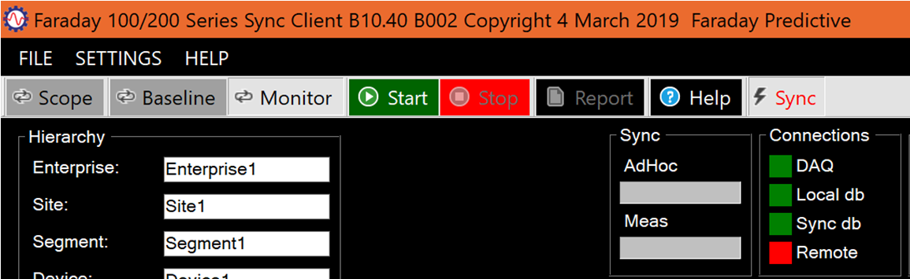

A new group of sync controls appears. Operation of the system remains the same, but now there will be a periodic check on whether the remote server contains data as recent as that on the device. If not, the system sends the new data from the device to the server. While this is completing, the two progress bars in the sync group show what proportion of device data has been transferred and what still has to be transferred. The AdHoc progress bar shows transfer of measurements taken in Scope mode, and the Meas progress bar shows transfer of measurements taken in Monitor mode (during which new Baseline data is also transferred). During sync, the progress bars are read to show that transfer is not yet complete and then change to green when the transfer is complete. In normal operation new measurements are transferred in each measurement cycle.

If the connection to the server is interrupted, the system will continue to store measurements locally and will then catch up when the next periodic check is made. This eliminates vulnerability to poor network connections (especially when a mobile network connection is being used). The time to transfer new data depends on the volume of unsynchronised data on the device and the speed of the connection, so it is important to sync frequently if possible to avoid delays.