Diagnostic settings

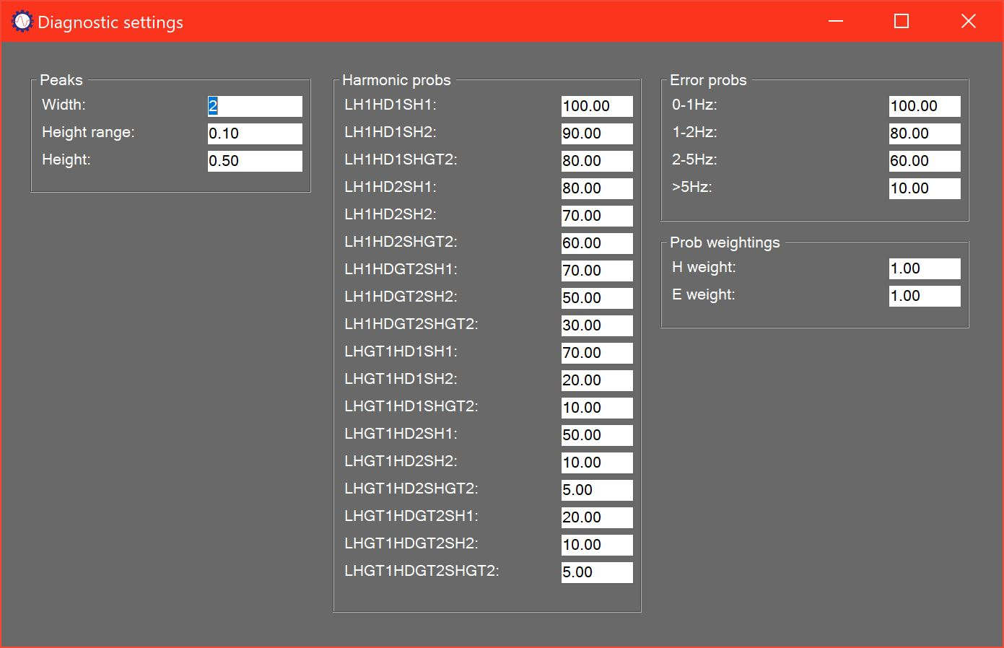

# Settings summary

The Diagnostic settings form is used to change the way the system detects and evaluates faults from the measured data. These parameters should only be changed by a very experienced user with support from a Faraday Predictive product specialist.