Frequency chart

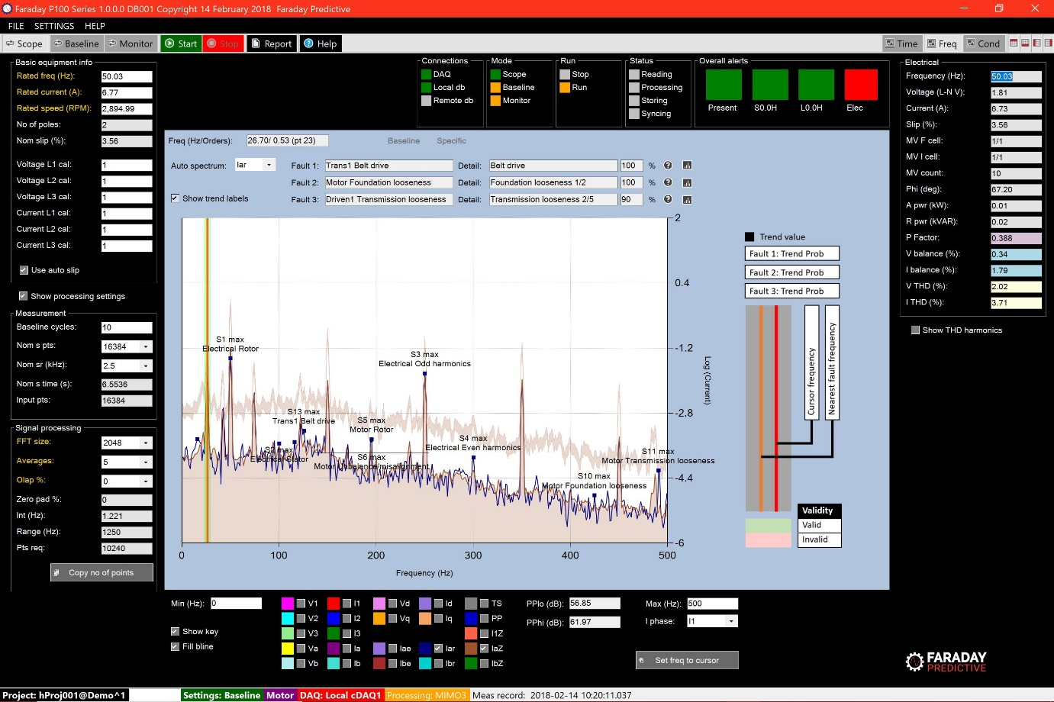

# Chart summary

The Frequency chart provides extensive frequency-domain information for the more expert user.

# Controls

Minimum and maximum frequencies in Hz can be entered in the appropriate text boxes below the chart.

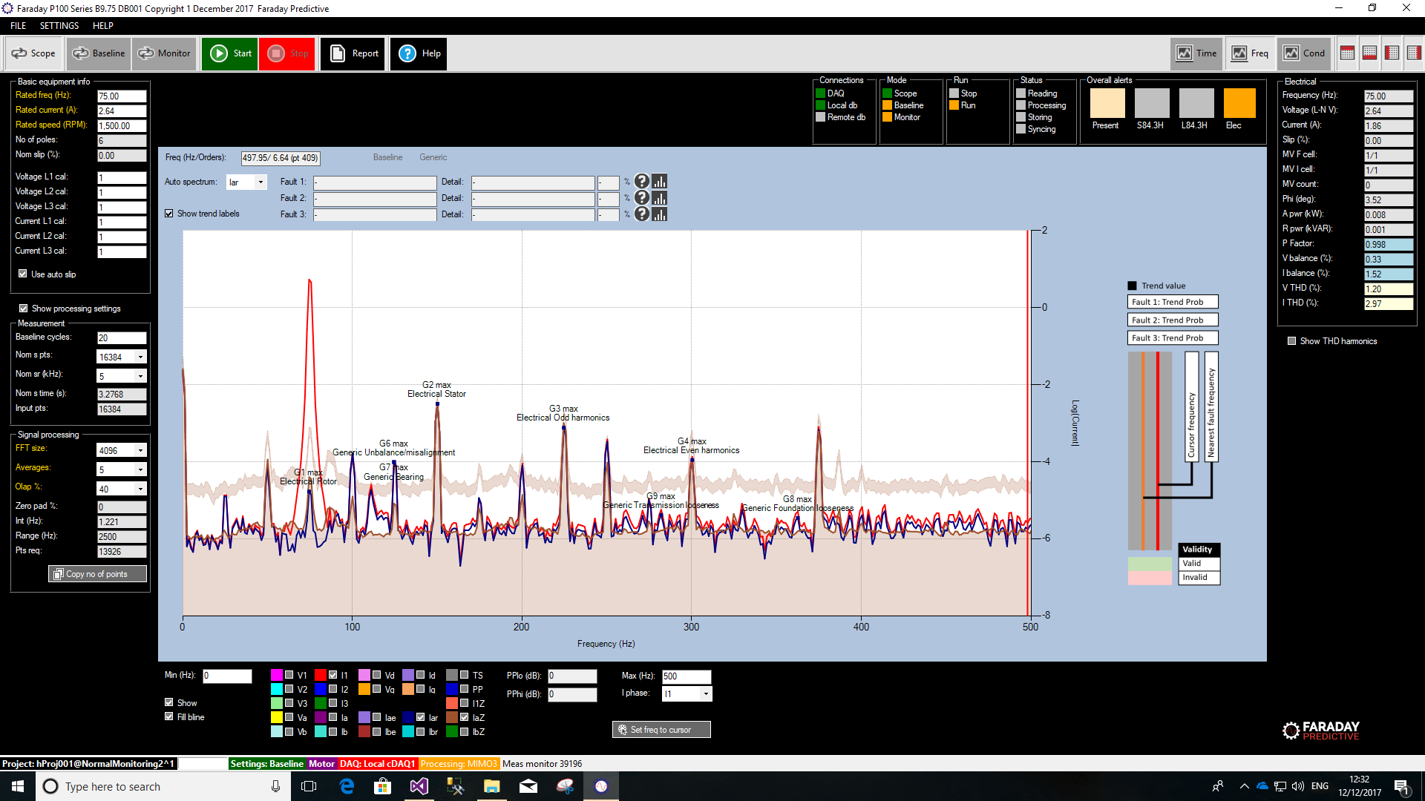

Show tick box enables/disables the peak legend

Fill bline fills the Baseline with some colour. This helps when comparing instantaneous spectrum against the baseline.

Measured parameters can be selected/deselected for display using checkboxes, and the colour of each plot can be changed by clicking on the colour label for that parameter.

Detailed information for selected faults can be presented, along with trend plots if required.

Specific controls are available for checking rotor bar condition.

# Cursor

The intelligent cursor is used to identify faults producing specific frequency peaks. Each peak is shown with a green background if validated, and the three most probable faults are shown in the information panel above. If the peak is not validated, the background is pink and no faults are listed. Optionally, the largest peaks for each fault group are added to the chart as annotations. These values are stored as trends in Monitor mode.

Faults can be identified from either I1, Iar, or Ibr data, and the source can be set in the information panel.

# Displays

Provide valuable information of the faults being identified by the Cursor.

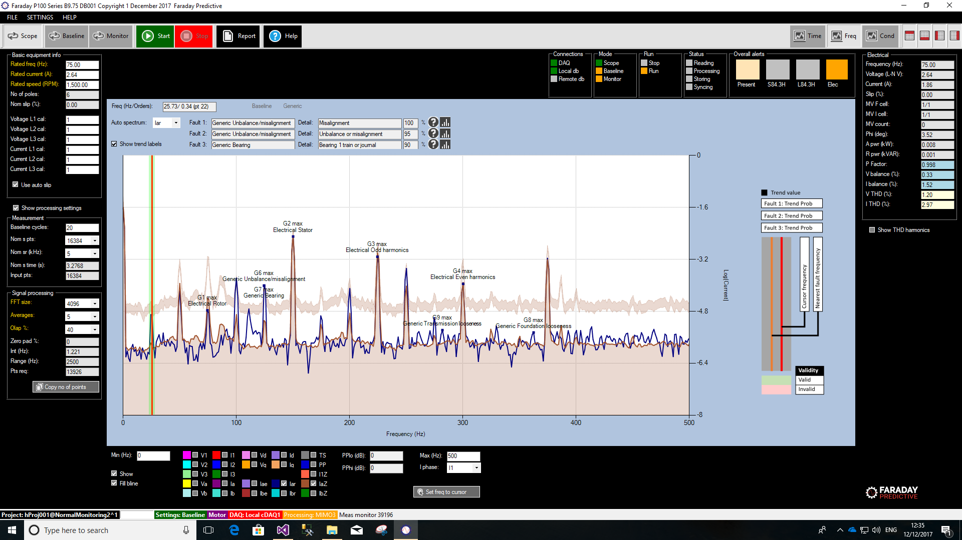

Freq (Hz/Orders) displays the frequency selected by the user, where the cursor is pointing at. It is presented in Hz and in Orders, showing within parenthesis the selected point on the spectrum (pt xxx). It is not possible to select a frequency between to adjacent points; the software will select the closest one to be displayed.

For the frequency selected, the software will display up to three potential faults, shown in order of confidence (higher top, lower bottom).

The first Colum from the RHS shows likely fault or band, whereas the LHS column shows the group where that fault belongs to.

# Parameters

Raw measurements: V1, V2, V3, I1, I2, I3.

Combined measurements: Va, Vb, Ia, Ib, Vd, Vq, Id, Iq.

Modelling estimates: Iae, Ibe.

Residual measurements: Iar, Ibr.

Alarm zone: I1Zone, IaZone, IbZone.

Processed measurements: Torque spectrum, pole pass amplitudes.

# Fault information

Information about individual faults can be selected by clicking on the information symbol next to each fault:

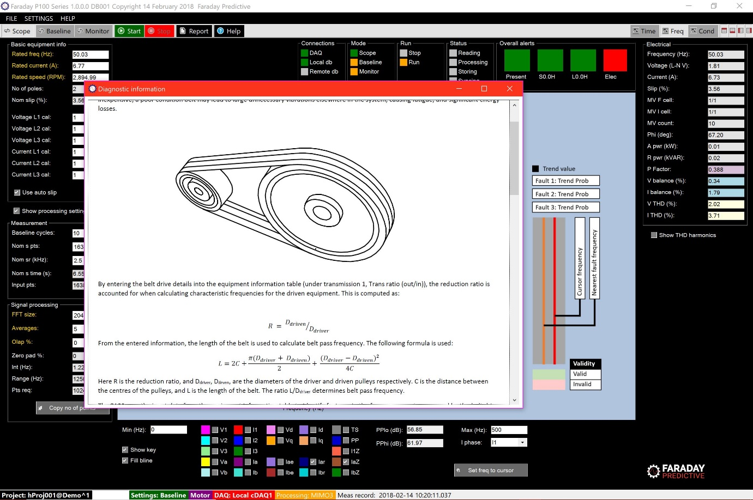

# Trend plots

Trend plots for any parameter can be selected by clicking on the Trend plot button next to each fault.

# Markers

When the Markers checkbox is checked, an set of panels are presented that contain controls that allow the user to add markers to the frequency chart at frequency points calculated from input values. This allows the expert user to build a more complete picture of specific faults and is very useful when diagnosing unusual or complex problems.

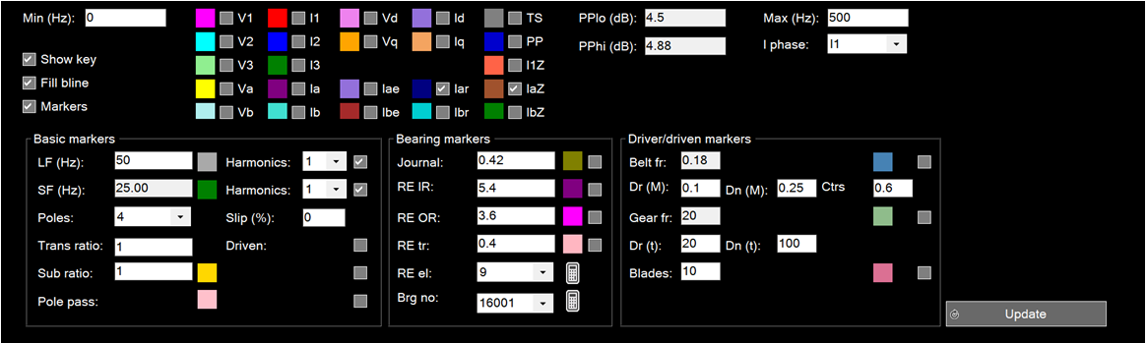

## Basic markers

Start by entering the following:

* LF (Hz): The line frequency of the supply in Hz.
* SF (Hz): The shaft frequency in Hz. This is usually set by entering values for the Poles and Slip % controls, but can also be set manually.

Now by changing the LF Harmonics and SF Harmonics numbers and pressing the Update button (this is required whenever any controls have been changed), markers appear for all selected line and shaft harmonics.

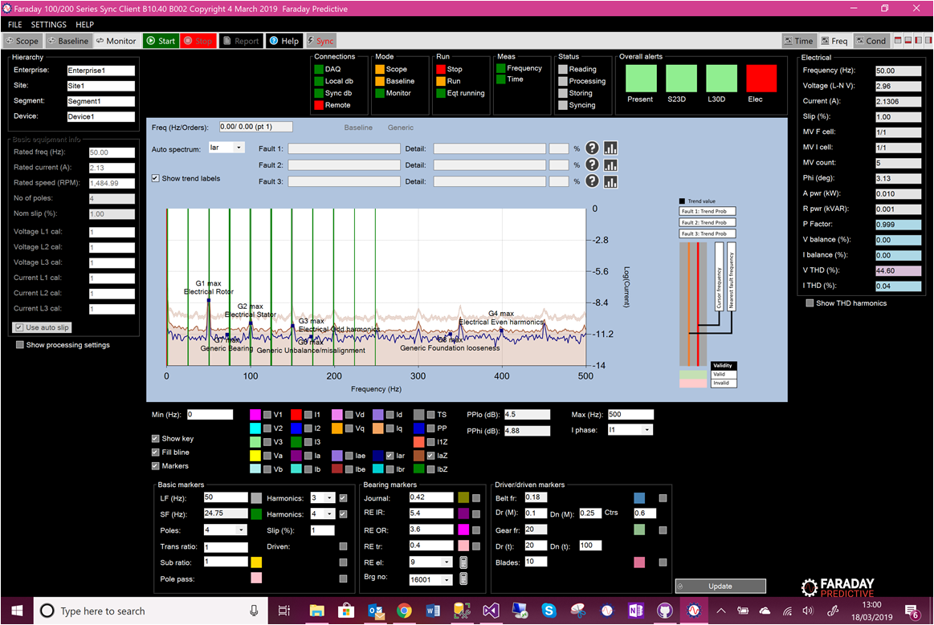

Each can be turned on and off using the checkboxes for each item, and the colour of the markers can be changed by clicking on the colour labels for each item. Pole pass markers can then be added if required by checking the Pole pass checkbox, and the colour of the markers can be changed in the same way. Similarly, subharmonic markers can be added by checking the Sub ratio checkbox, which uses the subharmonic ratio (such as 2 for half, 3 for third) set in the Sub ratio text box.

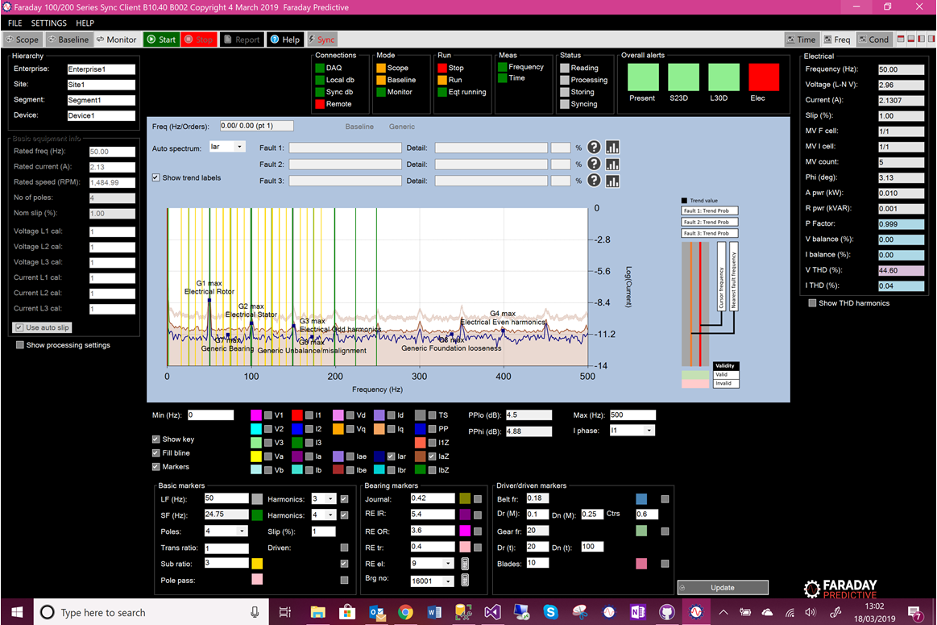

If the driver or driven system is running at a different speed to the main machine, markers can be shown for this system by checking the Driven checkbox, which uses the transmission ratio set in the Trans ratio text box.

## Bearing markers

The controls in this panel allow the user to add markers for specific bearings. The Journal control adds journal bearing markers using the ratio set in the Journal text box. The remaining controls in this panel all deal with rolling element bearings.

If the bearing number is known, the user can access the bearing database by clicking on the Brg no dropdown box. Once a bearing has been selected, clicking on the adjacent calculator symbol will populate all bearing controls automatically. Otherwise, if the number of rolling elements is known the user can enter that number in the RE el text box and click on the adjacent calculator symbol to populate bearing controls.

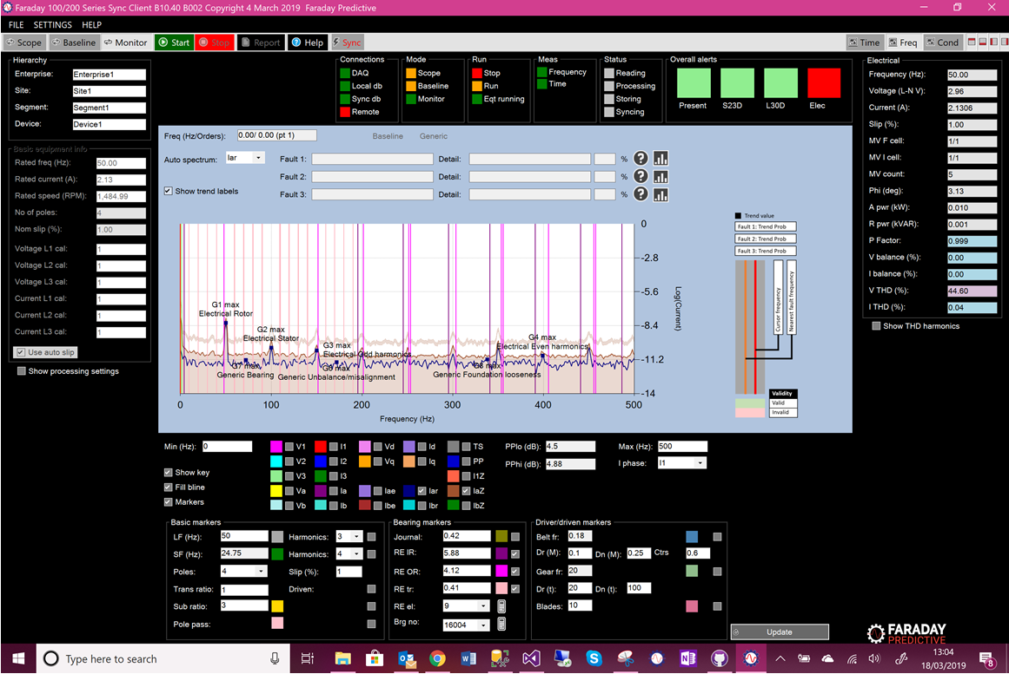

Bearing frequencies can also be entered manually (inner race, outer race, train frequencies).

## Driver/driven markers

The controls in this panel allow the user to add markers to specific components of the driver or driven system.

If the system contains a belt drive transmission then markers for this can set up by entering the driver diameter, driven diameter, and centre spacings. Alternatively if the system contains a gearbox then markers can be set up by entering numbers of driver and driven teeth,

If the driver or driven system includes a component like fan blades or pump vanes then the markers for this can be set up by entering the number of blades or vanes in the Blades text box.

# Rotor bar fault assessment

Rotor bar assessment can be carried out by making a high-resolution measurement in Scope mode, and then selecting any raw current spectrum with Pole Pass markers:

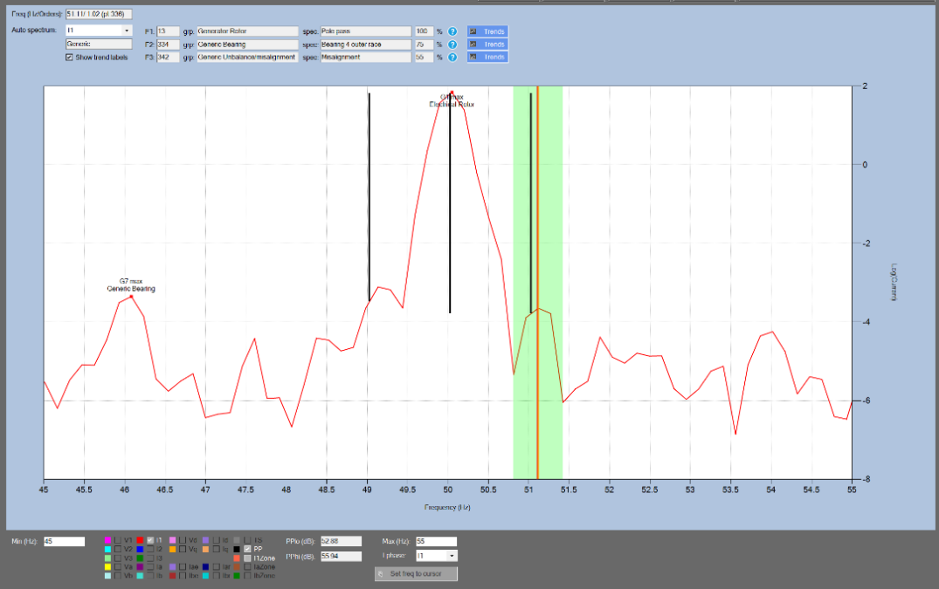

Pole Pass amplitude drops from the line frequency peak are shown in text boxes below the chart for assessment.

Understanding the PSD

Most users of the P100 system are not expected to be experts in spectral interpretation; the system is set up so that most functions require simply pointing and clicking, and an overall appraisal of equipment health can be made simply by scanning the condition bars. The following explanation is for a more experienced user who wants to learn some of the details of how the P100 system operates.

# Basic Functionality: Recap

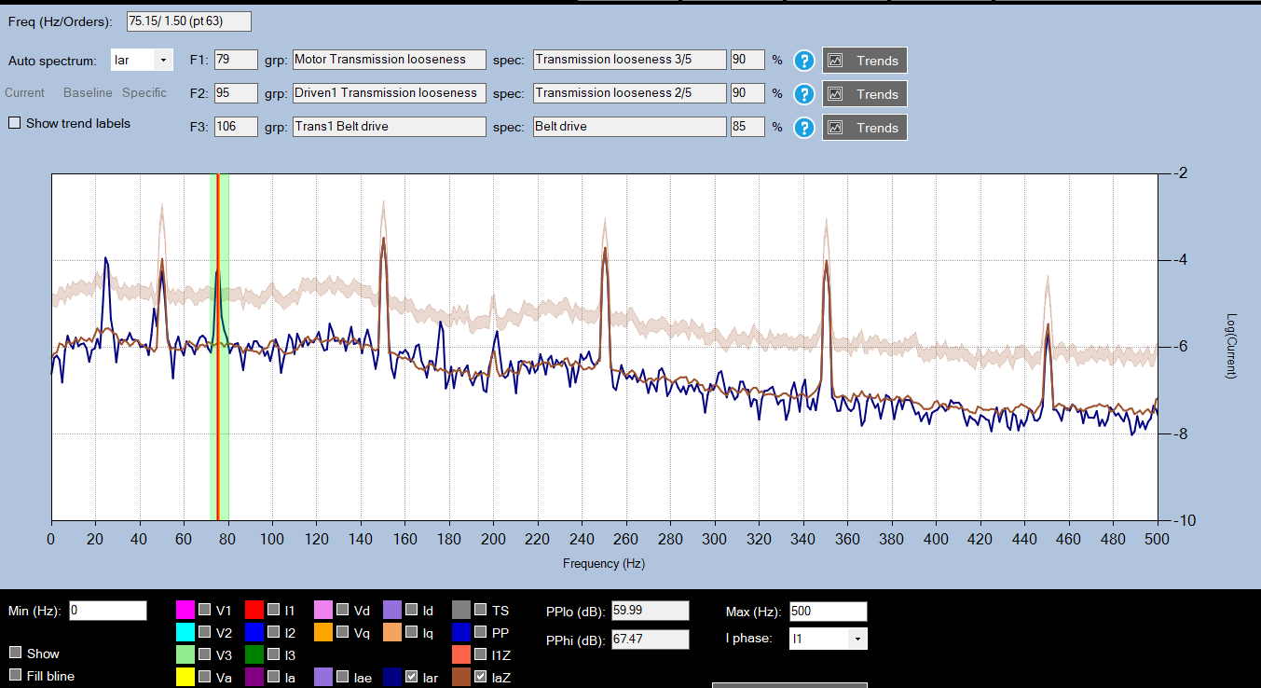

Normal operation: click on a peak you want to identify (one that was not in the baseline measurement or default Zone of Goodness). Most likely fault is identified (circled). To get the system to identify significant peaks for you, click “show trend labels” and the system will label most significant peaks in the PSD. Here we are looking at Iar (a phase residual current, blue) and IaZ (a phase residual Zone of Goodness i.e. baseline, brown) for comparison. The baseline was taken during good conditions, and the blue PSD made during a period when a faulty belt drive was attached.

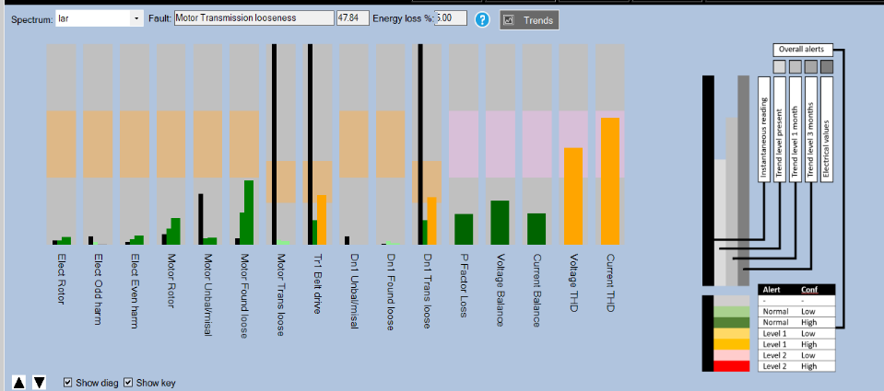

Condition chart: system indicates motor/driven transmission looseness and belt drive responses are severe. Based on the data available it predicts levels at future times, never predicting further than the range of data available to avoid errors.

# Detailed Explanation

The P100 creates a spectral plot, which is either referred to as the spectrum or the PSD. PSD stands for *power spectral density*. The word spectral refers to a frequency spectrum, since the x axis is shown in Hz. Power refers to the y axis, which is in units of log( I2). I is of course the universal symbol for current. The reason why it is called a *power* spectral density is that I2 is proportional to power (power = I2R may be a familiar formula). When using logs, it does not matter whether I or I2 is used (this is just a rescaling by a factor of 2) so the y axis is labelled as log(current).

The y axis is on a log scale; without this it would be impossible to see any peaks other than the main harmonic frequencies! With a line frequency current of something like 10A, the sort of residual currents the system needs to detect is more along the order of 0.001A. It would be impossible to spot these on the PSD without some sort of axis scaling. If the user is familiar with decibels, they can imagine the y axis scaling to simply be a decibel scale, since this is an almost identical unit.

Where there is a fault, these frequencies appear on the spectrum as *sidebands on a carrier frequency*; in the previous example at line frequency ± belt frequency. The complete formula for this kind of fault is:

Here n and m are integers, and most often n = 1, which means faults appear either side of line frequency. F_problem is the characteristic frequency of the problem; it could be belt pass frequency, a resonant frequency, shaft frequency, a bearing frequency, an impeller blade pass frequency… etc.

As long as the correct equipment information is entered into the P100, peaks at these frequencies are detected automatically.

Otherwise, the system operates in a “generic” mode, making some guesses about the equipment.

# PSD Generic Features

The P100 has two kinds of spectral plot, residual spectra (where the system has tried to remove the linear behaviour of the system and leave only the residual current corresponding to faults), and “raw” spectra like the a or b phase voltage, or current on the first phase (I1).

The PSD *always* has large peaks at various line harmonics, and usually larger peaks at the 5th and 7th harmonic. The “raw” phases also have an extremely large peak at line frequency, in the residual spectrum this peak is usually not present. In scope mode, looking at the default zone of goodness (IaZ) should give an indication of what an average healthy spectrum might look like – this is an average is made from data taken from multiple machines under quite general conditions and so real equipment might deviate from this default zone by a fair margin.

# PSD Specific Features

Aside from these line harmonics, there may be a number of other peaks or features present in the system, which are generally due to some mechanical phenomenon or a fault. Examples include:

* Peaks: the most common feature – peaks in the spectrum that are not at some line harmonic frequency
* Sidebands: sidebands are peaks either side of a carrier frequency. Sidebands are a kind of peak but in some cases they might be so close to a main peak that they look like one overall feature. Most peaks do appear as sidebands on a carrier frequency, see the examples below, and at the top of the page.
* Humps: a very broad hump around some frequency, e.g. at blade pass frequency for equipment with an impeller
* DC signal: a hump / lot of noise near 0 Hz, due to something like turbulence or foundational looseness

# Example 1: Bearing frequencies

Bearings have 3 characteristic frequencies that might appear on the PSD: train frequency, ball pass inner race frequency, and ball pass outer race frequency. These might appear as sidebands on a line frequency of 50Hz.

In the example below, train frequency ftrain is 9Hz, finner race is 212 Hz and fouter race is 108Hz. The relevant values are in red. It is not important how these frequencies are calculated, they depend on the structure of the bearings and rated speed of the machine; and are calculated automatically if the correct bearing information is put into the system.

The schematic diagram below shows how these frequencies might appear on the PSD, either side of the 50Hz peak. Since negative frequencies don’t make physical sense, the “peaks” at 50 – finner race and at 50 – fouter race can’t be seen on the PSD.

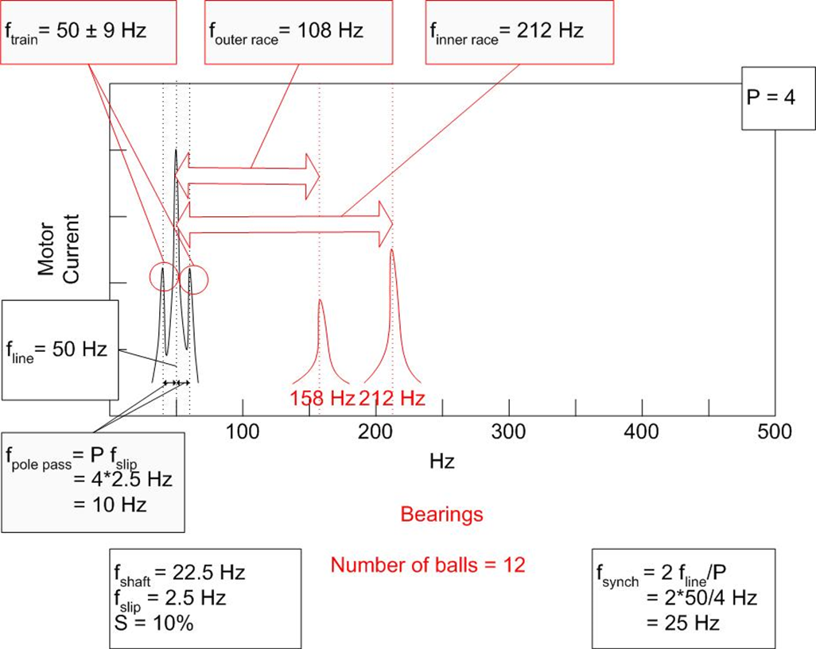

# Example 2: Shaft Looseness

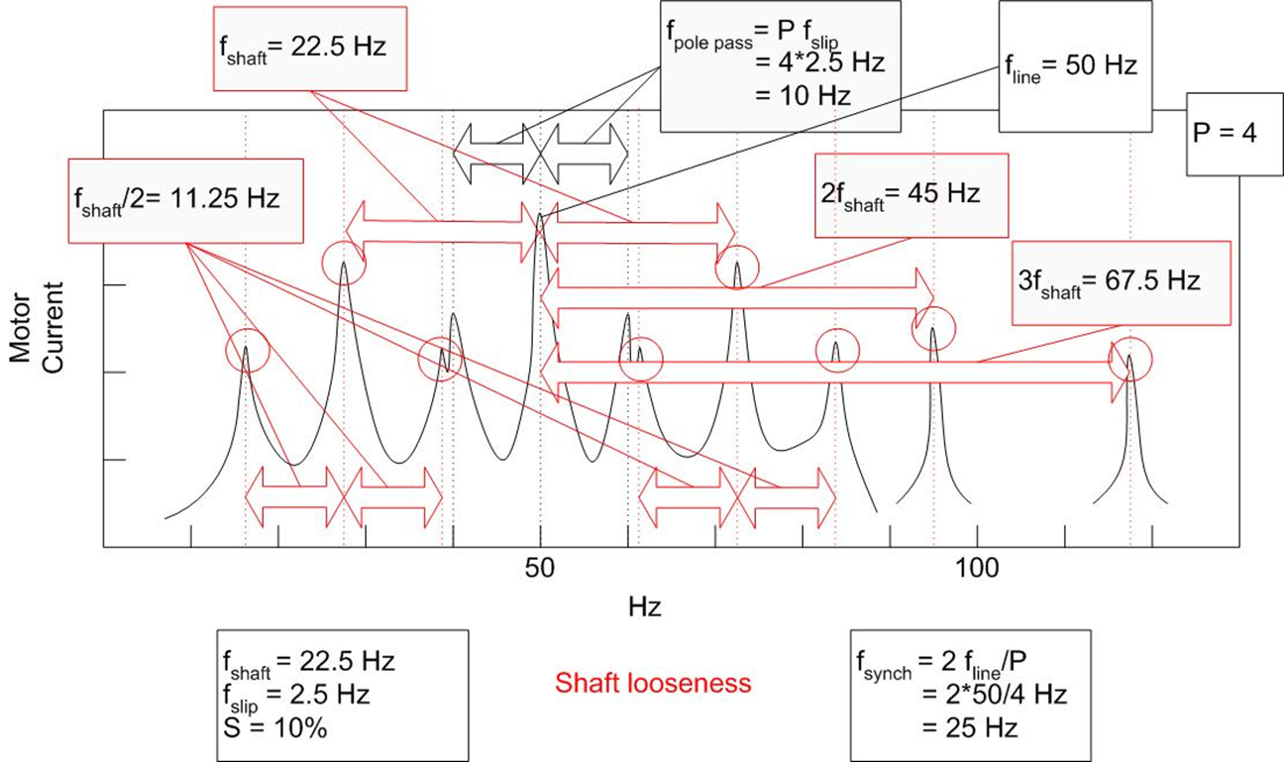

The above diagram looks more complicated, but it is just an extension of the previous principle: faults will appear at the frequencies,

However, in this case, shaft looseness appears as *½ subharmonic* sidebands on a carrier frequency, which means that m could be any multiple of ½: 0.5, 1, 1.5, …etc.

In the above example, shaft frequency is 22.5Hz, and so the ½ subharmonics appear at ± 11.25Hz either side of the 50Hz line frequency peak. But peaks *also* appear at multiples of this: i.e. ± 11.25Hz, ± 22.5Hz, ± 33.75Hz, ± 45Hz. It is worth noting that there are usually peaks at 1x shaft frequency anyway (which in this case is 22.5Hz), and so these peaks constructively add to the even multiples of the subharmonic peaks.